**Instructions:**

1. After deriving the intrinsic share price based on our model, the next step is to focus on putting together a report with an investment recommendation.
2. You are required to fill in the report template below using the sample report attached and your readings on the company’s guidance in terms of key segments and products.
   1. Identify two to three key products that are vital for the company’s growth and you can discuss about the trends and expectations. But remember to keep them all short cause and effect sentences.
3. You can take up to two days for this task and feel free to reach out to me if you have any questions.

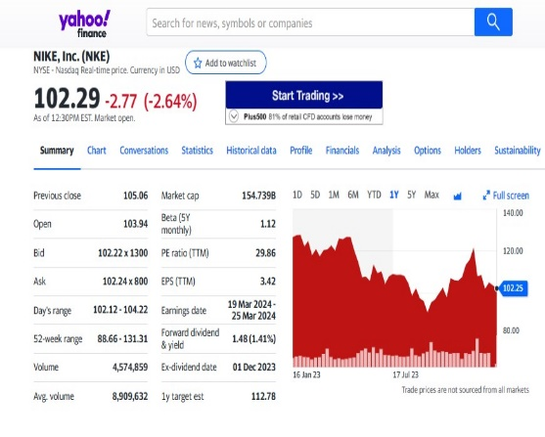

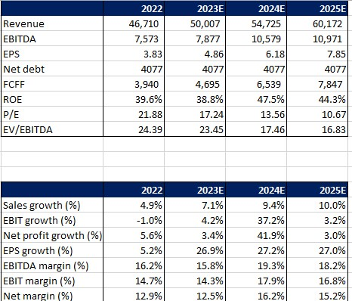

Driven by strong revenue growth and EBIT margin expansion of 10,000 bps (from 16% in FY22 to 2% in FY23 & 19.5% in FY 24), the EPS is expected to grow by 26.9% in FY23 to USD 4.86 mn.

Supported by a strong product line and market expansion through e-commerce sales, Nike’s stocks are expected grow by 7.7%.

**Investment thesis:**

**Nike has a strong 7.7% upside to its current share price, as a result of strong revenue and margin growth driven by its footwear segment.**

**EBITDA margin has expanded by 23.8% in FY23 to USD 9,375 mn. Operating segments are expected to contribute towards the margin as a result of volume growth and efficient cost control by the company.**

Nike’s revenue is expected to grow at 7.1% rate yoy in FY23 to USD 50,007 mn. Revenue growth is mainly driven from Footwear growth across North America and Asian region. Nike Air Max and the Nike Air Jordan are expected to contribute to the footwear segment further supported by the growth in apparel.

Company Name: NIKE

Ticker: NKE

Current Share Price: 113.80

Upside/Downside to current share price: ((Forecasted Price – Current Price)/Current Price): 0.07