|  |
| --- |
| **Instructions** |
|  |
| You are required to map out **the revenue drivers** and **cost drivers** for the following companies: |
| Marriot Inc. |
| Johnson & Johnson |
| You are free to refer to company websites, annual and quarterly reports, press releases and any other publicly available data |
| You are required to break-down the company's revenue into price volume data and map-out how each of these individual variables affect the revenue growth |
| For cost drivers, identify each of the cost item's correlation with revenue (fixed or variable and if variable varies based on what?) |
| You are required to comment on the company performance in the light of revenue and cost drivers |
| You are required identify peers and compare their performance with the given company, however, you are not required to go deep into identifying drivers for the peers |
|  |
| **Format:** |
| You can use charts/smart arts in word document and have bullet points below the diagram for any further explanations |
| The comment of company performance should be limited to a single page |
|  |

**Marriot Inc.**

**Revenue drivers**

Marriot plc is one of the largest hotel chains in the world by the number of available rooms. This section aims to break-down the company's revenue into price volume data and map-out how each of these individual variables affect the revenue growth

The firm’s main source of revenue is base management fees, franchise fees, incentive management fees, gross fee revenues. In its 2022 annual report, Marriot plc reported a total of 8288 properties with 1,525,407 rooms, contributing to a sales revenue of $20.8 billion. The source of revenue is mainly from its US and Canadian market, which has about 5846 properties and 964412 rooms. 5121 of its US and Canada properties are Franchised with the remaining being leased, managed and residential. This indicates that 87% of its revenue is most likely generated from franchised properties.

Also, 74% of its revenue in 2022 if from its cost reimbursement revenue indicating that the firm has been effective in reimbursements from its property level and centralised program and services. These services are often operated for the benefit of the hotel owners.

Revenue is driven as RevPAR * No. Rooms where,

RevPAR is the function of ADR (price impact) * Occupancy (volume impact)

Note that for each of the segments, North America (full service, limited service), APAC and Other international, RevPAR, Room count Occupancy and ADR are reported by the company. These will be forecasted based on historical trend analysis.

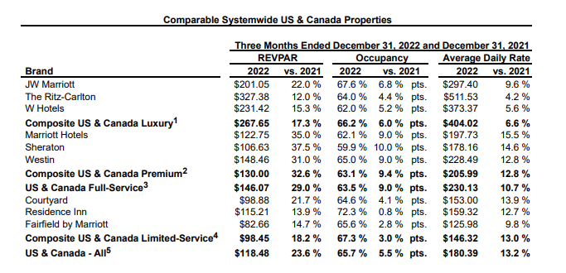

**Cost drivers**

In 2022, Marriott’s variable costs include its trading costs, selling and administration expenses, taxes, reimbursed expense, which with the level of production and sales. Its fixed costs on the other hand include interest expense as fixed costs. For 2022, the variable costs to sales ratio is 77% which means the firm is spending about 77 cents on variable costs to earn each dollar it makes in sales. The fixed costs to sales ratio in 2022 is 8% which means the firm is spending about 8 cents on fixed costs to earn each dollar it makes in sales.

Large portion of Marriot’s cost is the reimbursed expenses which is directly related to reimbursed revenue. Management and franchise related operating expenses will have be derived as a % of revenue.

**Johnson & Johnson**

This section aims to break-down the company's revenue into price volume data and map-out how each of these individual variables affect the revenue growth. Source of revenue is major consumer health franchise sales, major pharmaceutical therapeutic area sales, and major MedTech franchise sales. In 2022 Johnson and Johnson made sales revenue on £94,943m, its pharmaceutical therapeutic area contributes to 55% of its total sales revenue in 2022. Johnson and Johnson in its 2022 annual report reported worldwide sale increase of 1.3% to $94.9 billion as compared to an increase of 13.6% in 2021. These sales changes consisted of the following:

|  |  |  |
| --- | --- | --- |
| , **Johnson and Johnson 2022 AR** |  |  |
| Sales increase due to | 2022 | 2021 |
| Volume | 6.90% | 12.90% |
| Price | -0.8 | -0.7 |
| Currency | -4.8 | 1.4 |
|  | **1.30%** | **13.60%** |

Each of the three segments, Consumer, Pharmaceuticals and Medical Devices have sub segments with product lines like Remicade, Darzalex , Stelara and Tremfya  or Surgery, Orthopaedics and Intervention solutions. All of these lines have US & International sales. US revenue can be driven by annual growth rates, international revenue growth has two components, organic growth and currency impact.

Cost Drivers – as % of revenue (trend analysis)

* Selling, Marketing and Administrative Expenses
* Research and Development Expenses
* In-process research and development
* Cost of products sold

Sales by US companies were $48.6billion in 2022, which comprises 51% of total sales in 2022 which was $94.9billion.

**Cost drivers**

In 2022, Johnson and Johnson’s variable costs include its costs of goods sold, selling marketing and administration expenses which with the level of production and sales. Its fixed costs on the other hand include research and development, and interest expense as fixed costs. For 2022, the variable costs to sales ratio is 63% which means the firm is spending 59 cents on variable costs to earn each dollar it makes in sales. The fixed costs to sales ratio in 2022 is 17% which means the firm is spending 17 cents on fixed costs to earn each dollar it makes in sales.