**Instructions:**

1. After deriving the intrinsic share price based on our model, the next step is to focus on putting together a report with an investment recommendation.
2. You are required to fill in the report template below using the sample report attached and your readings on the company’s guidance in terms of key segments and products.
   1. Identify two to three key products that are vital for the company’s growth and you can discuss about the trends and expectations. But remember to keep them all short cause and effect sentences.
3. You can take up to two days for this task and feel free to reach out to me if you have any questions.

Nike’s revenue is expected to grow at roughly 11% rate yoy in FY23 to USD 70,000 mn. Revenue growth is mainly driven from Footwear growth across North America and Asian region. Nike Air Max and the Nike Air Jordan are expected to contribute to the footwear segment further supported by the growth in apparel. Both of these vital products demonstrate Nike’s commitment to performance, innovation, and cultural relevance.

EBITDA margin has expanded by 17% in FY23 to USD 8,805 mn. North America, Europe and other segments are expected to contribute towards the margin as a result of volume growth and efficient cost control by the company. Cost of sales, selling & administrative expenses grew steadily, corresponding to its growth in sales. Nike continues to invest in its R&D such as sports research lab for athletes tailored products.

EPS is expected to grow constantly at 19% per year, reaching up to 8.41 in 2027. Similarly, due to increased investment and profit, FCFF and Capex are expected to grow up to over 10,000 million USD and 1,000 million USD respectively. Nike’s key developments include more diversity in global workforce and sustainability in both production and supply chain. Additionally, Nike continues to focus on its R&D and launching of its new innovative product, such as in the area of cushioning, basketball shoes or trainers.

Nike has a strong 28.24% upside to its current share price, as a result of strong revenue and margin growth driven by its footwear segment. This implies a buy recommendation to investors based on the forecasted share price.

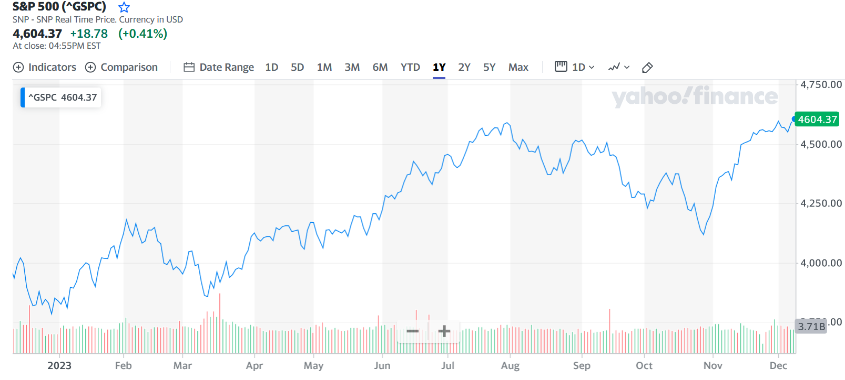

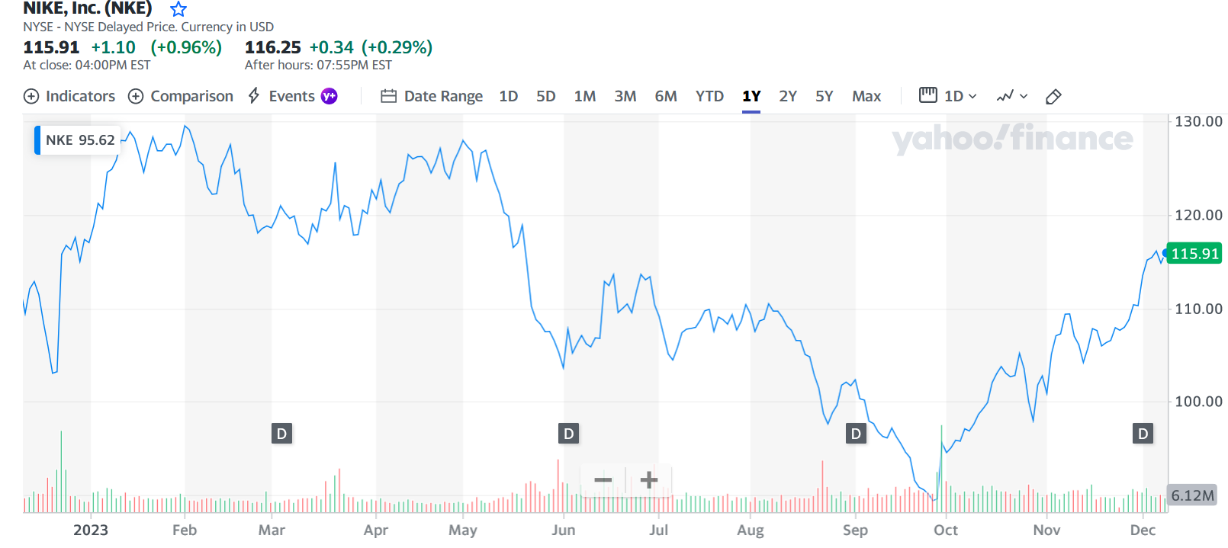

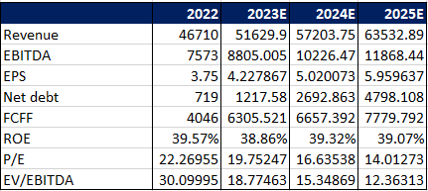

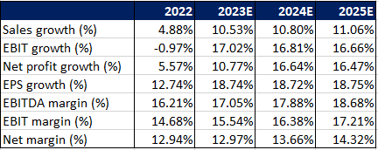

Nike Inc

NYSE: NKE

Current Share Price: 116.11 Forecasted Share Price: 148.9

Upside/Downside to current share price: 28.24%