Instructions:
- After deriving the intrinsic share price based on our model, the next step is to focus on putting together a report with an investment recommendation.
- You are required to fill in the report template below using the sample report attached and your readings on the company’s guidance in terms of key segments and products.
  - Identify two to three key products that are vital for the company’s growth and you can discuss about the trends and expectations. But remember to keep them all short cause and effect sentences.
- You can take up to two days for this task and feel free to reach out to me if you have any questions.
Company Name: NIKE INC.
Ticker
Current Share Price: $116.65
Upside/Downside to current share price: ((Forecasted Price – Current Price)/Current Price): 113.15-116.65/116.65 = -3%
Investment thesis:
Short 2-line summary of the stock’s expected performance, based on your model.
The value of Nike shares expected to drop by $3.5 and reach $113.15 per share by FY23 but is expected to grow afterwards by its 10-year average of 16% yoy due to expected favorable economic conditions from 2024.

Keep this blank for tables
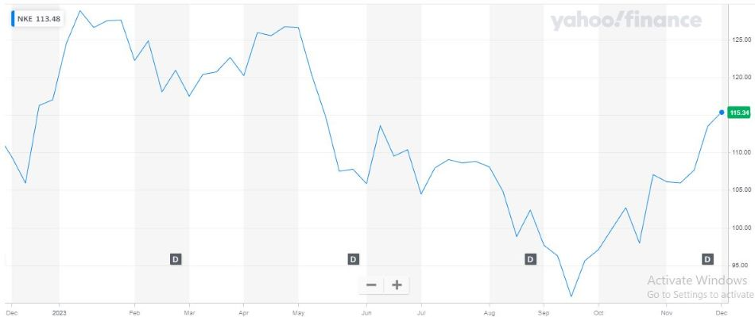
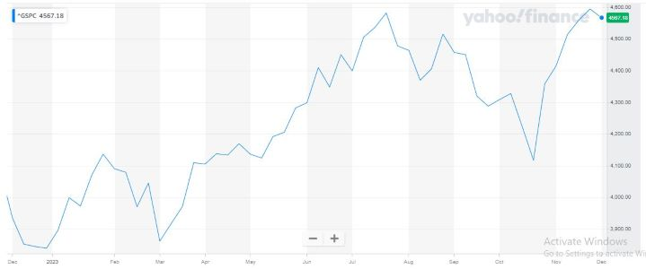
 | 2022 | 2023E | 2024E | 2025E
Revenue | 46,710 | 51,040 | 55,561 | 58,539
EBITDA | 7,573 | 7,871 | 9,936 | 12,017
EPS | 3.75 | 3.78 | 4.76 | 5.68
Net debt | (4,151) | (5,354) | (6,983) | (10,034)
FCFF | 10,055 | 12,639 | 15,393 | 19,124
ROE | 16.4% | 16.1% | 19.3% | 21.4%
P/E | 31.11 | 22.9 | 18.2 | 15.3
EV/EBITDA | 32.08 | 14.9 | 11.8 | 9.7

Point 3:
EPS is expected to show strong recovery despite global political and economic headwinds driven by strong sales volume and robust margins, growing by 0.8% from USD 3.75 in FY22 to USD 3.78 in FY23.

Point 1:
Revenue expected to double in growth to 9.3% yoy in FY23 from $ 46.7 million in FY22 and 8.9% in FY24.
Revenue growth driven by strong sales growth in Footwear in EMEA and China.
Apparel and Footwear is expected to contribute the 9.3% yoy revenue growth in EMEA from FY22 to FY23.
Point 2:
EBITDA margins are expected to remain robust at 15.4% for FY23, despite the rising cost of raw materials and production costs implying earnings are stable.
North America, EMEA & China are expected to contribute to most (16.5%, 22.9% and 33.2% respectively) to EBITDA in FY23.

