Instructions:
- After deriving the intrinsic share price based on our model, the next step is to focus on putting together a report with an investment recommendation.
- You are required to fill in the report template below using the sample report attached and your readings on the company’s guidance in terms of key segments and products.
  - Identify two to three key products that are vital for the company’s growth and you can discuss about the trends and expectations. But remember to keep them all short cause and effect sentences.
- You can take up to two days for this task and feel free to reach out to me if you have any questions.
Point 1: Nike’s revenue is expected to grow at roughly 11% year-on-year in FY 2023 to USD $49,988 million. Revenue growth is driven mainly from footwear growth across the North America and Asian regions. Nike Air Max and the Nike Air Jordan are expected to contribute to the footwear segment, further supported by the growth in apparel.
The CEO stated the company is committed to reaching 50% digital business by 2025. Nike Inc will further promote its “Nike Jordan” line which gives it significant advantages over its fast fashion rivals due to its reputation as a collectible.
Point 2: EBITDA margin has expanded by 3.5% in FY23 to USD $7835 million. Footwear and apparel segments are expected to contribute towards the margin as a result of volume growth and efficient cost control by the company.
Point 3: Driven by strong revenue growth and despite EBIT margin contraction of 50 bps (from 14.7% in FY22 to 14.2% in FY23 and FY24), the EPS is expected to fall by 5.6% to $3.54 in FY23 before then rising 18.9% in FY24 to $4.21). FCFF is forecasted to reach $17.1 billion by 2032. Nike Inc will continue to focus on expanding its direct sales, in-store and digital, which in FY22 were up 32%, reaching $16 billion in revenue (37% of Q4 revenue in 2021).
Investment thesis:
Nike has a strong 34.5% upside to its current share price, as a result of strong revenue and margin growth driven by its footwear segment.

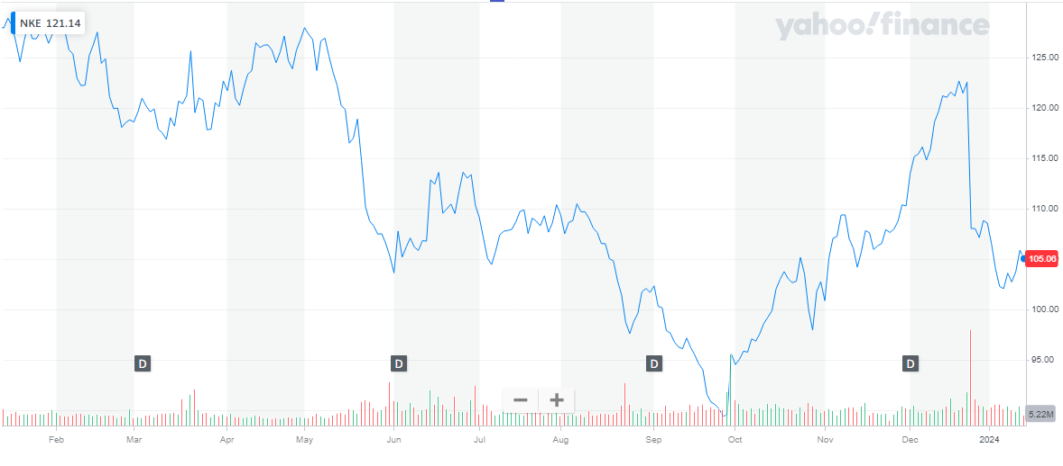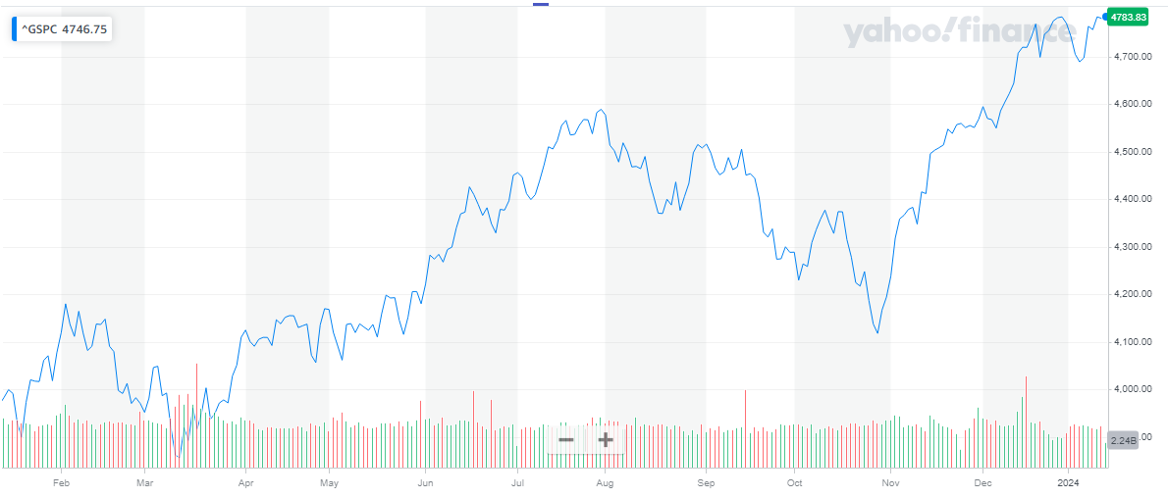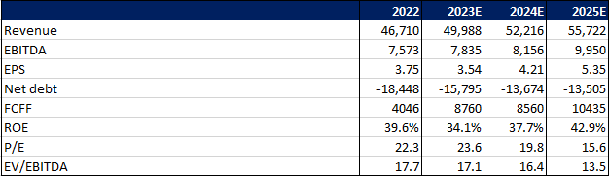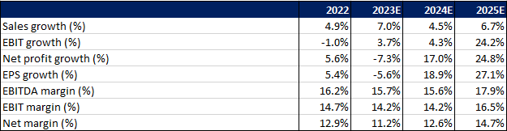
Company Name: Nike Inc
Ticker: NKE
Current Share Price: $102.08 (as of 5th Jan 2024)
Upside/Downside to current share price: 34.5% upside

