Johnson and Johnson total sales revenue for 2022 worldwide totalled $94'943 billion
The revenue was generated from the following:
Pharmaceuticals
The company discovers, develops, and sells pharmaceutical products globally. Its drugs are used for the treatment of various types of diseases, including cancer, heart-related, and infectious diseases, among others.
The pharmaceutical segment of Johnson & Johnson generates the majority of the company's sales. This division accounted for more than half of J&J's revenue for the full year. At just 60% of overall revenue, pharmaceuticals drew in a total of $52'563 billion in sales.
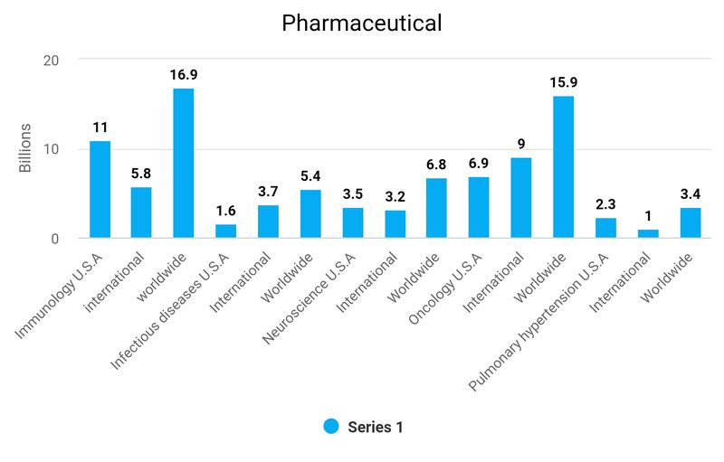

The largest individual product, a drug named Stelara generated 10% of total revenue alone, making up 16% of the entire pharmaceutical segments revenue.
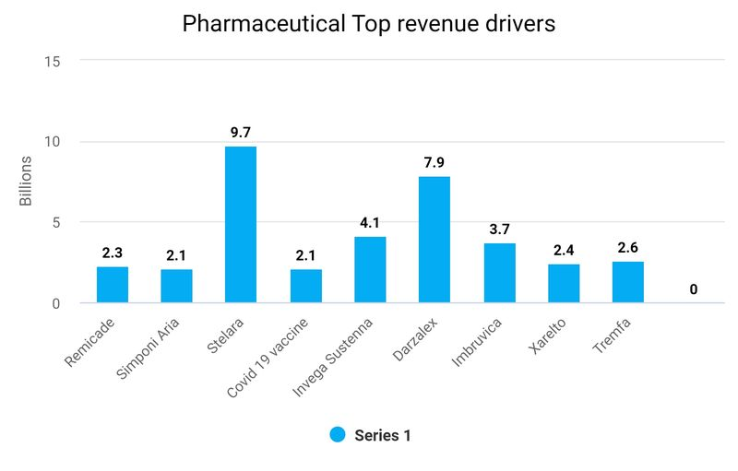

Medical Devices
This division is divided into four different areas, including:
Orthopaedics: joint reconstruction, trauma, spine, sports medicine, and power tools
Surgery: surgical systems and instruments
Interventional solutions: heart rhythm disorders and neurovascular care support for health care professionals
Revenue from Medical devices generated about $27'427 billion in sales, which represented 29% of total revenue.
The highest individual generators of revenue are Med tech surgery supplies generating 10% of total revenue and Orthopaedics at 9%

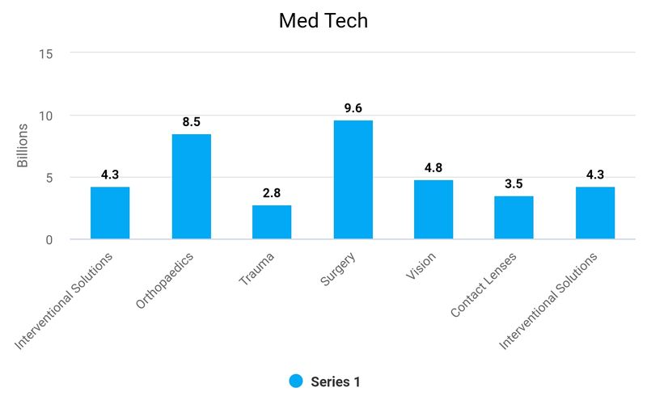

Consumer Products
Johnson & Johnson's consumer products segment offers a broad range of products used in three distinct categories:
Skin health
Self-care
Essential health
These categories provide consumers with a wide range of products ranging from baby care, oral care, beauty products, women's health, wound care, to over-the-counter medicines.
This segment of the company was responsible for 16% of total sales, representing $14'953 billion of revenue.

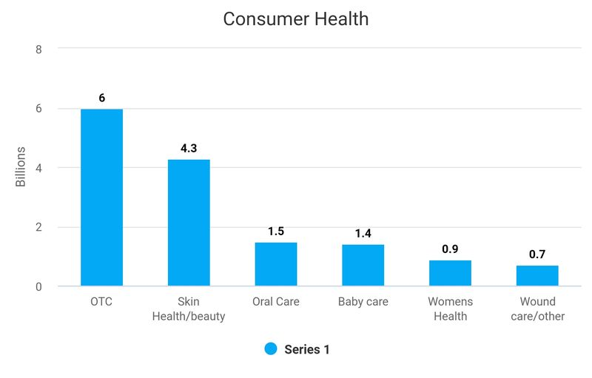

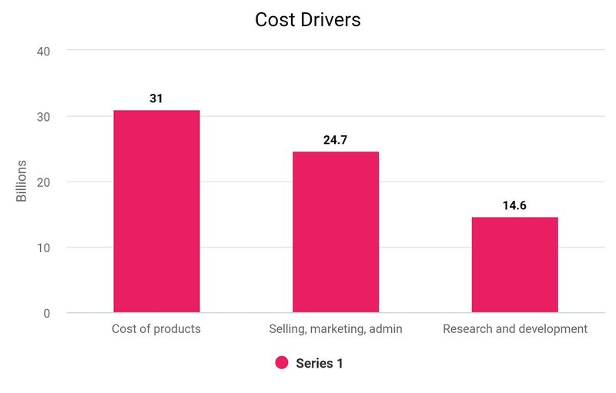
Total revenue was 94943, cost of goods, research and development, selling marketing and administrative totalled 70457 equating to 74% of revenue.

Total revenue after cost drivers deducted was around 26%, anything over 20% is considered very good and I conclude that this is an impressive return for the company.

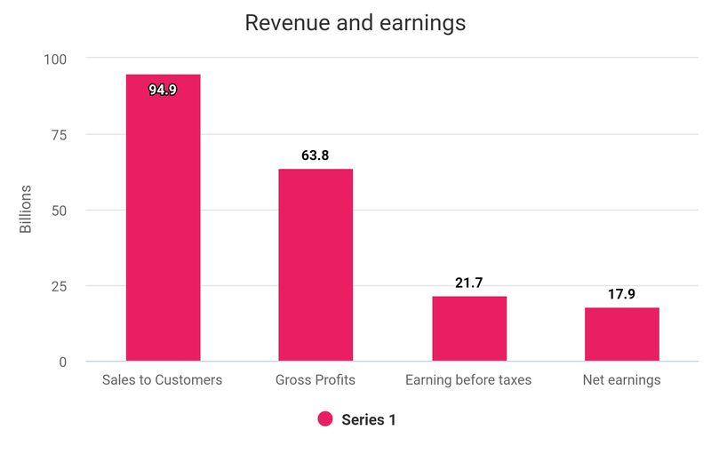

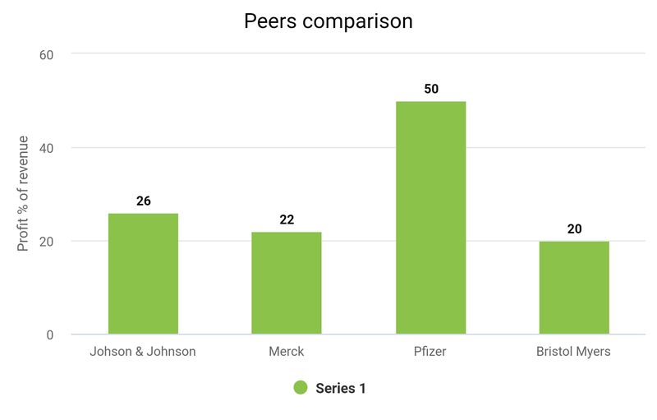
Merck total revenue for 2022 was 22232, cost of sales was 8527 equating to 39% of revenue.
Research and development, administration expenses, marketing and selling expenses totalled 8521, 39% of revenue. Combined this equates to 78% of total revenue.
Pfizer total revenue 2022 was 100,330, Cost of sales was 34,344 equating to 34% of revenue.
Research and development, administration expenses, marketing and selling expenses totalled 26,058 26% of revenue. Combined this equates to 50% of revenue and has far exceeded Johnson and Johnson performance.

Bristal Myers total revenue for 2022 was 46159, Cost of sales was 10137 equating to 22% of revenue.
Research and development, administration expenses, marketing and selling expenses totalled 17323 38% of revenue. Amortisation of intangible assets totalled 9,595, 20% of revenue.
Combined this equates to 80% of revenue.
Johnson and Johnson is performing well in comparison to its peers and outperforming them in terms of revenue/cost drivers returns, all except for Pfizer who had an extraordinary year.

