**Marriott**

Marriott generates revenue through several revenue streams: – Room Reservations: Earnings from hotel room reservations. – Loyalty Program: Revenue from membership fees and loyalty program-related activities. – Meetings and Events: Profits from event and meeting planning services.  
  
Hotel revenues are the income generated by a hotel via all its various operations and services, including room rentals, food and beverage sales, event and conference bookings, and other auxiliary services.  
  
Renting hotel rooms.  
Food and beverage services.  
Renting event spaces for meetings, conferences, and weddings.  
Amenities such as parking and spa treatments.

The Marriott hotel franchise consists of **8288** hotels worldwide in 138 countries under 30 brand names with a total of **1'525407** rooms.  
  
**USA and Canada** has a total of **5846** properties with **964412** rooms  
  
**Europe** has **721** properties with **135078** rooms  
  
**Middle east and Africa** has **327** properties and **72131** rooms.  
  
**Asia Pacific and China** has **980** properties **264946** rooms.  
  
**Caribbean and Latin America** has **320** properties with **65947** rooms.

Marriott also has a yacht with **149** rooms.  
  
There is also **93** timeshare properties globally with **22745** rooms.

All Marriott hotels are listed/defined as either luxury, premium or select tiers.  
There are 494 luxury Hotels situated globally under 7 brand names making up a total of 7% of Marriott properties.  
JW Marriott and The Ritz Charlton making up 228 properties between them. The Ritz Charlton franchise generated around 3 billion in revenue alone.  
  
The premium standard has 2117 properties globally at around 25% and consists of 11 brand names. The biggest being Marriott hotels 575 properties and Sheraton 430.  
  
The select tier of hotel consists of 5470 properties under 11 brand names making up around 66% of the Marriott franchise.  
Courtyard by Marriott has the largest number of hotels globally at 1280, around 15% of Marriott properties. Fairfield by Marriott is a close second with 1253, these two making up 30% of the Marriott franchise.

Marriott operates what's known as a Rev/Par system in order to measure performance of its properties. It is calculated by dividing room sales for comparable properties by room nights available for the period. Rev/Par is a meaningful indicator of performance because it measures the period over period change in room revenues for comparable properties.  
  
**Below we have a table of Marriott global Rev Par results for 2022.**  
Note: this is not a measure of actual revenue and should not be used as a measure to actual fees revenue generated.

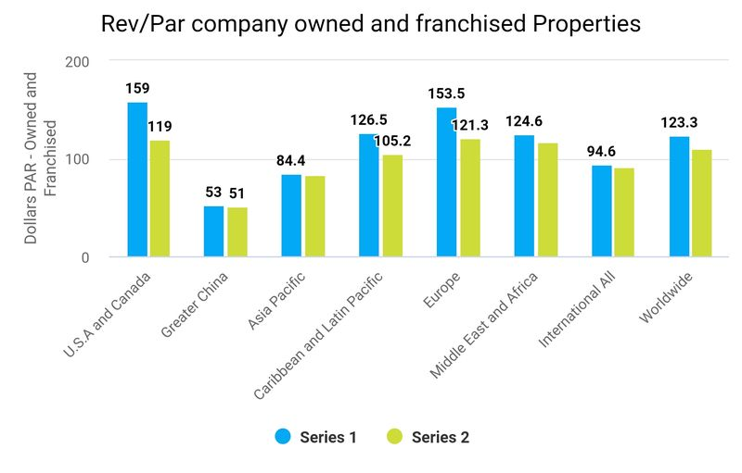

We can see U.S.A, Canada, Europe and the Caribbean had the best results of Revenue per available rooms per property.  
  
U.S.A, Canada and Europe also having the largest number of properties and rooms representing a very impressive performance and showing where the highest revenue drivers for Marriott are located globally.  
  
We can also see that Company owned and managed property's have the best RevPar results in every region and are out performing franchised properties.

Here we have a graph showing the % Annual increase from 2021 of RevPar for company owned properties(blue) and franchised(green).

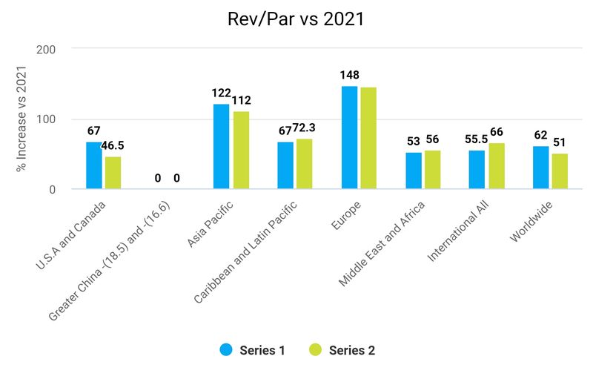

An outstanding performance especially Europe that consists of 135078 rooms being a key driver of revenue in 2022 for both owned and franchised properties with an increase of 148%, especially company owned properties which have given the best RevPar returns for Marriott.  
  
U.S.A and Canada had an increase of 67% company owned and 46.5% franchised and although a much lower increase than others this consists of the majority of Marriott properties with over 964412 rooms and is an impressive increase for a large quantity and huge driver of revenue for 2022.  
  
China was the only bad performer with a decrease of (18.5%) owned and (16.6%) franchised consisting of around 500 properties and over 100000 rooms.

Overall we can now understand how Marriots generates its revenue and see what locations and types of properties are making the most returns for the company.  
  
Now we can look at some of the costs incurred by Marriot in order to drive its revenue.

**Loyalty and credit card programs**  
  
Marriott operates a loyalty system named Marriott Bonvoy which gives members access to many benefits like travel experiences, stays at hotels and villas, discounts, airline tickets, rental cars and much more. Member earn points and redeem them for there chosen benefits.  
  
Marriott Bonvoy is a huge driver of revenue for Marriott and generates business that might otherwise go to competing hotels.  
In 2022 over half of Marriott global rooms were booked by Marriott members.  
  
The total cost of Marriot Bonvoy was 119 Million, considering this was responsible for over half of Marriots bookings this is indeed an incredible driver of revenue for the company.  
  
  
  
**Advertising** is a key part of Marriott success, the company invested 635 million into advertising in 2022 and is reflected in the reimbursed expenses on the operations costs and expenses.

**Capital expenditures** totalled 332 million, this consists of purchases of property, land, furniture, maintenance, and the overall upkeep of properties in order to keep them at a high standard to make sure they run as required and are an appealing and pleasing environment for guests to stay and want to return.  
  
  
**Contract acquisition** totalled 149 million. Further investment into the acquisition of more properties to further expand the company and cover new locations generating more revenue in the future.  
  
At the end of 2022 Marriott had more than 496000 rooms in the development pipeline, which includes  
199000 hotel rooms under construction  
22300 approved for development but not yet signed  
726 new management and franchise agreements representing 108000 rooms.  
42 luxury hotel agreements representing 8000 rooms.  
  
Over half the rooms planned are outside of the us and Canada and will increase Marriott global presence and revenue.

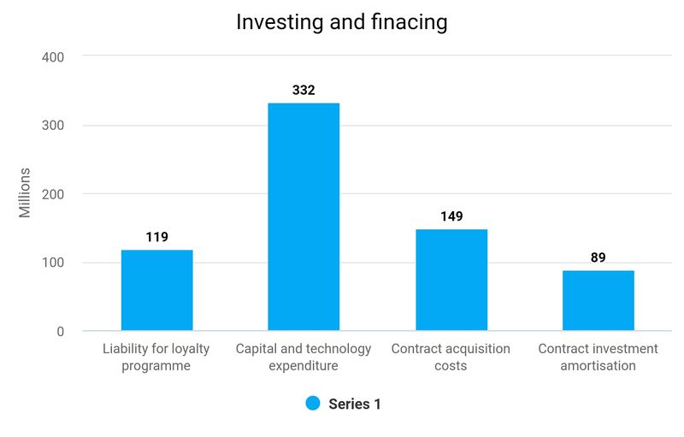

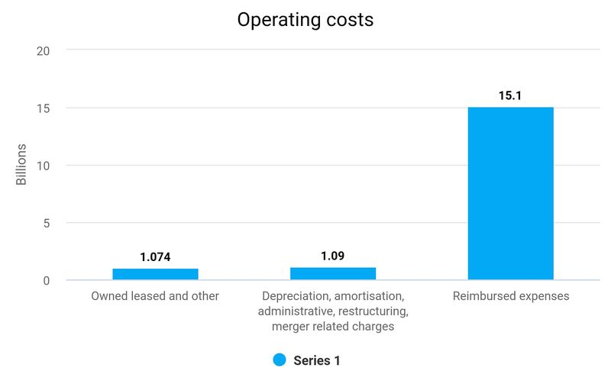

Reimbursed expenses totalled 15.1 billion in costs. Under the company's management and franchise agreements they are reimbursed for costs. Hotel owners and franchises participate in certain centralised programmes and services such as marketing, sales, reservations and insurance programs. All these costs are then reimbursed by the hotel owners and franchises and do not impact Marriott economics positively or negatively.  
Marriott total operating cost was 17'311 billion, of which 15'141 was reimbursed expenses. All other costs totalled 2'164 Billion.  
  
Marriott total revenue was 20'773 billion with a gross profit of 3'114 generating 2'358 net profit.  
Net profit margin calculates to 11.3% of total revenue.  
However if you exclude reimbursed revenue you get 5'745 billion from hotel management, franchise fees and other.  
  
This calculates to a profit margin of 41% of actual revenue, which is an impressive return and performance by Marriott.

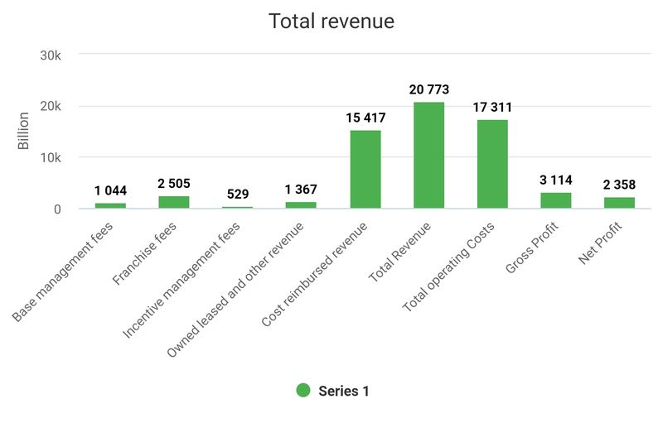5745

Here we will compare Marriott peers and have identified Hilton hotels as there biggest competitor followed by IHG and Hyatt.

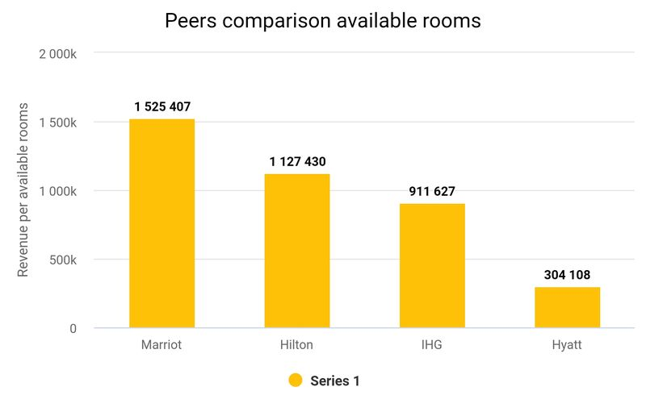

Here as can see the number of rooms the peers currently have with Marriott far exceeding them all even Hilton by around 400'000 rooms.

This is also reflected in Total revenue generated

Marriott revenue was 20'77 billion with a net profit of 2'358 billion.  
  
Hilton's revenue was 8'77 billion with a net profit of 1'255 billion.  
  
IHG revenue was 3'89 billion with a net profit of 828 million.  
  
Hyatt revenue was 5'89 billion with a net profit of 455 million.

If we calculate actual revenue by available rooms we can also see what each company is generating per room.

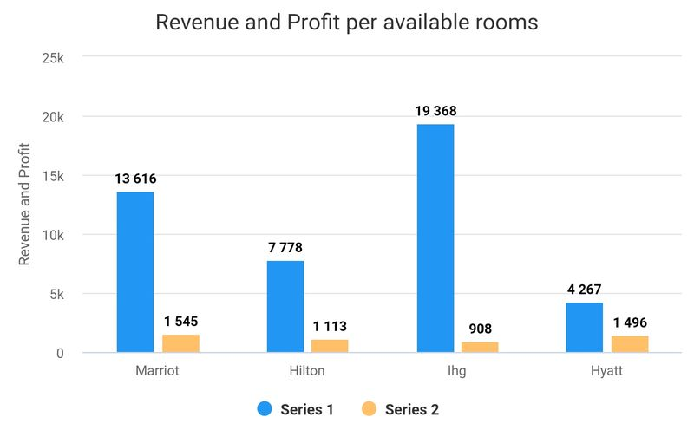

We can see that Marriott generates the second highest amount of revenue per rooms but more importantly the most profit. Considering the number of rooms far exceeding other companies this is most impressive.  
  
We can also calculate the average revenue and profit for each property under each company.

Marriott has **8288** properties with an average revenue of **2'506"000** million and **284'000** in profit.  
  
Hilton has **7165** properties with an average revenue of **1'224"000** million and **175'100** in profit.  
  
IHG has **6028** properties with an average revenue of **645'000** million and **137'358** in profit.  
  
Hyatt has **1142** properties with an average revenue of **5'157"600** million and **398'400** in profit.  
  
  
Although there will be many factors influencing revenue and profit per property this is still an interesting metric to view. Excluding Hyatt which has far less properties and rooms, Marriott performance is far exceeding Hilton and IHG which are more similar peers in terms of property numbers. Marriott average revenue per property is double that of Hilton and average profits are more than 100'000 per property.  
  
The performance of Marriott is easily the best out of it peers in terms of profit per available rooms and properties concluding that Marriott remains the number one hotel franchise.

