Johnson & Johnson Revenue and Cost Drivers

Revenue Drivers

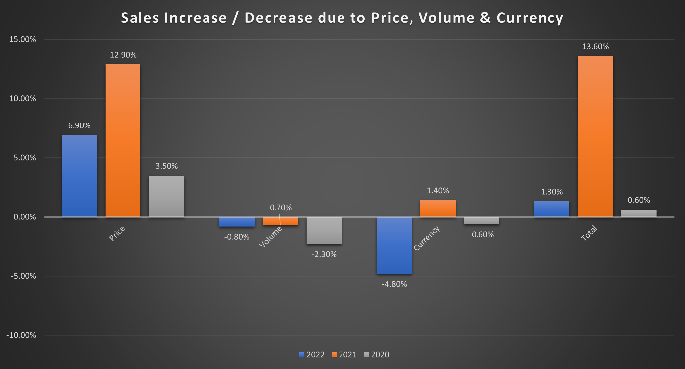
Sales increase / (decrease) due to: | 2022 | 2021 | 2020
Price | 6.90% | 12.90% | 3.50%
Volume | -0.80% | -0.70% | -2.30%
Currency | -4.80% | 1.40% | -0.60%
Total | 1.30% | 13.60% | 0.60%

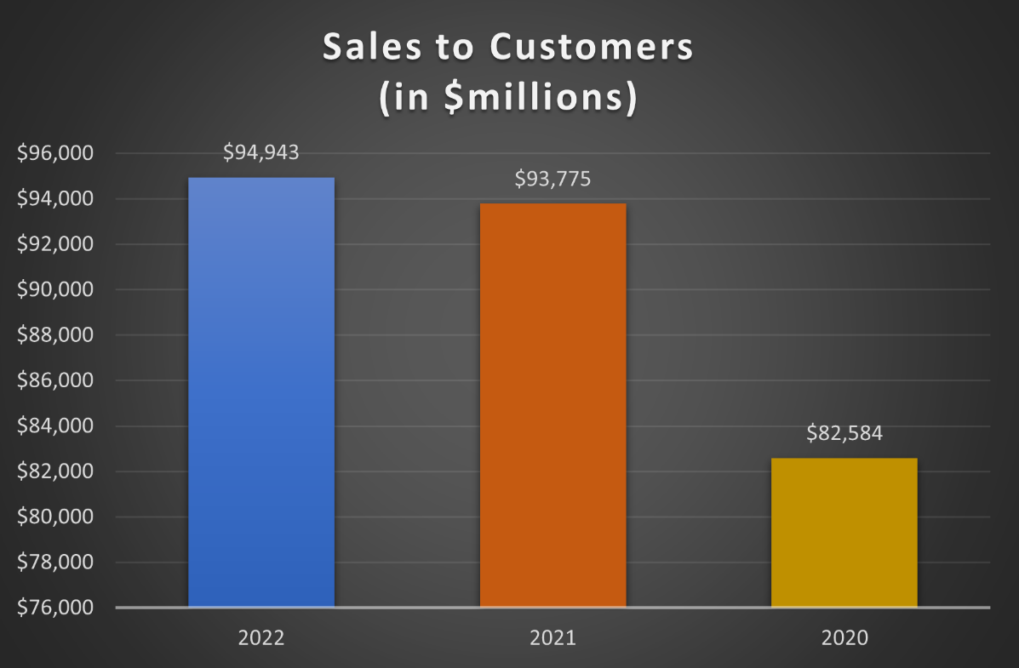
An analysis of Johnson & Johnson's Sales to Customers underscores the pivotal role played by price, volume, and currency in shaping the company's financial performance. Notably, the consistent year-over-year increase in price has been a primary driver, with the most substantial surge recorded in 2022, exhibiting a notable 12.6% uptick compared to the previous year.

Conversely, the impact of volume on sales has manifested as a persistent year-over-year reduction, maintaining a relatively stable trajectory from 2021 to 2022, with each year witnessing a modest decrease ranging between 0.7% and 0.8%.

The influence of currency fluctuations has been dynamic, presenting varying effects annually. In 2022, currency fluctuations resulted in a substantial 4.8% reduction in total sales. This contrasts with 2021 when currency fluctuations contributed positively with a 1.4% increase.

Despite the fluctuations in volume and currency, the overall trend reveals a commendable increase in Sales to Customers each year. The most noteworthy surge occurred in 2021, primarily attributed to robust price increases. The aggregate impact on total sales in 2022 reflects a modest 1.3% increase, showcasing the company's resilience in sustaining growth amid nuanced market dynamics. This comprehensive analysis underscores the interplay of price, volume, and currency in influencing Johnson & Johnson's Sales to Customers, providing valuable insights into the factors shaping its financial landscape.

Cost Drivers

Cost Item Correlation to Revenue
- Royalties – Variable. Based on sales or usage of a particular product.
- Advertising – Variable. Tied to the level of promotional activities.
- Shipping & Handling – Variable. Depends on the volume of products shipped.
- Upfront Payments to Collaborative Partners - Fixed in the short term, can become variable over the long term. Variation may occur if the collaboration leads to increased production or sales. It might be fixed for a specific time or amount but variable if it is tied to performance metrics.
- Research & Development Payments to Collaborative Partners – Variable. Tied to specific R&D projects or milestones.
- Patents & Trademarks – Mostly Fixed.
- Customer Relationships – Mostly Fixed.
- Purchased In-Process Research & Development – Fixed, One-Time.
- Restructuring – Variable. Varies according to specific actions
Company Performance

Johnson & Johnson has demonstrated commendable performance in the fiscal year spanning from 2021 to 2022, marked by notable advancements in its revenue streams. Across the pivotal sectors of Consumer Health, Pharmaceutical Sales, and Medical Devices, the company has experienced robust growth, registering increases of 4.1%, 14.3%, and 17.9%, respectively.

In terms of operational costs, there has been a discernible upward trend. The Cost of Sales has risen by 4.1%, indicating the impact of various factors on the company's cost structure. Conversely, Selling, Marketing, and Administrative expenses have maintained relative stability, with only a marginal uptick of 0.4%. Strategic measures, including a prudent 1.4% reduction in Research & Development costs, have contributed to enhancing overall operational efficiency.

Nonetheless, the imperative need for restructuring has led to a consequential surge of 27.3% in associated costs. These restructuring efforts aim to channel resources strategically, fostering investments in critical capabilities, technologies, and solutions essential for manufacturing and supplying the product portfolio, thereby augmenting agility, and driving growth. This has been further compounded by losses attributed to negative interest income and an augmented interest expense, resulting in a 14% decline in net income.

It is noteworthy, however, that despite the challenges encountered, the net income for the fiscal year 2022 stands at a commendable 21.9% higher than that of 2020. This underscores the resilience and strength of the company's overall operating efficiency and profitability. Johnson & Johnson's ability to navigate the complexities of the business landscape while maintaining an upward trajectory in net income reflects its robust foundation and strategic prowess.
Coupled with losses due to negative interest income and an increase in interest expense has seen net income drop by 14%.

Peer Comparison

Johnson and Johnson
- Sales: $94,943 million
- Cost of Sales: $ 31,089 million
- Research and Development: $ 14,603 million
- Net Income: $17,941 million

Pfizer
- Sales: $100,330 million
- Cost of Sales: $34,344 million
- Research and Development: $11,428 million
- Net Income: $31,372 million

Merck & Co
- Sales: $59,283 million
- Cost of Sales: $17,411 million
- Research and Development: $13,548 million
- Net Income: $5,71 million

GlaxoSmithKline
- Sales: $29,324 million
- Cost of Sales: $9,554 million
- Research and Development: $5,488 million
- Net Income: $15,621 million

Comparison:
Sales
Pfizer leads in total sales, followed by Johnson and Johnson. Merck & Co and GlaxoSmithKline have notably lower sales figures in comparison.
Cost of Sales
All companies show a proportionate relationship between sales and cost of sales, with Pfizer having the highest cost, followed by Johnson and Johnson. Merck & Co and GlaxoSmithKline demonstrate lower costs relative to their sales figures.
Research & Development
Johnson and Johnson allocate the highest amount to R&D, followed by Merck & Co and Pfizer. GlaxoSmithKline spends the least on research and development.
Net Income
Pfizer exhibits the highest net income, while Johnson and Johnson and GlaxoSmithKline follow closely. Merck & Co lags behind in net income, relative to its peers.

In summary, Pfizer outperforms its peers in terms of total sales and net income. Johnson and Johnson, although trailing Pfizer, maintains a strong position in the market with substantial sales and a balanced cost structure. Merck & Co and GlaxoSmithKline, while having lower sales figures, show diverse strategies with Merck & Co investing significantly in R&D, and GlaxoSmithKline maintaining a higher net income relative to its sales.

