**Point 3:**

Driven by strong revenue growth and EBIT margin expansion of 110 bps (from 14.7% in FY22 to 15.8% in FY23 & 16.8% in FY 24), the EPS is expected to grow by 9.3% in FY23 to USD $4.10

FCFF will see consistent growth of between 8-12% each year.

Capex growth should be stable, keeping a very low 1.5% of revenue.

Nike’s focus on production improvements and direct-to-consumer digital efforts are set to reap the benefits of the current positive trends.

**Point 1:** We expect revenue growth to be stable at around 8% per annum from 2023 onwards, with the greatest segment growth occurring in EMEA and APLA regions. Greater China has great potential for growth but is still unstable due to the impact of COVID-19.

Footwear will remain the strongest revenue driver across all regions, but apparel revenue in EMEA is expected to grow at a high rate of almost 15% in 2023 and going forward so that revenues almost rivals that of footwear in the region.

**Point 2:** EBITDA margins are expected to remain in the high teens to early twenties. Currently, North America contributes roughly 40% of total group revenue, with EMEA at 27% and APLA at 13%. Future forecasts predict EMEA growing to represent roughly 30% of revenue. Historically, Nike has invested heavily in improving production lines and increasing its digital presence, this is now likely to slow down as focus shifts to future growth.

**Investment thesis:**

Based on our DCF analysis, which values the stock at $91.72, it is currently overvalued at $107.18.

Nike has a weak 14% downside to its current price, as a result of inconsistent growth through the COVID period. However, strong revenue and margin growth from its footwear segment suggest high potential for growth.

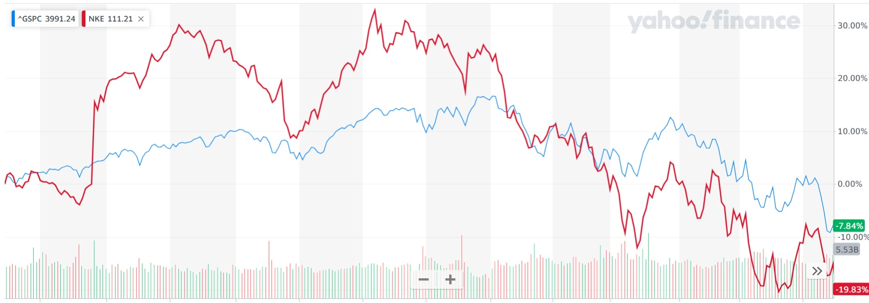Nike Share Performance (Red) vs S&P 500 for period 1 June 2021 to 31 May 2022





**NIKE, Inc.**

**NYSE: NKE**

**Current Share Price: 107.18**

**Upside to current share price: -0.14**