**Marriott Inc Analysis**

**Revenue Drivers Analysis**

**Price Volume Data Breakdown and Impact on Revenue Growth**

**Base Management Fees:**

Increased significantly from £443m in 2020 to £1,044m in 2022, showing strong growth in the company's management segment, potentially due to an increase in the number of hotels managed and improved performance metrics.

**Franchise Fees:**

Also showed substantial growth from £1,153m in 2020 to £2,505m in 2022, indicating a successful expansion of Marriott's franchise model, likely driven by both an increase in the number of franchises and possibly improved per-unit revenue.

**Incentive Management Fees:**

Displayed the most significant percentage increase, from £87m in 2020 to £529m in 2022, suggesting enhanced operational efficiency and profitability in managed properties.

**Owned, Leased, and Other Revenue:**

Increased from £568m in 2020 to £1,367m in 2022, reflecting improved performance in directly owned and leased properties.

**Cost Reimbursement Revenue:**

This is the largest revenue component, significantly growing from £8,452m in 2020 to £15,417m in 2022, indicating an expansion in scale and services provided that have direct cost reimbursements.

**Cost Drivers and Their Correlation with Revenue:**

Variable Costs: Primarily include reimbursed expenses (£15,141m in 2022), directly correlated with the volume of services provided. As Marriott's service volume increases, these costs and the corresponding revenue from cost reimbursements also grow, reflecting a direct variable relationship with revenue.

**Fixed Costs:**

Depreciation, amortization, and other costs (£193m in 2022) are relatively stable and do not directly fluctuate with revenue, representing typical fixed cost behavior.

**Company Performance**

**Operating Margin:**

Improved from 1% in 2020 to 17% in 2022, indicating a strong recovery and growth in profitability. The drastic revenue growth rate and efficient cost management have likely contributed to this improvement.

**Cost-to-Revenue Ratio:**

Decreased from 99% in 2020 to 83% in 2022, showing improved efficiency in managing costs relative to revenue generation.

**Contribution Margin:**

Increased significantly, indicating better leverage of the company's fixed and variable cost structure to improve profitability.

**Peer Comparison**

Compared to competitors like Wynn Resorts, Caesars Entertainment, Hyatt, Hilton, and MGM Resorts, Marriott's market share in Q4 2023 is 22%, showcasing strong industry positioning. The comparison indicates Marriott's effective strategy in maintaining a significant market share amidst competition, supported by its diversified revenue streams and efficient operational model.

**Conclusion**

Marriott International Inc has demonstrated strong revenue growth across its various service lines, driven by an effective mix of price and volume factors. The significant increase in incentive management fees highlights improved operational efficiency and profitability of managed properties. Cost management reflects a balanced approach, with variable costs aligned with service volume and fixed costs being well contained. The company's performance, characterized by improved operating margins and contribution margins, suggests robust recovery and growth post-2020 challenges. Compared to peers, Marriott maintains a leading position, indicating competitive strength and strategic effectiveness in its operations.

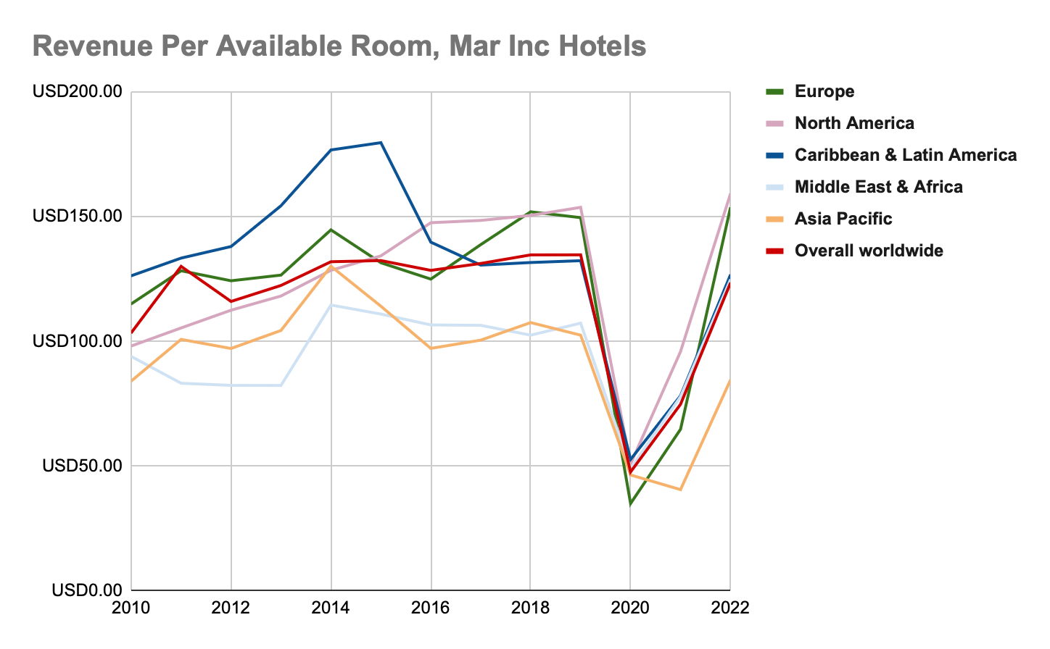

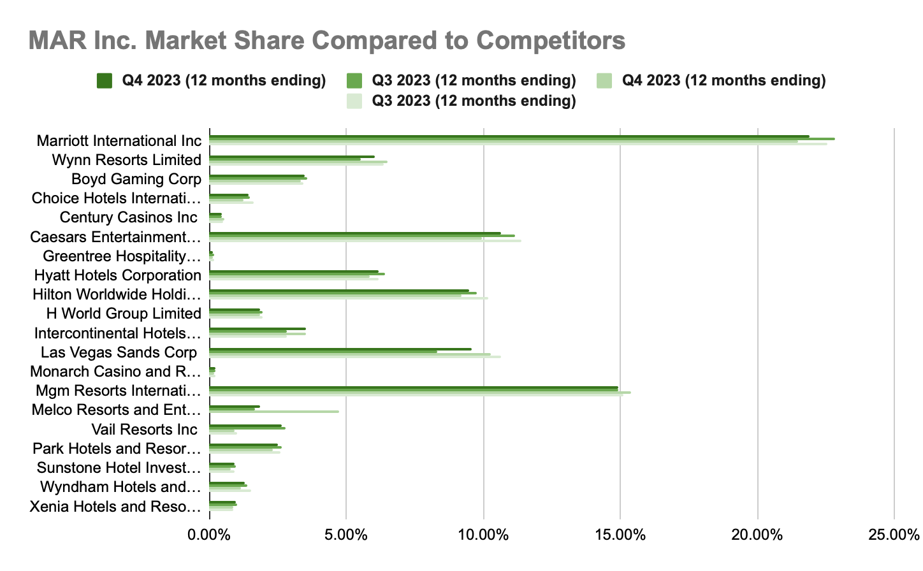

**Johnson & Johnson Analysis**

**Revenue Drivers Analysis**

**Breakdown by Price and Volume**

**Geographic Distribution:**

Sales show a significant portion of revenue generated from the U.S. (51%), followed by EU (25%), APAC & Africa (18%), and Western Hemisphere (6%). This distribution indicates a strong domestic market presence and significant international operations, with growth opportunities in emerging markets.

**Segment Distribution:** The Pharma segment is the largest revenue contributor at 55%, followed by Med Tech at 29%, and Consumer Health at 16%. The dominance of the Pharma segment highlights JNJ's strong position in pharmaceuticals, which is critical for driving revenue growth.

**Impact on Revenue Growth:**

**Pharma:** Growth in this segment is driven by key products in Immunology, Oncology, and Neuroscience. For instance, TREMFYA and DARZALEX show significant sales increases due to their market acceptance and expanded indications.

**Med Tech:** Stability in this segment with slight operational changes indicates a resilient demand for medical devices and technology, although currency changes have impacted reported sales.

**Consumer Health:** The modest changes in sales reflect the competitive nature of consumer health products and the impact of currency fluctuations.

**Cost Drivers and Correlation with Revenue**

**Variable Costs:** Major variable costs include Selling, Marketing, and Administrative Expenses, which are directly tied to the company's efforts to grow sales and manage its operations efficiently.

**Fixed Costs:** Research and Development expenses, while substantial, are more fixed in nature, as they are committed to long-term product development and are less directly influenced by sales volume in the short term.

**Company Performance**

JNJ shows a diversified revenue stream with a strong emphasis on the Pharma segment, indicating a focus on high-margin products that can drive future growth. The global geographic distribution underscores the company's international reach and potential vulnerability to currency fluctuations. The operational changes versus currency changes highlight the company's ability to grow operationally, even as it navigates the challenges of global financial markets.

The cost structure, with a significant portion allocated to selling, marketing, and R&D, emphasizes JNJ's strategy towards maintaining its market position and investing in future growth. The operating margin and contribution margin show a healthy profitability level, although the cost-to-revenue ratio suggests areas for efficiency improvements.

**Peer Comparison**

When comparing JNJ's performance with peers like Eli Lilly, Pfizer, Amgen, Bristol Myers Squibb, Merck, Abbott, and AbbVie, JNJ demonstrates a balanced portfolio across Pharma, Med Tech, and Consumer Health. This diversification might provide more stability compared to peers focused primarily on one segment. Market share data indicates competitive positioning within the industry, with JNJ holding a significant share but facing strong competition, especially in the Pharma segment.

**Conclusion**

Johnson & Johnson's financial performance reveals a robust business model with a focus on high-growth segments like Pharma and a balanced presence in Med Tech and Consumer Health. The company's global footprint provides a broad market base, while also exposing it to currency risks. Operational growth, despite currency headwinds, showcases the underlying strength of JNJ's business. Going forward, maintaining operational efficiency, especially in cost management, and capitalizing on growth opportunities in emerging markets and innovative product lines will be key to enhancing JNJ's competitive stance and financial performance compared to its peers.

