**Johnson & Johnson**

Johnson & Johnson is a holding company with more than 152,000 employees based and incorporated in USA, which is engaged in the research and development, manufacture and sale of a broad range of products in worldwide in the healthcare industry. The Company’s primary focus is products related to human health and well-being in three business segments: Consumer Health, Pharmaceutical and MedTech (Medical Devices).

Johnson & Johnson's Pharmaceuticals segment has made 55 % in total revenues in each financial year from 2020 to 2022, while Medical Devices segment has increased by 17.9 % in 2021 and further increased by 1.4 % in 2022 to its revenue growth over the years. Also, Consumer Health segment has increased by 4 % in 2021 with respect to 2020 and declined by 0.5% in 2022 based in 2021.

Pharmaceutical segment is expected to be the single-biggest revenue driver with $55 B in revenues with 65% of total revenues over FY2023.

Medical Devices segment is expected to be the fastest-growing segment in coming years based on the information over 2020 to 2022.

Upfront, milestone and royalty or profit share payments made to third parties in connection with research and development collaborations are expensed as incurred up to the point of regulatory approval. Payments made to third parties subsequent to regulatory approval are capitalized and amortized over the remaining useful life of the related product.

Costs associated with advertising are expensed in the year incurred and are included in selling, marketing and administrative expenses. Advertising expenses worldwide have been shown were $2.1 billion, $2.7 billion and $2.1 billion in fiscal years 2022, 2021 and 2020, respectively.

Cost of products sold increased as a percent to sales driven by Commodity inflation in the MedTech and Consumer Health segments.

Merck & Co Inc. as a major competitor, a global healthcare company, is operated and managed on a product basis with two operating segments under Pharmaceutical and Animal Health. Worldwide sales were $59.3 billion in 2022, an increase of 22% compared with 2021. Cost of sales was $17.4 billion in 2022 and $13.6 billion in 2021.

Merck’s Selling, general and administrative (SG&A) expenses were $10.0 billion in 2022, an increase of 4% compared with 2021. Research and development (R&D) expenses were $13.5 billion in 2022, an increase of 11% compared with 2021. Restructuring costs, primarily representing separation and other related costs associated with these restructuring activities, were $337 million in 2022 and $661 million in 2021.

AbbVie operates as a single global business segment dedicated to the research and development, manufacturing, commercialization and sale of innovative medicines and therapies.

AbbVie’s revenue has increased by 22.7 % in 2021 from 2020 and slight increase in 2022 by 3.3 %. The total operating cost and expenses were increased by 11.1 % in 2021 compared with 2020, while it was increased further by 4.3 % in 2022 having a upward trend in revenue growth.

* Consumer Health segment sales in 2022 were $15.0 billion, a decrease of 0.5% from 2021.
* Pharmaceutical segment sales in 2022 were $52.6 billion, an increase of 1.7% from 2021.
* MedTech segment sales in 2022 were $27.4 billion, an increase of 1.4% from 2021.
* Revenue in U.S region has increased by 9.3 % in 2021 and grown by 3 % in 2022 from 2021.
* Revenue in International has gradually increased by 18.2 % in 2021 from 2020 and slightly declined by 0.5 % in 2022 from 2021.

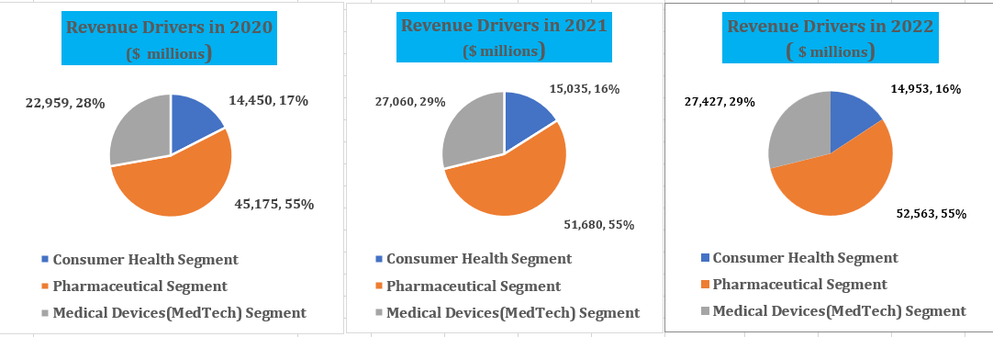

* Pharmaceutical segment has made 55 % in total revenues in each financial year from 2020 to 2022.
* Medical Devices segment has increased by 17.9 % in 2021 and further increased by 1.4 % in 2022 to its revenue growth over the years.
* Consumer Health segment has increased by 4 % in 2021 with respect to 2020 and declined by 0.5% in 2022 based in 2021.
* Cost of products has been increased by 5% in 2021 and 4.1% in 2022 with respect to 2020 and 2021 respectively.
* Research and development cost has been increased by 21% in 2021 and declined by 0.8% in 2022 with respect to 2020 and 2021 respectively.
* In-Progress research and development cost has been increased by 397.2% in 2021 and declined by 13% in 2022 with respect to 2020 and 2021 respectively.
* Advertising cost has been increased by 28.6% in 2021 and declined by 22.2% in 2022 with respect to 2020 and 2021 respectively.
* Selling, marketing and administrative cost have been increased by 11.7% in 2021 and 0.4% in 2022 with respect to 2020 and 2021 respectively.