**Report on Market Research of Visa Inc.**

**Industry and Company Profile**

Visa Inc. is one of the largest global electronic payments technology companies in the financial services industry by facilitating money movement across more than 200 countries and territories to fast, secure and reliable digital payments networks based on payments volume, number of transactions and number of cards in circulation among a global set of consumers, merchants, financial institutions, strategic partners and government entities through innovative technologies.

Visa’s advanced transaction processing network facilitates authorization, clearing and settlement of payment transactions and enables to provide their financial institutions and merchant clients a wide range of products, platforms and value-added services.

Visa’s network of networks approach creates opportunities by facilitating person-to-person(P2P), business-to-consumer (B2C), business-to-business (B2B), government-to-consumer (G2C) payments, and consumer to business (C2B) payments.

Visa offers a wide range of Visa-branded payment products to their clients, including about 14,500 financial institutions in worldwide, use to develop and offer payment solutions or services, including credit, debit, prepaid and cash access programs for individual, business and government account holders.

During fiscal year 2023, Visa’s total payments and cash volume has been reported about $15 trillion, and $ 4.3 billion respectively. which have been issued Visa card accounts worldwide to be used at more than 130 million merchant locations. Furthermore, Visa has processed 276 billion payments and cash transactions with Visa’s brand or other networks. Visa credentials have been used on average 757 million transactions per day, and 213 billion out of the 276 billion total transactions have been processed by Visa.

**Peer Identification**

Visa competes in the global payments industry with other card networks including, Mastercard, American Express, China UnionPay, JCB, and Discover.

Visa, Inc and two other key competitors of Mastercard and American Express engage in the provision of global digital payment services to facilitate secure, reliable and efficient money movement among consumers, issuing and acquiring financial institutions and merchants.

The peer companies have been traditionally structured as the “four-party” model that the payer (often referred to as the cardholder), the payee (often referred to as the merchant), the payer's payment service provider (often referred to as the issuer) and. the payee's payment service provider (often referred to as the acquirer).

They offer debit cards, credit cards, prepaid products, commercial payment solutions, and global automated teller machines.

According to Nelson Report on the World’s Top Card Issuers and Merchant Acquirers in 2023, the global network cards by market shares of purchase transactions worldwide by region in 2023, The Asia-Pacific, United States, Europe, and Latin America regions have generated 46 %, 22%, 20 % and 8 % respectively.

The global digital payments industry with only a few main competitors within the United States in 2022, Visa has secured about 58 %, and its major competitor, Mastercard, has secured about 33 %, and the other competitor, American Express has controlled about 6 % of total transactions volume in $ billions.

Visa, Mastercard, and American Express have accounted for 60 % ,35 %, and 2 % in the calendar year 2022 of the total transactions processed (billions) respectively.

Visa, Mastercard, and American Express have accounted for 57 % ,37 %, and 2 % in the calendar year 2022 of the total number of cards issued (millions) respectively.

**Figure 1: Comparison of operational statistics among competitors from 2020 to 2022**

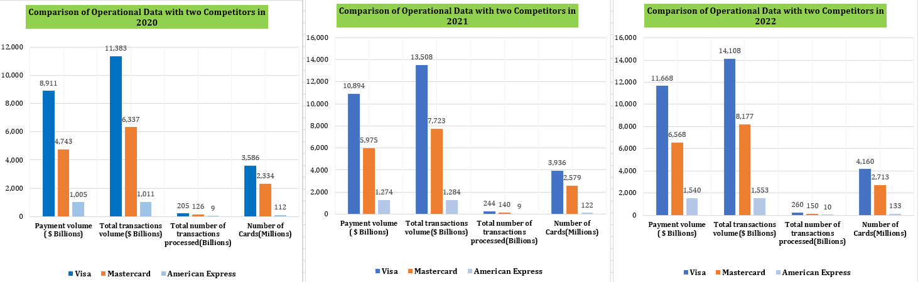

The above three charts represent the payment volume ($ billions), total transactions volume ($ billions), total number of transactions processed(billions), and the number of cards(millions) that the three companies of Visa, Mastercard, and American Express have shown in the operational statistics from the calendar year 2020 to 2022 as per the annual reports of Visa Inc.

Visa has dominated the market share in all four parameters shown above, Whilst Mastercard became the second largest market leader, and American Express was the third largest in all the operational data shown in the above charts over the years from 2020 to 2022.

**Figure 2: Comparison of Diluted EPS and Operational Income among competitors from 2019 to 2023**

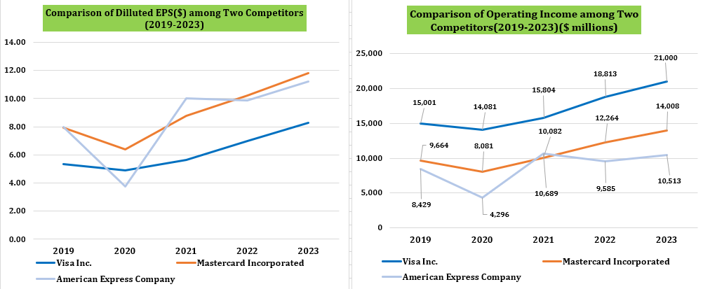

The above line graph 1 highlights that Mastercard and American Express have shown the higher diluted EPS than Visa. However, the line graph 2 highlights that Visa has shown the highest operating income than two other competitors.

**Figure 3: Comparison of Stock price ($) as at each year ended 30 September and net revenue ($ millions) from 2019 to 2023**

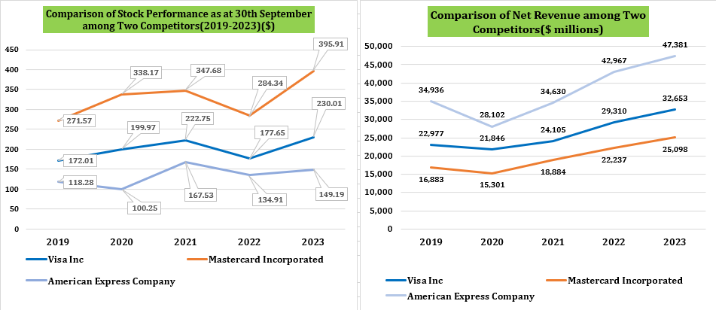

The above line graph 1 shows that Mastercard has illustrated the highest stock price and Visa’s stock price has been fluctuated between Mastercard and American Express over the years 2019 to 2023.

The line graph 2 shown above represents that American Express has the highest net revenue whilst Visa has an increasing trend above Mastercard over the years 2019 to 2023.

**Substitutes and new markets**

The global digital payments ecosystem is a highly dynamic and competitive industry that any competitor has to undertake development in technology and innovation on payment solutions, and shift consumers’ preferences to create new opportunities for existing competitors and new entrants.

The fast growing of alternative digital payments platforms could disrupt the existing digital payment ecosystem networks due to the increase of new entrants of the industry, such as various blockchains.

Visa’s prepaid reloadable cards have been made an alternative to cash. However, it has also enabled for some competitors to enter the market with new payment solutions such as biometrics or QR code systems or blockchain crypto currencies payment methods to face a moderate threat of substitution with the introduction of new and innovative technologies on the market in a highly dynamic landscape as new competitors emerge.

The digital payment networks in financial services industry have shown low bargaining power from suppliers and high from buyers, and low to moderate threat of substitute’s products such as Buy Now Pay Later (BNPL), Blockchains in Cryptocurrencies, Digital Wallets, ACH, RTP and Wires.

Further, Visa competes with other global and local card networks for payment processors for the processing of Visa transactions. These processors would be benefitted from the mandatory requirements to handle processing under local regulation. Visa may also struggle with the competition from other networks, processors and other third parties who could process Visa transactions directly with issuers and acquirers.

Visa competes with alternative solutions to their new flows (e.g., Visa Direct and Visa B2B Connect), since, some financial institutions and other different clients who are experimenting with B2B, P2P, C2B, and B2C blockchain payments providers such as closed commerce ecosystems, BNPL (Buy Now Pay Later) solutions and cryptocurrency platforms, often have a primary focus of enabling payments through e-commerce and mobile channels such as Binance, Blockchain.com, etc.

Blockchains could be used as alternative digital ways of payments with digital currencies such as Bitcoins and some other Cryptocurrencies with some websites and mobile apps such as Binance, Blockchain.com, Lbank, BitMEX,MEXC, Okcoin etc. The new entrants of digital payment blockchains in cryptocurrencies allow consumers to avoid the intermediate parties (card networks) sch as Visa, Mastercard, American Express. These alternatives can potentially disrupt the process of verification by consumers and traditional card payments. Although different countries of networks' operations can differentiate the payment ecosystem, it could create issues for companies in various cashless markets.

In addition, Visa has to cope with other companies that provide alternatives to their value-added services, which include technology companies, information services and consulting firms, governments and merchant services companies.

The integration of technology like generative AI (Artificial Intelligence) can create new and better offerings that compete with Visa’s value-added services such as strengthened risk monitorization and managing digital identification. Regulatory initiatives could also lead to increased competition in these areas.

**The key revenue and cost drivers**

The revenue is basically driven in five main segments: Service Revenues, Data Processing Revenues, International Transaction Revenues, Other Revenues and Client Incentives, accounted for as reductions to revenues. Service Revenues, Data Processing Revenues, international transaction revenues, and other revenues are represented by 33 %, 35.6%, 25.9 %, and 5.5 % of the total revenue in the fiscal year 2023 respectively.

Visa Inc ‘s operating revenue is driven from four main segments as follows.

**Service revenues** areearned from services provided in support of client usage of Visa payment services and, it has been declined to 33.0%of overall revenues in 2023 from 33.7% in 2022 and 35.3**%** in 2021.

**Data processing revenues** are earned for authorization, clearing, settlement, and network access that facilitate transaction and information processing. This segment has been represented **35.6%** of total revenue in 2023 and has been declined from 36.5% in 2022 and 39.4 % in 2021.

**International transaction revenues** are derived from cross-border transaction processing and currency conversion activities, which has been accounted for **25.9%** of total revenues in 2023 and increased it from 24.8 % in 2022 and 20.1 % in 2021.

Finally, **other revenues** which are consisted mainly of license fees for the use of the Visa brand, it represents 5.5%of total revenues in 2023 and increased from 5.0 % in 2022 and declined 5.2 % in 2021.

Although every revenue driver has been grown, it can be seen that the other revenues have been the fastest growing driver at growth rates of 24.5 %, 18.9 % and 17.0 %,in 2023, 2022 and 2021 respectively. Overall, this segment has the potential and stability to become the main source of revenue for the company over the next few years.

Overall, the net revenue from all five segments of Visa has been grown by 11.4 % in 2023 compared to 21.6 % growth in 2022 with an upward trend in revenue drivers, whilst, Mastercard’s overall net revenue has also been increased by 12.9 % in 2023 compared to 17.8 % growth in 2022 despite of a massive revenue drop in other network assessment due to Covid-19 pandemic with an increasing trend.

The overall net operating revenue of American Express has also been increased by 10.3 % in 2023 compared 24.1 % growth in 2022 with an upward trend in revenue drivers.

Visa’s operating expenses as cost drivers can be divided into seven main segments such as Personnel, Marketing, Network and Processing, Professional Fees, Depreciation and Amortization, General and Administrative and Litigation Provision, which was not considered a core expense.

The main core expense in 2023 are costs related to employees (Personnel) that account for almost half of total operating expenses (50**%**). Follows Marketing cost at 11.5 %, then Network and Processing cost at 6.3%, Professional fees at 4.7 %, Depreciation and Amortization at 8.1%, and General and Administrative cost weights to 11.4%, finally, Litigation provision at 8%.

The overall net core operating expenses have grown by 11% in 2023 compared to 26.5 % growth in 2022, although, Visa has adopted an overall cost reduction strategy, there is a steady increasing trend in the personal cost over the years considered. Overall, the net operating cost over the years has shown an upward trend. In comparison with the peers, Mastercard’s overall net operating expenses have also been grown by 11.2 % in 2023 compared to 13.3 % growth in 2022 with an increasing trend.

The overall key operating expenses of American Express has also increased by 9.3 % in 2023 compared to 24.1% growth in 2022 with an upward trend.

**Current Industry and Market Trends**

The gross profit margins of Visa, Mastercard and American Express in 2023 were derived at 64 %, 56 %, and 22 % respectively. Visa has higher margin compared to Mastercard and the lowest margin has been shown by American Express. Visa is connecting crypto and blockchain networks to their trusted, global payment network. Visa is propelling innovation to deliver even more access and value to the crypto ecosystem at present.

The development of emerging technologies is one of the most critical aspects of digital

payment platform industry. Visa can affect the development of further trends in the industry. The traditional card system is based under the strong pressure of other innovative payment platforms, such as mobile applications that are independent and processed transactions directly from account holders to merchants. The development of these technologies leads to an expansion of a variety of merchants. It can increase a company's profit by increasing the number of processed transactions.

Visa’s latest technology platforms are comprised of software, hardware, data centers and a large telecommunications infrastructure.

Visa’s marketing strategy is to increase revenue growth drivers in consumer payments, new flows and value-added services, and strengthen the key foundations of the business model based on network of networks, technical platforms, security, brand, and talent.

The cost reduction strategy to minimize cost structure as a value-driven company with a high cost of charges in comparison with its competitors. Its cost structure can be categorized to process maximum transactions per second or per day with maintaining high security standards of its cost structure such as marketing, personnel, IT and emerging technologies.

Visa’s growth has been driven by the strength of the core products of credit, debit and prepaid with three strategic areas in investing in and growing card-based payments, accelerating the efforts in non-card, cross-border payments and digitizing domestic accounts payable and accounts receivable processes.

Visa has also enabled consumer payments and help their clients grow as digital commerce, new technologies and new participants continue to transform the payments ecosystem using **Tap to Pay**, ***Tokenization, Click to Pay.***

Visa’s new flows have focused on facilitating commercial and global money movement across Visa’s network of networks. It can create opportunities to capture new sources of money movement through card and non-card flows for consumers, businesses and governments around the world by facilitating P2P, B2C, B2B and G2C payments*.*

Visa Cross-Border Solutions have also aligned with the global network of networks strategy by focusing on building the infrastructure that enables our clients of all sizes to deliver cross-border products with visibility, speed and security. The key component of the network of networks strategy is to open up the network and increasingly using other networks to reach accounts that cannot be connected and enabling new types of money movement using Visa B2B Connect, Visa Direct, and Visa+.

The strategy of Visa Inc is to increase the number and volume of cashless transactions between cardholders and merchants through the development of modern and convenient digital payment platforms and networks, such as a global mobile wallet covering all smartphones' users all over the world. It also focuses in growing existing clients base and extending into new geographies, expanding into new areas and deepening engagement with partners.

**SWOT Analysis**

|  |  |
| --- | --- |
| **Strengths**   * **One of the most innovative, reliable, convenient, and secure payment networks in the world**   - spans more than 200 countries  - more than 28,800 employees  - 14,500 financial institutions  - more than 130 million merchant locations   * **One of the world’s largest retail electronic payments networks based on payments volume, number of transactions and number of cards in circulation**   - 2nd global leader in payments card market share (22%)  - largest market share in United States  - 4.3 billion payment credentials(cards)  - $ 15 trillion in total transactions volume  - 276 billion transactions   * **Effective partnerships with developers of innovative digital payments platforms and Applications**   - over 2,800 global programs  - more than 500 commercial partnerships  - more than 2,000 consulting engagements  - top 265 largest clients use on average 22 Visa services  - Visa Direct solutions supported more than 500 partners  - Visa DPS is one of the largest issuer processors of Visa debit transactions in the world  - partnership with DailyPay, i2C, PayPal, TabaPay, Venmo and Western Union to pilot Visa+ | **Weaknesses**   * **Regulatory Risks**   - complex and evolving regulations that govern business operations  - Increased scrutiny and regulation of the global payments industry  - Government-imposed obligations and/or restrictions on international payments systems  - Laws and regulations regarding the handling of personal data and information may impede services or result in increased costs, legal claims, or fines  - subject to tax examinations or disputes, or changes in tax laws   * **Litigation Risks**   - adversely affected by the outcome of litigation or investigations  - violations of competition and antitrust law, consumer protection law, privacy law and intellectual property law   * **Business Risks**   - intense competition in the industry to continue to shift and evolve  - revenues and profits are dependent on client and merchant base, which may be costly to win, retain and develop  - depend on relationships with financial institutions, acquirers, processors, merchants, payment facilitators, ecommerce platforms, fintechs and other third parties.   * **Structural and Organizational Risks**   **-** may not be achieved the anticipated benefits of acquisitions, joint ventures or strategic investments, and may face risks and uncertainties as a result |
| **Opportunities**   * Expanding product and service portfolios by developing innovative independent payment platforms including mobile apps * Implementing certain cybersecurity and data-handling practices, create new individual privacy rights and data protection obligations * Providing Value Added Service to the integration of technology like generative AI that can be created new and better offerings to compete with other value-added services * Providing New Flows to compete with other global and local card networks for commercial card portfolios from financial institution clients who are experimenting with B2B blockchain payments * Attracting, developing and advancing the best talent globally is critical to our continued success * Visa’s strong brand helps deliver added value to their customers, financial institutions, merchants and partners * Embedded security in the software development lifecycle; identity and access management controls to protect against unauthorized access * Technology Platforms are comprised of software, hardware, data centers and a large telecommunications infrastructure * Visa DPS is one of the largest issuer processors of Visa debit transactions in the world * Visa’s risk and identity solutions transform data into insights for near real-time decisions and facilitate account holder authentication to help clients prevent fraud and protect account holder data | **Threats**   * Poor maintenance and enhancement of brand or reputation could be harmful to business if it is not able to maintain and enhance the brand name, if events occur that have the potential to damage the brand name or reputation, or if it experiences brand disintermediation * Global economic, political, market, health and social events or conditions may harm to the business * Lack of addressing corporate responsibility and sustainability (CRS) matters and considerations could adversely be affected to the business and financial results or negatively impact the reputation * Indemnification obligation to fund settlement losses of clients exposes to significant risk of loss and may reduce liquidity * Technology and Cybersecurity Risks   - Failure to anticipate, adapt to, or keep pace with, new technologies in the payments industry could harm the business and impact future growth  - A disruption, failure or breach of networks or systems, including as a result of cyber-attacks, could harm the business   * Significant growth of independent innovative payment platforms over cashless markets would be a threat to the business * Growth of digital fraud * Expansion of new entrants, such as blockchains, that increase the number of alternative cashless payments as a threat of new entry |

**PESTEL Analysis**

|  |  |  |
| --- | --- | --- |
| **Politics**   * Government Regulation-Imposed Market Participation Restrictions on digital payment systems   - by imposing regulations that favor domestic providers, impose local ownership requirements on processors, require data localization or mandate that domestic processing be done in that country  - subject to complex and evolving global regulations in the various jurisdictions in which Visa’s products and services are used   * subject to anti-corruption, anti-money laundering, sanctions and anti-terrorist financing laws and regulations * European and United Kingdom Regulations and Supervisory Oversight   - Visa in Europe continues to be subject to complex and evolving regulation in the EEA and the UK   * Geopolitical trends towards nationalism, protectionism, and restrictive visa requirements, and uncertainty around economic sanctions, tariffs or trade restrictions also limit the expansion of the business in certain regions (Ukraine-Russia War)   - economic sanctions were imposed on Russia by the U.S and suspended Visa’s operations in Russia and as a result | **Economy**   * Increase in use of all forms of electronic payments in the world   - Global or Multi- Regional Networks offer a range of branded, general purpose card payment products to consumers at millions of merchant locations around the world   * Subject to tax examinations or disputes, or changes in tax laws   - changes in existing laws in the U.S. or foreign jurisdictions  - unilateral/bilateral actions of foreign jurisdictions to introduce digital services taxes, or changes resulting from the OECD or UN framework relating to the BEPS, Double Tax Avoidance, and Tax Disputes Resolution Schemes | **Social**   * Corporate Responsibility and Sustainability   - strives to join with clients, partners and other stakeholders to empower people, businesses and communities to thrive as an industry leader in addressing the corporate responsibility and sustainability (CRS)  - focuses on empowering people and economies; securing commerce and protecting customers; investing in the workforce; protecting the planet; and operating responsibly   * Visa’s total workforce has increased to 28,800 by 9 % in 2023 with voluntary workforce at 6 % and the total workforce located outside the U.S is 54 % * Visa Foundation partnership has helped financially empower millions of women-led micro and small enterprises globally * Visa has committed to digitally enable 50 million small and micro businesses worldwide by 2023, as part of their efforts to advance digital equity * Sponsoring many sports and world championships |
| **Technology**   * Visa Direct utilizes more than 70 domestic payment schemes, 10 real-time payments schemes, 15 card-based networks and five payment gateways * Innovative service to help individuals send money quickly and securely between different participating P2P digital payment apps * Enabling payments through ecommerce and mobile channels such as closed commerce ecosystem solutions and cryptocurrency platforms * New technologies and new participants continue to transform the payments ecosystem using biometric or QR enabled Visa products such as Tap to Pay, Click to Pay, and Tokenization (Visa Token Service) * Creating compelling and differentiated cardholder experiences with the technological solutions such as Buy Now, Pay Later (BNPL), Visa Consulting and Analytics (VCA), Visa DPS, Visa Direct, Visa Net, etc. | **Environment**   * Visa has achieved carbon neutrality in our operations and transitioned to 100% renewable electricity   - working to drive sustainable commerce  - support urgent climate action and the transition to a low-carbon economy   * working to minimize the footprint of Visa offices, data centers and business activities * enabling sustainable payment card options and calculating customer CO2 footprint one transaction at a time * empowering our employees to commute with a lighter footprint   -140 onsite electric vehicle charges   * embedding sustainability into our partnerships and initiatives * partnered with CPI Card Group to help launch Earthwise   - a payment card made of up to 98% upcycled plastic dependent on design | **Legal**   * Legal and Regulatory Matters   -Critical estimates are currently involved in various legal proceedings   * Violations of competition and antitrust law, consumer protection law, privacy law and intellectual property law * Government-imposed obligations and/or restrictions on international payments systems * Laws and regulations regarding the handling of personal data and information may impede services or result in increased costs, legal claims, or fines * Assumptions and judgment   -evaluate the likelihood of a potential loss from legal or regulatory proceedings as a party   * engage in settlement discussions or mediations with respect to one or more of its outstanding litigation matters |

**Sources**

* Annual Reports-Visa Inc, Mastercard Incorporated, and America Express Company (2020-2023)
* <https://corporate.visa.com/en/>
* <https://seekingalpha.com/symbol/MA/historical-price-quotes>
* <https://www.paymentsdive.com/news/visa-mastercard-amex-4Q-results-/>
* <https://www.stock-analysis-on.net/NYSE/Company/Mastercard-Inc/Ratios/Short-term-Operating-Activity/Quarterly-Data>
* <https://www.statista.com/statistics/279469/market-share-of-credit-card-companies-in-the-united-states-by-purchase-volume/>
* https://nilsonreport.com/research/