**Instructions:**

1. After deriving the intrinsic share price based on our model, the next step is to focus on putting together a report with an investment recommendation.
2. You are required to fill in the report template below using the sample report attached and your readings on the company’s guidance in terms of key segments and products.
   1. Identify two to three key products that are vital for the company’s growth and you can discuss about the trends and expectations. But remember to keep them all short cause and effect sentences.
3. You can take up to two days for this task and feel free to reach out to me if you have any questions.

**Point 3:**

The EPS is expected to be increased up to $ 4.3 in 2024 with the significant increase in 2021 by 123%.

FCFF is expected to be increased by 23% in 2024 with a positive trend, although a steep decrease in 2023.

Capex is also expected to be elevated further by 7 % compared with 6% in 2022. In growing confidence in digital platforms with continuous new product pipeline and Nike’s Air Zoom Pulse for health newness towards sustainable long-term growth.

**Point 2:**

The cost of R & D was declined year over year until 2022 and it is expected to be increased in 2024 onwards.

The group margin for EBITDA is expected to be grown at 26.2 % in 2024 with an increasing trend compared with 16.2 % in 2022.

North America, EMEA, Greater China, APLA, and Converse are expected to be contributed for the group EBIT at 44 % ,31%,13%,19% and 6% respectively in 2024.

The EBIT margins for North America, EMEA, Greater China, APLA, and Converse are expected to be at 27.9 %,26.4 %,8.6%,31.8%, and 3.7% respectively in 2024.

Europe, Middle East & Africa

Greater China

Asia Pacific & Latin America

**Point 1:**

The group revenue is expected to be grown by 7 % in 2024 in line with an upward trend shown at 5% growth in 2022.

Having forecasted with an upward trend, the key segmental revenue growth from Asia Pacific & Latin America (APLA) at 16.2 %, Europe, Middle East & Africa (EMEA) at 12 %, and North America at 7% are the key segments in 2024.

The key products of equipment division are expected to be grown by 9.6 % in consistent from 2021 compared with 5.4% by footwear and 3% by apparel in 2024 with a downward trend since 2021.

**Investment thesis:**

The intrinsic stock value under the forecasted model compared to the current market price has been overvalued by 15 %. Although, an increasing trend in the forecasted stock price, the current market price has declined by 26 % from its year back.

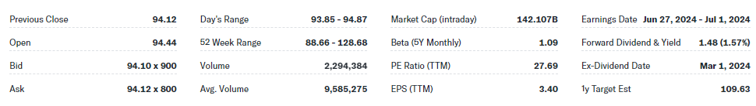

Company Name **NIKE, Inc.**

Ticker **NKE**

Current Share Price **$ 93.95**

Upside/Downside to current share price: ((Forecasted Price – Current Price)/Current Price) = (79.70-93.95)/93.95=**-15.17**