Instructions:
- After deriving the intrinsic share price based on our model, the next step is to focus on putting together a report with an investment recommendation.
- You are required to fill in the report template below using the sample report attached and your readings on the company’s guidance in terms of key segments and products.
  - Identify two to three key products that are vital for the company’s growth and you can discuss about the trends and expectations. But remember to keep them all short cause and effect sentences.
- You can take up to two days for this task and feel free to reach out to me if you have any questions.

Point 2:
The Margin of the group EBITDA is between 10% and 15% since 2015. By 2027 it is expected to be 12.0%. North America’s contribution to earnings is the most, whereas Global Brand Divisions is the least at -4.042 billion USD in 2022. Margin growth of EBITDA is expected to reduce by 3.3% from 2023 to 2027.
Key cost trends include long term debt which almost tripled from 2019 to 2020.
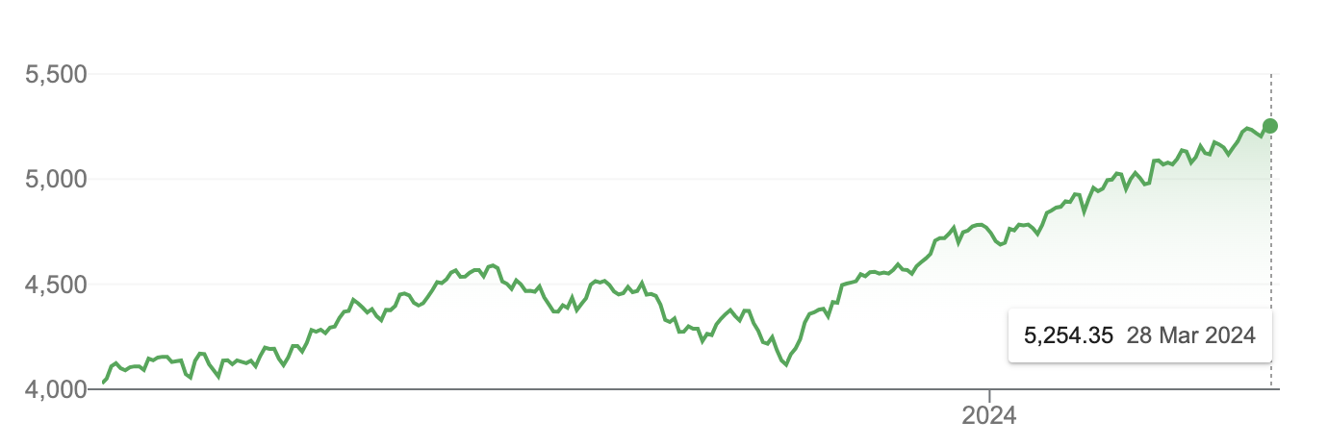
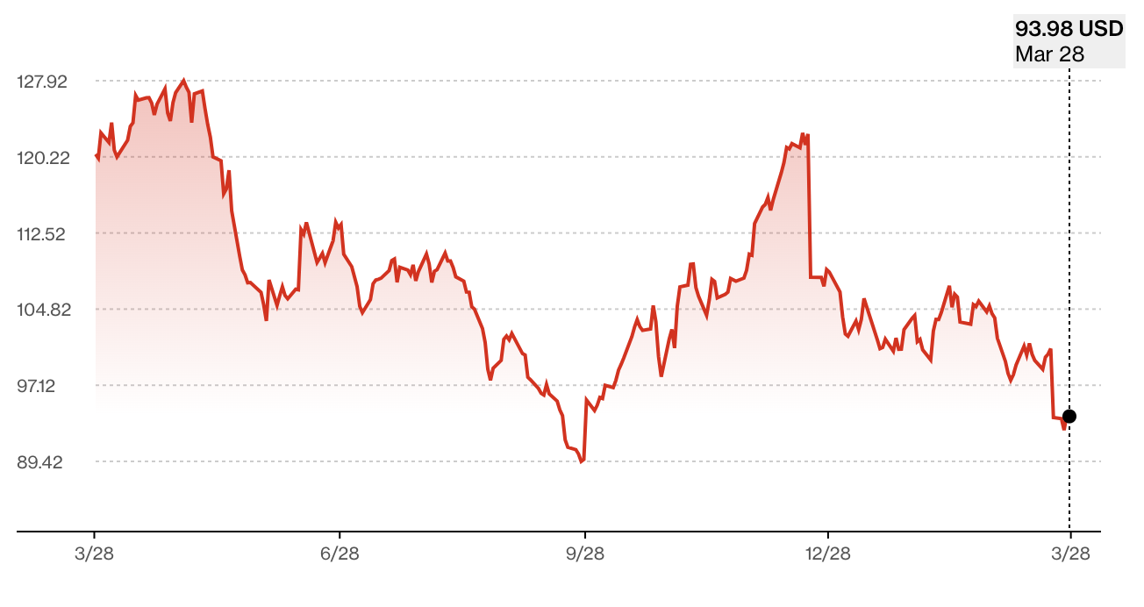
 | 2022 | 2023E | 2024E | 2025E
Revenue | 46,710 | 48,999 | 51,400 | 53,918
EBITDA | 7,573 | 7,482 | 7,392 | 7,304
EPS | 3.75 | 3.17 | 3.14 | 3.11
Net debt (cash) | -3,935 | -2,522 | 183 | 1,021
FCFF | 6,537 | 7,121 | 7,322 | 7,522
ROE | 39.6% | 42.9% | 42.2% | 41.5%
P/E | 30.83 | 26.04 | 26.29 | 26.55
EV/EBITDA | 24.00 | 16.48 | 17.41 | 17.85
 | 2022 | 2023E | 2024E | 2025E
Sales growth (%) | 4.9% | 4.9% | 4.9% | 4.9%
EBIT growth (%) | -1.0% | -1.0% | -1.0% | -1.0%
Net profit growth (%) | 5.57% | -15.56% | -0.98% | -0.99%
EPS growth (%) | 5.34% | -15.47% | -0.95% | -0.96%
EBITDA margin (%) | 16.21% | 15.27% | 14.38% | 13.55%
EBIT margin (%) | 14.68% | 13.86% | 13.09% | 12.35%
Net margin (%) | 12.94% | 10.42% | 9.83% | 9.28%

Point 1: The revenue growth expectation is 4.9% per year based on historical performance with 2022 being the end year. NIKE’s main segment is North America, and its main product is athletic footwear. As of 2022 NIKE’s group revenue is 46.71 billion USD. By 2027 this is expected to grow to 59.332 billion USD.

The main products that are key for NIKE’s growth are footwear, mainly ‘Air Force One’. And also, apparel, mainly ‘athletic apparel’.
The main trend is that they are increasing their revenue particularly in Asia and Middle East segment.
The Olympics and Euro 2024 will increase brand awareness leading to increased sales.
This will in turn drive up the share price of NIKE to our Forecasted Price of 130.46.

Investment thesis:
The stock is expected to grow to a value of at least 130.46 USD per share. Or by 39.16% within the next year.

Point 3:
EPS is expected to reduce 3.17 USD in 2023 to 3.04 USD in 2027.
FCFF is expected to grow from 7.121 billion USD in 2023 to 7.922 billion USD in 2027. CAPEX is expected to grow from 798 million USD in 2023 to 980 million USD in 2027. In the future NIKE will have to innovate its centerpiece air force one product and develop newer products that older generations can also be happy using. For example, NIKE could start a fashion sector for new streams of revenue.
Company Name NIKE
Ticker. NKE
Current Share Price 93.75 USD (OPENING PRICE ON 26TH MARCH 2024)
Upside/Downside to current share price: ((Forecasted Price – Current Price)/Current Price) ((130.46-93.75)/93.75 )*100= 39.16%

