**MARRIOTT**

Marriott’s business model centers around providing hospitality services and accommodations to a diverse range of customers, including travelers, corporations, and event organizers. The company generates revenue through hotel operations, brand development, and customer loyalty programs

The followings are the Revenue Drivers of Marriott Inc.

* Room Revenue: Marriott generates significant revenue from the rental of hotel rooms across its portfolio of brands, including luxury, premium, and select-service properties. These source of revenue is influenced by occupancy rates, average daily rates (ADR), and revenue par room available (RevPAR).
* Food and Beverage Revenue: Marriott operates restaurants, bars, room service, and catering services within its hotels, contributing to food and beverage revenue.
* Meetings, Events, and Banquet Revenue: Marriott properties offer meeting and event spaces for conferences, weddings, and other gatherings, generating revenue from venue rental, catering services, and related event packages.
* Franchise Fees and Royalties: Marriott earns revenue from franchising its brands to third-party hotel owners and collecting franchise fees and royalties.
* Management Fees: Marriott earns management fees by operating hotels on behalf of third-party owners under management agreements. The company's management services include operational support, sales and marketing, revenue management, and guest services.
* Loyalty Program Revenue: Marriott's loyalty program, Marriott Bonvoy, generates revenue through membership fees, co-branded credit card partnerships, and the sale of points to partners. The loyalty program incentives drives direct bookings, contributing to overall revenue growth.

Breaking down the revenue into price and volume data and mapping out how these individual variables affects revenue growth necessitates the analysis of how changes in average daily rates (ADR) and occupancy rates (volume) impact total room revenue, which is a significant portion of Marriott's overall revenue.

* Price Data:

Average Daily Rate (ADR): This represents the average price paid for a hotel room per day and it is influenced by factors such as room type, location, seasonality, demand trends, and pricing strategies.

The relationship between these variables and revenue can be seen with the aid of the data extracted from the company websites below.

|  |  |  |
| --- | --- | --- |
| Marriott Inc | | |
| Year | 2022 | 2021 |
| Average Daily Rate (ADR) | 203.23 | 145.56 |
| Occupancy rate | 60.70% | 51.30% |
| Revenue per available room (RevPAR) | 123.3 | 74.66 |

The above table was further analyze with the chart below:

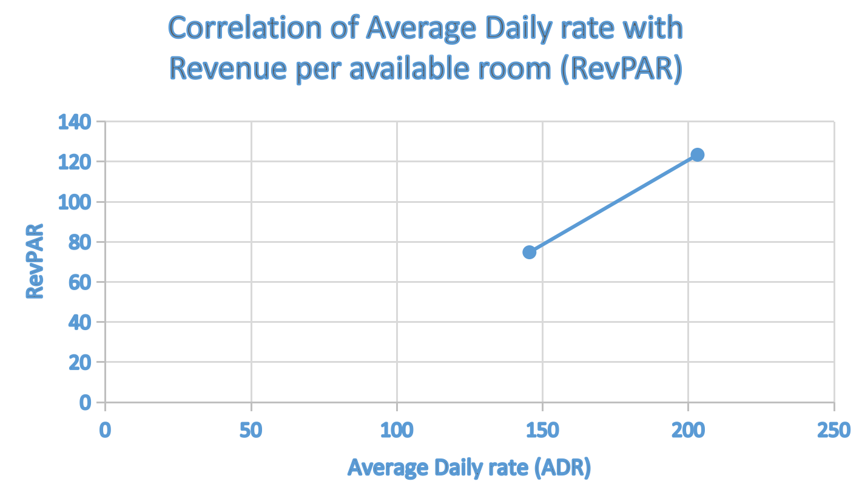

As seen above, any changes in ADR will directly impact room revenue. Increasing ADR can lead to higher revenue per available room (RevPAR) if demand remains relatively stable as shown above. However, if ADR increases too much, it may result in decreased occupancy and potentially lower total revenue.

* Volume Data:

Occupancy Rate: This indicates the percentage of available rooms that are occupied at a given time. Occupancy rate is influenced by factors such as market demand, seasonality, marketing efforts, and economic conditions.

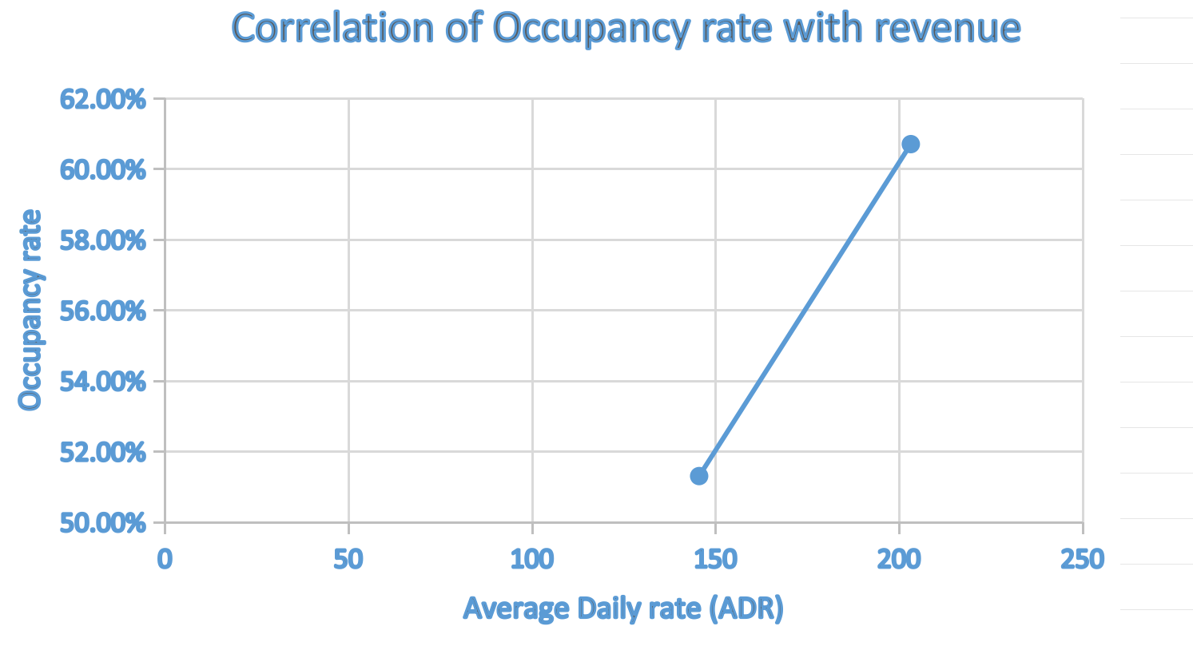

Changes in occupancy rate affect room revenue by determining the number of rooms sold. Higher occupancy rates lead to increased room revenue, assuming ADR remains relatively stable. Conversely, lower occupancy rates result in lower revenue, even if ADR is high.

**Cost Drivers:**

The followings are the cost driver of Marriott Inc as well as the correlation with revenue.

* Labor Costs (Variable with revenue): Labor costs represent a significant expense for Marriott, including salaries, wages, benefits, and training for hotel staff. Labor costs typically vary with revenue since they depend on factors such as occupancy rates and business activity levels. As revenue increases, there's often a need to hire more staff to accommodate higher demand. Conversely, during periods of low revenue, labor costs may decrease as fewer staff may be needed.
* Operating Expenses (Mixed): Marriott incurs various operating expenses, including utilities, property taxes, insurance, maintenance, and repairs. Some operating expenses, like property taxes and insurance, tend to be fixed and don't directly vary with revenue. However, other expenses, such as utilities and maintenance, may be variable and varies with changes in occupancy rates and property usage.
* Marketing and Sales Expenses (variable with revenue): Marketing and sales expenses are typically variable because they are incurred to drive revenue and attract customers.
* Property and Equipment Costs (Mixed): Costs like depreciation and amortization are fixed and do not directly vary with revenue. However, capital expenditures for property improvements and renovations may have variable components that correlate with revenue growth, especially if investments are made to attract more customers or enhance guest experiences.

**JOHNSON & JOHNSON**

The revenue driver identified for Johnson & Johnson are:

* Pharmaceutical Sales: Revenue generated from the sale of prescription drugs and over-the-counter medications, including blockbuster drugs like Remicade, Stelara, and Zytiga.
* Medical Devices: Revenue from the sale of medical devices and equipment, such as surgical instruments, orthopedic implants, cardiovascular devices, and diagnostic equipment.
* Consumer Health Products: Revenue from consumer health brands, including skincare products, baby care items, oral care products, and over-the-counter medicines like Tylenol and Band-Aid.
* Licensing and Royalties: Revenue earned through licensing agreements and royalties from the use of intellectual property, including patents, trademarks, and technologies.
* Contract Manufacturing: Revenue generated from manufacturing services provided to other pharmaceutical and healthcare companies.

**Cost Drivers:**

* Cost of Goods Sold (COGS): Costs directly associated with manufacturing pharmaceuticals, medical devices, and consumer health products, including raw materials, labor, and overhead. As revenue increases (due to higher sales volume), COGS typically increases proportionally.
* Research and Development (R&D) Expenses: Costs incurred for research, development, and clinical trials of new drugs, medical devices, and healthcare technologies. Although, the total R&D spending may be relatively fixed over the short term due to long-term research commitments and strategic objectives, certain R&D expenses can vary with revenue.
* Marketing and Sales Expenses: Costs related to marketing campaigns, sales promotions, advertising, and distribution of products across global markets. These expenses tend to vary directly with revenue, as companies typically allocate a percentage of sales for marketing and sales efforts.
* Administrative Expenses: These expenses include general overhead costs associated with running the business, such as salaries, rent, utilities, and office supplies. While some administrative expenses may vary with revenue (e.g., customer service costs, credit card processing fees), the majority of administrative costs are considered fixed or semi-variable in nature. These expenses are typically incurred regardless of changes in sales volume and are necessary to support the company's overall operations.
* Legal and Litigation Expenses: Costs related to legal proceedings, litigation, settlements, and regulatory fines. This does not vary with the company’s revenue.
* Distribution costs: This involve expenses related to delivering products to customers, including transportation, warehousing, and logistics. As revenue increases, distribution costs typically rise in tandem due to higher shipping volumes, increased warehousing needs, and expanded distribution networks.

**Accessing the firms performance with peers.**

This section considered the performance of Johnson & Johnson with Pfizer and GlaxosmithKline taking into account their Net margin and return on equity.

* **The Net margin** of the peers as shown below are 41.28% , 3.62% and 16.25% for Johnson & Johnson, Pfizer and GlaxoSmithKline respectively, suggesting that J & J is the most profitable because it has the largest percentage of it revenue as net income among the peers.

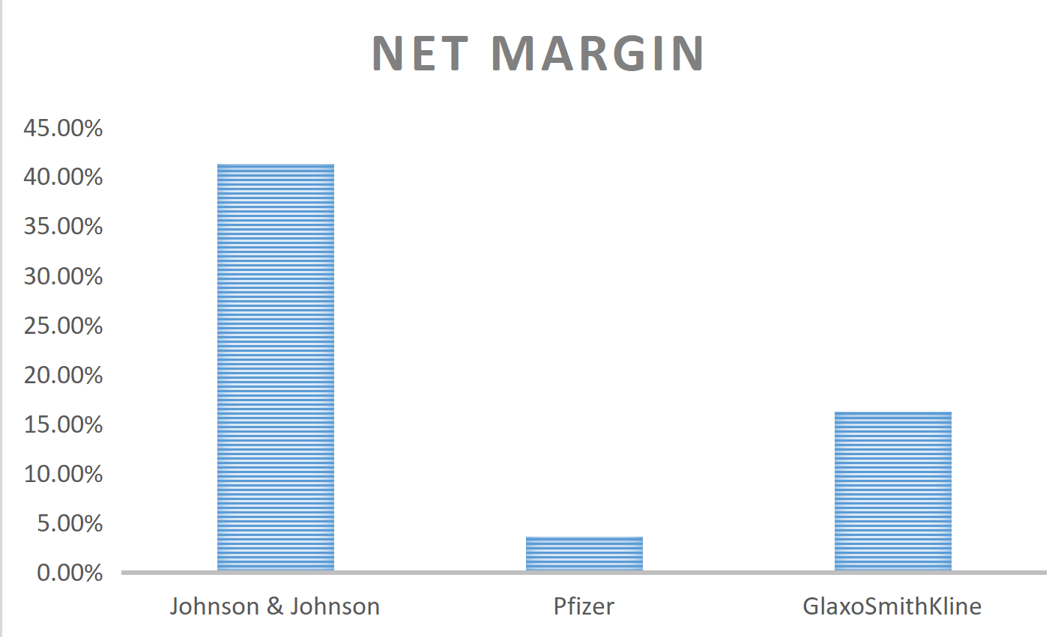

* **Return On Equity:** Johnson and Johnson has the highest return on equity among the peers under considerations. This further confirms that it is generating profits relative to its shareholders' equity, managing cost and growing its revenue more than the others.

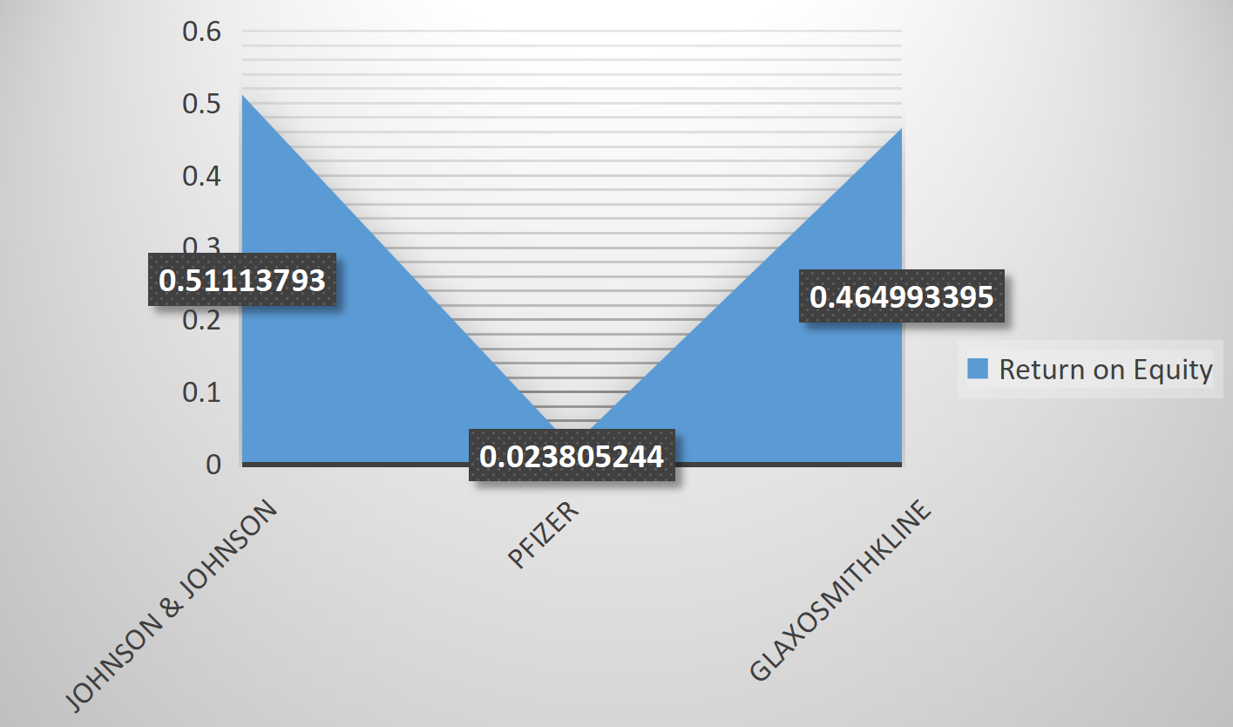

* **The Net margin** of the peer firms are 14.84% , 3.30% and 11.15% for Marriott, Hyatt and Hilton Worldwide respectively. This figure implies that Marriott is the most profitable because it has the largest percentage of it revenue as net income among the peers under consideration.
* 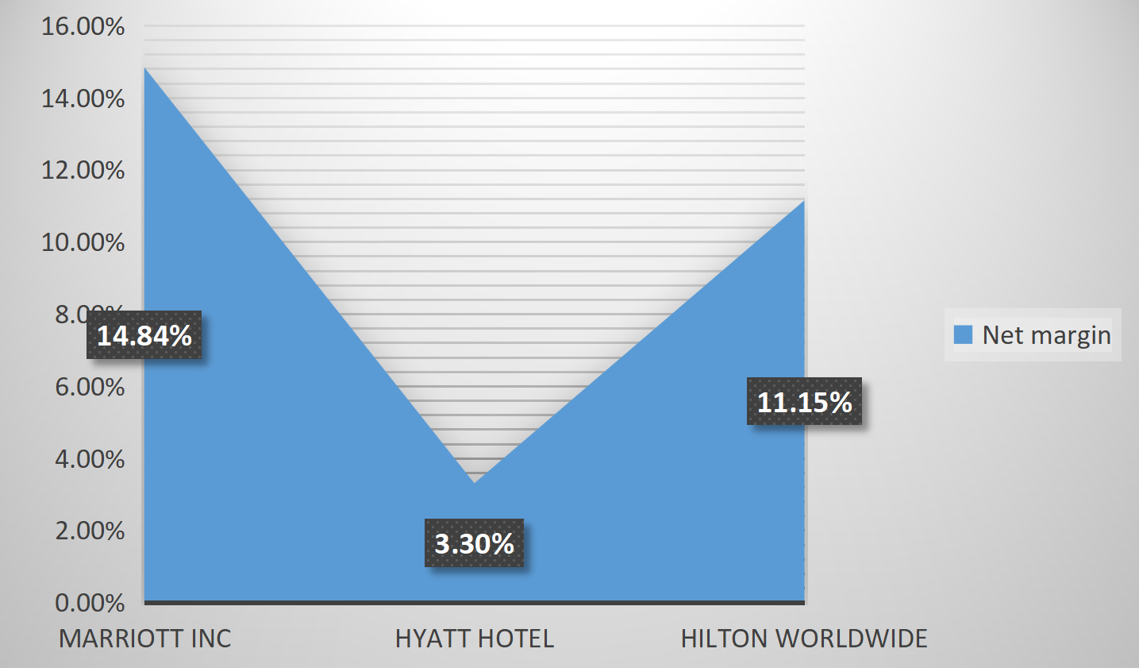
* However, the **Return on Equity** is negative suggesting that the net income is insufficient to cover its shareholders' equity. This is caused by excessive debt that amplify the losses and reduce equity, leading to a negative Return on equity.

