**PEER GROUP 1**

* **The Net margin** of the peers are 13%, 3% and 11% for Marriott, Hyatt and Hilton Worldwide respectively. This figure implies that Marriott is the most profitable because it has the largest percentage of it revenue as net income among the peers under consideration.

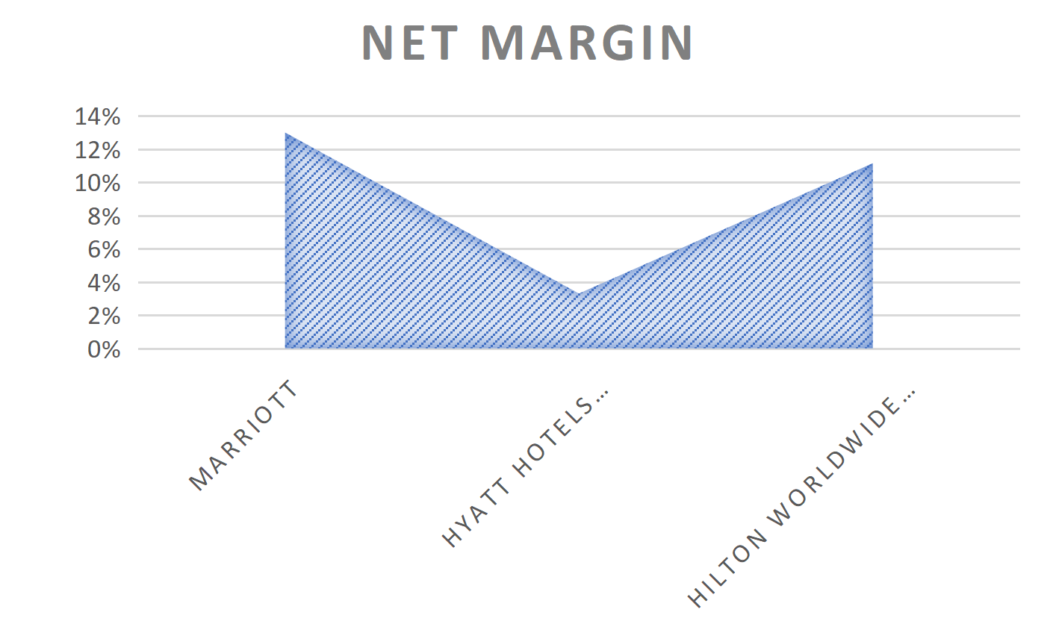

* J&J has the highest return on asset at 0.12 indicating that its ability to generate profits relative to assets than the other. This is shown with the aid of the chart below:

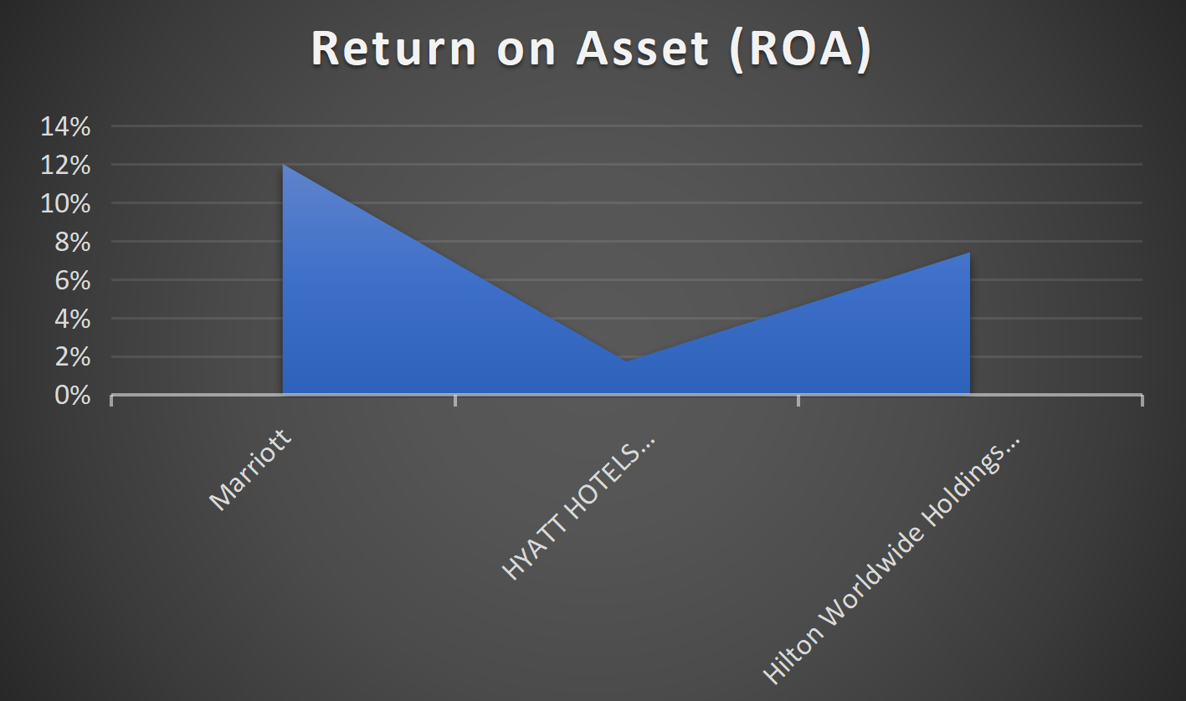

* The **Return on Equity** is negative suggesting that the net income of Marriott is insufficient to cover its shareholders' equity. This is caused by excessive debt that amplify the losses and reduce equity, leading to a negative Return on equity as shown below.
* 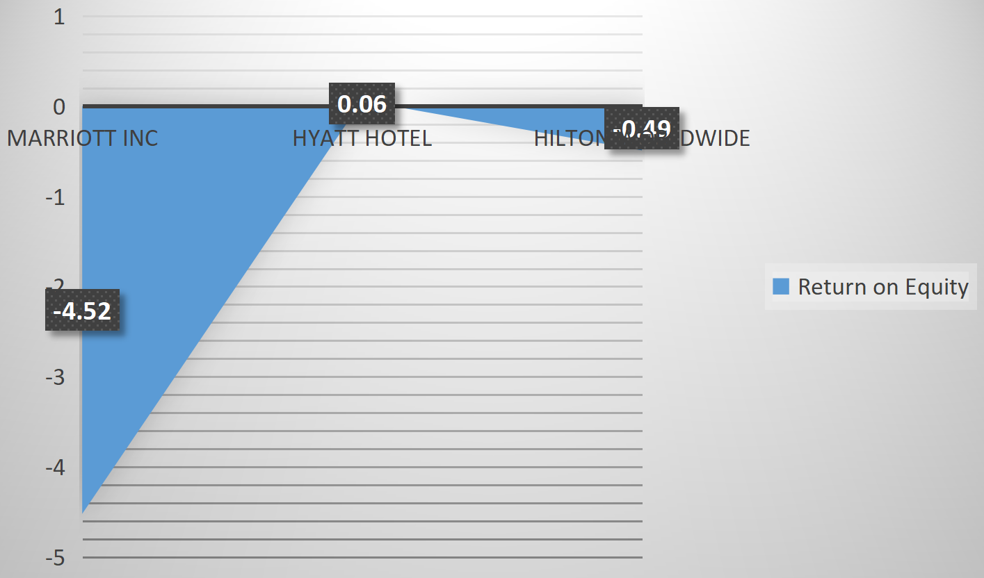

**PEER GROUP 2**

* The analysis clearly indicate that J & J has the best liquidity in terms of meeting its debt obligations without external funding among the the peers under considerations.

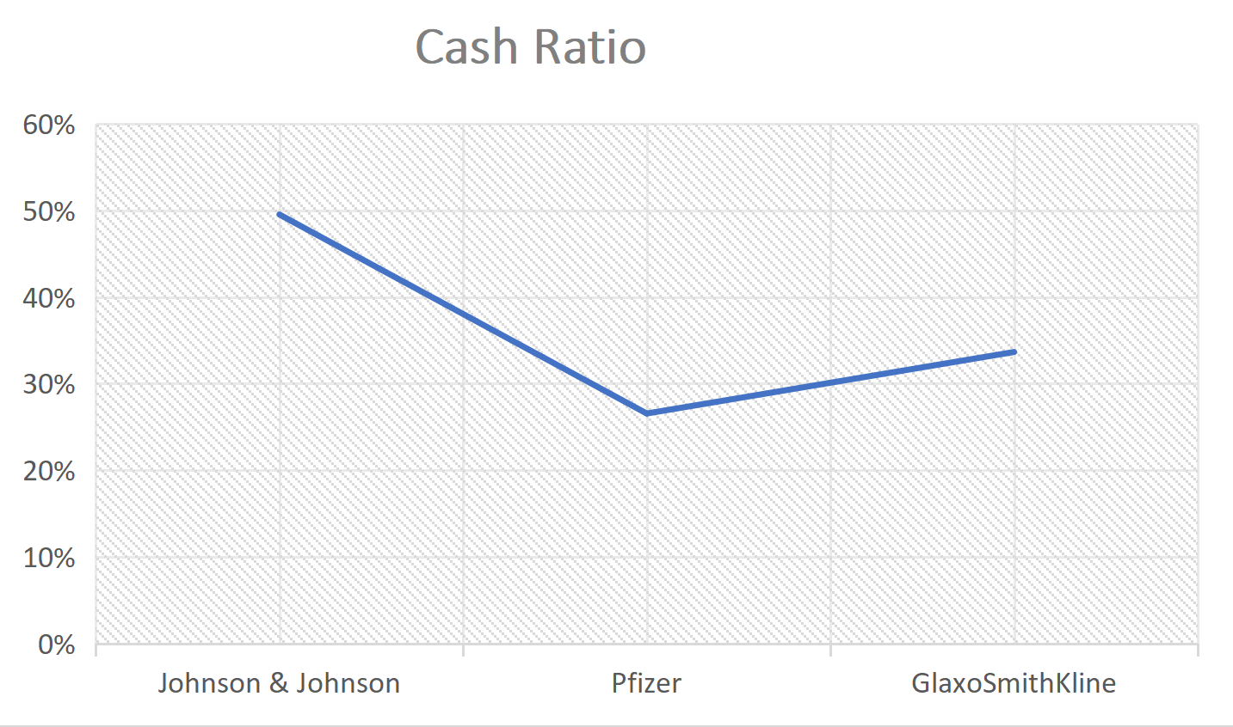

* It is also the most profitable considering her Net margin of 41% as shown by the chart below.

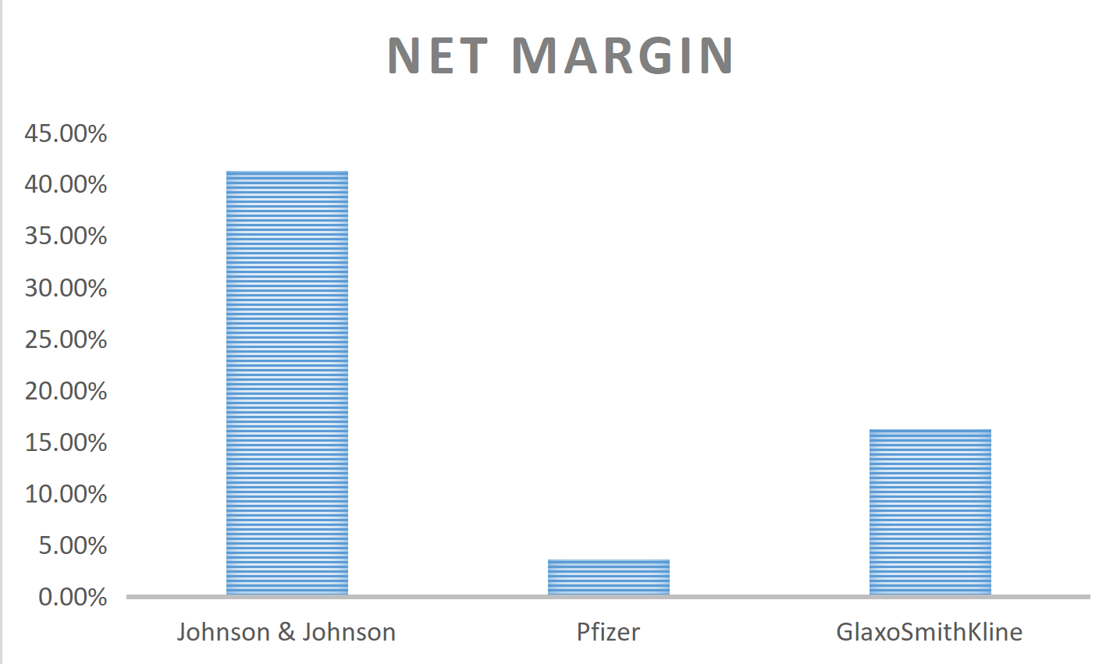

* J&J has the highest return on asset and equity at 0.21 and 0.51 respectively indicating that its ability to generate profits relative assets, or equity than the other. This is shown with the aid of the chart below:

