1. I have checked the source advised for the risk free rate used in your calculations but I didn't get the same value (3%) used. Pls advise which of the following options was used to get the risk free rates: "Daily Treasury Par yield curve rates, Daily Treasury Bills rate, Daily Treasury Long term rates, Daily Treasury Par real Yield curve rate or Daily Treasury Real Long-term rates".
When I used the link below, I got 2.4%. https://home.treasury.gov/resource-center/data-chart-center/interestrates/TextView?type=daily_treasury_real_long_term&field_tdr_date_value=2024
2. Also, take a look at the Yahoo finance information below, can we use 23.57% as highlighted for the S&P index 1 year return because I saw in the correction that you used 12% and 15%, however, I am unable to find the source for the value you used.
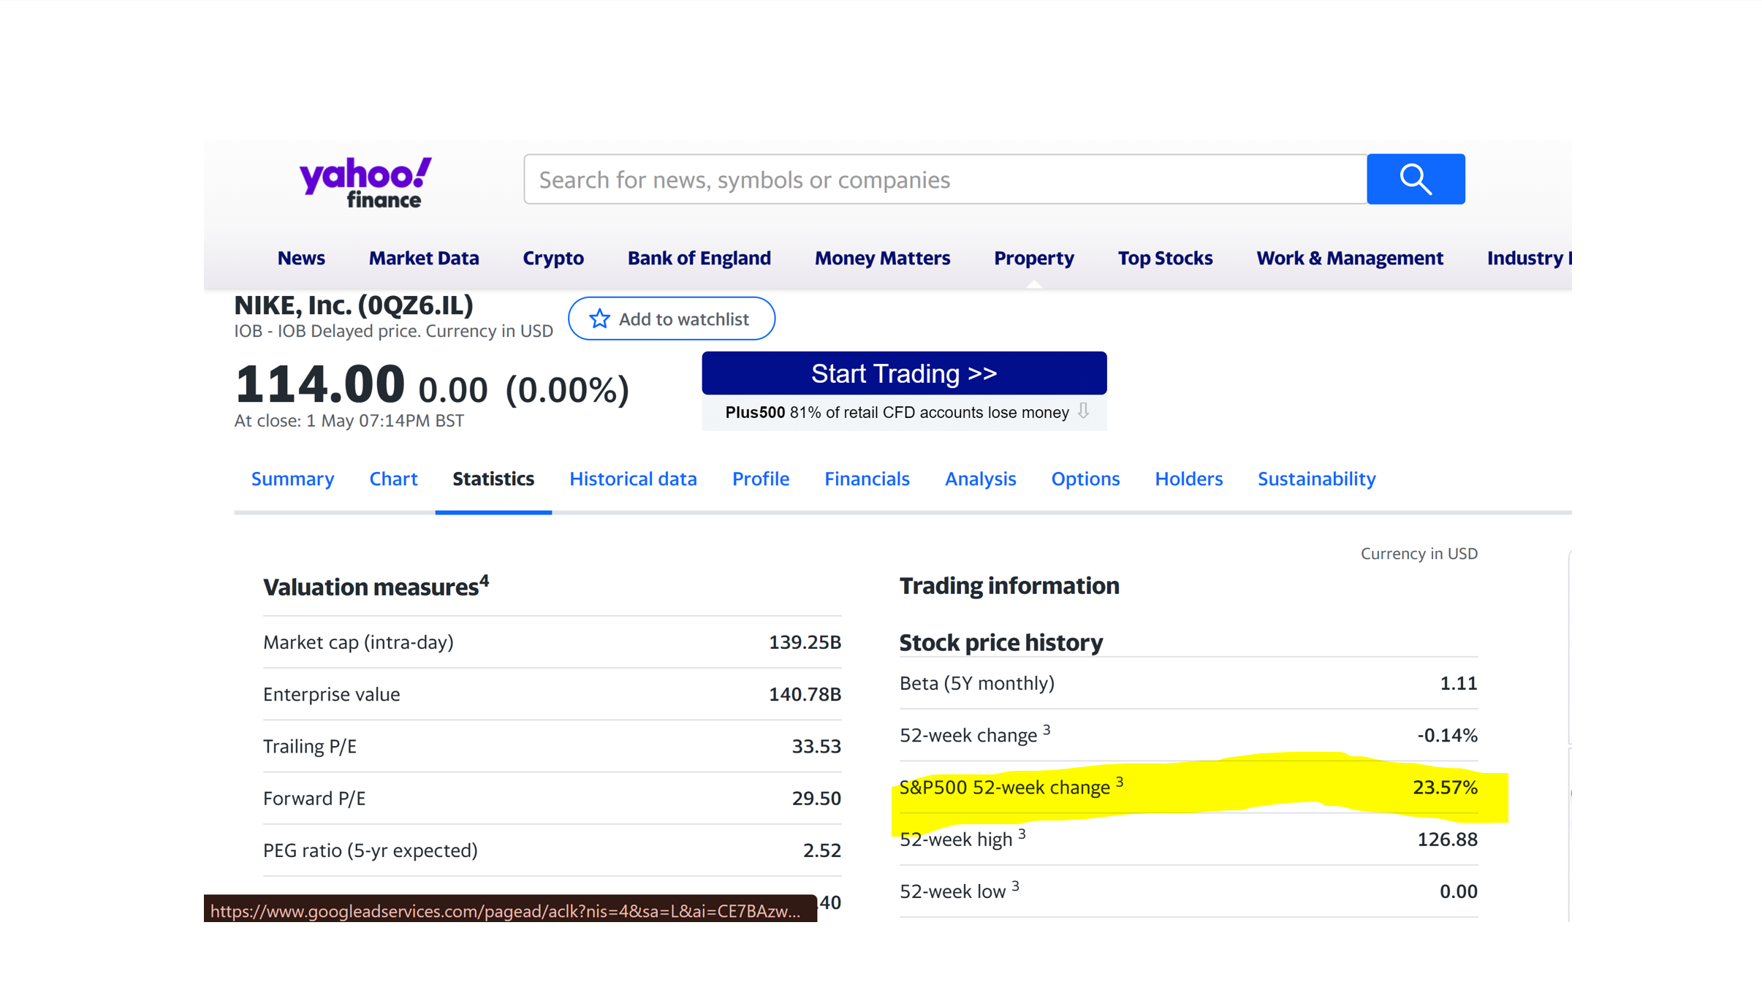
Furthermore, may I know the source of the rates you used for future reference?
3. The formular for Cost of Equity (Re) is as follows: Re= Risk-Free Rate (Rf)+(Beta (β)×Market Risk Premium (Rm−Rf)). RF is found on cell 23 in the excel sheet but you used cell 25 (Cost of debt) in your calculation, can I take that as an oversight on your part or the formular written above is wrong?

