Instructions:
- After deriving the intrinsic share price based on our model, the next step is to focus on putting together a report with an investment recommendation.
- You are required to fill in the report template below using the sample report attached and your readings on the company’s guidance in terms of key segments and products.
  - Identify two to three key products that are vital for the company’s growth and you can discuss about the trends and expectations. But remember to keep them all short cause and effect sentences.
- You can take up to two days for this task and feel free to reach out to me if you have any questions.
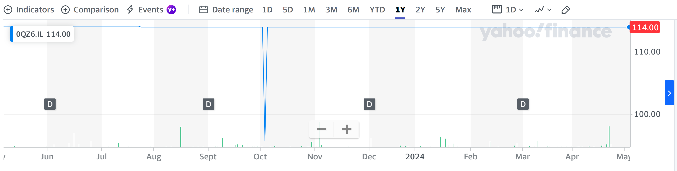
 | 2022 | 2023E | 2024E | 2025E
Revenue | 46710 | 46710 | 46710 | 46710
EBITDA | 7573 | 7573 | 7573 | 7573
EPS | 3.75 | 3.32 | 3.66 | 3.72
Net debt | 6653 | 15453 | 16642 | 17704
FCFF | 4993 | 8030 | 4890 | 4543
ROE | 39.6% | 33.0% | 32.1% | 30.4%
P/E | 31.66 | 31.69 | 28.77 | 28.30
EV/EBITDA | 27.45 | 24.61 | 24.79 | 24.86
 | 2022 | 2023E | 2024E | 2025E
Sales growth (%) | 4.9% | 0.0% | 0.0% | 0.0%
EBIT growth (%) | -1.0% | 0.0% | 0.0% | 0.0%
Net profit growth (%) | 5.6% | -12.9% | 8.4% | 0.03%
EPS growth (%) | 5.5% | -11.5% | 10.1% | 1.7%
EBITDA margin (%) | 16.2% | 16.2% | 16.2% | 16.2%
EBIT margin (%) | 14.7% | 14.7% | 14.7% | 14.7%
Net margin (%) | 12.9% | 11.3% | 12.2% | 12.2%

Company Name
Nike Inc.
Share Price (2019): USD 75.01
Upside/Downside to current share price: ((USD 105.26 – USD75.01)/USD75.01) = 0.403
Point 3
The forecasted value of Earning Per share is 3.83, FCFF was 5724 and capital expenditure was 986.
Nike is known for its commitment to innovation in footwear and apparel. Future developments may include advancements in materials, manufacturing processes, and design technologies to create products that are more sustainable, performance-enhancing, and fashionable.
Point 1:
Nike's athletic footwear products are its core offering and historically have been the primary revenue driver for the company.
Revenue grows at 6.6% average considering 5 previous years (2018 to 2022). This trend is expected to continue with increased demand by consumers seeking versatile and comfortable clothing for various activities and lifestyles.
Point 2:
Group EBITDA grows at an average rate of 14.4% in the last 5 years. The contributions of the North America segments to Revenue was 26%; Europe, Middle East & Africa; Greater China; Asia Pacific & Latin America were 21.5%, 37% , and 27% respectively.
Investment thesis:
The key products vital for the company’s growth are Footwares, Apparel and Equipment. The demand for athleisure and sports-inspired footwear will continues to rise, driven by factors like increased health consciousness, fashion trends, and casualization of attire enhancing the stock performance.

