Executive Summary:
This market research report provides a comprehensive analysis of the market position of Visa Inc (Visa). The report focuses on identifying the sector and industry which Visa operates as well as its peers and substitutes, new markets, the key revenue, and cost drivers. A SWOT and PESTEL grid is developed to highlight the competitive environment of the company and the industry. The findings of this report aim to assist stakeholders, including executives, investors, and shareholders, in understanding Visa's market position and performance in a highly evolving and competitive landscape.
Introduction:
Visa Inc. (Visa) is a global financial technology corporation that connects consumers and businesses, financial institutions, governments, and merchants. According to Bloomberg (2024), Visa operates a retail electronic payments network and manages global financial services by offering global commerce through the transfer of value and information. In 2007, regional businesses around the world were merged to form Visa Inc. and in 2008, the company went public in one of the largest IPOs in history. The company facilitates fast, secure, and reliable electronic P2P, B2C, B2B, B2b and G2C payments and operates in more than 200 countries and territories in the Americas, Europe, Asia-Pacific, the Middle East, and Africa. Visa is headquartered in San Francisco, California, the US with an estimated 26,500 employees.
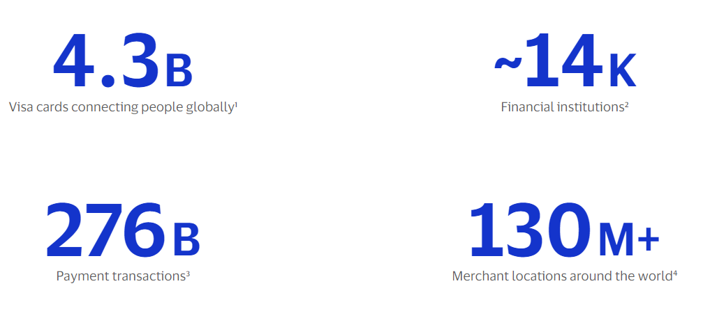Source: Visa, 2024
Sector and Industry Identification:
The Global Industry Classification Standards (GICS) were established by MSCI and S&P Dow Jones Indices to categorize publicly-traded equities. According to the GICS, Visa was classified as a company in the technology sector but has now been reclassified as Financials effective after the close on March 17, 2023. Visa operates as a Financial Technology company in the Transaction & Payment Processing Services industry.
Peer Identification:
Mastercard: Mastercard is a direct competitor to Visa. According to the GICS classifications, it operates in the financial sector and Transaction & Payment Processing Services industry.
American Express: It is a multinational financial services corporation that specializes in payment cards.
Company | Visa Inc | Mastercard Inc | American Express Company
Ticker | V | MA | AXP
Valuation Measures
Last price (26/03/2024) | 280.60 | 476.80 | 224.46
Market Cap | 576.37B | 444.80B | 161.62B
Enterprise Value | 579.73B | 450.59B | N/A
Trailing P/E | 32.40 | 40.24 | 20.16
Forward P/E | 28.33 | 33.00 | 17.54
Enterprise Value/Revenue | 17.38 | 17.95 | N/A
Enterprise Value/EBITDA | 24.40 | 30.01 | N/A
Profitability Measures
Revenue (ttm) | 33.35B | 25.10B | 55.59B
EBITDA | 23.42B | 15.35B | N/A
Profit Margin | 53.92% | 44.60% | 15.06%
Operating Margin | 69.06% | 56.19% | 17.36%

Substitutes:
The world of digital payments is rapidly evolving, with a rising number of alternatives. There are several substitutes to the products offerings by Visa.
- Online Payment and Digital Wallets: Stripe, and PayPal can be used to make online transactions simple and secure.
- Mobile Payment Systems: Apple pay, and Google pay allow users to make transactions online or in-person leveraging Near Field Communication (NFC) technology to enable contactless payments using mobile devices.
- Cryptocurrency Payments: Bitcoin and Ethereum provide unique benefits such as borderless transactions, security, and the possibility for price appreciation.
New Markets:
- Blockchain Technology and Digital Currencies: Capitalizing on the growing interest in crypto and integrating crypto and blockchain networks to Visa trusted brand and global payment network will aid crypto holders to pay quickly and securely at over 100 million merchants worldwide. This will aid crypto to realize its full potential while driving revenue growth via the crypto ecosystem.
- Emerging Economies: Countries in Africa, Asia, and Latin America with growing middle classes and increasing internet and mobile penetration represent new markets for Visa. These regions have large unbanked or underbanked populations, presenting opportunities for digital payments expansion.
Key Revenue and Cost Drivers:

SWOT Grid:
SWOT analysis provides a comprehensive overview of Visa internal strengths and weaknesses, as well as external opportunities and threats in the competitive landscape.
VISA INC
STRENGTHS | WEAKNESSES | OPPORTUNITIES | THREATS
Global presence | Dependency on interchange fees | Blockchain technology and digital currencies | Competition
Brand reputation | High Personnel Cost | Expansion into emerging markets | Regulatory change
Strong financial performance | Dependency on partnerships | Partnership or acquisition of smaller fintech companies | Cybersecurity threats
Large and diversified customer base |  | Increasing number of Banks and financial inclusion | Political instability
 |  |  | Economic downturns

The analysis above shows Visa as a company whose competitive advantage lies in its strength. Despite the industry dynamism, it is positioned as a force to be reckoned with in the global transaction and payment processing service industry.
PESTEL Grid:
This analysis aids businesses and industries in understanding external factors that affect their operations.
POLITICAL | ECONOMIC | SOCIAL | TECHNOLOGICAL | LEGAL | ENVIRONMENTAL
Government regulations | Global economic conditions | Consumer preferences | Data Security | Anti-money laundering laws | Climate change
Political stability | Exchange rates | Demographic trends | Digital transformation | Data privacy laws | Regulatory compliance
 | Inflation rates |  | Disruptive technology | Antitrust laws

The grid shows that each company classified in the global transaction and payment processing service industry is susceptible to the factors highlighted.
PERFORMANCE INDICATORS - 2023
Parameters | Visa | Mastercard | American Express
Revenue ($’M) | 32,653.00 | 25,098.00 | 33,416.00
Net Income ($’M) | 17,273.00 | 11,195.00 | 8,060.00

Competitive Analysis:
- Market Position and Reach: Visa and Mastercard lead in global transaction volume and network size, making them dominant players in the payment processing industry. American Express, while smaller in network size, captures a niche market with its integrated card issuance and processing model.
- Technology and Innovation: All three companies prioritize technology and innovation, but Visa and Mastercard have more focus on processing efficiency and security, given their roles as intermediaries. American Express focuses more on customer experience and digital transformation.
- Financial Performance: Visa and Mastercard generally have lower risk profiles, as they do not issue credit. Their revenue comes from processing fees, making their business models highly scalable. American Express's integrated model provides high margins per transaction but comes with credit risk.
- Strategic Focus: Visa and Mastercard are expanding into new payment technologies and markets, including digital currencies and B2B payments. American Express maintains its focus on the premium market segment, leveraging high spending and loyalty.
Conclusion:
Visa consistently showcases robust financial growth with an expansive network process of over $14 trillion in total volume leading to significant revenue from transaction processing. Its extensive global network contribute to its strong position reflecting its dominant market position. Visa continues to innovate, with investments in open banking and cloud-native platforms signalling future growth opportunities. Regulatory challenges and competitive pressures remain key threats to Visa's operational landscape. Mastercard operates a similar model to Visa and has a strong financial performance, a comparable global presence and brand recognition. American Express operates with a different model, a unique value proposition issuing cards and processing payments and consistently maintains a high level of customer loyalty and spending among its cardholders.
Sources:
https://www.bloomberg.com/profile/company/V:US
https://www.financemagnates.com/fintech/payments/best-alternatives-to-visa-or-mastercard/
https://usa.visa.com/solutions/crypto.html
https://uk.investing.com/news/stock-market-news/indepth-analysis-visa-versus-competitors-in-financial-services-industry-3366552
https://dcf.fm/blogs/blog/v-pestel-analysis
https://www.marquetteassociates.com/gics-reclassifies-away-tech/#:~:text=Effective%20after%20the%20close%20on,others%2C%20were%20reclassified%20as%20Financials.
https://www.marketresearch.com/MarketLine-v3883/Visa-Strategy-SWOT-Corporate-Finance-34080379/
https://s26.q4cdn.com/747928648/files/doc_financials/2023/q4/American-Express-Company-10K-4Q2024.pdf
https://investor.visa.com/financial-information/quarterly-earnings/default.aspx
https://finance.yahoo.com/quote/AXP/profile
https://www.visa.co.uk/about-visa.html#:~:text=We're%20a%20world%2Dleading,to%20pay%20and%20be%20paid.
https://finance.yahoo.com/news/decoding-visa-inc-v-strategic-050749379.html
https://pestleanalysis.com/visa-swot-analysis/#google_vignette
https://dcf.fm/blogs/blog/v-pestel-analysis
https://www.disruptionbanking.com/2023/03/09/visa-and-mastercard-duopoly-time-to-go/
https://www.gurufocus.com/news/2124880/decoding-visa-inc-v-a-strategic-swot-insight?r=caf6fe0e0db70d936033da5461e60141
https://en.wikipedia.org/wiki/List_of_S%26P_500_companies
https://stripe.com/gb
https://investor.mastercard.com/overview/default.aspx

