**Instructions:**

1. After deriving the intrinsic share price based on our model, the next step is to focus on putting together a report with an investment recommendation.
2. You are required to fill in the report template below using the sample report attached and your readings on the company’s guidance in terms of key segments and products.
   1. Identify two to three key products that are vital for the company’s growth and you can discuss about the trends and expectations. But remember to keep them all short cause and effect sentences.
3. You can take up to two days for this task and feel free to reach out to me if you have any questions.

**Point 1:** Revenue is expected to grow at an average of 6.4% annually from historical trends. The North America, alongside the EMEA are the main segment and they jointly contributed 66% in year 2022. The footwear is the main driver of revenue along the product line.

**Point 2:** The group EBITDA for 2022 stood at 16.2%. Nike Inc is expected to maintain an average of 15% margin in line with historical trends. The operating segments of North America and EMEA have significant contributions to earnings. In addition, The APLA have had consistent growth in earnings.

The projected cost of operation is expected to be at 87% of revenue which is considerably high.

**Point 3:** EPS should continue to grow annually as revenues are projected to grow by 6.4%. Nike Inc is expected to have more funds available to investors. FCFF is projected to be available at an expected growth rate of 17.91%.

Capital expenditures are expected to steadily increase as Nike Inc is expected to continue to invest in the digital market and in opportunities inherent in emerging markets.

**Investment thesis:**

The intrinsic share price as calculated in line with the model adopted stood at $130.95. The results shows that the stock price of Nike Inc is currently undervalued. This impacts positively on Nike Inc market price with and outlook of an upward trajectory by 0.43.

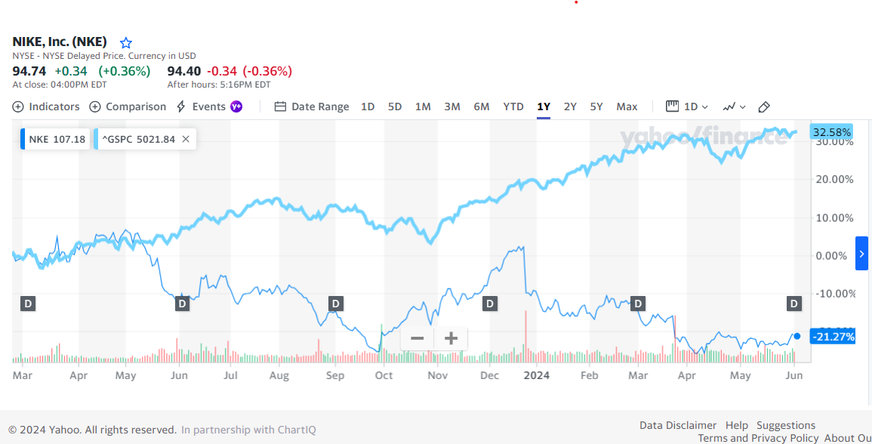





Company Name: Nike Inc

Ticker: NKE

Current Share Price: $91.67 (At close, May 29 2024)

Upside/Downside to current share price: ((Forecasted Price – Current Price)/Current Price): 0.43