Johnson & Johnson Revenue 2023 (Millions)

Source: <https://www.statista.com/statistics/266405/global-revenue-of-johnson-und-johnsons-pharmaceutical-segment-by-product/#:~:text=The%20highest%20revenue%20generating%20drug,of%20revenue%20for%20the%20company>.

Total= 43, 743

Pfizer Revenue Drivers 2023 (Millions)

1. Comirnaty - $11,220
2. Eliquis - $6,747
3. Prevnar $6,440
4. Ibrance - $4753
5. Vyndaqel - $3,321
6. Xejanz - $1,703
7. Paxlovid - $1,279
8. Xtandi - $1,191
9. Inlyta - $928

<https://www.pfizer.com/sites/default/files/investors/financial_reports/annual_reports/2023/pdf/Pfizer_Performance_2023_V6.pdf>

Total= 36,091

Comparing at Johnson & Johnsons top pharmaceutical with Pfizer’s we can see both companies have 2 drugs each which almost make up halve of their revenues. Pfizers largest driver comes from Cominaty at 31% and J’n’J’s is Stelra at 25%. This difference is partly due to Pfizer having fewer drugs at 9 compared to J’n’J’s 11. With a more diverse range Johnson n Johnson has a larger total revenue by $7,652.

Other revenue sources for JnJ such as Med tech and innovative medicine make up 10.3 and 21.8% of sales respectively. As stated in the 2023 Annual report $85,159 Million was made at a product cost of $26,553 Million.

Mariott Revenue 2023 ($) millions

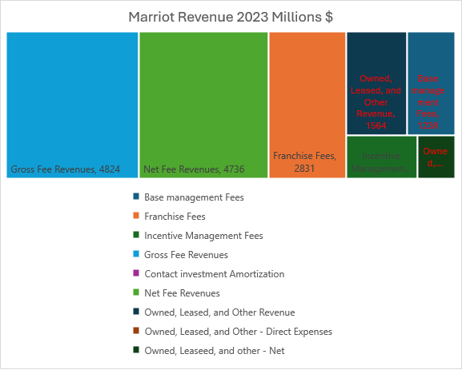

The Marriott operates as a franchise model so a result its costs are very minimal which is why the difference between gross and net revenue is only 88. Their largest stream of revenue comes from Franchise fees from 8,800 properties across 139 countries according to the 2023 Annual Report. One of the Marriotts competitors the Hilton, who have a 7,530 Hotels.