**Instructions:**

1. After deriving the intrinsic share price based on our model, the next step is to focus on putting together a report with an investment recommendation.
2. You are required to fill in the report template below using the sample report attached and your readings on the company’s guidance in terms of key segments and products.
   1. Identify two to three key products that are vital for the company’s growth, and you can discuss about the trends and expectations. But remember to keep them all short cause and effect sentences.
3. You can take up to two days for this task and feel free to reach out to me if you have any questions.

Looking at the 3 points, point 1 indicates that the Jordan brand, in particular the shoes will be a driver for the revenue growth this will see North America lead this as the most profitable global region. With the growth of the Capex it can be assumed that more stores and factories will be built over the next few years likely focusing on the Jordan brand for the NA market.

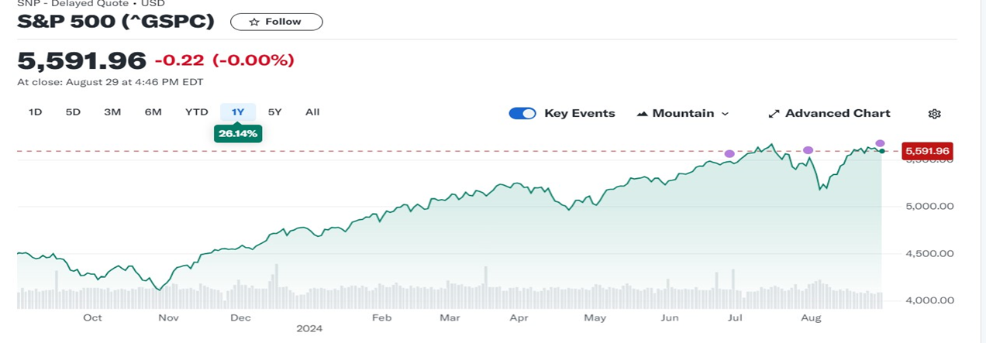

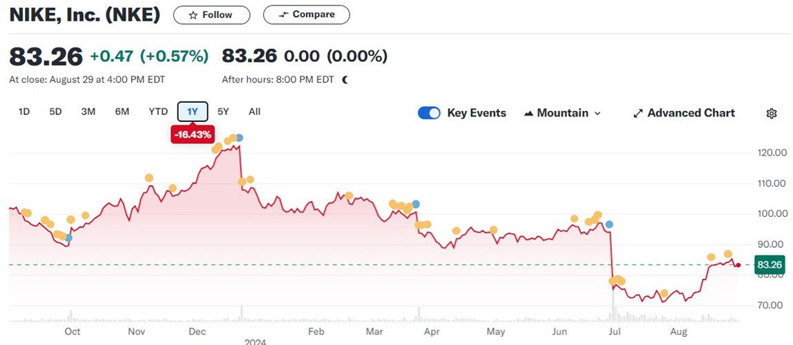

|  |  |  |  |  |
| --- | --- | --- | --- | --- |
|  | **2022** | **2023E** | **2024E** | **2025E** |
| Revenue | 46710 | 48987.92 | 51376.93 | 53882.45 |
| EBITDA | 7573.0 | 8419.7 | 8580.5 | 8746.3 |
| EPS | 3.8 | 3.2 | 3.2 | 3.2 |
| Net debt | 1298.0 | 1361.3 | 1427.7 | 1497.4 |
| FCFF | 7114.0 | 4339.0 | 4576.5 | 4826.1 |
| ROE | 0.526 | 0.829 | 1.305 | 2.055 |
| P/E | 23.301 | 27.077 | 27.077 | 27.077 |
| EV/EBITDA | 4.038 | 3.632 | 3.564 | 3.496 |
|  |  |  |  |  |
|  |  |  |  |  |
|  |  |  |  |  |
|  | **2022** | **2023E** | **2024E** | **2025E** |
| Sales growth (%) | 5% | 5% | 5% | 5% |
| EBIT growth (%) | -1% | 12% | 2% | 2% |
| Net profit growth (%) | 6% | 8% | 3% | 3% |
| EPS growth (%) | 12% | -212% | -23% | -25% |
| EBITDA margin (%) | 16% | 17% | 17% | 17% |
| EBIT margin (%) | 15% | 16% | 15% | 15% |
| Net margin (%) | 13% | 13% | 13% | 13% |

Keep this blank for table????

**Point 1:** Comment on revenue growth expectation, key segment and product performance (not required to talk about all, which is the main segment and the main product that can impact the revenue growth the most)

Based on the Segmental Forecast Nike’s revenue is forecast to grow at an Average of 3.2% between 2024- 2027. This growth will be driven largely by the footwear market. The Jordan brand is expected to be the lead in driving this.

**Investment thesis:**

Based on the model, Nike’s is expected grow at around 3% till 2027 which is a fall in the average rate between 2015 – 2022 at 6.4%.

Company Name: Nike Inc

Ticker: NKE

Current Share Price: $83.48 Premarket 23/08/2024

Upside/Downside to current share price: ((Forecasted Price ($94.3 fintel.io) – Current Price)/Current Price)

93.3-83.84/83.48= $\frac{\left(93.3-83.48\right)}{83.48}$ = 0.11

**Point 2:** Margin of the group EBITDA, each segment’s contribution to earnings. The expectation of the margin growth. Key cost trends according to historic numbers (R&D).

EBITDA makes up 17% of the 2027 forecasted revenue. With in this North America is expected to be a significant contributor to the EBITDA at 58%. NA also contributes 34% of the forecasted revenue.

**Point 3:** EPS, FCFF and Capex forecasts. Any future developments, company’s key drug pipeline/development.

Nike’s Capex forecasts a growth around ~25% however the FCFF shrunk by 25% over the same period. EPS also was estimated to reduce from 3.75 to 3.23. This is likely due to the forecasted growth in Capex, while a decrease in the Eps maybe expected this should be off set by the growth of the average share price.

My recommendation is to buy with the intention to hold for the long term.