Financial Health of Amazon.com, Inc.

In this management report, the overall financial health of Amazon.com, Inc. is analysed over the three-year period from 2020 to 2022. Amazon is a US-based E-commerce giant that provides wide range of products to online customers across the globe. The report covers five key ratio topics that in depth analyse the financial health of the company and outlines what it looks ahead.

# **Liquidity Ratios**

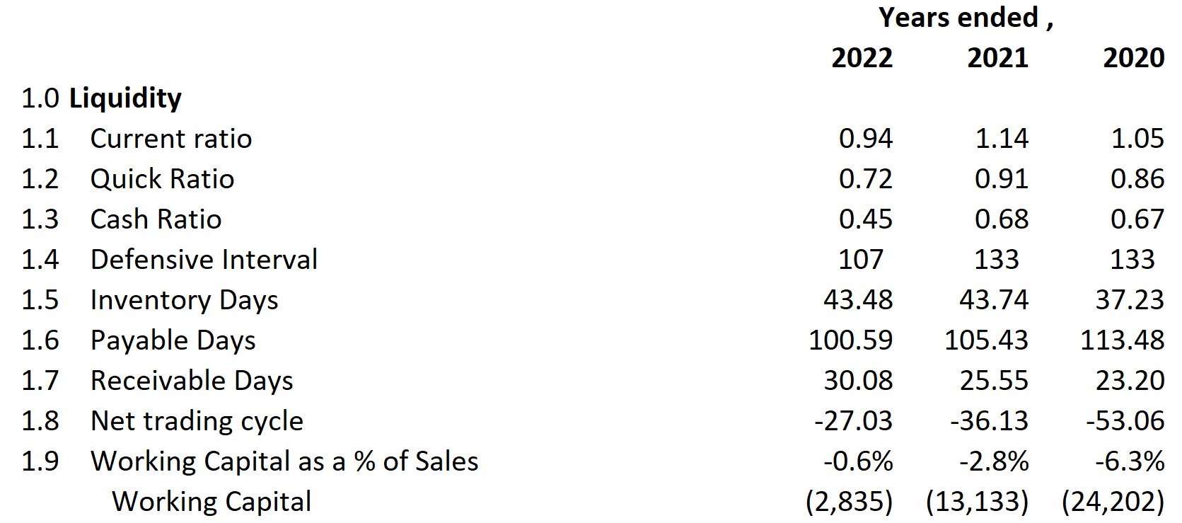

During the three year period, liquidity appears to have worsened for Amazon. All of the nine measurable liquidity metrics registered poor progress from 2020 mainly due to an increased surge of 73% in accounts receivable and already high accounts payable. It has led to the injection of $22 billion in two years in to the working capital, and deteriorated working capital inflows. Inventory days increased while payable days decreased suggesting a weaker demand of products as result of high inflation and tightened monetary environment. All of these changes are reflected in net trading cycle which has reduced by almost half.

# **Profitability Ratios**

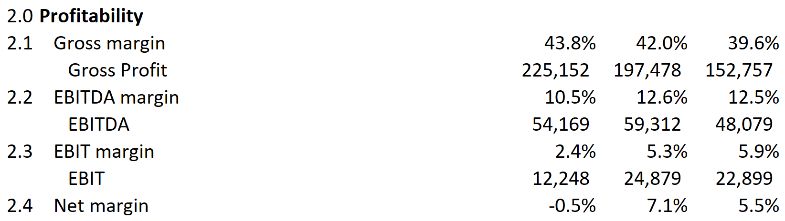

Amazon experiences significant fluctuations in its operating results and growth rate. It gave mixed returns for investors during the three year period, when it comes to evaluating it from three different metrics. Gross profit showed a robust growth of 47% in two years, while EBITDA only rose by a mere 13%, operating profit dampened by a huge 47% and net profit turned into a loss. The extreme fluctuation in profitability is already communicated by Amazon to its shareholders, saying that a significant portion of their expenses and investments are fixed, and are not able to adjust quickly to sales and global economic developments.

# **Solvency/Debt Management Ratios**

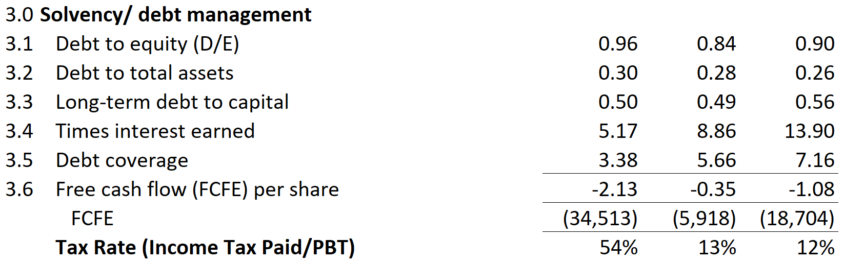

Amazon’s gearing and coverage ratios deteriorated a little over the three years. It is because in 2022, the company leveraged its operations by taking in almost $62.7 billion of fresh proceeds from short-term and long-term debt, against $27.0 billion in 2021. The significant jump in borrowing is reflected in higher Debt-to-equity and assets ratio. Times interest earned and debt coverage ratio worsened dramatically largely due to increased finance cost in a tight monetary and higher interest rate environment. Amazon currently holds negative free cash flows as they invest heavily in their fixed assets while looking to expand their operations further across the world. The company is optimistic about long-term sustainable growth in free cash flows considering the future return on its current investments.

# **Asset Utilization Ratios**

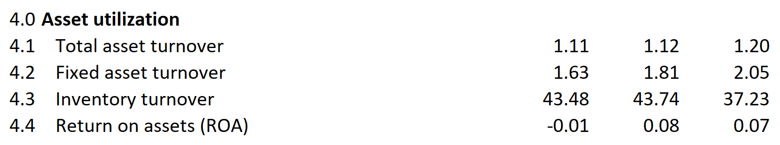

There has been no positive advancements in asset unitization as returns and turnovers have remained sluggish during the period. The foremost reason of the reduction in asset turnover is the significantly high capital expenditures of $55.4 billion and $58.3 billion being made in 2021 and 2022 respectively. The company aims to generate revenue from and operating returns on these investments in two-three years to come. Amazon expects some variability in its inventory turnover days, due to its nature of business and its high correlation with global economic environment. The return on assets turned negative in 2022 from 2021 primarily because of net loss of $2.7 billion in the year.

# **Investor/Market Ratios**

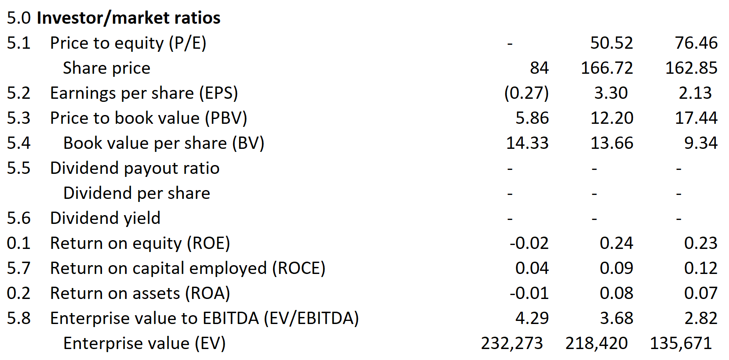

Year 2022 had been a forgettable year for Amazon as far as returns are considered, comparing from past two years. The company always had enjoyed staggering investor confidence which is reflected in its exorbitantly high P/E multiple. This suggests that investors view Amazon as a rapidly growing company in future, and thus strongly value its share. Its share price remained almost same in 2020 and 2021, before halving in 2022 predominantly due to worse macroeconomic challenges and outlook. The book value per share increased as shareholder equity rose after higher retained earnings from previous years.

Amazon is not a dividend paying stock, hence its dividend and payout ratios are blank. It completely focuses on reinvesting it’s earning for future returns for shareholders, which can be seen in higher capital expenditures being carried out during the period under consideration. It is also one of the reasons why investor’s value Amazon so high in normal circumstances. It is reflected by its whopping P/E ratio for 2020 and 2020. Moreover, Amazon’s enterprise value surged by mammoth 71% over the three-year period, mainly due to higher piling of debt and taking on more leverage, and also due to increase in shareholder’s equity due to retained earnings and stock issues. Shareholder equity and long-term debt, including long-term lease contracts, increased by 56% and 66% respectively in three-years.

# **Conclusion**

Amazon had a mediocre financial year in 2022, which was also adversely influenced by poor global economics developments. However, company looks optimistic for better earnings results in future, mainly for two reasons. One that the globally economy will ease off and sales will increase, resulting in improved operating results, and secondly it hopes for additional returns from significant capital investments it had carried out in the period under consideration.