**Marriott International, Inc. (MAR)**

**Revenue Drivers for Marriott International, Inc. (MAR)**

Based on the latest data and earnings call transcript, the key revenue drivers for Marriott International, Inc. are:

1. RevPAR (Revenue per Available Room) Growth:

Global RevPAR :

2024:$114.88, Growth: 5%

2023 Q4: $116.81, Growth: 27.9

2022: $91.3, Growth: 55.4%

2021: $58.75, Growth: 41.53%

2020: $41.51, Growth: -62.77%

2019: $111.51, Growth: -2.66%

Marriott's global RevPAR for Q4 2023 was $116.81, showing a significant growth of 27.94% compared to the previous year. For Q1 2024, the RevPAR slightly decreased to $114.88, with a growth rate of 5%

* + International RevPAR: $116.81 with a growth of 27.94% for FY 2023.

1. Average Daily Rate (ADR):  is a key performance metric in the hospitality industry that represents the average rental income per paid occupied room in a given time period. It is calculated by dividing the total room revenue by the number of rooms sold.
   * Increase in ADR by around 3% in Q2 2024.

2024 Q1: $174.24, Growth: 3%

2023: $172.05, Growth: 7.39%

2022: $160.21, Growth: 15.5%

2021: $138.71, Growth: 5.38%

2020: $131.63, Growth: -16.32%

2019: $157.31, Growth: -2.58%

Marriott's global ADR for Q4 2023 was $172.05, with a growth of 7.39%. For Q1 2024, the ADR increased to $174.24, with a growth rate of 3%.

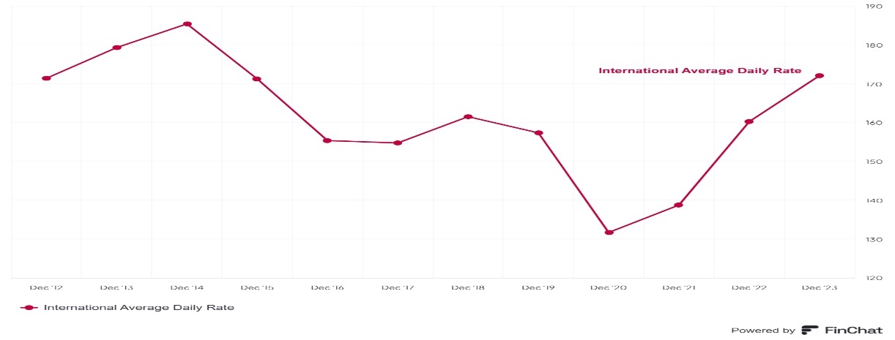

1. Occupancy Rates:
   * Increase in occupancy by about 150 basis points in Q2 2024.
   * US & Canada Occupancy: 69.8% with a growth of 4.18% for FY 2023.
   * International Occupancy: 67.9% with a growth of 19.12% for FY 2023.

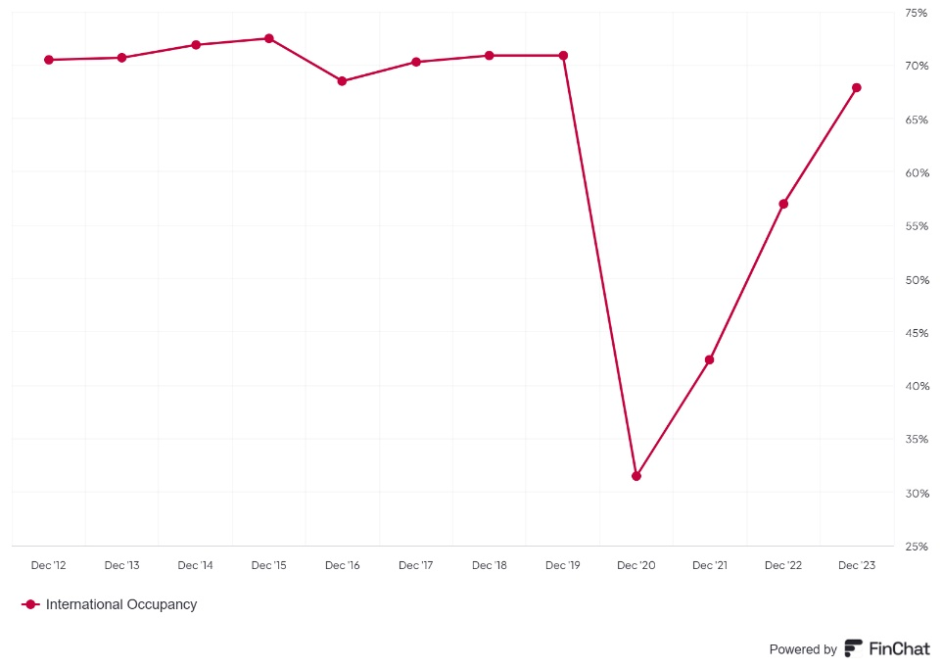

1. Customer Segments:
   * Robust growth in group, business transient, and leisure transient segments.
2. Loyalty Program:
   * Continued growth in Marriott Bonvoy loyalty program membership and penetration.
3. Global Portfolio Expansion:
   * 6% year-over-year net rooms growth.
   * Strength in conversions, representing 37% of openings and 32% of signings.

**Impact of Price and Volume Data on Revenue Growth**

1. Price (Average Daily Rate - ADR):

* Impact on Revenue Growth: An increase in ADR directly boosts revenue as it represents the average price paid per room. Higher ADR indicates that Marriott can charge more for its rooms, which can be due to higher demand, improved service offerings, or market positioning.
* Q2 2024 Data: ADR increased by around 3%, contributing to overall revenue growth.

2. Volume (Occupancy Rates and Number of Rooms):

* Occupancy Rates:
  + Impact on Revenue Growth: Higher occupancy rates mean more rooms are being sold, which increases total revenue. Occupancy rates reflect the percentage of available rooms that are occupied over a given period.
  + Q2 2024 Data: Occupancy increased by about 150 basis points, indicating more rooms were occupied, thus driving revenue growth.
* Number of Rooms:
  + Impact on Revenue Growth: Expanding the number of rooms available (through new hotel openings or acquisitions) increases the potential revenue base. More rooms mean more opportunities to generate revenue.
  + Global Portfolio Expansion: 6% year-over-year net rooms growth, contributing to increased revenue potential.

Summary of Revenue Drivers and Their Impact

* RevPAR Growth: Combines both price (ADR) and volume (occupancy rates) to provide a comprehensive measure of revenue performance per available room. An increase in RevPAR indicates that Marriott is effectively managing both pricing and occupancy to maximize revenue.
* ADR (Price): Directly increases revenue by raising the average price per room.
* Occupancy Rates (Volume): Increases revenue by selling more rooms.
* Customer Segments: Growth in specific segments (group, business transient, leisure transient) indicates diversified revenue streams and resilience across different market conditions.
* Loyalty Program: Enhances customer retention and repeat business, contributing to stable and growing revenue.
* Global Portfolio Expansion: Increases the number of rooms available for sale, thus expanding the revenue base.

Marriott International, Inc.'s revenue growth is driven by a combination of price (ADR) and volume (occupancy rates and number of rooms). The company's strategic focus on expanding its global portfolio, enhancing its loyalty program, and targeting diverse customer segments has enabled it to effectively leverage both price and volume to drive revenue growth. The positive trends in RevPAR, ADR, and occupancy rates highlight Marriott's ability to optimize its pricing strategy and maximize room utilization, contributing to its overall financial performance.

**Cost Drivers for Marriott International, Inc. (MAR)**

Based on the latest data and earnings call transcript, here are the key cost drivers for Marriott International, Inc., along with their correlation with revenue:

1. Cost of Goods Sold (COGS)

* Nature: Variable
* Correlation with Revenue: High
* Details: COGS includes expenses directly related to providing hotel services, such as housekeeping, utilities, and guest amenities. These costs increase with higher occupancy rates and room sales.
* Recent Data:
  + Annual Data:
    - 2023: $1,165M (Growth: 8.47%)
    - 2022: $1,074M (Growth: 46.32%)
    - 2021: $734M (Growth: 8.42%)
  + Quarterly Data:
    - Q1 2024: $286M (Growth: 1.78%)
    - Q4 2023: $304M (Growth: 3.05%)
    - Q3 2023: $293M (Growth: -2.66%)
    - Q2 2023: $287M (Growth: 2.14%)

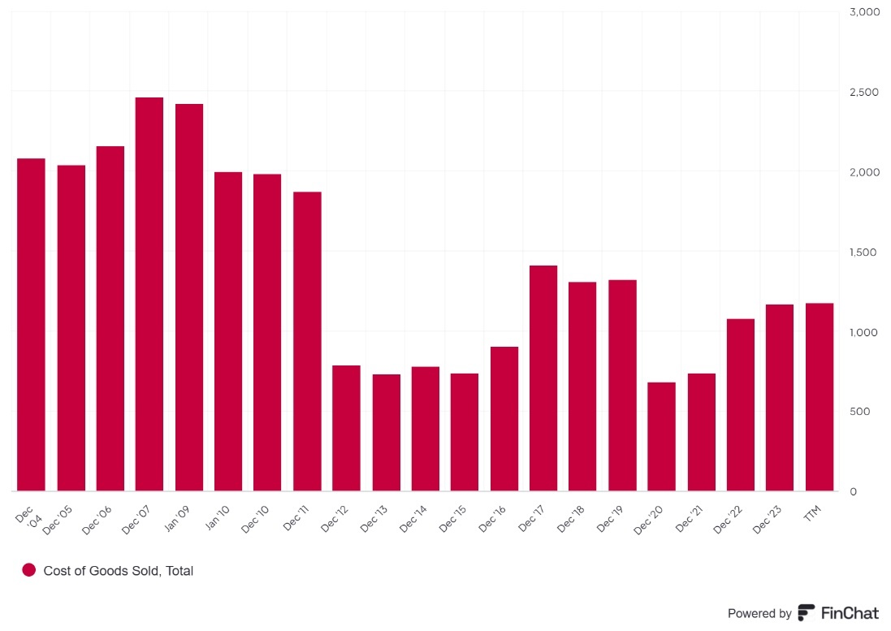

2. Incentive Management Fees

* Nature: Variable
* Correlation with Revenue: High
* Details: Fees paid to hotel managers based on performance metrics like RevPAR and occupancy rates. Higher performance leads to higher fees.
* Recent Data: Specific numbers for incentive management fees are not provided, but they are impacted by market weaknesses in regions like Hawaii and Greater China.

3. Marketing and Sales Expenses

* Nature: Variable
* Correlation with Revenue: High
* Details: Costs related to advertising, promotions, and sales commissions. These expenses increase with efforts to drive higher occupancy and room rates.
* Recent Data: Specific numbers for marketing and sales expenses are not provided, but they are variable and increase with revenue-generating activities.

4. Property and Equipment Costs

* Nature: Fixed
* Correlation with Revenue: Low
* Details: Costs related to owning or leasing hotel properties, including depreciation and maintenance. These costs remain constant regardless of occupancy rates.
* Recent Data: Specific numbers for property and equipment costs are not provided, but they are fixed and do not fluctuate with revenue.

5. Administrative Expenses

* Nature: Fixed
* Correlation with Revenue: Low
* Details: Salaries of corporate staff, office rent, and other overhead costs. These expenses do not fluctuate with revenue.
* Recent Data: Specific numbers for administrative expenses are not provided, but they are fixed and do not fluctuate with revenue.

6. Franchise Fees

* Nature: Semi-Variable
* Correlation with Revenue: Mixed
* Details: Franchise fees include fixed base fees plus variable components based on hotel performance metrics. The fixed component remains constant, while the variable component fluctuates with revenue.
* Recent Data: Specific numbers for franchise fees are not provided, but they are semi-variable and include both fixed and variable components.

7. Maintenance Costs

* Nature: Semi-Variable
* Correlation with Revenue: Mixed
* Details: Regular maintenance costs are fixed, but additional maintenance may be required based on occupancy levels and wear and tear.
* Recent Data: Specific numbers for maintenance costs are not provided, but they are semi-variable and include both fixed and variable components.

Summary of Cost Drivers and Their Correlation with Revenue

| Cost Item | Nature | Correlation with Revenue | Recent Data (Annual) |
| --- | --- | --- | --- |
| Cost of Goods Sold (COGS) | Variable | High | 2023: $1,165M (8.47%) |
| Incentive Management Fees | Variable | High | Not specified |
| Marketing and Sales Expenses | Variable | High | Not specified |
| Property and Equipment Costs | Fixed | Low | Not specified |
| Administrative Expenses | Fixed | Low | Not specified |
| Franchise Fees | Semi-Variable | Mixed | Not specified |
| Maintenance Costs | Semi-Variable | Mixed | Not specified |

Marriott International, Inc.'s cost structure includes a mix of fixed, variable, and semi-variable costs. Variable costs, such as COGS, incentive management fees, and marketing expenses, have a high correlation with revenue as they increase with higher occupancy rates and room sales. Fixed costs, such as property and equipment costs and administrative expenses, have a low correlation with revenue as they remain constant regardless of revenue levels. Semi-variable costs, such as franchise fees and maintenance costs, have a mixed correlation

**Pricing strategy**

Marriott International employs a comprehensive pricing strategy that includes dynamic pricing to adjust rates based on real-time demand, segmented pricing tailored to different customer groups like business travellers and loyalty members, and seasonal/event-based pricing to capitalize on high-demand periods. The company also uses competitive pricing to remain attractive in the market, value-added pricing to justify higher rates with additional services, promotional pricing to boost occupancy during low-demand times, and loyalty program pricing to offer exclusive rates and benefits to Marriott Bonvoy members. These multifaceted approaches enable Marriott to optimize revenue, attract diverse customers, and maintain a competitive edge in the hospitality industry.

**Peer Comparison:**

Marriott International (MAR) leads its key peers—Hilton Worldwide (HLT), Hyatt Hotels (H), InterContinental Hotels Group (IHG), and Accor SA (AC)—in several financial metrics. With a market capitalization of $68.2B, Marriott is the largest among its peers, followed by Hilton at $54.47B. Although Hilton tops in total revenues with $9,450M, Marriott excels in profit margins: gross profit (81.65%), EBITDA (65.95%), operating (60.48%), and net profit (45.33%), indicating superior cost management and operational efficiency. Marriott also shows strong growth, with the highest 3-year revenue CAGR (53.27%) and competitive 5-year revenue CAGR (4.01%). Additionally, Marriott's diluted EPS growth rates over 3 and 5 years are the highest among its peers, showcasing robust financial performance and investor confidence.

**Johnson & Johnson (J&J)**

**Revenue drivers for Johnson & Johnson (J&J)**

The main revenue drivers for Johnson & Johnson (J&J) can be categorized into three primary segments: Pharmaceuticals (Innovative Medicine), Medical Devices (MedTech), and Consumer Health. Each of these segments has specific product categories and key brands that significantly contribute to the company's overall revenue. Here’s a detailed breakdown:

1. **Pharmaceuticals:** This segment generates the majority of Johnson & Johnson’s sales.  This division accounted for more than half of JNJ's revenue for the full year. At over 55% of overall revenue driven by key brands such as DARZALEX, CARVYKTI, TECVAYLI, ERLEADA, TREMFYA, and SPRAVATO. The segment accounted for $55.67 billion in revenue for the latest trailing twelve months (LTM).
2. **Medical Devices**: Johnson & Johnson’s medical device business is another key revenue driver: Growth in this segment is driven by commercial execution, new product introductions, and strong procedure volumes. The segment contributed $30.91 billion in revenue for the latest LTM .

This division is divided into four different areas, including:

* Orthopedics: joint reconstruction, trauma, spine, sports medicine, and power tools
* Surgery: surgical systems and instruments
* Interventional solutions: heart rhythm disorders and neurovascular care support for health care professionals

3**.Consumer Health Products**: This division covers consumer goods like over-the-counter medications, skincare, and hygiene products. Although it’s not as large as pharmaceuticals or medical devices, it still contributes significantly. This segment was responsible for 17% of total sales, representing $10.05 billion of revenue for the full year. segment offers a broad range of products used in three distinct categories:

* Baby Care: JOHNSON'S, AVEENO Baby
* Oral Care: LISTERINE
* Skin Health/Beauty: AVEENO, CLEAN & CLEAR, DR. CI:LABO, NEUTROGENA, OGX
* Over-the-Counter (OTC) Products: TYLENOL, SUDAFED, BENADRYL, ZYRTEC, MOTRIN IB, NICORETTE, PEPCID
* Women's Health: STAYFREE, CAREFREE, o.b.
* Wound Care: BAND-AID, NEOSPORIN

According to the [earnings report](https://www.investopedia.com/articles/fundamental-analysis/10/decoding-earnings-reports.asp), the division's sales grew by 3% from the previous year, fueled by demand for some of its key brand names, including Tylenol and Listerine.

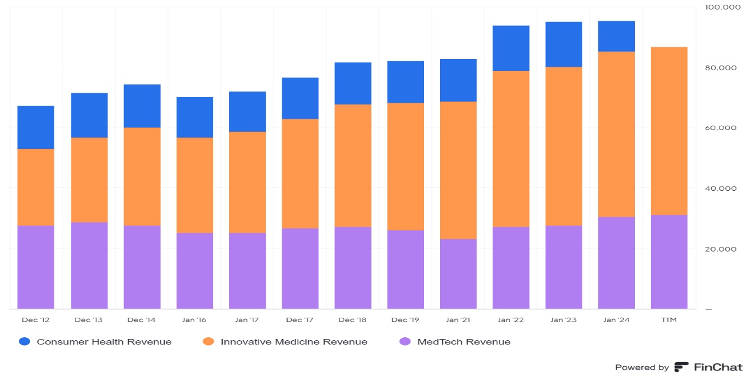

Annual Revenue Segments Breakdown (2023 Q4):

* Innovative Medicine Revenue: $54.76B (57.52%)
* MedTech Revenue: $30.4B (31.93%)
* Consumer Health Revenue: $10.04B (10.54%)
* Total Revenue: $95.2B

**Cost drivers for Johnson & Johnson (J&J)**

 Key Cost Drivers

* Total Revenue (2023): $86.58 billion

Breakdown of Major Costs:

1. COGS: $30.5 billion (35% of revenue)
2. R&D Expenses: $14.6 billion (16% of revenue)
3. SG&A Expenses: $22.3 billion (25% of revenue)
4. Interest and Financing Costs: $1.2 billio Cost of Goods Sold (COGS): Primarily variable, at $30.5 billion, accounting for 35% of revenue. It directly correlates with production and sales volume—higher sales lead to higher COGS.
5. Research & Development (R&D): Both fixed and variable, totaling $14.6 billion or 16% of revenue. Fixed costs include staff salaries and infrastructure, while variable costs depend on the number and scale of projects, showing some correlation with revenue.
6. Selling, General, and Administrative (SG&A) Expenses: Both fixed and variable, at $22.3 billion, representing 25% of revenue. Fixed costs include salaries and rent, while variable costs like sales commissions and marketing vary with sales volume.
7. Manufacturing Overhead: Included in COGS, with both fixed (depreciation) and variable (utilities, indirect labor) components, showing some correlation with production levels and revenue.
8. Distribution and Logistics: Part of SG&A, primarily variable, highly correlated with sales volume—higher sales lead to higher distribution costs.
9. Regulatory and Compliance Costs: Included in SG&A and R&D, with both fixed (compliance staff salaries) and variable (regulatory filings) components. Variable costs correlate with the number of new products and regulatory requirements.
10. Intellectual Property and Licensing Costs: Part of SG&A and R&D, with both fixed (patent fees) and variable (royalties) components. Variable costs depend on sales—higher sales lead to higher royalties.
11. Interest and Financing Costs: Generally fixed at $1.2 billion or 1.4% of revenue, influenced by debt levels and interest rates, and not directly correlated with revenue.

In summary, J&J’s cost structure is a mix of variable costs (e.g., COGS, distribution, variable R&D, SG&A) and fixed costs (e.g., fixed R&D, SG&A, manufacturing overhead, compliance, financing), with variable costs closely tied to production and sales volumes, while fixed costs remain relatively stable regardless of revenue.

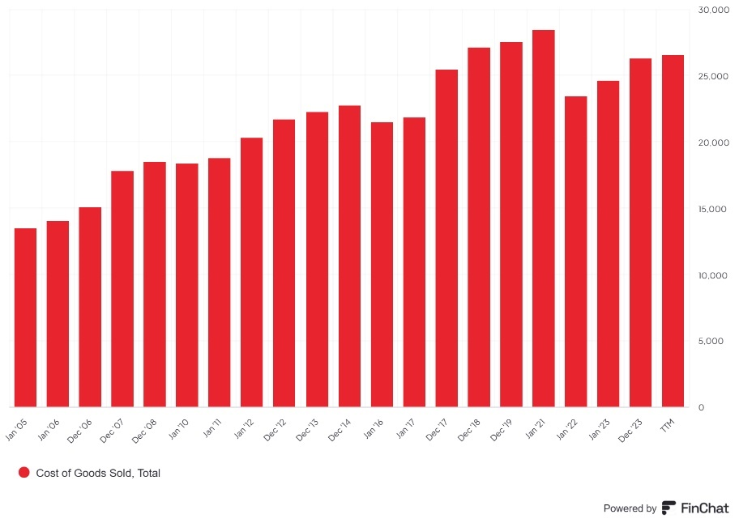

**Pricing strategy**

Johnson & Johnson (J&J) employs a multifaceted pricing strategy across its diverse product portfolio, balancing profitability, competitiveness, regulatory compliance, and value delivery. For pharmaceuticals, J&J uses value-based pricing, setting prices based on clinical efficacy and patient value, often working with healthcare payers to demonstrate cost-effectiveness. Tiered pricing addresses varying global economic conditions, while patent protection allows higher prices during exclusivity, with reductions upon generic competition. In medical devices, J&J applies cost-plus pricing, adding a markup to production costs to ensure profitability, and competitive pricing to match or undercut rivals in markets like orthopaedics. Bundling and value-added services justify premium prices, while innovation premiums are set for cutting-edge technologies. Consumer health products leverage strong brand equity for premium pricing, with promotional strategies like discounts to drive market share. Segmented pricing targets different consumer groups, offering premium and economy options. Regulatory compliance is crucial, with J&J adhering to pricing regulations globally. Market demand and competition influence pricing adjustments, while cost structure considerations ensure coverage of research, development, and manufacturing expenses. By integrating various pricing approaches, J&J balances profitability with accessibility, achieving sustainable growth and maintaining its leadership in the healthcare industry.

**Peer Comparison:**

Johnson & Johnson (J&J) is a leading player in its industry, with key peers including Pfizer, Merck, AbbVie, Medtronic, and Procter & Gamble. J&J's 2023 revenue of $86.58 billion is the highest among its peers, followed by Pfizer ($81.29 billion) and Procter & Gamble ($80.19 billion). Pfizer leads in net income with $22.02 billion, while J&J is second at $17.94 billion. J&J also boasts the highest market capitalization at approximately $450 billion, reflecting strong investor confidence. In terms of valuation, Pfizer's P/E ratio is the lowest at 10.5, suggesting it might be undervalued, whereas J&J's P/E ratio is 25.1. For dividend yield, AbbVie leads at 4.1%, with J&J offering a competitive 2.6%. Overall, J&J excels in revenue and market cap, maintaining a robust financial performance amidst strong competition.