Amazon Inc. 2017-2019

Ratio Analysis & Interpretation

- The Activity :

We first start our analysis of Amazon Inc. financial results between 2017 and 2019 by reviewing trends in its activity. In fact, from our ratios and growth rates calculations, we can observe that the two periods 2017-2018, and 2018-2019 were excellent periods of growth for the company where the first period had known exceptional increase for all indicators. Net sales had increased by 30,53% in the first period while it continued to increase by 20, 45% in the first one. This progression had been driven by a net increase in Service sales, which had been 53,43% in the first period followed by an increase of 30,03% in the second, while Product sales had improved by 19% and 13% respectively. This improvement had led to an increase by 42% in the first period in Gross profit and 22,68% in the second period, highlighting the company’s profitability. Moreover, operating expenses during same periods had increased because of increased sales, but at lower rates, showing company’s ability to control its costs of production while generating more revenues. In fact, Operating expenses had increased respectively by 26% and 19,54% which emphasizes how revenues through Service sales are profitable at controlled cots. Indeed, COGS represented a stable percentage of sales of 59% during the two periods, and hence gross profit remained at 40% improving slightly at the second period. In addition, Selling, general and administrative costs remained at 1,85% of sales and operating expenses remained at 94% leading to an operating profit around 5%, and a net profit around 4%, showing how profitability remained stable.
Therefore, company’s wealth dah increased through same periods. We can notice how current assets had improved helping the company to run smoothly its operations. We can see how much Cash holdings had improved especially during same period. Fixed assets like PPE, essential for production had improved by 26% and 17% showing that the company continues to invest to generate more revenues. Capex represented 5,77% and 6% from total sales and 21,73% and 23% from fixed assets highlighting decisions to invests each year to support its operations and development.

- Ratio Analysis 1 Interpretation:

- Liquidity:

Liquidity ratio analysis shows that Amazon maintain good financial health in short term and can easily meets its current liabilities with its more liquid assets, and that they proved they had an improving and good working capital management. Indeed, its current ratio had been higher than one in 2018 and 2019, showing that it was easy for company to finance its current liabilities and meet its short-term obligation with its current assets. The quick ratio and cash ratio was also improving through the three years and highlight that an important part
of current liabilities can be financed directly with cash holdings and the most liquid assets like receivables. In addition, Amazon had no account payables for the three years which highlights its financial health and its ability to pay out its suppliers immediately. Receivable Days shows that the company had been efficient in managing its relations to debtor clients, where this ratio remained stable over years at 27 days. 27 Days is also its inventory ratio which highlight how quickly the company is turning its inventory, which was less than a month and remained stable over years, showing how effective is the company and which help it make more effective marketing, pricing, purchasing decisions. In addition, Working Capital had improved significantly from 2017 to 2019, going from negative to a significant $8,522 Million.

Liquidity | 2019 | 2018 | 2017
Current ratio | 1,10 | 1,10 | 0,93
Quick Ratio | 0,86 | 0,85 | 0,65
Cash Ratio | 0,63 | 0,60 | 0,54
Defensive Interval | 104 | 96 | 93
Inventory Days | 27 | 27 | 33
Payable Days | 0 | 0 | 0
Receivable Days | 27 | 26 | 27
Net trading cycle | 54 | 53 | 60
Working Capital as a % of Sales | 3,04% | 2,88% | -2,26%
Working Capital | 8,522 | 6,71 | -4,015

Liquidity Ratios

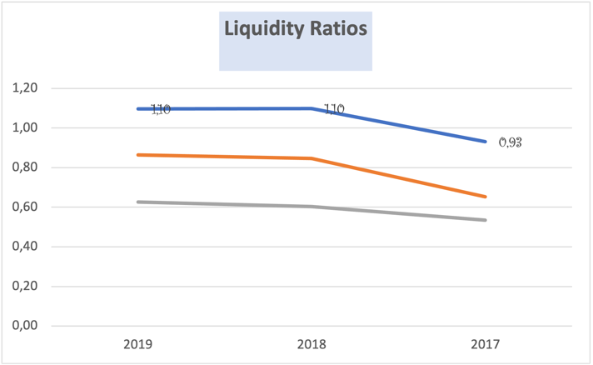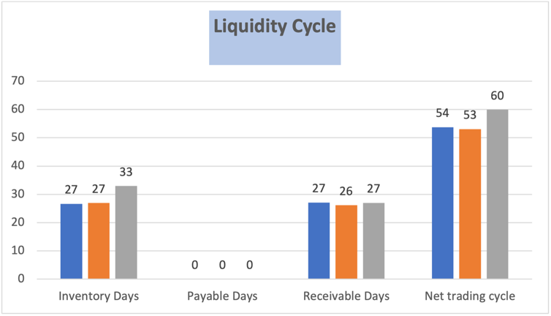

- Profitability:

Profitability ratios indicates how the company had been improving its profitability from 2017 to 2019. Gross margin almost doubled between 2017 and 2019 going from $65,932 Million in 2017 to $114,986 Million in 2019; with an EBITDA margin and EBIT margin continuously increasing to reach 14,95% for EBITDA margin. Net Margin had greatly increased and more than doubled from 2017 to 2018, and remained stable in the second period, emphasizing how efficient company was in reducing and controlling its operating costs while improving its revenues.

Profitability | 2019 | 2018 | 2017
Gross margin | 114,986 | 93,731 | 65,932
EBITDA margin | 12,95% | 11,92% | 8,76%
EBITDA | 36,330 | 27,762 | 15,584
EBIT margin | 5,18% | 5,33% | 2,31%
EBIT | 14,541 | 12,421 | 4,106
Net margin | 4,13% | 4,33% | 1,71%
Profitability Ratios

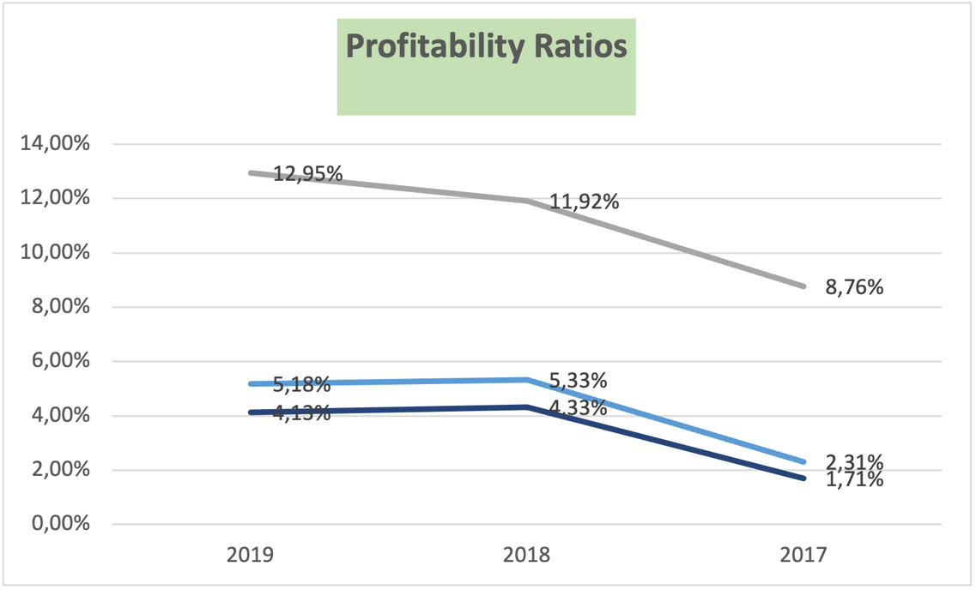

- Solvency:

Solvency ratios describe company’s capital structure and how it leverages debt to finance its operations, and also how solvent it was and able to meet its long-term obligations. Debt to equity ratio improved in the first period and then remained stable,and shows that the company had been successful in paying a considerable part of its debt. Debt to Asset ratio, which improved continuously highlights company’s wealth and its ability to meet its obligations, where total liabilities are less than its total assets. Long-term Debt to Capital shows that company started relying less in debt financing and had been meeting its obligation by reducing long term debt from its capital. Times Interest Earned and Debt Coverage emphasize how easy it could be for the company to meets in debt obligations and service and she is greatly solvent. Last, FCFE had been improving and reached $851,418 Million in 2019 highlighting total free cash flow available for equity holders.

Solvency/ debt management | 2019 | 2018 | 2017
Debt to equity (D/E) | 2,63 | 2,73 | 3,74
Debt to total assets | 0,72 | 0,73 | 0,79
Long-term debt to capital | 0,27 | 0,35 | 0,47
Times interest earned | 9 | 9 | 0
Debt coverage | 9,09 | 8,77 | 0,00
Free cash flow (FCFE) per share | 1689,32 | -443,47 | -388,10
FCFE | 851,418 | -221,737 | -191,331
Solvency/Debt Management

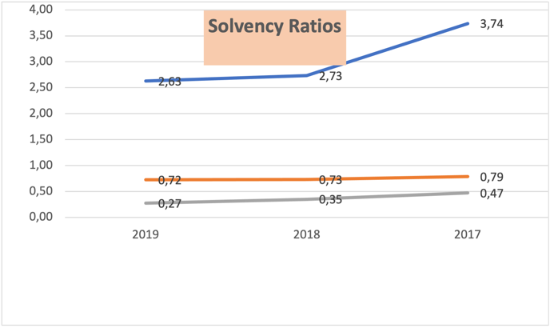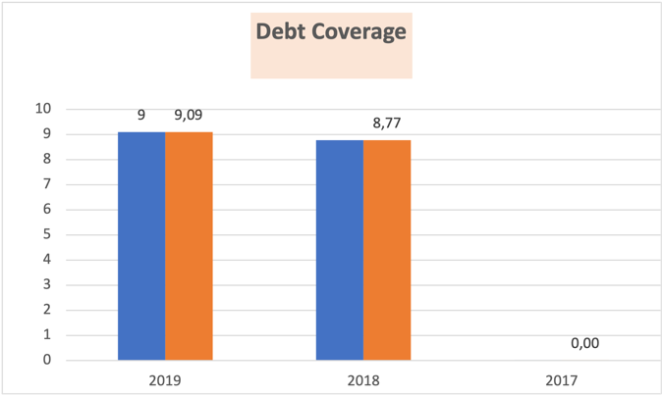

- Asset utilization:

These ratios show how efficient company had been in using its assets and fixed assets in generating increasing revenues. Fixed Asset Turnover had been continuously improving through the two periods, showing how company was becoming more and more efficient in using its assets per Dollar of sales. On the hand Total Assets had been deteriorating showing some inefficiencies in total asset’s utilization. In the same time, Return on Assets had more than doubled in the first period and then slightly lowered in the second one, but had remained robust highlighting a significant return on utilization of assets.

Asset utilization | 2019 | 2018 | 2017
Total asset turnover | 1,25 | 1,43 | 1,35
Fixed asset turnover | 3,86 | 3,77 | 3,64
Inventory turnover | 13,69 | 13,56 | 11,08
Return on assets (ROA) | 5,14% | 6,19% | 2,31%

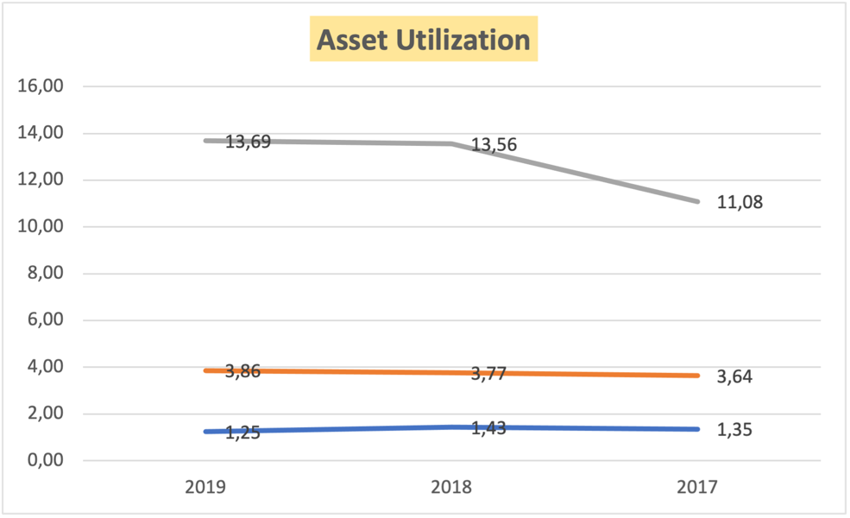

- Market Ratios:

These ratios show how company is valued by the market relatively to its book values based on its prospects and market views of its future and recent performance. Company had been valued 4 times its book value in 2019, which indicate a positive view of investors about its performance. So, while company is paying no Dividend to its stockholders, total return they had been obtaining from holding its stock came from stock price increase. Thus, Return On Equity more than doubled in the first period and then slightly lowered in the second one, reaching 18,67%, but stayed relatively high showing the important performance in the first period. ROCE had known same improvement and trend, reaching 10,58%, giving a good return to investors.

Investor/market ratios | 2019 | 2018 | 2017
Price to equity (P/E) | 4,02 | 4,59 | 15,02
Earnings per share (EPS) | 22,99 | 20,15 | 6,15
Price to book value (PBV) | 0,03 | 0,05 | 0,27
Book value per share (BV) | 123,13 | 87,10 | 56,20
Dividend payout ratio | 0,00 | 0,00 | 0,00
Dividend per share | 0,00 | 0,00 | 0,00
Dividend yield | 0,00% | 0,00% | 0,00%
Return on equity (ROE) | 18,67% | 23,13% | 10,95%
Return on capital employed (ROCE) | 10,58% | 13,18% | 5,59%
Return on assets (ROA) | 5,14% | 6,19% | 2,31%
Enterprise value to EBITDA (EV/EBITDA) | 0,93 | 1,37 | 3,19
Enterprise value (EV) | 33 886 560,00 € | 37 940 000,00 € | 49 769 270,00 €

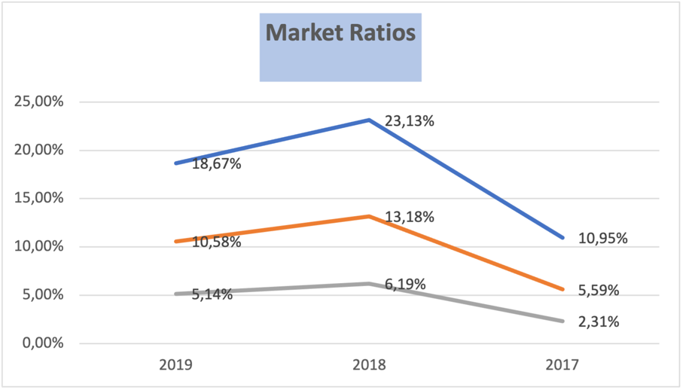

In Conclusion, Ratio Analysis then, shows that Amazon had known great development and improved performance especially from 2017 to 2018, and had continued improving its indicators and efficiency from 2018 to 2019, and that company has good prospects and very good valuation by market participants.

