**FINANCIAL HEALTH OF AMAZON INC.**

**Introduction**

This report assesses Amazon.com Inc.'s financial well-being in 2021 and 2022, focusing on five crucial areas: Liquidity, Profitability, Solvency/Debt Management, Asset Utilization, and Investor/Market Ratios. An analysis of these ratios can provide a thorough understanding of Amazon's financial performance and ability to meet both short-term and long-term obligations.

**Liquidity Ratios**

|  |  |
| --- | --- |
|  |  |

Amazon's liquidity situation has decreased, as seen by a drop in the Current Ratio from 1.14 in 2021 to 0.94 in 2022, implying that the business now has more short-term obligations than assets, raising possible liquidity difficulties. Moreover, the Quick Ratio dropped from 0.91 to 0.72, indicating greater liquidity risk owing to a reduced capacity to meet current liabilities with the company's most liquid assets. However, the Cash Ratio rose from 0.25 to 0.35, indicating a stronger immediate liquidity situation. The Defensive Interval fell from 105.77 to 81.76 days, decreasing Amazon's cushion against possible liquidity difficulties. Inventory days were stable, whereas payable days declined marginally, resulting in quicker cash outflows. Receivable Days have risen, suggesting a lengthier collecting time, which may strain

**Profitability Ratios**

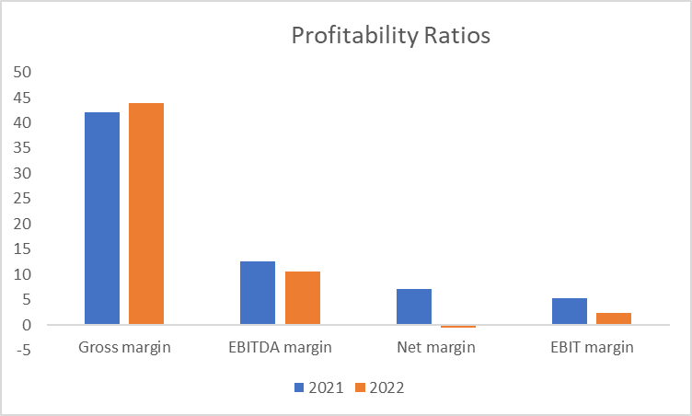

Amazon's profitability metrics show mixed results. While the Gross Margin improved slightly from 42.03% to 43.81%, reflecting better control over production costs relative to revenue, other key indicators declined. The EBITDA margin fell from 12.62% to 10.54%, indicating reduced operational efficiency. The EBIT Margin also dropped from 5.30% to 2.38%, pointing to increased operating expenses or slower revenue growth. Most concerning is the significant decline in Net Margin, which fell from 7.10% to -0.53%, indicating an overall loss in 2022 and highlighting substantial profitability challenges.

Solvency/ debt management

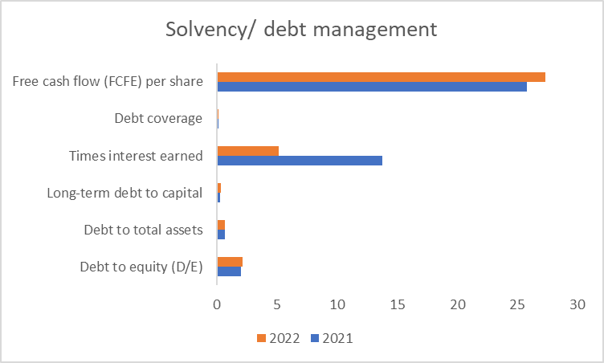

Amazon's solvency and debt management ratios point to rising financial risk. The debt-to-equity (D/E) ratio increased from 2.04 to 2.17, indicating more leverage and financial risk. Similarly, the Debt to Total Assets and Long-term Debt to Capital ratios climbed marginally, indicating a greater reliance on debt financing. The Times Interest Earned ratio fell sharply from 13.75 to 5.17, showing a diminished ability to meet interest costs. Despite these risks, Free Cash Flow (FCFE) per share increased from $25.81 to $27.35, while total FCFE rose, showing higher cash-generating capabilities.

**Asset Utilization**

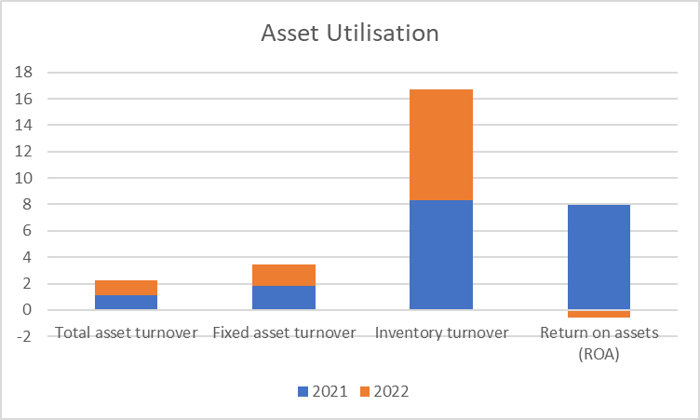

Amazon's asset utilisation metrics yield conflicting outcomes. Total Asset Turnover was practically constant, falling slightly from 1.12 to 1.11, suggesting continued efficiency in producing revenue from assets. However, Fixed Asset Turnover fell from 1.81 to 1.63, indicating that fixed assets are being used less effectively to produce revenues. Inventory turnover improved marginally, from 8.34 to 8.40, indicating excellent inventory management. The most notable worry is the dramatic decline in Return on Assets (ROA) from 7.93% to -0.59%, which indicates a loss in 2022 and poor overall asset utilisation**.**

**Investor and Market Ratios**

Amazon's investor and market ratios reflect mixed market perceptions and valuation concerns. The Price-to-equity (P/E) ratio slightly decreased, indicating continued market pessimism. Earnings per Share (EPS) fell from $3.26 to -$0.27, highlighting the company's overall loss. The Price to Book Value (PBV) ratio declined, while Book Value per Share (BV) increased, indicating growth in shareholders' equity. However, Return on Equity (ROE) and Return on Capital Employed (ROCE) both dropped, signaling weaker profitability and efficiency. The Enterprise Value to EBITDA (EV/EBITDA) ratio rose, suggesting a higher valuation relative to earnings. Despite a slight increase in enterprise value, Amazon continues to forgo dividends, opting to reinvest earnings for growth instead of distributing profits to shareholders.

|  |  |
| --- | --- |
|  |  |

**Conclusion**

Amazon.com Inc.'s financial health in 2022 faces various hurdles, compared to 2021. The firm is experiencing liquidity challenges, as indicated by a decline in current and quick ratios and a significant drop in working capital. Profitability has also suffered, with lower EBITDA and Net Margins and negative ROA and EPS.

Solvency ratios indicate growing leverage, raising worries about financial risk. Despite these hurdles, Amazon has demonstrated some encouraging trends in cash flow generation and asset utilisation, including constant inventory turnover and improved free cash flow.

Investor/market ratios show conflicting feelings, with a lower P/E ratio but a larger enterprise value, signalling market volatility and concern about future performance.