Management Report: Financial Health Analysis of Amazon Inc. (2021 & 2022)

Amazon Inc., a global leader in e-commerce and cloud computing, has significantly shaped modern retail and technology landscapes. Founded in 1994, the company has grown from an online bookstore into a multifaceted enterprise, encompassing everything from digital streaming to artificial intelligence. This report provides an in-depth analysis of Amazon’s financial health based on its financial statements from 2021 and 2022.

Liquidity Analysis

Amazon's liquidity metrics reflect some challenges in its short-term financial flexibility. The current ratio declined from 1.05 in 2021 to 0.94 in 2022, indicating a reduced capacity to cover short-term obligations and raising concerns about the company’s financial agility, particularly in a high-interest-rate environment where liquidity is crucial. Similarly, the quick ratio dropped from 0.86 in 2021 to 0.72 in 2022, highlighting a weakened ability to meet immediate liabilities, partly due to increased inventory levels as Amazon prepared for potential supply chain disruptions during and after the pandemic. However, the cash ratio saw a modest improvement from 0.33 in 2021 to 0.35 in 2022, signalling a slight increase in cash reserves relative to liabilities. This could be viewed as a positive aspect of Amazon's cash management amidst economic uncertainty. In response to these financial pressures, Amazon has been focusing on cost-cutting measures and optimizing its logistics network to enhance efficiency and liquidity. In 2023, the company has been reported to scale back on some of its physical retail stores, redirecting efforts towards its core e-commerce and cloud businesses, which aligns with its strategic focus on strengthening financial stability.

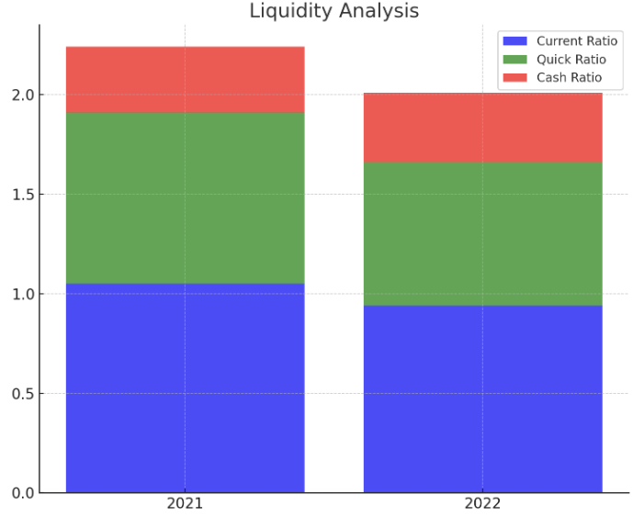

Profitability Analysis
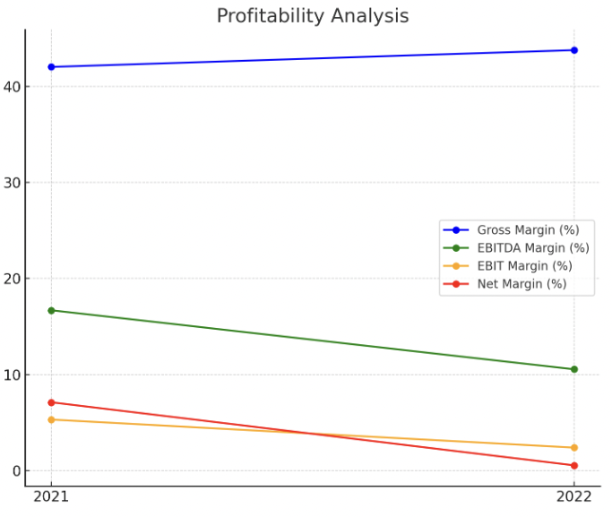
In 2022, Amazon faced notable profitability challenges despite a slight improvement in gross margin from 42.04% to 43.79%, reflecting better cost control in high-margin services like AWS. However, the EBITDA margin fell sharply from 16.69% to 10.54%, and the EBIT margin decreased from 5.3% to 2.38%, driven by rising operating expenses and supply chain disruptions. The net margin suffered the most, dropping from 7.1% to 0.53% due to increased costs, competition, and slower growth in some areas.

Recent pressures include heightened regulatory scrutiny, rising labour costs, and significant investments in cloud computing and AI, which could impact margins in the short term but aim to enhance Amazon's market position long-term.
Solvency Analysis
Amazon's solvency has shown signs of increasing strain in 2022, with several key indicators highlighting a rise in financial leverage. The Debt to Equity (D/E) ratio increased from 3.07 in 2021 to 3.23 in 2022, indicating that Amazon is relying more on debt to finance its growth. While this approach can accelerate expansion, it also introduces risk, particularly if revenue growth does not keep pace with the rising debt obligations. Similarly, the Debt to Total Assets ratio edged up from 1.01 in 2021 to 1.02 in 2022, reflecting the overall increase in debt. Although Amazon’s strong cash flow generation provides some cushion, this higher leverage could pose challenges if there is a significant downturn in cash flows.
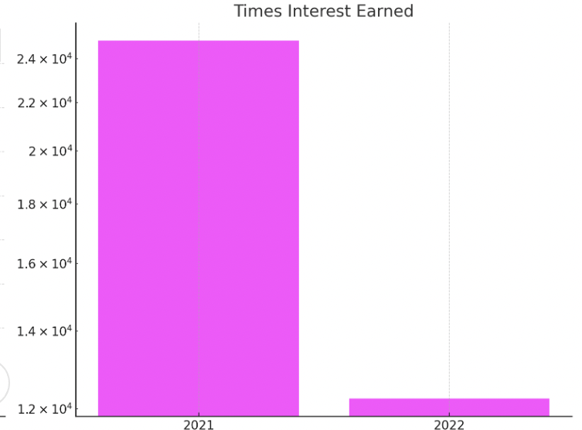
The Times Interest Earned ratio saw a significant drop from 24,879 in 2021 to 12,248 in 2022, signalling a reduced capacity to cover interest expenses. This decline suggests that Amazon's growing debt levels could strain its ability to meet interest obligations, especially if profitability continues to face pressures.
In recent developments, Amazon has been active in raising capital through the debt markets to fund its various expansion initiatives. However, with the global rise in interest rates, the cost of borrowing is increasing, which could further impact Amazon’s net income and overall financial health. The company will need to carefully manage its debt levels and interest expenses to maintain financial stability in this environment.
Asset Utilization
In 2022, Amazon's asset utilization showed mixed results. The Total Asset Turnover ratio slightly decreased from 1.12 in 2021 to 1.11 in 2022, indicating a minor decline in the efficiency of using assets to generate revenue. The Fixed Asset Turnover ratio also fell from 2.93 to 2.75, reflecting reduced efficiency in utilizing fixed assets, likely due to ongoing investments in logistics and infrastructure.
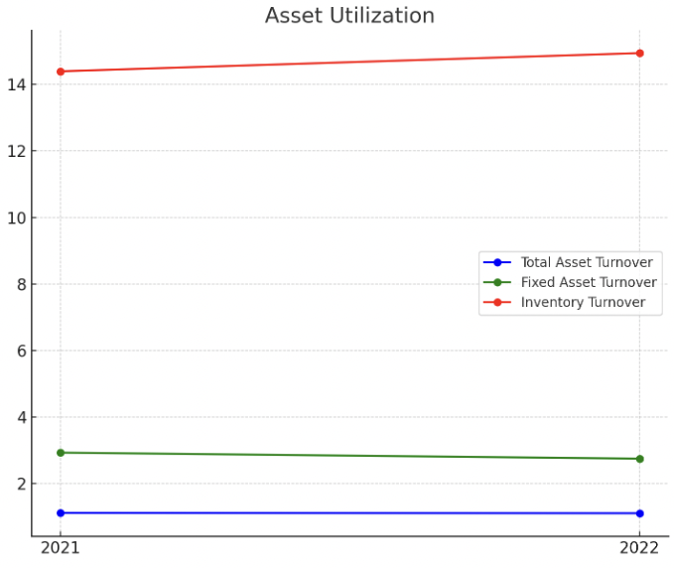
However, the Inventory Turnover ratio improved slightly from 14.39 to 14.94, suggesting better inventory management. Recent efforts to optimize Amazon's supply chain and logistics networks, along with upgrades to its delivery infrastructure, are expected to enhance asset utilization in the future
Investor/Market Ratios
Amazon’s financial metrics present a mixed picture of its recent performance. Earnings Per Share (EPS) dropped dramatically from $3.24 in 2021 to -$0.27 in 2022, reflecting a sharp decline in profitability that has likely contributed to stock price volatility. Despite this, the Price to Book Value (PBV) ratio remains relatively high, suggesting sustained investor confidence in Amazon's market valuation despite the profitability challenges. The Return on Equity (ROE) has also fallen significantly, signalling reduced efficiency in generating returns for shareholders amid rising costs and competitive pressures. Additionally, the Enterprise Value (EV) to EBITDA ratio increased from 21.05 in 2021 to 22.13 in 2022, indicating a higher market valuation relative to earnings. This uptick suggests that investors remain optimistic about Amazon's long-term growth prospects despite short-term profitability issues. Overall, while Amazon’s stock price has been volatile due to these profitability concerns, the company’s strong fundamentals and dominance in key markets like cloud computing and e-commerce continue to attract investors
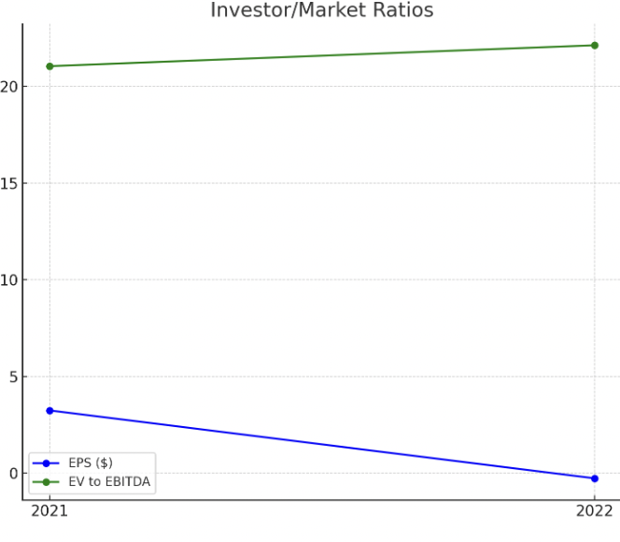
The line graph for EPS and EV to EBITDA Ratio shows a dramatic decline in EPS, while the EV to EBITDA ratio increased, reflecting market optimism despite profitability issues.

