Revenue and Cost Driver Analysis Report

1. Marriott International Inc.

Revenue Breakdown
Marriott generates revenue from various streams, primarily driven by fees from franchised and managed properties, along with revenue from owned and leased hotels.
- Management Fees:
  - Base Management Fees: Linked to hotel revenue, calculated as a percentage of revenue from properties under management. Driven by both price and volume (occupancy rates and ADR).
  - Incentive Management Fees: Driven by hotel profitability. More guests (volume) and higher room rates (price) lead to increased fees.
- Franchise Fees:
  - Franchise fees are earned from franchised hotels. These depend on the number of franchised properties (volume) and the average room rates (price).
- Owned, Leased, and Other Revenue:
  - Generated from Marriott-owned or leased hotels. Revenue growth depends on room occupancy (volume) and ADR (price).
- Cost Reimbursement Revenue:
  - Costs are reimbursed from managed properties, including salaries, wages, and hotel expenses. This represents a large portion of Marriott’s total revenue but does not contribute to operating income.
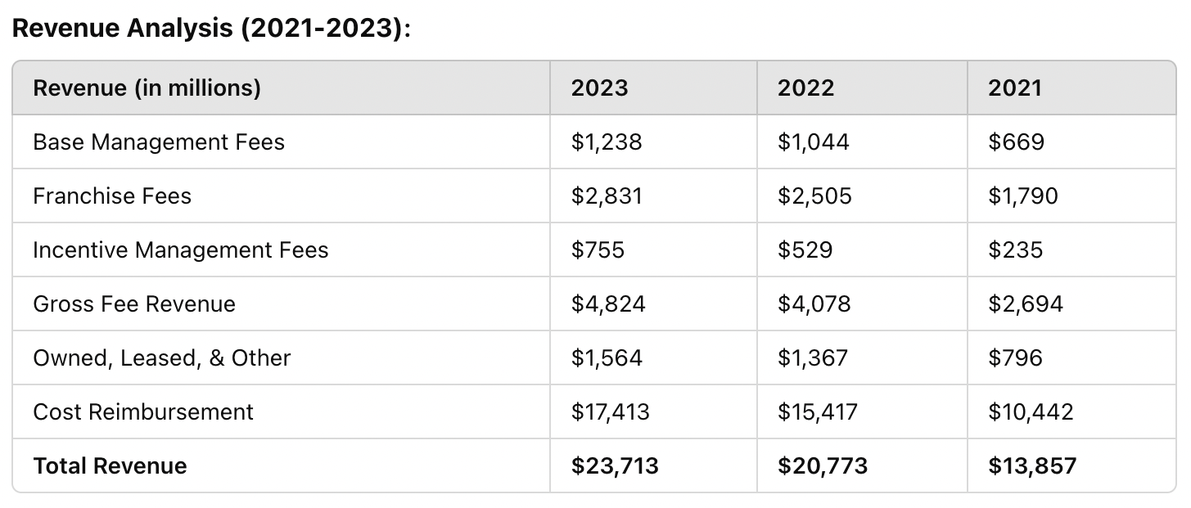

Key Revenue Drivers:
- Price (ADR): Higher average daily rates post-pandemic has contributed significantly to growth.
- Volume (Occupancy/Number of Properties): Increased demand for travel and expansion in the number of managed and franchised hotels have been crucial volume drivers.
Cost Breakdown
- Fixed Costs:
  - Depreciation & Amortization: These are fixed costs tied to Marriott’s owned assets.
  - General, Administrative, and Other: These fixed costs cover head office expenses, executive salaries, and administration, relatively stable regardless of the number of guests.
- Variable Costs:
  - Owned, Leased, and Other - Direct: Varies with occupancy and volume of guests, including costs like utilities, cleaning, and maintenance.
  - Reimbursed Expenses: Variable and proportional to the revenue generated from managed properties (salaries, wages, etc.).

Key Cost Drivers:
- Variable Costs: Increase with hotel occupancy and volume (direct hotel operations costs, reimbursed expenses).
- Fixed Costs: Depreciation and corporate expenses remain steady.
Performance Commentary:
Marriott's revenue recovery post-pandemic has been driven by higher ADR (price) and increased occupancy (volume). Franchise and management fees have grown due to the recovery in global travel. Cost reimbursement revenue dominates overall revenue but doesn’t affect net income, whereas the core fee-based revenue has grown substantially. Costs have increased proportionally with occupancy rates and hotel expansions, but fixed costs have remained stable, aiding profitability.
Peer Comparison:
- Hilton: Similar recovery trajectory, driven by price increases and higher occupancy, with a similar fee-based business model. Marriott has outpaced Hilton in terms of franchise growth.
- Hyatt: More focused on luxury and resort properties; Hyatt has seen strong recovery but lags in terms of sheer volume compared to Marriott.

2. Johnson & Johnson
Revenue Breakdown
Johnson & Johnson generates revenue primarily through three segments:
- Pharmaceuticals: The largest contributor to revenue, driven by sales of drugs like Stelara, Darzalex, and Tremfya.
- Medical Devices: Driven by surgical, orthopaedics, and vision care products.
- Consumer Health: Prior to the separation of Kenvue, J&J’s consumer health business contributed significantly to revenue.
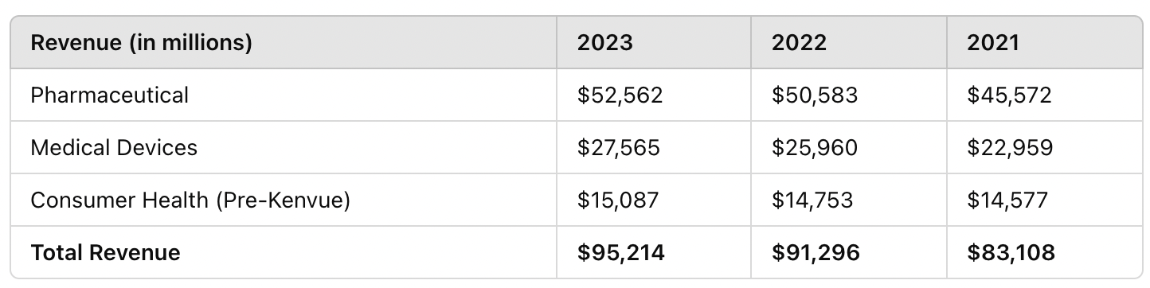

Key Revenue Drivers:
- Price: J&J’s pricing power in its pharmaceutical division is significant, driven by its strong product portfolio.
- Volume: Growth in surgical and vision care procedures as hospitals resumed normal operations post-pandemic.
Cost Breakdown
- Fixed Costs:
  - Depreciation & Amortization: Capital expenses for manufacturing facilities.
  - R&D: Johnson & Johnson has large, fixed costs tied to R&D to maintain its product pipeline.
- Variable Costs:
  - Manufacturing Costs: Vary with the production volume of pharmaceuticals and medical devices.
  - Sales and Marketing: Variable based on promotional efforts and sales commissions, especially in new product launches.

Key Cost Drivers:
- R&D: A stable, significant cost that drives future revenue by maintaining J&J’s leadership in pharmaceutical and medical device innovation.
- Manufacturing: Varies with volume but is managed efficiently as J&J scales production globally.

Performance Commentary:
Johnson & Johnson’s revenue growth has been driven by strong demand in its pharmaceutical segment and recovery in medical devices. The separation of Kenvue refocused the company on higher-margin businesses. While fixed costs such as R&D remain significant, they are necessary for maintaining leadership in innovation. J&J has maintained a healthy margin, driven by its high price realization in key drugs and the volume growth in medical devices.

Peer Comparison:
- Pfizer: Had strong revenue growth in 2021-2022 due to COVID-19 vaccine sales but has seen declines as demand tapers off. J&J’s diversified portfolio has provided steadier growth.
- Merck: Has experienced growth similar to J&J in its pharmaceutical segment, with strong contributions from its cancer drug Keytruda.

