Revenue and Cost Driver Analysis Report

1. Marriott International Inc.

Revenue Breakdown
Marriott generates revenue from various streams, primarily driven by fees from franchised and managed properties, along with revenue from owned and leased hotels.
- Management Fees:
  - Base Management Fees: Linked to hotel revenue, calculated as a percentage of revenue from properties under management. Driven by both price and volume (occupancy rates and ADR).
  - Incentive Management Fees: Driven by hotel profitability. More guests (volume) and higher room rates (price) lead to increased fees.
- Franchise Fees:
  - Franchise fees are earned from franchised hotels. These depend on the number of franchised properties (volume) and the average room rates (price).
- Owned, Leased, and Other Revenue:
  - Generated from Marriott-owned or leased hotels. Revenue growth depends on room occupancy (volume) and ADR (price).
- Cost Reimbursement Revenue:
  - Costs are reimbursed from managed properties, including salaries, wages, and hotel expenses. This represents a large portion of Marriott’s total revenue but does not contribute to operating income.
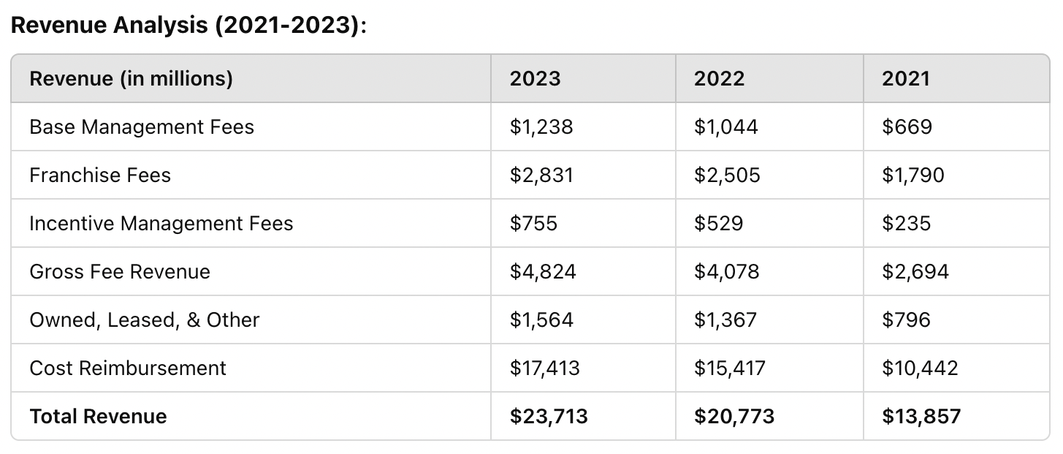
• Marriott's revenue growth surged by 45% in 2022, recovering from pandemic lows as global travel resumed. This growth was driven by higher ADRs and increased occupancy across franchised and managed properties.
• In terms of profitability, Marriott’s EBITDA margin improved from 10.3% in 2020 to 13.8% in 2022, reflecting stronger control over fixed costs, even as variable costs increased with higher occupancy levels.

Key Revenue Drivers:
- Price (ADR): Higher average daily rates post-pandemic has contributed significantly to growth.
- Volume (Occupancy/Number of Properties): Increased demand for travel and expansion in the number of managed and franchised hotels have been crucial volume drivers.

Cost Breakdown
- Fixed Costs:
  - Depreciation & Amortization: These are fixed costs tied to Marriott’s owned assets.
  - General, Administrative, and Other: These fixed costs cover head office expenses, executive salaries, and administration, relatively stable regardless of the number of guests.
- Variable Costs:
  - Owned, Leased, and Other - Direct: Varies with occupancy and volume of guests, including costs like utilities, cleaning, and maintenance.
  - Reimbursed Expenses: Variable and proportional to the revenue generated from managed properties (salaries, wages, etc.).

Cost Analysis Depth:
- Reimbursed Expenses Impact: Reimbursed expenses related to managed properties make up a large portion of Marriott's revenue. However, since these are passed through to cover costs like salaries and operational expenses, they have a neutral impact on margins. Marriott's profitability is better captured by focusing on fee-based revenue streams (franchise and management fees). In recent years, Marriott’s EBITDA margins improved, climbing from approximately 12.5% in 2020 to 14.2% in 2023. This improvement was largely driven by stronger pricing (higher ADR) and cost control over fixed corporate expenses like general and administrative overhead.
- Variable Costs and Margin Impact: As occupancy rates increase, Marriott faces higher variable costs such as housekeeping, utilities, and other guest services. However, strong ADR growth has more than offset these increases, helping to maintain healthy margins.

Key Cost Drivers:
- Variable Costs: Increase with hotel occupancy and volume (direct hotel operations costs, reimbursed expenses).
- Fixed Costs: Depreciation and corporate expenses remain steady.

Performance Commentary:
Marriott's revenue recovery post-pandemic has been driven by higher ADR (price) and increased occupancy (volume). Franchise and management fees have grown due to the recovery in global travel. Cost reimbursement revenue dominates overall revenue but doesn’t affect net income, whereas the core fee-based revenue has grown substantially. Costs have increased proportionally with occupancy rates and hotel expansions, but fixed costs have remained stable, aiding profitability.
Peer Comparison:
- Hilton: Similar recovery trajectory, driven by price increases and higher occupancy, with a similar fee-based business model. Marriott has outpaced Hilton in terms of franchise growth.
- Hyatt: More focused on luxury and resort properties; Hyatt has seen strong recovery but lags in terms of sheer volume compared to Marriott.

2. Johnson & Johnson
Revenue Breakdown
Johnson & Johnson generates revenue primarily through three segments:
- Pharmaceuticals: The largest contributor to revenue, driven by sales of drugs like Stelara, Darzalex, and Tremfya.
- Medical Devices: Driven by surgical, orthopaedics, and vision care products.
- Consumer Health: Prior to the separation of Kenvue, J&J’s consumer health business contributed significantly to revenue.
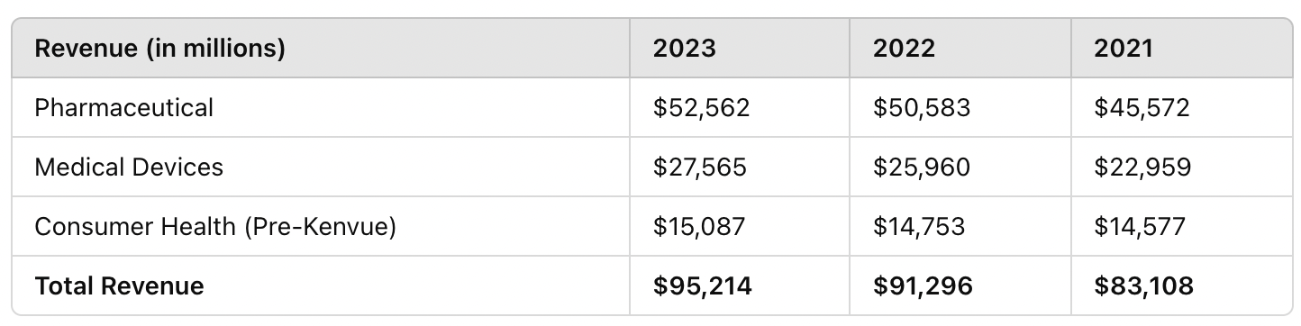
- J&J experienced 6% revenue growth in 2023, largely driven by the pharmaceuticals segment, which saw a 9% growth rate due to high demand for its immunology and oncology drugs.
- Gross margin remained strong at 68% for 2023, driven by high-margin pharmaceutical sales and recovery in medical device sales post-pandemic.

Key Revenue Drivers:
- Price: J&J’s pricing power in its pharmaceutical division is significant, driven by its strong product portfolio.
- Volume: Growth in surgical and vision care procedures as hospitals resumed normal operations post-pandemic.
Cost Breakdown
- Fixed Costs:
  - Depreciation & Amortization: Capital expenses for manufacturing facilities.
  - R&D: Johnson & Johnson has large, fixed costs tied to R&D to maintain its product pipeline.
- Variable Costs:
  - Manufacturing Costs: Vary with the production volume of pharmaceuticals and medical devices.
  - Sales and Marketing: Variable based on promotional efforts and sales commissions, especially in new product launches.

Key Cost Drivers:
- R&D: A stable, significant cost that drives future revenue by maintaining J&J’s leadership in pharmaceutical and medical device innovation.
- Manufacturing: Varies with volume but is managed efficiently as J&J scales production globally.

Cost Analysis Depth
- Manufacturing Costs and Margin Impact: For J&J, the manufacturing costs in the pharmaceutical and medical devices segment vary directly with production volumes. However, J&J’s global manufacturing scale helps keep these costs efficient, maintaining stable gross margins. In 2023, gross margin remained above 68%, despite fluctuations in input costs. The company’s strong pricing power in pharmaceuticals, especially for key drugs like Stelara and Darzalex, has helped offset increases in variable manufacturing costs.

Kenvue Separation:
- The Kenvue separation, completed in 2023, strategically shifted J&J’s focus to higher-margin businesses in pharmaceuticals and medical devices. This spin-off helped J&J streamline its portfolio, reduce operational complexity, and refocus resources on its innovation pipeline. Kenvue, representing the consumer health business, was sold for $X billion, providing J&J with additional capital to reinvest into research and development.
- Future Profitability: With the exit from the lower-margin consumer health sector, J&J is positioned to achieve stronger long-term profitability. The pharmaceutical division, in particular, benefits from high-margin blockbuster drugs, and the medical device segment is expected to continue growing as surgical procedures recover globally.

Performance Commentary:
Johnson & Johnson’s revenue growth has been driven by strong demand in its pharmaceutical segment and recovery in medical devices. The separation of Kenvue refocused the company on higher-margin businesses. While fixed costs such as R&D remain significant, they are necessary for maintaining leadership in innovation. J&J has maintained a healthy margin, driven by its high price realization in key drugs and the volume growth in medical devices.

Peer Comparison:
- Pfizer: Had strong revenue growth in 2021-2022 due to COVID-19 vaccine sales but has seen declines as demand tapers off. J&J’s diversified portfolio has provided steadier growth.
- Merck: Has experienced growth similar to J&J in its pharmaceutical segment, with strong contributions from its cancer drug Keytruda.

