**Company Overview**

Visa is one of the world’s leaders in digital payments. Our purpose is to uplift everyone, everywhere by being the best way to pay and be paid. We facilitate global commerce and money movement across more than 200 countries and territories among a global set of consumers, merchants, financial institutions and government entities through innovative technologies.

**Company’s Industry**

Visa Inc. operates in the financial services industry, specifically in the payment processing and digital payment technology sector.

**Company’s Peers**

Two close peers for Visa Inc. are

* Mastercard Inc. (MA)
* American Express Co. (AXP)

The company operates in a highly competitive landscape, directly rivalling major players like Mastercard and American Express. Additionally, it faces intense competition from various other entities, including:

* Local and regional payment networks
* Alternative payment providers
* Real-time payment (RTP) networks
* Digital wallet providers
* Payment processors
* New flows providers
* Value-added service providers
* These diverse competitors pose significant challenges to the company's market position and growth prospects.

The following chart compares our network with these network competitors for calendar year 2022

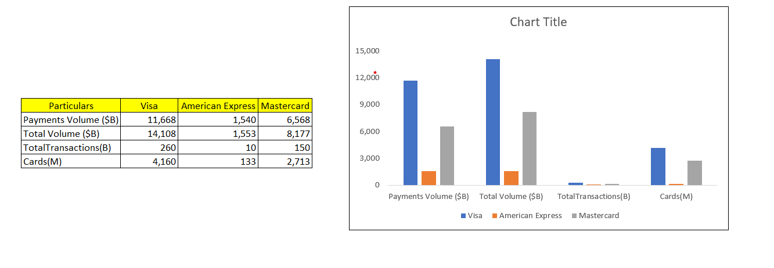

**Substitute and New Markets**

**Consumer Payments:** Visa continues to focus on growing digital commerce by connecting buyers and sellers globally with safe, simple, and innovative digital payments solutions.

**New Flows**: The company is expanding its network to capture new sources of money movement through card and non-card flows for consumers, businesses, and governments.

**Value Added Services**: Visa is diversifying its revenue with products and solutions that differentiate its network, deepen client relationships, and deliver innovative solutions across other networks

**Cryptocurrencies:** Digital currencies like Bitcoin and Ethereum offer an alternative to traditional payment methods. They provide decentralized, peer-to-peer transactions without the need for intermediaries like Visa.

**Fintech Companies:** Fintech firms such as Stripe and Adyen provide innovative payment solutions, often with lower fees and more flexible integration options for businesses.

**New Markets for Visa Inc.**

**Emerging Markets:** Regions like Africa and Southeast Asia present significant growth opportunities due to increasing digital payment adoption and economic development.

**Digital Wallets and Payment Apps:** The rise of digital wallets and payment apps, such as Google Wallet and Apple Pay, opens new avenues for Visa to integrate its services and expand its user base.

**Real-Time Payments:** The push towards real-time payments and banking is a growing trend that Visa is capitalizing on to enhance transaction speed and convenience.

**Tokenized Payment Credentials:** The acceleration of digital wallets with tokenized payment credentials is another area where Visa is innovating to stay ahead of the competition