**Visa Inc**

**Company Overview**

Visa is one of the world’s leaders in digital payments. Our purpose is to uplift everyone, everywhere by being the best way to pay and be paid. We facilitate global commerce and money movement across more than 200 countries and territories among a global set of consumers, merchants, financial institutions and government entities through innovative technologies.

**Company’s Industry**

Visa Inc. operates in the financial services industry, specifically in the payment processing and digital payment technology sector.

**Company’s Peers**

Two close peers for Visa Inc. are

* Mastercard Inc. (MA)
* American Express Co. (AXP)

The company operates in a highly competitive landscape, directly rivalling major players like Mastercard and American Express. Additionally, it faces intense competition from various other entities, including:

* Local and regional payment networks
* Alternative payment providers
* Real-time payment (RTP) networks
* Digital wallet providers
* Payment processors
* New flows providers
* Value-added service providers
* These diverse competitors pose significant challenges to the company's market position and growth prospects.

The following chart compares our network with these network competitors for calendar year 2022

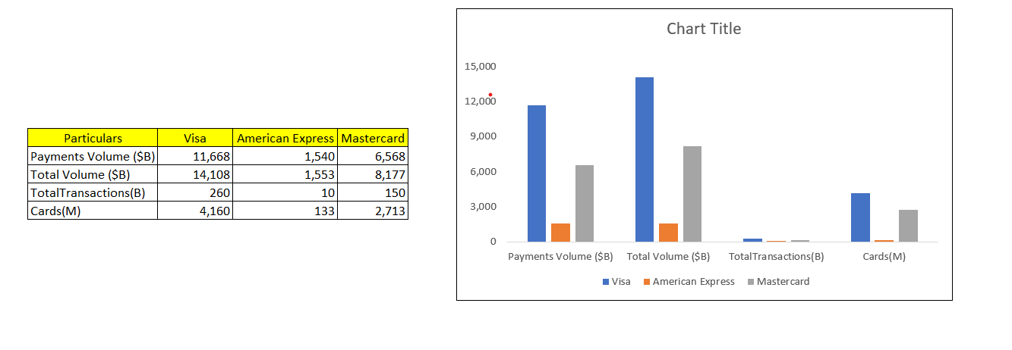

**Substitute and New Markets**

**Consumer Payments:** Visa continues to focus on growing digital commerce by connecting buyers and sellers globally with safe, simple, and innovative digital payments solutions.

**New Flows**: The company is expanding its network to capture new sources of money movement through card and non-card flows for consumers, businesses, and governments.

**Value Added Services**: Visa is diversifying its revenue with products and solutions that differentiate its network, deepen client relationships, and deliver innovative solutions across other networks

**Cryptocurrencies:** Digital currencies like Bitcoin and Ethereum offer an alternative to traditional payment methods. They provide decentralized, peer-to-peer transactions without the need for intermediaries like Visa.

**Fintech Companies:** Fintech firms such as Stripe and Adyen provide innovative payment solutions, often with lower fees and more flexible integration options for businesses.

**New Markets for Visa Inc.**

**Emerging Markets:** Regions like Africa and Southeast Asia present significant growth opportunities due to increasing digital payment adoption and economic development.

**Digital Wallets and Payment Apps:** The rise of digital wallets and payment apps, such as Google Wallet and Apple Pay, opens new avenues for Visa to integrate its services and expand its user base.

**Real-Time Payments:** The push towards real-time payments and banking is a growing trend that Visa is capitalizing on to enhance transaction speed and convenience.

**Tokenized Payment Credentials:** The acceleration of digital wallets with tokenized payment credentials is another area where Visa is innovating to stay ahead of the competition

**Revenue and Cost drivers**

**Revenue Drivers**

* Payments Volume: Visa's net revenues are significantly driven by the total payments volume processed on its network. For FY 2023, the payments volume was $12.3 trillion, up from $11.6 trillion in FY 2022.
* Transaction Volume: The number of transactions processed on Visa's network also plays a crucial role. In FY 2023, Visa processed 212.6 billion transactions, an increase from 192.5 billion in FY 2022
* Card Growth: The number of Visa-branded cards issued globally contributes to revenue growth. As of FY 2023, there were 4.3 billion Visa cards issued, up from 4.0 billion in FY 2022
* Geographic Expansion: Visa's revenue is also driven by its expansion into new markets and regions, facilitating global commerce and money movement across more than 200 countries and territories.
* Innovative Products and Services: Visa's core products—credit, debit, and prepaid cards—along with value-added services like tokenization and tap-to-pay, contribute to revenue growth.

**Cost Drivers**

* Operating Expenses: Visa's operating expenses are a major cost driver. For FY 2023, operating expenses were $11.653 billion, up from $10.497 billion in FY 2022.
* Technology and Security: Investments in technology and security to maintain and enhance the payment network are significant cost drivers. This includes expenses related to fraud prevention, cybersecurity, and maintaining the infrastructure.
* Marketing and Promotion: Visa spends on marketing and promotional activities to attract new customers and retain existing ones. This includes advertising, sponsorships, and promotional campaigns.
* Employee Compensation: Salaries, benefits, and other employee-related expenses are a substantial part of Visa's operating costs
* Regulatory Compliance: Costs associated with complying with various regulatory requirements and legal obligations also contribute to Visa's expenses.

**Current industry/market trends in relation to the revenue and cost drivers**

***Revenue Elements***

* Growth of Digital Payments: The continued adoption of digital payments across the globe is serving as a revenue growth engine. Maintaining consistent trends, the expenditure on e-commerce both domestic and international has not weakened, even with the mitigation of the effects of the pandemic.
* Revolution in Payment Processing: Real-time payment systems are gaining traction. There is an increasing expectation from consumers and businesses for instant settlement of payment transactions and this is where Visa has an advantage.
* Growth of Digital Wallets and Tokenization Payment: Another leading trend is the rise of deployment of digital wallets and tokenized payment credentials. This increases security and ease of use to the clients’ which results in more transactions being done.
* Buy Now, Pay Later (BNPL): The buy now pay later trend is likely to persist, causing over-indexation on the growth of lending sectors not backed by collateral. It is estimated that the gross merchandise volume will reach $1 trillion in the year 2025.
* Cross Border Transactions: There has been a substantive rise in Cross border volume parameters encapsulating out of Europe intra-business. This is due to the expansion of global trade and tourism which in turn drives revenues for Visa.

***Cost Elements***

* Expenditure on Systems and Security: The firm does not only care for the budget aimed at enhancing reservation systems but also security and technology in a bid to expand its payment processing network. This includes expenses incurred in enhancing security against fraud and cyber-attack in addition to maintaining the current infrastructure in place.
* Expenditure Incurred Due to Enforcement: Operating expenses are still high as the enterprises that engage in the payment processing business are subject to a number of legal compliance requirements.
* Taking Care of Marketing - Advertising And Public Relations: This can be advertising or it can be organizing and managing events or just putting something for sales, all geared towards increasing the changes for more business opportunities in Visa services.
* Salaries: A large part of the operating costs incurred by the visa services sector is on salary, provision of employee benefits and other human resources management expenditures needed to run the organization.

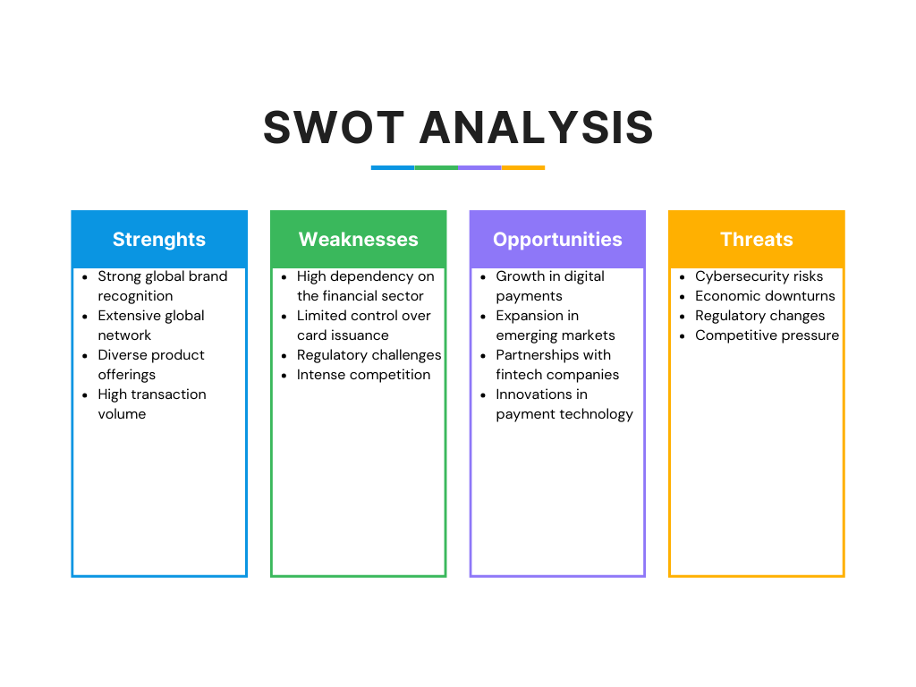

|  |  |  |  |  |  |
| --- | --- | --- | --- | --- | --- |
| **Political** | **Economic** | **Social** | **Technological** | **Environmental** | **Legal** |
| Government regulations | Economic stability | Consumer behaviour | Technological advancements | Environmental sustainability | Compliance requirements |
| Trade policies | Interest rates | Demographic shifts | Digital transformation | Carbon footprint | Data protection laws |
| Political stability | Inflation rates | Lifestyle changes | Blockchain technology | E-waste management | Anti-money laundering laws |

**Competitive Environment, Performance Evaluation, & Key Strategies**

**Mastercard**: Mastercard, the main rival of Visa, functions a payment network like Visa does, and offers similar services in the areas of digital wallets, cybersecurity, and so on. Mastercard has experienced a steady rate of growth, concentrating on broadening its scope and the alliances it forms. Mastercard continues to innovate its offerings incorporating digital wallets, cyber security, real time payments so as to retain its market share.

**American Express:** Popular for its exclusive offers and passionate memberships, American Express primarily avails herself to the high earning individuals and business entities. American Express defined region has additional overlap with premium services and offers to corporates, but has lower gross transaction volume in comparison to the two payment networks, Visa and Mastercard. American Express is looking to improve its premium services while also growing the number of corporate clients.

**Apple Pay and Google Wallet:** These activities are based on smartphones as they have become popularly acceptable among every user therefore most people engage in payments with no much pressure. Mainly due to the high penetration of mobile phones, it presents these digital wallets as smart payment devices. These digital wallets are connecting with more merchants and improving their services to attract more consumers respectively.