



**2020-2022**

**Apple Inc.**



1. **Liquidity Ratios**

* 1. **Current Ratio**

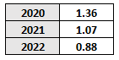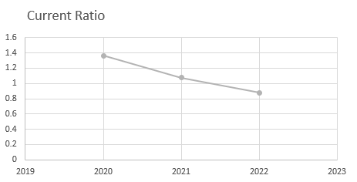

As per the values from the period between 2020 to 2022 shows, it is possible so analyse that the current ratio is in a downtrend and falling under 0, meaning that the company is losing the ability to cover their short-term liabilities compared with the current assets. In the Latest report year, it is possible to see that the current ratio is 0.88 meaning that they might be having liquidity issues.

* 1. **Quick Ratio**

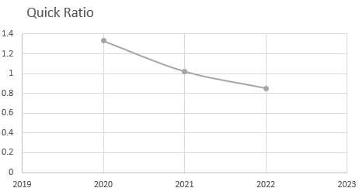

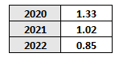

The quick ratio is implying the same as the current ratio showing that the company might struggle to pay off its short-term obligations.

* 1. **Cash Ratio**

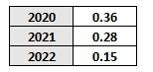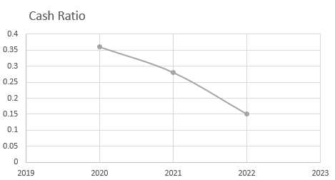



As per the Cash ratio, it is possible to analyse also a decrease, showing that the quantity of Cash and Cash equivalents represents/has the capacity to liquidate only 15% in 2022 of the company’s current liabilities compared with 36% back in 2020.

* 1. **Key insights from Ratios**

At a first glance, through the ratios it is possible to analyse that the company has weakened its position towards liquidity which increases its financial risk in terms of meeting the short-term obligations.

Therefore, this could mean that the company is having cash-flow issues, it is using its liquidity position to generate more capital in the foreseeable future.

In a financial point of view, it is advisable to keep a Current and Quick ratio Closer to 1.0 meaning that the company would be able to meet any obligations in the short-term and a Cash ratio closer to 0.5. However, as these indicators only show information regarding current positions, they could be managed by a reduction in the number of inventory days and receivable days and, and increase of payable days. Which, would increase the ability of the company of generating capital and also delay the payments to its suppliers, making their position more liquid in terms of cash.

There are also other options such as reducing the amount of current liabilities by liquidating assets, reducing dividends, transform it in non-current liabilities and others. However, if not managed properly, this could affect future revenues, reduction of production, increase of cost of sales, difficulty to acquire additional financing in the future.

* 1. **Inventory Days**

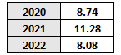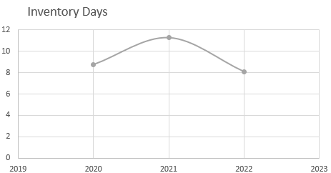

It is possible to analyse that the company has increase its capacity to turnover inventory has there was a decrease of 3.20 days regarding the previous year. This means that the company became of efficient in terms of sales.

* 1. **Payable Days**

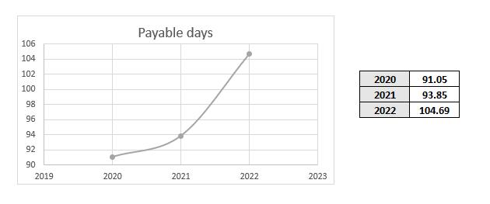

It is possible to verify with the data that the company has been able to increase their payable days, meaning that they have more time to pay the suppliers. It has increased almost 11 days in comparison with the previous year. This could mean that they are applying certain strategies or improved their power of negotiation to increase their working capital.

* 1. **Receivable Days**

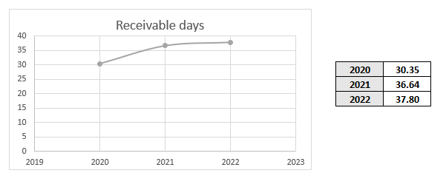

The receivable days are increasing, meaning that they are taking longer to receive the conversion of products and services sold. From 30.35 to 37.80 in 2020 to 2022, respectively, meaning that there is a delay of over 20% on time. Payments systems via credit towards the company, an ease on their credit terms and a default on credit payments toward their products could cause this increase.



* 1. **Net Trading Cycle**

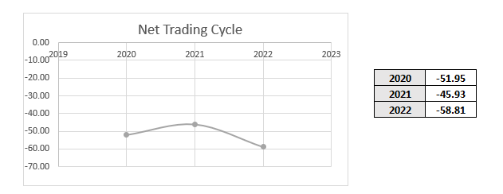

They were able to reduce their Net trading cycle even further. From - 51.95 to -58.81 in 2020 to 2022 respectively. Meaning that they have over 58.81 days to pay the suppliers after receiving the cash from sales. Low the number of Net Trading cycle, better as companies have a better cash flow management.

* 1. **Working Capital as a % of Sales**

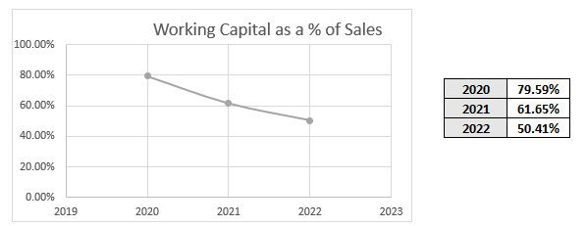

Regarding these values, we can see a downtrend from 79.59% until 50.41% which could mean that the company as previously addressed in the insights (1.4.) is having some liquidity issues, however it could also mean that they were able to convert part of their working capital not as dependent of Sales but also from other type of investments.

* 1. **Cycle days and Working Capital Insights**

Through out the numbers, it is possible to see an improvement on their position towards inventory and payable days, meaning that the company is in a better position in terms of cash flow management.

However, their working capital could be showing some liquidity issues or independence from sales. A further analyse regarding this might be needed in order to be able to check all details.



1. **Profitability Ratios**

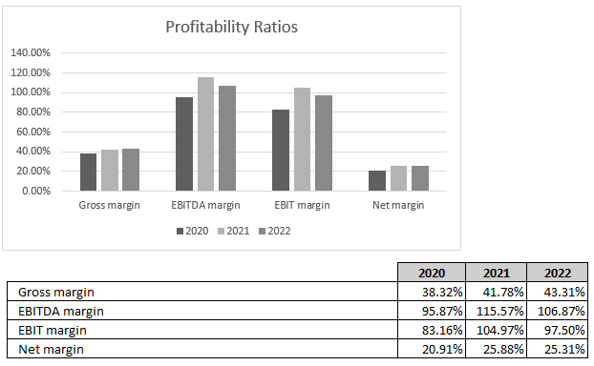

* 1. **Gross Margin**

The company is showing an increase of over 5% on their Gross Margin since 2020. Meaning that the company has became more efficient in terms of production or has readjusted their equilibrium point depending on the elasticity of their products.

* 1. **EBITDA Margin**

The company had a reduction from 2021 to 2022 from 115.57% to 106.87% meaning that the company has reduced their operation efficiency and cost management comparing with the previous year.

* 1. **EBIT Margin**

Same situation is showing on this indicator, there was a reduction from 2021 to 2022 of over 7%. Meaning that they are not as efficient in controlling their operating expenses with comparison with the previous year. However, the company is still in a good position.

* 1. **Net Margin**

Net Margin have a minor decreased close to 0.5% in comparison with the previous year. Values are showing as normal.



**3.0. Solvency/Debt Management**

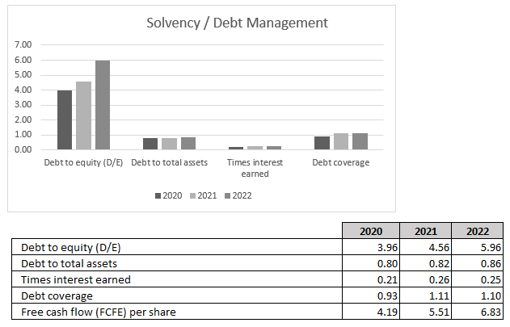

**3.1. Debt to equity (D/E)**

The Debt to equity ratio has increase in 2.0 units from 2020 to 2022 suggesting that the company has increased its financial risk. This suggest that the company is less stable financial which could lead to higher returns or losses depending how it is managed.

**3.2. Debt to total assets**

Apple has increased by 0.06 units from 2020 to 2022, meaning that the company has a lower risk of solvency and it has strengthen its position regarding this.

**3.3. Long-term debt to capital**

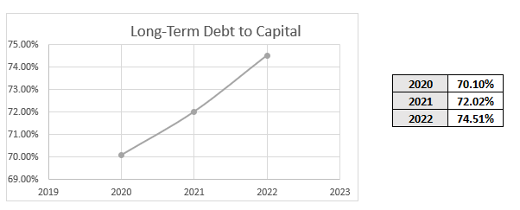

In terms of Long term debt, it is possible to see that the company has increased by 4.41% compared with 2020, meaning that the company is seeking a long term financial strategy. By increasing, this could increase their liquidity ratios, which weakened over the last years.



**3.4. Times interest earned**

From 2020, the company has increased massively their times interest earned by almost 50%. Meaning, that the company as a much better position to grow and meet its interest obligations.

**3.5. Debt coverage**

The company has increased their ability to service its debt obligations using operating income as it is reflected in its debt coverage ratio. This is possible to see on an increase from 2020 until 2021 (0.93 to 1.11) and a steady value from 2021 to 2022 (1.11 to 1.10).

3.6. Free cash flow (FCFE) per share

The free cash flow per share has increased over this 3 year (2020 to 2022) which means that the company enhanced its position to generate cash for Shareholders after meeting all its financial needs.

Regarding the previous Debt management ratios, it is possible to see that the company is operation prudently regarding its debt levels. Cash flow metrics are increasing while long term debt to Capital is also increasing. Therefore, they are leveraging their position for the future.

This means, that if this strategy is applied successfully, they will be able to increase their shareholder value.

**4.0. Asset Utilization**

**4.1. Total Asset Turnover**

The total asset turnover ratio has consistently improved over the past three years, indicating the company's growing efficiency in utilizing its assets to generate sales. This upward trend reflects enhanced asset utilization and operational efficiency.

**4.2. Fixed Asset Turnover**

The fixed asset turnover ratio has also shown steady growth, signifying that the company is generating more sales for every unit of fixed assets. This trend points to better efficiency in the use of property, plant, and equipment.

**4.3. Inventory Turnover**

The notable increase in 2022 suggests a significant improvement in the company’s inventory management, with inventory being sold and replenished more quickly. This could be a sign of stronger product demand or more efficient supply chain management.



**4.4. Return on Assets (ROA)**

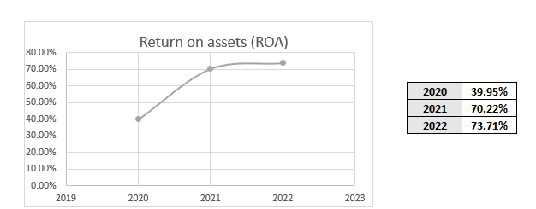

The consistent rise in ROA indicates that the company is becoming more profitable in relation to its total assets, highlighting improved efficiency in converting assets into profits.

**4.5 Insights of Asset Utilization**

In summary, the financial metrics analysed above paint a positive picture of the company’s operational efficiency and strategic effectiveness. The consistent improvements in total asset turnover, fixed asset turnover, inventory turnover, and return on assets collectively highlight a robust performance trajectory. These trends suggest that the company is not only increasing its sales but is doing so in a manner that optimizes asset utilization and enhances profitability. Such developments are fundamental for ensuring competitive advantage and positioning the company for future growth in a dynamic market environment. As the company continues to build on these strengths, it may further enhance its operational strategies to drive even greater efficiency and profitability in the years to come**.**

**5.0. Investor Market Ratios**

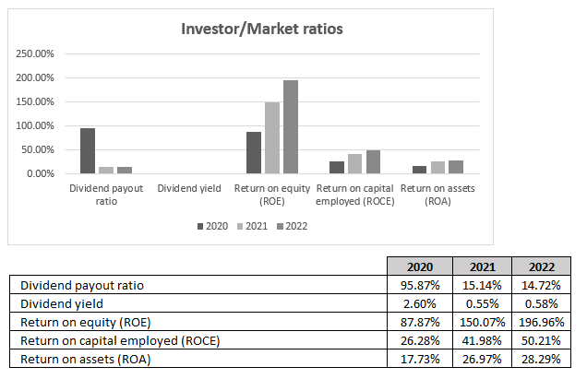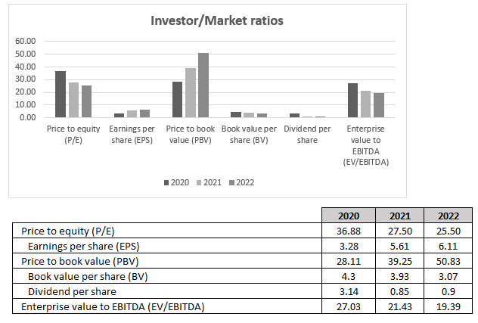

The company's profitability is on the rise, as indicated by the increasing earnings per share (EPS). The declining price-to-earnings (P/E) ratio, along with the rising EPS, suggests that the growth of the stock price is not keeping up with earnings growth. This situation could make the stock more appealing to value investors looking for opportunities.



Additionally, the increasing price-to-book value (PBV) ratio reflects strong market confidence in the company, though it also raises concerns about potential overvaluation. Together, these factors indicate that the company is demonstrating improving fundamentals and may be approaching a fair valuation in the market.

The combination of a decreasing P/E ratio and an increasing PBV suggests the need for the company to strike a balance between growth and market expectations. It is essential to communicate the company’s value proposition clearly to investors to enhance understanding and foster confidence in its future potential.

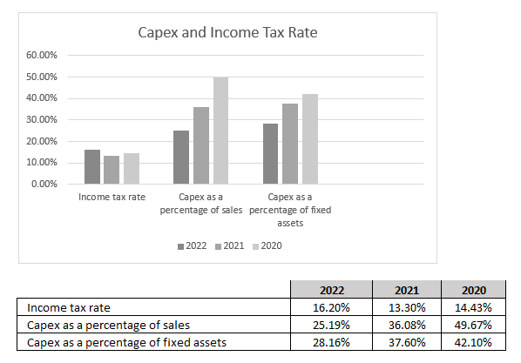**6.0. Margins as a % of Net Sales**

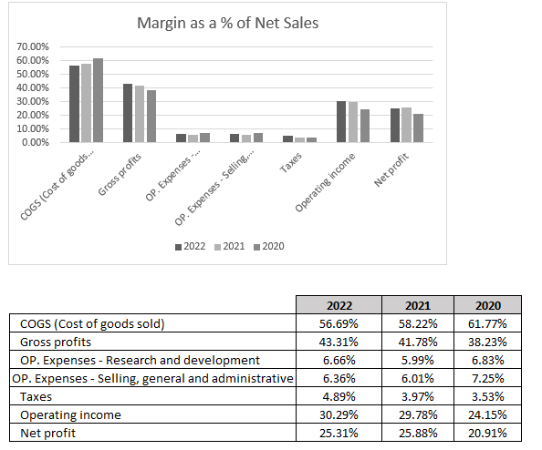

The company has effectively lowered its cost of goods sold (COGS) and selling, general, and administrative (SGA) expenses. It is essential to sustain this emphasis on efficiency to further enhance profitability.

Consider increasing investment in research and development (R&D) to foster innovation and stay competitive, especially since R&D spending has remained relatively stable despite improvements in other metrics.

Examine the factors leading to fluctuations in the tax rate and seek opportunities for consistent tax optimization.

Utilize the strengthened financial position to pursue new market opportunities or invest in initiatives that can support sustainable long-term growth.

Despite the positive trends in metrics, it is crucial to continue monitoring and controlling expenses to uphold the improvements in profitability.