**Marriott International Inc.**

PVM analysis

*Revenue drivers:*

Room price = price

Number of rooms = units – number of rooms

Room occupancy rate = occupancy rate - % of rooms sold

*Cost drivers:*

*Fixed-*

Admin. and general

* Mortgage/rent
* Property taxes
* Property insurance
* Labour
* Utilities

Depreciation and amortization

* Intangible assets (leases)
* Maintenance/repair/renovations

CapEx

Marketing

*Variable-*

Housekeeping/laundry

Guest amenities

Maintenance/repair (wear and tear)

|  |  |  |  |  |  |  |  |  |  |  |  |  |  |  |  |
| --- | --- | --- | --- | --- | --- | --- | --- | --- | --- | --- | --- | --- | --- | --- | --- |
|  | **2022** | | | | | **2023** | | | | |  | **=2023-2022** | | | |
| **Revenue drivers** | **Revenue ($m)** | **Units**  **(no. of rooms)** | **Occupancy rate**  **(% of rooms sold)** | **Price** | **Mix** | **Revenue ($m)** | **Units**  **(no. of rooms)** | **Occupancy rate**  **(% of rooms sold)** | **Price** | **Mix** | **Mix difference** | **Price impact**  **($m)** | **Units impact**  **($m)** | **Occupancy rate impact**  **($m)** | **Mix impact**  **($m)** |
| US & Canada | 15,753 | 983,251 | 67% | 16,021 | 64.46% | 17,696 | 998,470 | 69.8% | 17,723 | 62.51% | -1.95% | 1,699 | 138 | 495 | (106) |
| International | 3,486 | 542,156 | 57% | 6,430 | 35.54% | 4,455 | 598,910 | 67.9% | 7,439 | 37.49% | 1.95% | 604 | 172 | 486 | (193) |
| **Total** | **19,239** | **1,525,407** | **64%** | **12,612** | **100%** | **22,151** | **1,597,380** | **69.2%** | **13,867** | **100%** | **0.0%** | **2,005** | **310** | **981** | **(299)** |

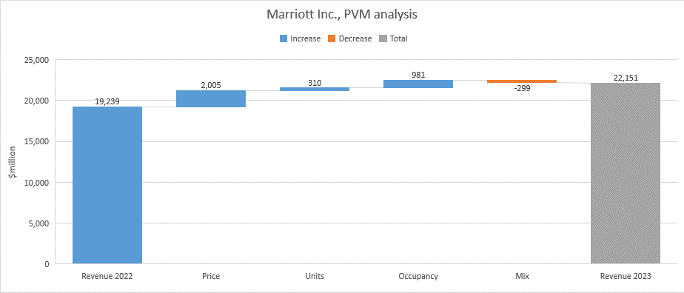

* Revenue is up $2,912 million in 2023 vs 2022.
* The main driver was price increase followed by the increase in room occupancy rates, with negative unit mix driving price per unit down.

Positive drivers were:

* $2,005 million from room price increase
* $981 million from higher room occupancy rates
* $310 million from new units coming on board

Negative driver was:

* $299 million due to drop in price per room rates
* The price increase is largely attributable to the US&Canada markets, although the international segment also contributed.
* More units came on live internationally but at a lower price point per unit as it is exhibited in the lower negative unit mix compared to the home market and Canada.
* The US&Canada segment also show a negative unit mix and considering the main revenue driver was price increase, it would be interesting to see which Tier/s within the two segments achieved a higher price per unit rate growth and which Tier/s had to drop prices.
* It would also be interesting to see the Tier of the new units as the proportions of each could affect revenue drivers.
* The occupancy rates are nearly identical in the two segments and growing meaning Marriott’s pricing strategy is working.
* It could be a mix of achieving higher room rate in the luxury and premium Tiers whilst exhibiting lower rates in the lower Tiers.

The revenue driver numbers are looking good however it must be noted that 2022 was still the back end of the COVID pandemic which seriously affected travel. The world opening up from 2023 and travellers returning could have been a major factor in the attractive 2023 numbers, especially in the international segment occupancy rates. This segment was more affected by the restrictions of international travel.

Cost drivers analysis ………………………………………………………………….

**Marriott Inc. peer group comparison (Hilton Inc., Intercontinental Group Plc., Hyatt Inc.)**

Basis for comparison:

1, Profitability: Revenue growth 2022 vs 2023, Gross profit margin 2023, EBITDA margin 2023, Net income margin 2023.

2, KPIs: Occupancy rate, Average Daily Rate, Revenue Per Available Room.

|  |  |  |  |  |
| --- | --- | --- | --- | --- |
| **2023** | **Marriott** | **Hilton** | **Intercontinental Group** | **Hyatt** |
| Revenue growth 2022vs2023 | 14.16% | 16.67% | 18.81% | 13.17% |
| Gross profit margin | 21.61% | 28.63% | 30.67% | 19.75% |
| EBITDA margin | 67.78% | 54.65% | 28.42% | 10.52% |
| Net income | 13% | 11.15% | 16.22% | 3.3% |
| System-wide occupancy | 69.2% | 71.8% | 67.6% | 69% |
| System-wide ADR ($) | 180.24 | 158.62 | 126.78 | 204.07 |
| System-wide RevPAR ($) | 124.70 | 113.90 | 85.68 | 141 |

* Revenue growth follows a similar pattern across the group.
* Gross margin figures are somewhat higher for Hilton and IC potentially indicating higher efficiency on COGS and direct labour costs.
* One of the most widely followed and quoted profitability ratios in the industry, EBITDA margin is way ahead of the group for Marriott, followed by Hilton with the other two at distinctively lower figures. It indicates significantly higher asset depreciation and amortization for Marriott and Hilton (asset rich).
* Net margin is again similar across the group, Hyatt is the only one lagging behind.
* Marriott and Hilton seem to be asset rich businesses however Intercontinental manages higher return on less assets and exhibit the best revenue growth and profitability ratios within the group.
* Hyatt is achieving the highest income per available rooms followed by Marriott and Hilton. IC is lagging in this regard within the group.
* Average daily rate exhibits the same pattern as RevPAR.
* Occupancy rates seem scattered by looking at the chart however the percentage differences are small and can be said that it is very similar across the group.
* What is interesting to see is that IC exhibit better profitability ratios with lower KPI figures than the rest of the group. It can mean that if the income side is weaker – although revenue increased most for IC – the expenditure side must be well controlled to achieve better profitability against the peers.