Apple Report

(Notes: all increases/decreases in growth rates will be stated as their respective CAGR rates unless stated otherwise. Large or multi-decimal values will be rounded.)

**Liquidity Ratios:**

**Current, Quick, Cash Ratios**

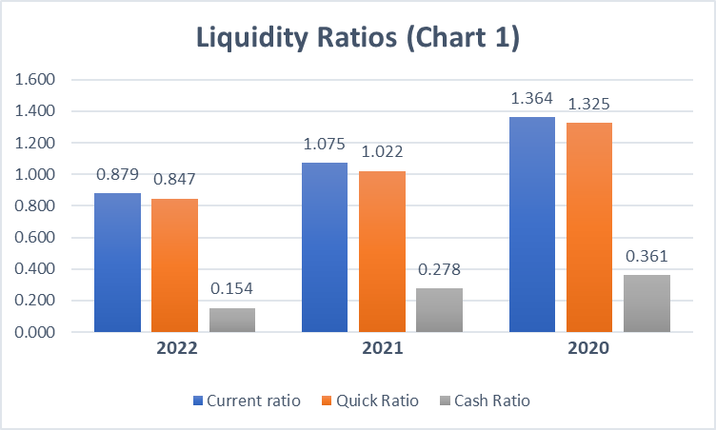From 2020 to 2022, Apple’s current, quick, and cash ratios all show a downward trend. This is due to a large increase in Accounts Payable (14.87%) and Other Current Liabilities (12.54%), increasing Total Current Liabilities which is outpacing Total Current Assets, lowering the current ratio year-over-year.

The quick ratio mostly stays in line with the movement of the current ratio as inventory does not play a significant role in Total Current Assets. The cash ratio has been decreasing mostly because of a combination of increasingly larger share repurchases ($72.4 million in 2020, $86 million in 2021, $89.4 million in 2022), and less income from maturing/selling marketable securities. While marketable security purchases have gone down ($114.9 million in 2020 to $76.9 million in 2022), the income from maturing securities as well as the ability to sell them if need be, has decreased by a larger margin which has decreased cash flow overall. These ratios seem to indicate; One, Apple has spent large amounts of cash trying to possibly boost its stock price back to pre-pandemic levels through share repurchases. Two, marketable securities play a large role in Current Assets which, as fewer securities are purchased, maturity income and the capacity to sell is reduced which is substantially affecting all three ratios resulting in a downward trend. Apple’s ability to cover short-term liabilities and day-to-day operations is decreasing as it struggles to recover from 2020.

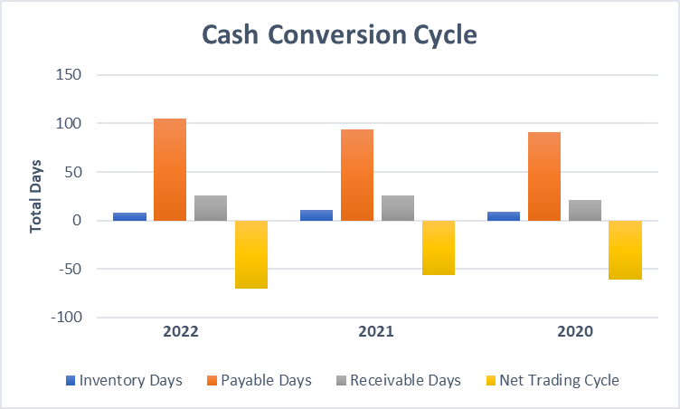**Inventory, Payable, Receivable Days, Cash Conversion Cycle, and Defense Interval Ratios**

The only significant change in the cash conversion cycle (CCC) ratios was the change in Payable Days in 2021 from 94 days to 105 days in 2022. This has a positive effect on the CCC, changing CCC from negative 56 days in 2021 to negative 71 days in 2022 which is beneficial to Apple.

This indicates that Apple is taking longer to pay its suppliers which means cash is being retained longer. This change could be due to new supplier negotiations as Apple is seemingly able to increase Accounts Payable year-over-year by an estimated average of 14-15%. While CCC is improving, overall liquidity is still decreasing as indicated by the defense interval ratio among other factors. The defense interval decreased from 990 days in 2020 to 547 days in 2022 which indicates that Apple is less able to pay current liabilities with current liquid assets such as cash, marketable securities, and accounts receivable.

**Profitability Ratios:**

**Gross, EBITDA, EBIT, and Net Margin Ratios**

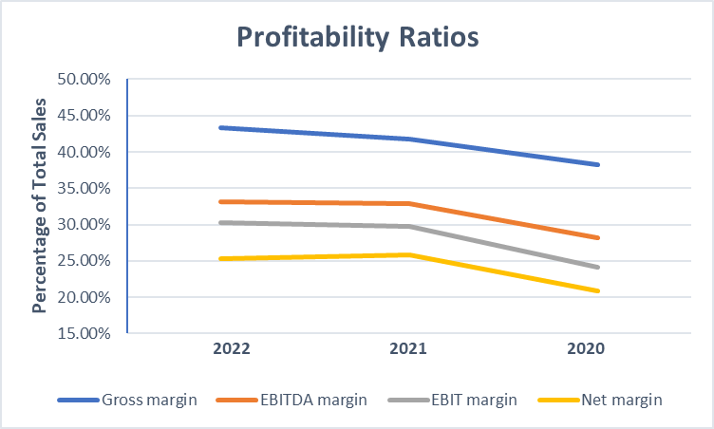Apple compared to its 2020 numbers is improving its profitability in all of the margin calculations done below with a 5.08% increase in gross margin alone.

However, this may not be due to anything in particular that Apple has done to improve itself. Most of Apple’s sales were due to increases in product sales aka iPhones, iPads, iPods etc. A higher gross margin means a lower COGS which could be linked entirely to economies of scale as it becomes cheaper to mass produce Apple products. The jump in all profitability margins from 2020 to 2021 and onward is more likely because of increased efficiency due to economies of scale and not improvements in ROA or other accounts.

**Solvency Ratios:**

**Debt/Equity, Debt/Total Assets, and Long-term Debt/Capital Ratios**

As shown in the graph below, debt as compared to equity, assets, and available capital is growing. While the use of debt is growing at a faster rate than the rate at which assets are growing, Accumulated Other Comprehensive Income (AOCI) is the main cause for the drop in 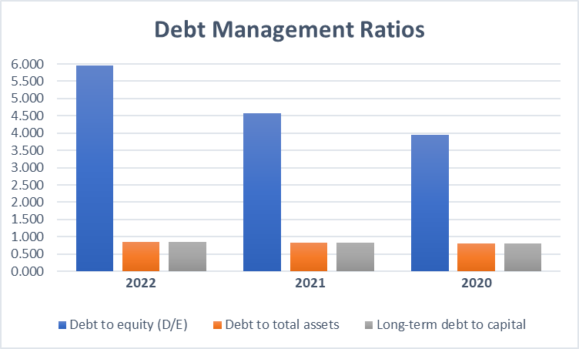the equity section of the balance sheet.

Since AOCI is accounting for unrealized gains/losses, it may or may not be significantly important depending on what type of AOCI Apple has. Apple may have unrealized losses due to hedging currency risk as many if not all its products are made overseas and require currency transactions for materials, shipping etc. While the negative $11.1 million unrealized loss in 2022 will be detrimental if realized, this loss does not seem to follow a negative trend as 2021 ($1.6 million) and 2020 (negative $4.06 million) do not follow this pattern. Overall, debt accumulation is increasing faster than asset and equity growth, but AOCI is only temporarily decreasing equity making the growth seem larger than what it actually is. A problem may exist however in Apple’s investing/hedging strategies as markets are still highly volatile as compared to pre-2020.

**Times Interest Earned, Debt Coverage, and Free Cash Flow Ratios**

There are a few notable changes from 2020 to 2021 as Apple is rebounding from its 2020 losses such as times interest earned jumping from 22.08 in 2020 to 40.55 in 2021. However, as discussed above, while 2020 to 2021 increases/decreases in different accounts are valuable, they do not accurately measure performance as 2020 losses were an anomaly when compared to Apple’s historical performance. The changes in debt coverage and free cash flow per share (FCFE) from 2021 to 2022 however are significant.

|  |  |  |  |
| --- | --- | --- | --- |
|  | **2022** | **2021** | **2020** |
| **Times interest earned** | 41.688 | 40.547 | 22.081 |
| **Debt coverage** | 0.776 | 0.868 | 0.629 |
| **Free cash flow (FCFE) per share** | 1.540 | 2.151 | 2.293 |

Debt coverage goes down to 0.78 in 2022 even though EBIT increases. This is another ratio that shows Apple’s debt growth is outpacing asset growth. Accounts payable and other current liabilities, not term debt or interest payments, seem to be the main cause of debt coverage decreasing. FCFE is affected by this trend although not as much so as the effects of marketable securities as discussed in the liquidity section. FCFE is also affected by the number of shares outstanding which is affected by Apple’s share repurchases ($89.4 million in 2022) but this has not led to improving FCFE as cash flow continues to decrease. Other factors include deferred payments from 2020 and 2021 maturing in 2022 (deferred income taxes, commercial paper etc.) which also contributes to less cash flow. These solvency ratios further prove that Apple’s ability to cover current liabilities is decreasing.

**Asset Utilization Ratios**

**Total Asset, Fixed Asset, Inventory Turnover, and ROA Ratios**

Asset utilization is improving as Apple reduces spending on assets while improving sales and net income.

|  |  |  |  |
| --- | --- | --- | --- |
|  | **2022** | **2021** | **2020** |
| **Total asset turnover** | 1.118 | 1.042 | 0.848 |
| **Current asset turnover** | 2.912 | 2.713 | 1.910 |
| **Fixed asset turnover** | 1.814 | 1.692 | 1.524 |
| **Inventory turnover** | 45.197 | 32.368 | 41.753 |
| **Return on assets (ROA)** | 0.283 | 0.270 | 0.177 |

These improvements are more so because of Apple’s improved usage of its current assets rather than its fixed assets as shown above. Although Apple’s liquidity is decreasing from selling off marketable securities prior to maturity, increasing AR, and repurchasing larger quantities of stock; Apple’s profitability per dollar of assets is increasing despite the loss of liquidity. This is to be expected as Apple is buying fewer assets while simultaneously selling other assets to bring the company back to pre-2020 levels as part of its long-term strategy. The inventory turnover drop in 2021 was most likely due to a combination of an overestimation of demand and/or a surplus of older, unsold inventory from 2020 which seems to have been corrected in 2022. Overall, Apple has successfully used fewer assets to generate more profit as asset turnover ratios continue to show positive growth.

**Market Ratios:**

**Price-to-Equity, Price-to-Book Ratios**

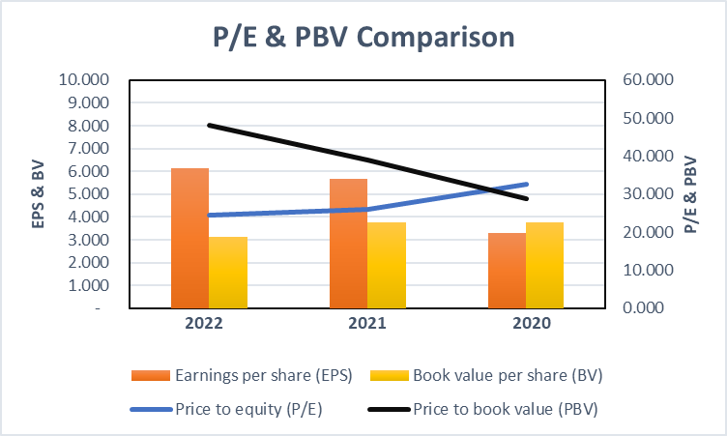Apple’s price-to-equity (P/E) has decreased from 32.7 in 2020 to 24.4 in 2022. As Apple repurchases shares this will raise EPS (as long as net income increases or remains constant) which decreases P/E.

Apple’s P/E value going down is a natural consequence of EPS going up although it is being pushed by share repurchases rather than net income growth. This indicates that investors are less willing to pay a premium (approximately $32 invested per actual dollar currently produced in 2020 down to $24 invested in 2022). For a tech company with very large P/E values, this is a negative trend as the market is still unsure what Apple is truly worth in the future. Apple sees this issue, which is one of the reasons why they are pursuing a more aggressive stock buyback program to boost EPS and attract more investors. As far as price-to-book-value (PBV) is concerned, it is basically a nonfactor. Apple is still a large, growing tech company whose value is weighted on its future and not its present. The book value of most of Apple’s assets is not consistent with its market value and should be considered irrelevant.

**Dividend Payout, Dividend Yield Ratios**

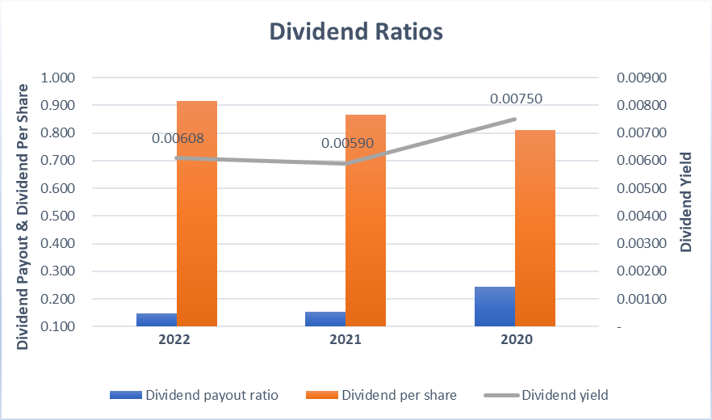Throughout the 2020-2022 period, Apple has not cut any dividend payments but has instead increased dividends per share through mostly through stock buybacks. The dividend yield dropped in 2021 to .00590 but improved in 2022 to .00608. This indicates that even though stock price is increasing, (which leads to a natural drop in the dividend yield) Apple has increased returns to investors based solely off dividends.

While Apple has improved dividend returns, the payout ratio shows that dividend payments to investors relative to earnings is actually lower in 2022 than it was 2021-2020. However, this should be seen as a problem because; One, dividends-per-share and the dividend yield are both increasing as Apple is increasing dividend payments; Two, Apple is retaining more of its earnings to use on recovery and growth while still increasing dividend payments. Both of these factors are good signs for investors looking for good returns coupled with Apple’s rising stock price.

**ROE, ROCE, ROA, Enterprise Value/EBITDA Ratios**

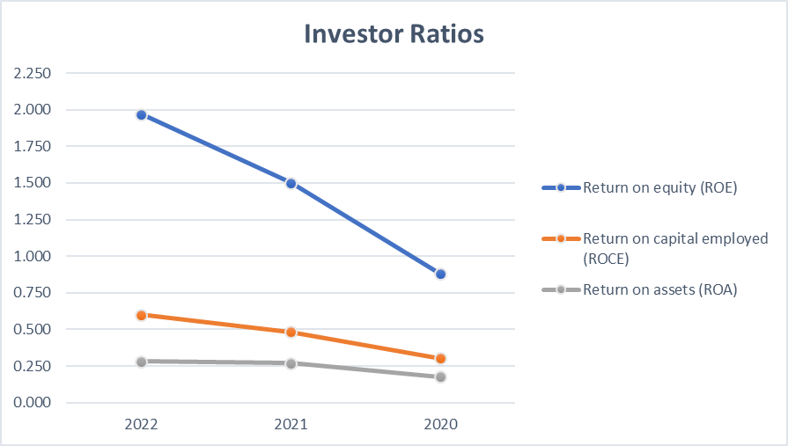Each of the ratios shown below are all positive indicators of Apple’s rebound except for enterprise value to EBITDA (EV/EBITDA). ROE is improving going from 0.88 in 2020

to 1.97 in 2022 as total shareholder equity stays relatively the same while net income increases. Apple is taking on more debt as current liabilities start to grow which could be overinflating ROE, but only current liabilities are substantially growing as term debt and other liabilities stay roughly the same year-over-year. Not only are higher ROE values also the norm in tech-central companies, but Apple in 2022 was beating its peers by a fair margin in ROE. Apple’s ROE growth is a positive indicator of the company’s ability to use smaller amounts of equity to generate large amounts of income.

Apple’s return on capital employed (ROCE) values are also increasing as operations improve in profitability and efficiency although probably due to economies of scale as discussed previously. ROCE is not as high as ROE as it is considering both debt and equity. While Apple’s use of both debt and equity is improving, its ability to generate earnings based off of equity is better than its ability to generate earnings off of assets as indicated boy ROCE, ROE, and ROA.

Enterprise value (EV) paints a more accurate picture of what a company is really worth as it incorporates not only market value, but also debt and cash reserves. After its 2020 rebound, Apple’s EV jumped in 2021 but then fell by a small margin in 2022. This is because of Apple’s declining cash reserves used for share buybacks as term debt has stayed relatively the same.

|  |  |  |  |
| --- | --- | --- | --- |
| **Enterprise value to EBITDA** | 19.349 | 21.105 | 25.177 |
| **Enterprise value (EV)** | $2,525,808 | $2,537,530 | $1,947,270 |

When examining the EV/EBITDA multiple, the decrease could be looked at as negative as a lower multiple can lead to a lower valuation of the company. This means that investors in 2020 were more willing to “overpay” for a piece of Apple than they are in 2022. However, this decrease could be a more truthful reflection of how much the company is actually worth after taking a heavy hit in 2020.

Overall, Apple is on a steady road to improved profitability which should result in an increased stock price as more investors are reassured by Apple’s efforts. Apple’s extensive use of short-term debt and spending on share repurchases is having an adverse effect on cash, but this may just be a temporary measure as Apple focuses on increasing EPS foremost. If negative FCF trends continue, Apple could be in trouble down the road as debt becomes the source of most funds. Illiquidity is still a present issue, but once Apple can satisfy shareholders through its dividend/stock buyback program it can free up more cash to use on internal growth.