Amazon 2021-2022 Financial Report

According to a CNBC article, Amazon stock tumbled 51% in 2022 wiping out billions of dollars making it the biggest decline since 2000 when stock price plunged 80%. (Palmer, 2022) This drop put Amazon stock back to its pre-pandemic levels and effectively wiped out the last 2 years of growth. (Yahoo, 2022) Amazon saw enormous growth during the height of the pandemic starting in March of 2020 until November of 2021. However, due to a combination of macroeconomic trends and company overexuberance, Amazon growth started to decline rapidly. Amazon forecasted continuing strong demand for 2022 and beyond which stemmed from pandemic spending as more people ordered items online and used more online services (movies, music, e-books, subscriptions etc.) Amazon built new warehouses, more services, and hired several thousand more employees to keep up with demand.

However, in December of 2021, holiday shopping was weaker than expected followed by decreasing demand overall as stir-crazy consumers started going out more and buying online less. This severely affected Amazon’s operations which were geared towards strong growing demand. CEO Andy Jassy in Amazon’s 2022 Annual Report discussed how measures were being taken to cut back on spending and focus on recovery. (Amazon, 2024) Not only are Amazon’s financial statements and their corresponding ratios indicative of the effects of the economy and consumer behavior, but they are also indicative of some of Amazon’s overly optimistic forecasting and their subsequent attempts to correct the company.

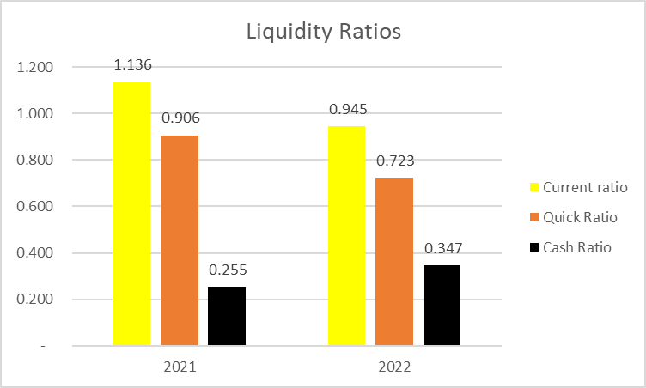Liquidity is decreasing as liabilities are not only growing but surpassing assets in 2022. A large part of this decrease in liquidity is due to subscriptions and some other services being discontinued by customers which is included as part of “Other Income” which drops to negative $16.8 million in 2022. Amazon also sold almost $40 million dollars’ worth of Marketable Securities to free up more funds as Amazon goes into emergency mode. Cash flow is greater in 2022, but this is because of a mass liquification of marketable securities as Amazon prepares to perform damage control.

Profitability is decreasing as Amazon had already spent a large amount of money on new technology, content, marketing etc. before they reversed course in late 2022. Gross margin has actually increased, but the aforementioned operating expenses increased with the expectation of pandemic level sales and not decreased demand. Andy Jassy states that several new technologies and services in development were being cancelled as Amazon has to reexamine the profitableness and viability of each item. (Amazon, 2024)

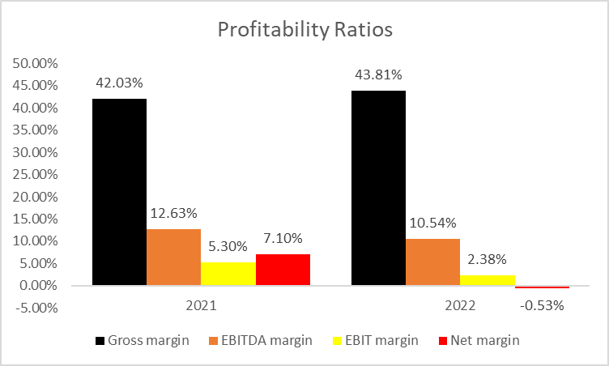

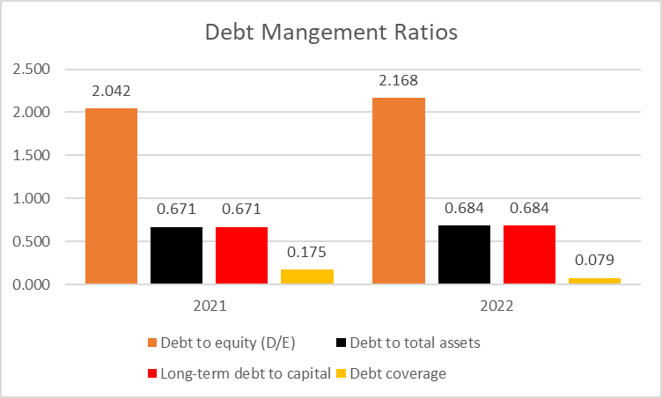Solvency is decreasing as debt compared to assets and equity is increasing although not by a large margin. Amazon’s ability to cover debt and interest payments is decreasing as current assets are not enough to pay off liabilities.

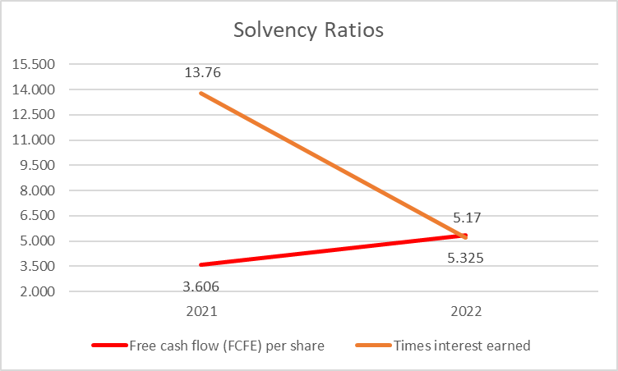Free cash flow per share (FCFE) is increasing but that is due to the $40 million sell-off of marketable securities making it a false positive. Amazon is using cash to prepare for possible restructuring, elimination of certain business segments, and possibly as way to make certain ratios look better than what they actually are.

Asset utilization is decreasing as certain assets are becoming less valuable and profitable. Amazon as of 2022 was working on eliminating certain business segments (physical stores, Amazon Fabric, Amazon Care etc.) but had not yet fully eliminated all unprofitable business units as reflected in its asset utilization ratios. A decrease in sales was also a contributing factor as fewer sales for relatively the same amount of assets would decrease asset utilization.

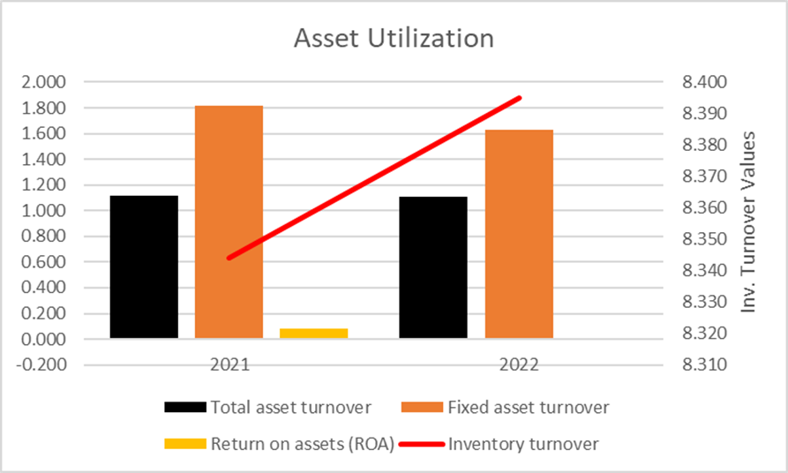

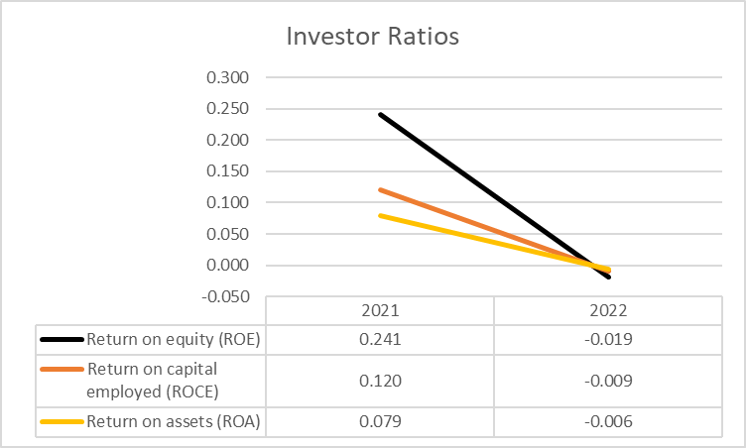Market ratios tanked as market price dropped 51% from $166.72 to $84.00 in one year. Because of this drop, most of the market ratios go down by half or go negative. These ratios are skewed to the point of being non usable in a line-by-line analysis but do give the big picture which is a major loss in market value for Amazon.

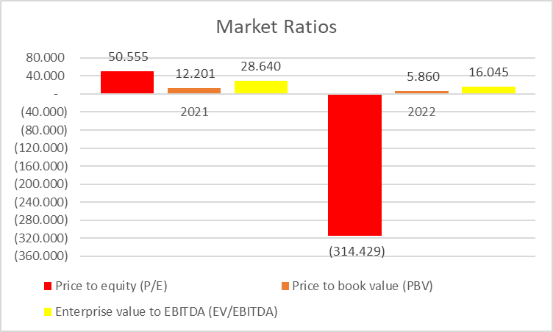Even though the market ratios look abysmal, Amazon still shows commitment to recover and cut out unprofitable business units which will lead to success in the long run. Most of these numbers are typical for most if not all of Amazon’s competitors and is by no means a sign of immediate collapse.

Bibliography

Palmer, Annie. 2022. “Amazon Lost Half Its Value This Year as Tech Stocks Got Crushed and Recession Fears Grew.” CNBC. CNBC. December 29, 2022. https://www.cnbc.com/2022/12/29/amazon-shed-half-its-value-in-2022-as-tech-stocks-got-crushed.html#:~:text=Shares%20of%20the%20e-retailer%20are%20wrapping%20up%20their.

Yahoo Finance Video. 2022. “Why Amazon Stock Has Tanked by 50% in 2022.” Yahoo Finance. Yahoo Finance. December 20, 2022. https://finance.yahoo.com/video/why-amazon-stock-tanked-50-145203924.html.

Amazon. 2024. “Amazon.com, Inc. - Annual Reports, Proxies and Shareholder Letters.” Ir.aboutamazon.com. 2024. https://ir.aboutamazon.com/annual-reports-proxies-and-shareholder-letters/default.aspx.

‌

‌

‌