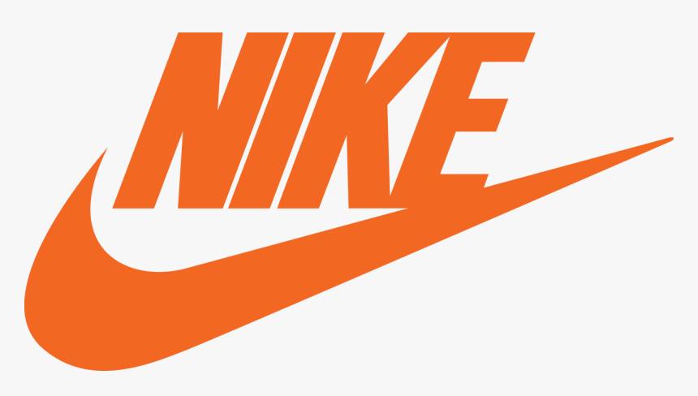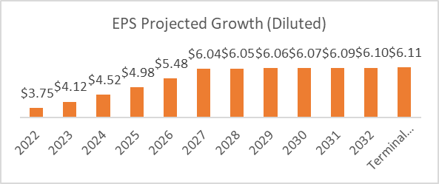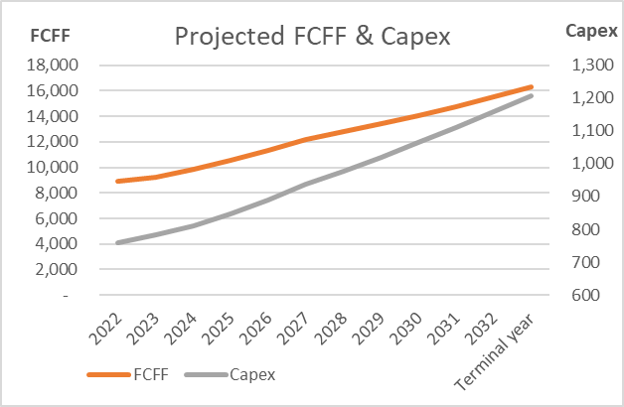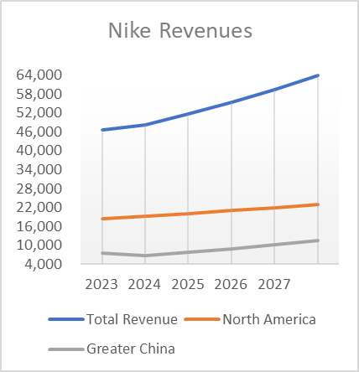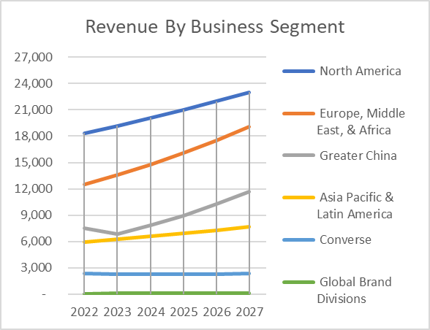 

**Revenue Growth/Key Segment Performance:**

Total revenue is forecasted to grow at an average of 6.5% each year. North America is expected to continue being the highest grossing segment line, however, the Greater China business segment is projected to have the highest growth of any segment at an average of 9.6% growth yearly as Asian countries are expected to increase their consumption of Nike products. Nike’s flagship shoe product segment made up 67% of total sales in 2022 and is expected to hold at around 66% for the next five years.

**Investment Thesis:**

According to the DCF analysis, Nike is expected to grow share price by an average of 6.7% spread over the next ten years. The model projects an increase of $96.76 in the next ten years which indicates a buy position for investors.

**Cash Flow/Future Projects:**

Nike still relies heavily on its main market group, young adults, to drive sales growth, but has started to expand into other product markets as well through technology and branding. Nike throughout 2022 has been focusing on the online experience with 100% of its North American stores having at least one online service. Nike has also focused on developing products for underserved product markets such as women’s fitness and children’s fitness with brands that have diverse endorsements, new technology, and eco-friendly materials for 2022 and beyond.

**Earnings/Costs:**

EBITDA average margin over next five years: 16.9%

*Average Forecasted Segment Growth:*

|  |  |
| --- | --- |
| * Europe, Middle East,   Africa: 8.8% | * Asia Pacific, Latin America: 5.2% |
| * Greater China: 9.6% | * North America: 4.6% |
| * Global Brand Divisions: 1.8% | * Converse: 0.1% |

Based on historic performance, Nike’s costs are increasing but this is mostly due to the variable nature of consumers as demand goes up. Demand creation expense has decreased by almost 1% over the last five years which is expected to decrease in the future as Nike is able to rely less on advertising/endorsements.

**Company Name:** Nike Inc.

**Ticker:** NKE

**Current Share Price:** $117.01 (12/26/2022)

**Upside/Downside to current share price:** +82.69%

**Growth/Ratio Projections**

**(2022-2025)**



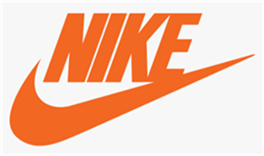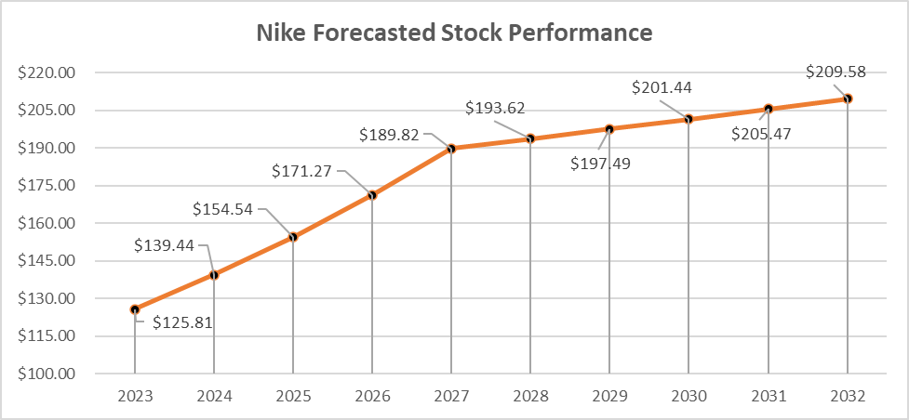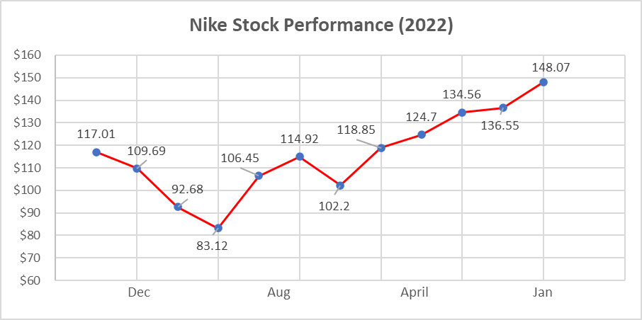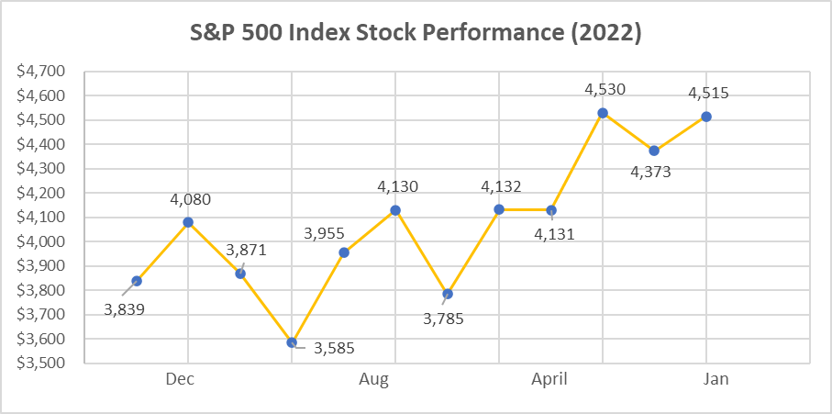

**Current & Forecasted Stock Performance (2022-2032)**