**Financial Analysis Report**

This Financial Analysis Report provides a comprehensive examination of the company's financial performance over the fiscal years 2020, 2021, and 2022. By delving into key financial metrics, including liquidity, profitability, solvency, asset utilization, and market ratios, this report aims to offer a thorough understanding of the company’s financial health and operational efficiency. Utilizing a combination of graphs and charts, we present trends and changes across these metrics to illustrate how the company has evolved over the three years. This analysis will aid stakeholders in making informed decisions by highlighting areas of strength and potential concerns.

**Liquidity Ratios:**

* **Current Ratio:**
  + 2022: 0.88
  + 2021: 1.07
  + 2020: 1.36
* **Quick Ratio:**
  + 2022: 0.85
  + 2021: 1.07
  + 2020: 1.33
* **Cash Ratio:**
  + 2022: 0.15
  + 2021: 0.28
  + 2020: 0.36

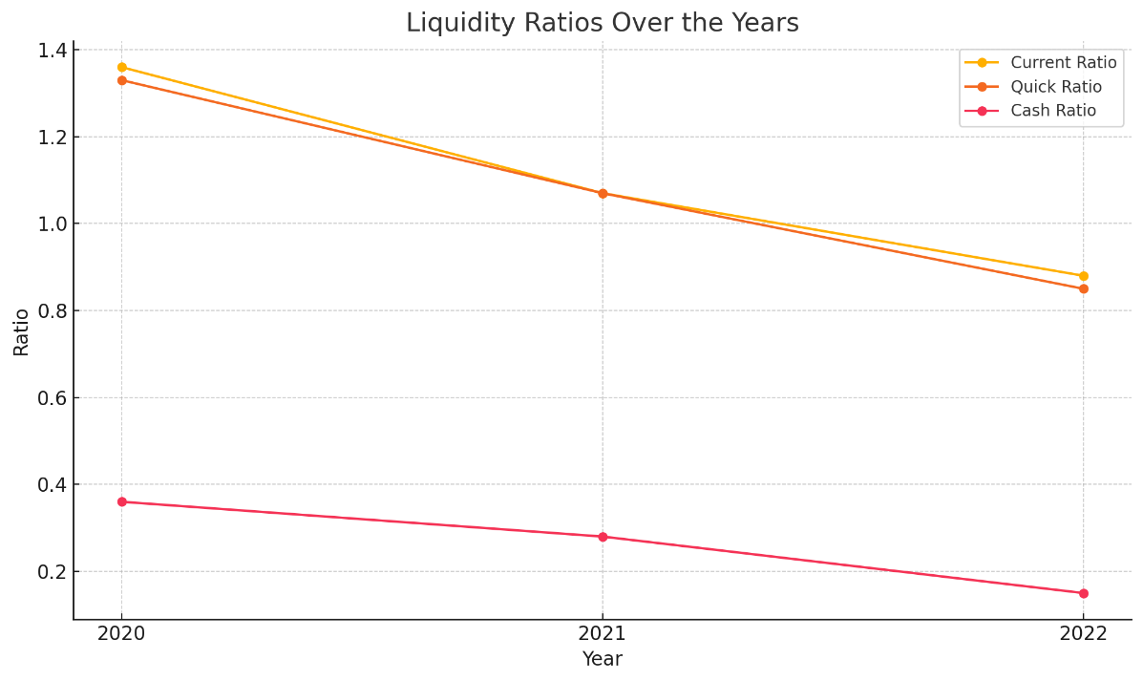

**Interpretation:**

* The liquidity ratios show a decreasing trend, indicating a decline in the company’s ability to cover its short-term obligations. This could signal a potential liquidity issue if the trend continues.

**2. Profitability Analysis**

**Profitability Ratios:**

* **Gross Margin:**
  + 2022: 43.30%
  + 2021: 41.80%
  + 2020: 38.20%
* **EBITDA Margin:**
  + 2022: 40.50%
  + 2021: 38.00%
  + 2020: 35.30%
* **EBIT Margin:**
  + 2022: 30.30%
  + 2021: 29.80%
  + 2020: 24.10%
* **Net Margin:**
  + 2022: 25.30%
  + 2021: 25.80%
  + 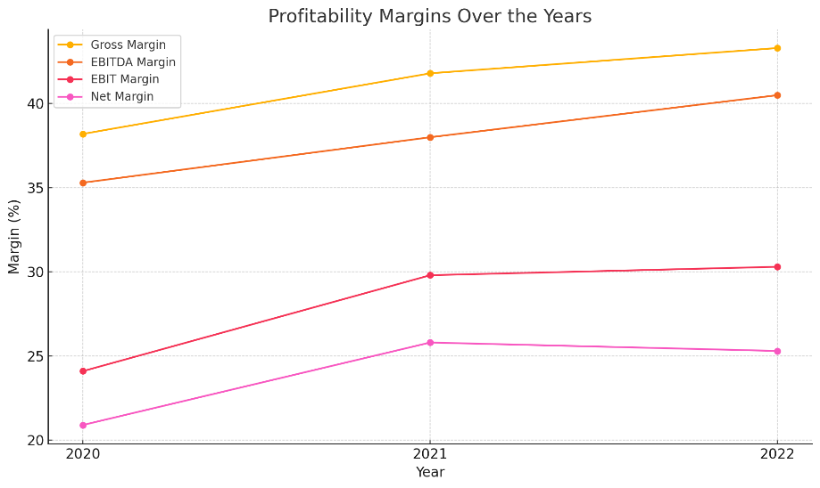2020: 20.90%

**Interpretation:**

* Profitability has improved consistently over the three years, with gross margin and EBITDA margin increasing. This indicates better cost management and an improved ability to convert sales into profits.

**3. Solvency/Debt Management**

**Solvency Ratios:**

* **Debt to Equity (D/E):**
  + 2022: 5.95
  + 2021: 4.56
  + 2020: 4.03
* **Debt to Total Assets:**
  + 2022: 0.86
  + 2021: 0.82
  + 2020: 0.80
* **Times Interest Earned:**
  + 2022: 20.91
  + 2021: 24.94
  + 2020: 18.12
* **Debt Coverage:**
  + 2022: 10.15
  + 2021: 13.11
  + 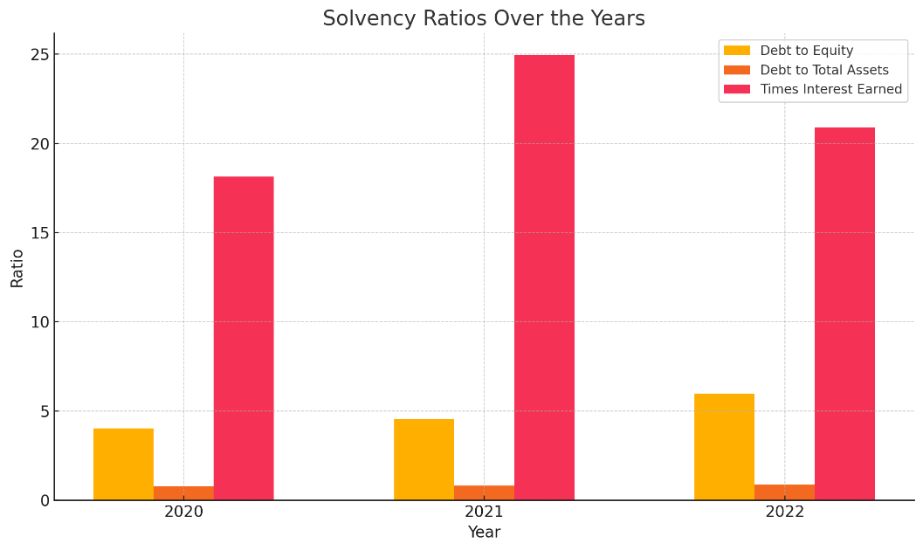2020: 8.77

**Interpretation:**

* The company’s solvency position indicates high leverage, with a rising debt-to-equity ratio. However, the ability to cover interest expenses remains strong, as indicated by the times interest earned ratio.

**4. Asset Utilization**

**Asset Utilization Ratios:**

* **Total Asset Turnover:**
  + 2022: 1.12
  + 2021: 1.04
  + 2020: 0.85
* **Fixed Asset Turnover:**
  + 2022: 2.50
  + 2021: 2.75
  + 2020: 2.16
* **Inventory Turnover:**
  + 2022: 48.43
  + 2021: 47.28
  + 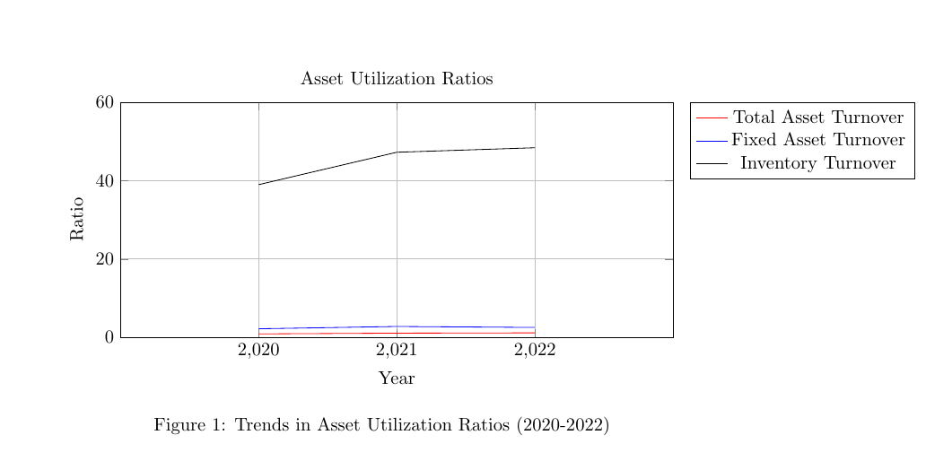2020: 39.00

**Interpretation:**

* The increasing trend in total asset turnover indicates improved efficiency in using assets to generate sales. Fixed asset turnover has remained relatively stable, while inventory turnover shows strong efficiency in managing stock.

**5. Investor/Market Ratios**

**Market Ratios:**

* **Price to Equity (P/E):**
  + 2022: 37.26
  + 2021: 40.42
  + 2020: 69.11
* **Earnings per Share (EPS):**
  + 2022: $6.15
  + 2021: $5.67
  + 2020: $3.31
* **Dividend Payout Ratio:**
  + 2022: 14.90%
  + 2021: 15.30%
  + 2020: 24.50

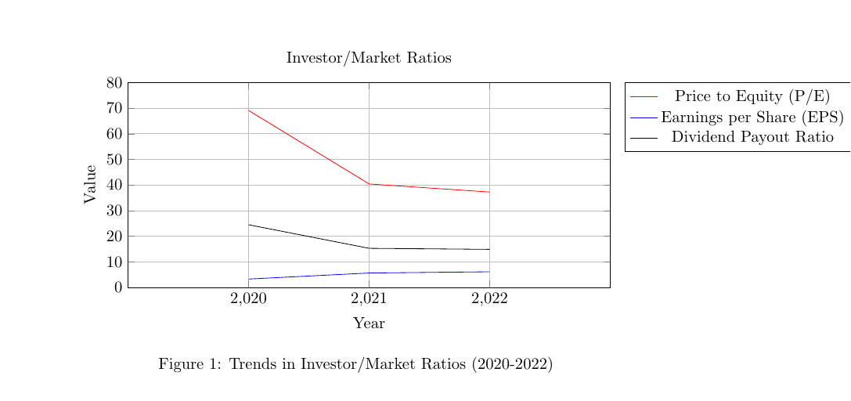

**Interpretation:**

* The P/E ratio shows a decrease, indicating a relatively lower valuation compared to previous years. The EPS has consistently improved, reflecting strong profitability. The dividend payout ratio indicates a stable approach to returning profits to shareholders.

**6. Additional Financial Metrics**

* **Income Tax Rate:**
  + 2022: 16.20%
  + 2021: 13.30%
  + 2020: 14.40%
* **Capex as a Percentage of Sales:**
  + 2022: 2.70%
  + 2021: 3.00%
  + 2020: 2.70%
* **Capex as a Percentage of Fixed Assets:**
  + 2022: 25.40%
  + 2021: 28.10%
  + 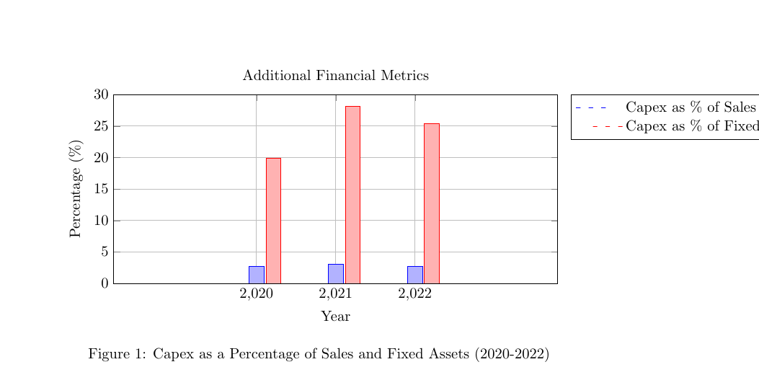2020: 19.90%

**Interpretation:**

* The income tax rate has fluctuated slightly but remains within a reasonable range. Capital expenditures (Capex) as a percentage of sales and fixed assets indicate ongoing investment in the company's infrastructure, which is vital for future growth.

**Conclusion**

In conclusion, the financial analysis of the company from 2020 to 2022 reveals a mixed but generally positive picture. The liquidity ratios indicate a declining ability to meet short-term obligations, which may warrant attention to avoid potential liquidity issues. On the profitability front, the company has demonstrated consistent improvement, with increasing margins across all key metrics, reflecting effective cost management and a robust conversion of sales into profits. However, the company’s solvency ratios show rising leverage, suggesting a growing reliance on debt, though the ability to cover interest expenses remains strong. Asset utilization has improved, with better efficiency in managing assets and inventory. Investor metrics, such as EPS, have shown positive growth, although the P/E ratio has decreased, signalling a lower valuation relative to previous years. Overall, while there are areas of concern, particularly regarding liquidity and rising debt, the company’s strong profitability and efficient asset use position it favourably for future growth. Continued focus on liquidity management and careful monitoring of debt levels will be crucial for sustaining long-term financial health.