**Amazon Financial Report João Azevedo**

This financial report provides a comprehensive analysis of Amazon's financial performance over the past three years, focusing on liquidity, profitability, solvency, asset utilization, and investor/market ratios. By examining key financial metrics, we aim to provide a clearer picture of Amazon's operational efficiency, financial health, and market position. This analysis highlights trends and changes in the company's financial standing, offering insights into how Amazon manages its resources, generates profits, and responds to market conditions.

**1. Liquidity Analysis**

Amazon’s liquidity position, which reflects its ability to meet short-term obligations, shows some fluctuations over the past few years:

* **Current Ratio:** In 2019, Amazon’s current ratio was 1.10, slightly improving from 1.04 in 2017. This means the company has more current assets compared to its current liabilities. While it suggests that Amazon can cover its short-term obligations, the ratio is only moderate, indicating stable but not significantly improved liquidity.
* **Quick Ratio:** At 0.86 in 2019, Amazon's quick ratio, which excludes inventory, shows a slight improvement from previous years. This ratio indicates that while Amazon is better at managing its most liquid assets, there is still room for improvement in covering short-term liabilities without relying on inventory.
* **Cash Ratio:** The cash ratio was 0.63 in 2019. This is an increase from previous years, suggesting that while Amazon maintains a substantial cash reserve, it has slightly increased its cash cushion relative to its liabilities.
* **Defensive Interval:** The defensive interval of 75.4 days in 2019 means Amazon can operate for over two months using its liquid assets before needing additional funding. This is an improvement from previous years, reflecting a better buffer of liquid assets.
* **Inventory Days:** Inventory turnover is stable at 45.8 days in 2019, meaning Amazon can sell its inventory in about a month and a half. This stability indicates effective inventory management.
* **Payable Days:** The increased payable days to 103.5 in 2019 means Amazon is taking longer to pay its suppliers. This may reflect improved supplier terms or a strategy to manage cash flow more effectively.
* **Receivable Days:** A decrease to 26.7 days in 2019 shows Amazon is collecting payments from customers faster. This improvement helps in maintaining a healthy cash flow.
* **Net Trading Cycle:** The negative net trading cycle of -31.0 days in 2019 indicates that Amazon receives cash from sales before it needs to pay its suppliers. This is a strong position, as it means Amazon’s cash flow is efficiently managed.
* **Working Capital as a % of Sales:** At 3.04% in 2019, this shows that a small portion of sales revenue is invested in working capital. It’s a healthy percentage, indicating efficient use of resources.
* 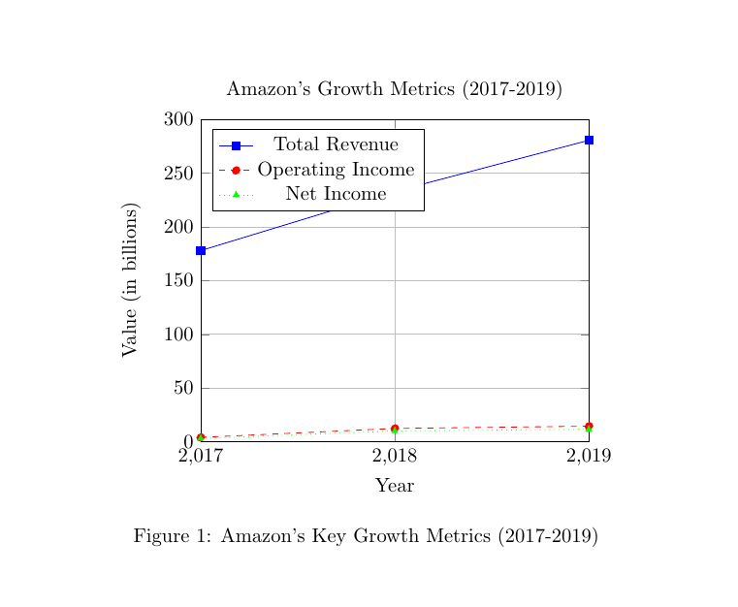**Working Capital:** The increase to $8,522 in 2019 reflects a positive trend in operational efficiency and liquidity management.

**2. Profitability Analysis**

Amazon's profitability metrics reveal how well it is managing costs and generating profits:

* **Gross Margin:** The gross margin of 40.9% in 2019 shows that Amazon is retaining a significant portion of revenue after covering production costs. This is an improvement from previous years, indicating better cost control and higher profitability on sales.
* **EBITDA Margin:** A decrease to 9.3% in 2019 from 11.9% in 2018 suggests that operating expenses have increased or revenue growth hasn’t kept pace with costs. While Amazon’s core operations remain profitable, there has been a slight decline in operational efficiency.
* **EBITDA:** At $26,019 in 2019, EBITDA has decreased from previous years. This decline might be due to higher operating costs or increased investments in growth initiatives.
* **EBIT Margin:** An increase to 5.2% in 2019 indicates that Amazon has improved its operating income relative to revenue, showing better control over operational expenses.
* **EBIT:** The rise to $14,541 in 2019 reflects stronger operational performance and better management of operating expenses.
* 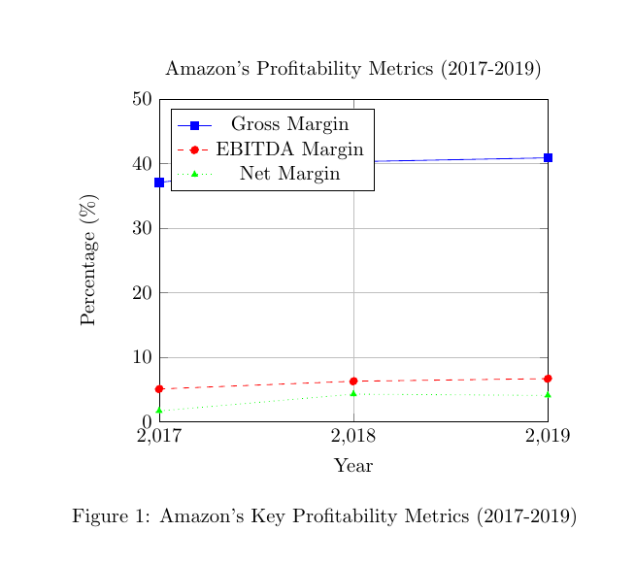**Net Margin:** With a net margin of 4.1%, Amazon has improved profitability compared to previous years. This indicates better overall financial health and effective cost management.

**3. Solvency/Debt Management**

Amazon’s ability to manage its debt and maintain financial stability is key to understanding its long-term health:

* **Debt to Equity (D/E):** The D/E ratio of 2.01 in 2019 shows that Amazon relies less on debt for financing compared to earlier years. This improvement suggests a stronger equity position and reduced financial risk.
* **Debt to Total Assets:** At 0.15, only 15% of Amazon’s assets are financed by debt. This low ratio indicates a conservative approach to using debt, contributing to financial stability.
* **Long-Term Debt to Capital:** With a ratio of 0.27, Amazon’s use of long-term debt is moderate. This balance shows a prudent approach to leveraging debt while maintaining financial flexibility.
* **Times Interest Earned:** The ratio of 9.09 in 2019 indicates that Amazon can comfortably cover its interest expenses with its earnings. This strong coverage reflects financial stability and low risk of default.
* **Debt Coverage:** The ratio of 0.85 means Amazon has a good ability to repay its debt using operating cash flow. This is a healthy indicator of debt management.
* **Free Cash Flow (FCFE) per Share:** At $13.67 in 2019, Amazon’s FCFE per share is positive, indicating that the company generates sufficient cash after expenditures to support shareholder value.
* 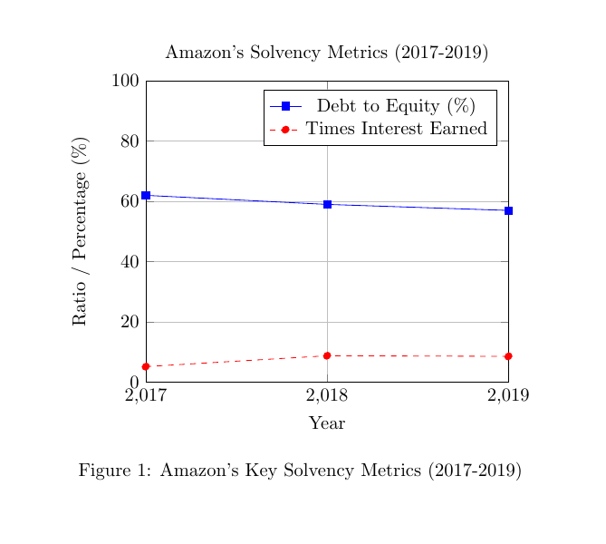**FCFE:** The total FCFE of $6,740 reflects a positive cash flow situation, showing that Amazon is generating enough cash to cover its investments, support growth, and potentially return value to shareholders.

**4. Asset Utilization**

Amazon’s efficiency in using its assets to generate sales and profits is essential for understanding its operational effectiveness:

* **Total Asset Turnover:** The ratio of 1.25 in 2019 indicates that Amazon is effectively using its assets to generate sales. While slightly down from previous years, it still shows strong asset utilization.
* **Fixed Asset Turnover:** At 2.21, this ratio shows that Amazon is efficiently using its fixed assets to generate revenue. The slight decrease from previous years might indicate increased investment in fixed assets or slower revenue growth.
* **Inventory Turnover:** With a ratio of 8.20, Amazon is managing its inventory well, selling and replacing it relatively quickly. This efficient inventory management helps maintain a healthy cash flow.
* 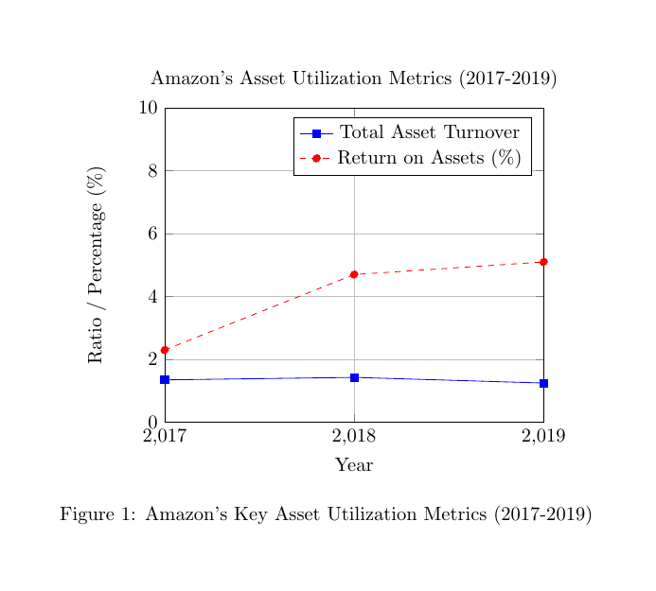**Return on Assets (ROA):** The ROA of 5.2% reflects improved profitability relative to assets. This increase from previous years indicates that Amazon is using its assets more effectively to generate profits.

**5. Investor/Market Ratios**

These ratios provide insights into how the market views Amazon and its financial performance:

* **Price to Equity (P/E):** The P/E ratio of 19.9 suggests that investors are willing to pay a premium for Amazon’s earnings, reflecting positive growth expectations.
* **Earnings per Share (EPS):** At $23.46, EPS is strong, indicating robust profitability on a per-share basis.
* **Price to Book Value (PBV):** The ratio of 9.4 shows that investors value Amazon’s stock highly compared to its book value, reflecting high market confidence.
* **Book Value per Share (BV):** At $63.38, this metric shows the value of the company’s equity per share.
* **Dividend Payout Ratio:** At 0%, Amazon does not pay dividends, which might be due to a focus on reinvesting profits for growth rather than distributing them to shareholders.
* **Dividend per Share:** Also $0.00, aligning with the zero dividend payout ratio.
* **Dividend Yield:** At 0%, reflects no dividend payments.
* **Return on Equity (ROE):** With a strong ROE of 18.7%, Amazon demonstrates effective use of shareholders’ equity to generate profits.
* **Return on Capital Employed (ROCE):** The 10.8% ROCE indicates a solid return on the capital invested in the business, reflecting efficient use of resources.
* **Return on Assets (ROA):** Consistent at 5.2%, this reflects efficient asset management.
* **Enterprise Value to EBITDA (EV/EBITDA):** The ratio of 23.5 indicates a high valuation relative to earnings before interest, taxes, depreciation, and amortization, suggesting strong market expectations.
* **Enterprise Value (EV):** At $611,500, this represents the total market value of Amazon’s equity and deb

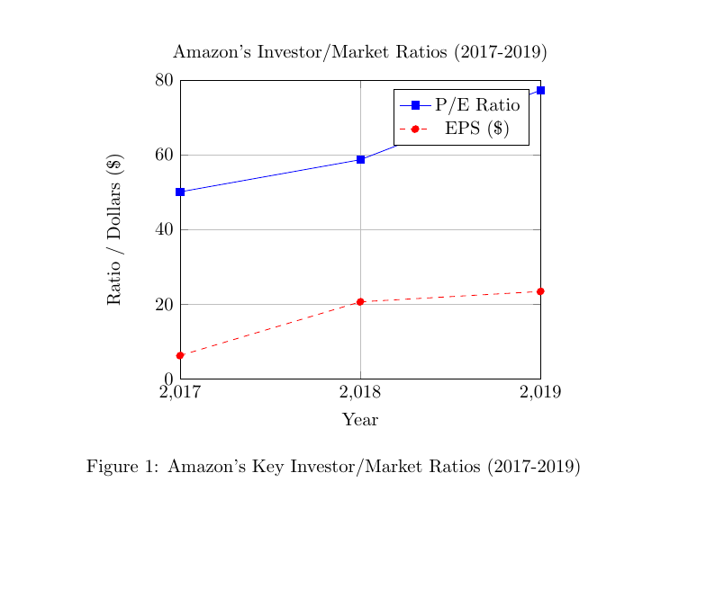

Amazon's financial performance over the past three years demonstrates a company that is generally strong and efficient, with some areas showing notable improvements and others requiring attention, Overall, Amazon exhibits a strong financial position with effective management of its resources, solid profitability, and prudent debt management. While there are areas for potential improvement, such as liquidity and cost control, the company's strategic focus on growth and operational efficiency positions it well for continued success in the competitive market landscape.