Revenue and Cost Drivers Analysis

# Marriott International

Marriott International generates revenue through a variety of channels, with its primary revenue drivers being hotel operations, franchise fees, and management fees. Its portfolio includes over 8,800 properties globally, spanning luxury and premium brands like Ritz-Carlton and St. Regis. Additionally, the company is benefiting from the post-pandemic recovery in global travel.

**Revenue Breakdown into Price and Volume:**

* **Price**: Marriott's pricing strategy varies across its luxury and premium brands. Room rates in luxury properties (e.g., Ritz-Carlton) are significantly higher than premium or economy brands. Revenue per available room (RevPAR) is a key metric, which combines both occupancy (volume) and pricing (ADR - Average Daily Rate). A higher ADR will positively impact revenue even if the number of rooms sold (volume) remains constant.
* **Volume**: The volume of bookings (occupancy rates) is another critical variable. High occupancy, especially in peak travel seasons and regions, drives more room sales. Volume growth is driven by increased global travel demand and expansion into new markets.
* **Revenue Growth Influences**:
  + **Price Increases**: Higher pricing in Marriott's luxury segments contributes to revenue growth, particularly in premium locations.
  + **Volume Growth**: Expansion into new geographic markets (e.g., Asia-Pacific) has boosted occupancy rates, and therefore volume.

**Cost Drivers and Their Correlation to Revenue:**

* **Fixed Costs**:
  + **Real Estate and Property Maintenance**: These costs remain stable regardless of the number of guests, as properties must be maintained regardless of occupancy levels.
  + **Management Salaries**: Higher executive salaries and general administrative costs are relatively fixed and are linked more to the scale of the operation rather than revenue fluctuations.
* **Variable Costs**:
  + **Labor**: As occupancy rates increase, more staff are required for hotel operations, housekeeping, and services, making labor a variable cost that scales with revenue.
  + **Marketing and Sales Costs**: These vary based on promotional campaigns aimed at increasing bookings. High marketing spending during peak seasons leads to an increase in bookings (volume), positively impacting revenue.
  + **Utilities and Operating Expenses**: Utility expenses like water and electricity increase with higher occupancy levels.

**Overall Performance:**

* Marriott has managed its cost structure effectively while capitalizing on both pricing and volume growth in key markets. Its focus on expanding its luxury brand portfolio and increasing customer loyalty has positioned it well for sustained revenue growth. Although variable costs rise with revenue, they are well-managed, ensuring profitability despite increasing operational complexity.

The pie chart below illustrates the breakdown of revenue sources for Marriott International:

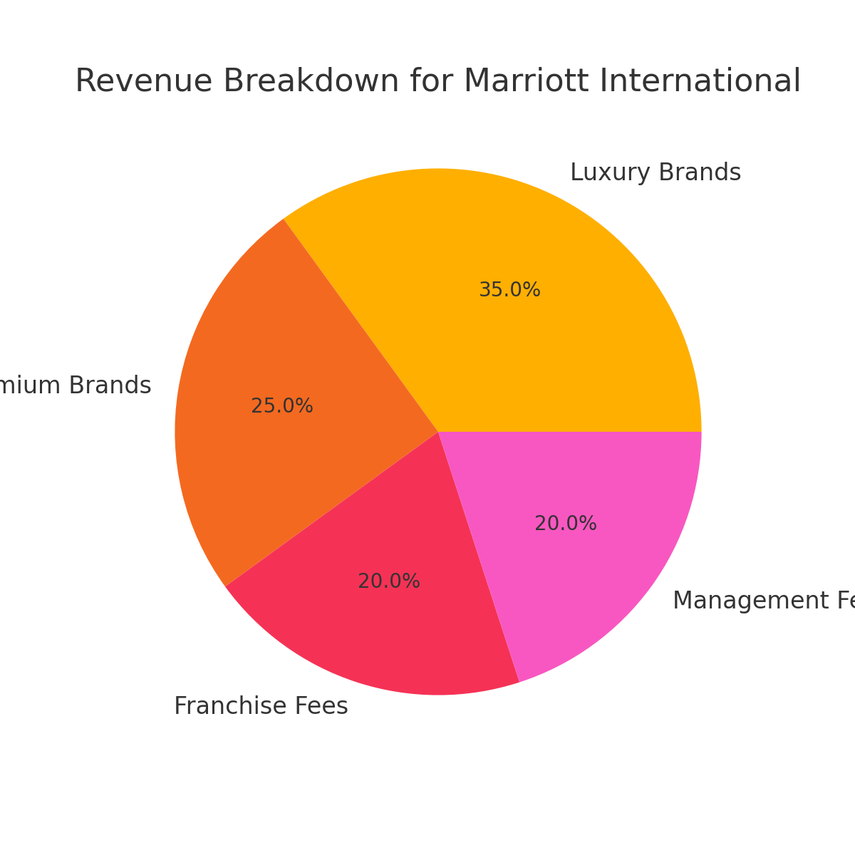

**Marriott International - Peer Comparison**

**Peers:**

* **Hilton Worldwide Holdings Inc.**
* **Hyatt Hotels Corporation**

**Revenue and Performance Comparison:**

* **Marriott International:**
  + **Revenue (2023):** $22.89 billion
  + **Revenue Per Available Room (RevPAR) Growth:** Strong recovery post-pandemic, with notable growth in premium and luxury segments.
  + **Global Reach:** Over 8,800 properties globally across various price points, including a dominant presence in luxury markets.
  + **Occupancy Rates:** Recovering occupancy rates close to pre-pandemic levels, especially in key markets like North America and Asia-Pacific.
* **Hilton Worldwide:**
  + **Revenue (2023):** $9.67 billion
  + **RevPAR Growth:** Similar to Marriott, Hilton has experienced a strong rebound in RevPAR, particularly in its premium and business travel segments.
  + **Global Reach:** Over 7,000 properties worldwide, with strong presence in mid-tier and premium brands like Hilton Hotels & Resorts and Waldorf Astoria.
  + **Occupancy Rates:** Hilton has seen strong recovery in leisure travel markets, though its recovery in business travel has lagged slightly compared to Marriott.
* **Hyatt Hotels Corporation:**
  + **Revenue (2023):** $6.56 billion
  + **RevPAR Growth:** Hyatt has experienced a significant rebound in RevPAR, driven by its expansion into luxury and lifestyle brands.
  + **Global Reach:** Smaller in scale compared to Marriott and Hilton, with around 1,250 properties, but growing rapidly in the luxury market.
  + **Occupancy Rates:** Strong occupancy rates in leisure destinations, but less diverse geographic coverage compared to Marriott and Hilton.

**Summary of Comparison:**

* **Marriott** leads in overall revenue, largely due to its size and luxury portfolio, which allows it to capture high-end customers globally.
* **Hilton** competes well in terms of RevPAR and occupancy, especially in its premium and mid-tier brands.
* **Hyatt**, while smaller in scale, focuses more on lifestyle and luxury segments, which has driven strong recovery and revenue growth. However, Marriott’s scale and brand diversification give it a stronger revenue base and resilience in various market conditions.

# Johnson & Johnson

Johnson & Johnson’s revenue is driven by two primary divisions: Innovative Medicine and MedTech. Products like DARZALEX (oncology) and STELARA (immunology) are significant contributors to revenue growth. The acquisition of Abiomed has bolstered the MedTech division, adding cardiovascular technologies.

**Revenue Breakdown into Price and Volume:**

* **Price**: J&J’s pricing strategy depends on its Innovative Medicine and MedTech segments. In pharmaceuticals, higher pricing for specialty drugs like **DARZALEX** (used in oncology) contributes to higher revenue per unit. MedTech pricing is driven by premium offerings like advanced surgical equipment.
* **Volume**: The volume aspect relates to the number of units sold for medicines and medical devices. Growth in patient access and global distribution leads to higher volumes sold.
* **Revenue Growth Influences**:
  + **Price Increases**: Breakthrough drugs that treat critical conditions (e.g., DARZALEX for cancer) allow J&J to set premium prices, contributing significantly to revenue growth.
  + **Volume Growth**: As J&J continues to expand into emerging markets and new product segments (like cardiovascular tech with Abiomed), the volume of units sold grows, thus increasing revenue.

**Cost Drivers and Their Correlation to Revenue:**

* **Fixed Costs**:
  + **Research & Development (R&D)**: Significant R&D investments are required to develop new drugs and medical technologies. These costs are fixed as they do not fluctuate directly with current revenue but are crucial for long-term growth.
  + **Manufacturing Facilities**: J&J has extensive manufacturing facilities for pharmaceutical and MedTech products. These costs are relatively fixed as capacity is built to meet long-term demand.
* **Variable Costs**:
  + **Raw Materials**: Costs for materials used in drug production and medical devices vary depending on the number of units produced. A higher volume of sales leads to increased raw material costs.
  + **Sales and Marketing**: Marketing expenses, especially in pharmaceutical segments, are variable and scale with the level of product launches and expansions into new markets.
  + **Regulatory Compliance**: Costs related to compliance with local and international regulations can vary depending on the number of new product launches and global expansions.

**Overall Performance:**

* Johnson & Johnson has consistently managed its high R&D costs, understanding that the long-term revenue growth from innovative therapies outweighs these expenses. The company’s ability to maintain premium pricing on essential drugs while expanding volume globally ensures robust revenue growth. J&J has also managed its variable costs effectively, especially in its growing MedTech division, ensuring that increases in sales translate into improved profitability.

The pie chart below illustrates the breakdown of costs for Johnson & Johnson:

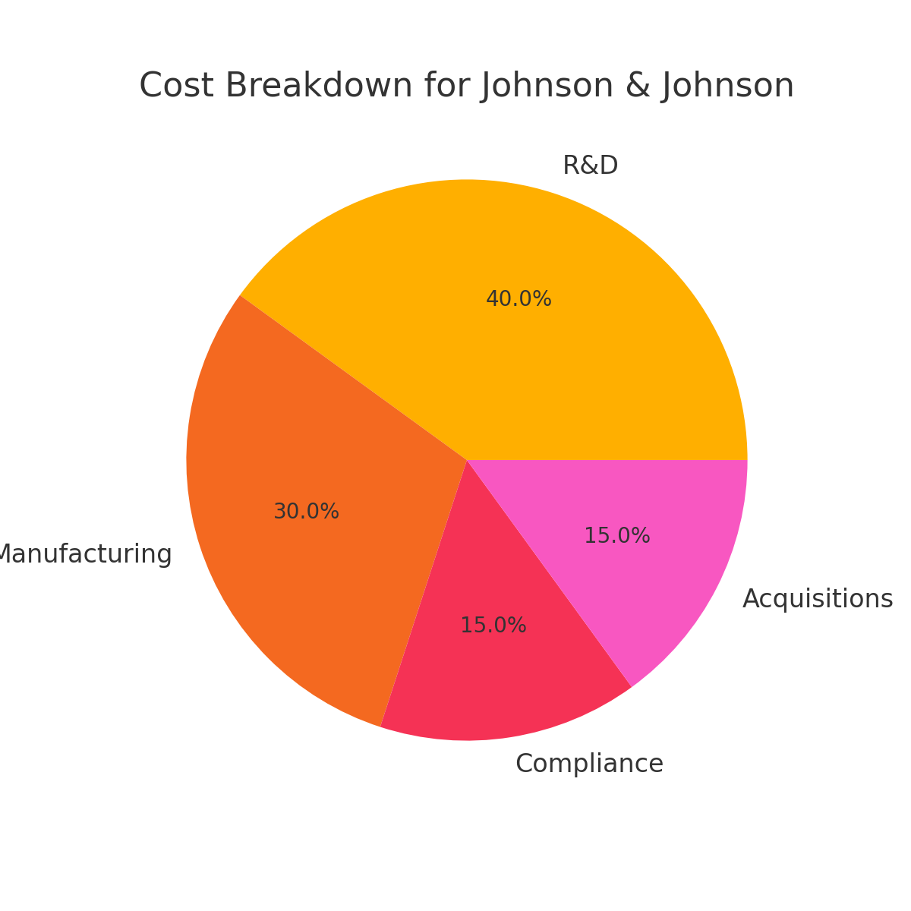

**Johnson & Johnson - Peer Comparison**

**Peers:**

* **Pfizer Inc.**
* **Medtronic plc**

**Revenue and Performance Comparison:**

* **Johnson & Johnson:**
  + **Revenue (2023):** $95 billion
  + **Key Segments:** Innovative Medicine (pharmaceuticals) and MedTech.
  + **Revenue Growth Drivers:** Premium pricing of specialty drugs like DARZALEX and STELARA; expanding global access to its MedTech solutions through acquisitions like Abiomed.
* **Pfizer Inc.:**
  + **Revenue (2023):** $81 billion
  + **Key Segments:** Pharmaceuticals, particularly vaccines and oncology.
  + **Performance:** Pfizer’s COVID-19 vaccine was a major driver of revenue growth in 2021-2022, but post-vaccine revenue has normalized. The company’s oncology and rare disease segments are still strong revenue drivers.
  + **R&D Costs:** Like J&J, Pfizer invests heavily in R&D for drug development, which constitutes a major part of its fixed costs.
* **Medtronic plc:**
  + **Revenue (2023):** $31.7 billion
  + **Key Segments:** Medical devices, particularly in cardiovascular, diabetes, and neurology.
  + **Performance:** Medtronic, as a peer in the MedTech segment, competes directly with J&J’s medical devices business. The company has seen steady growth due to innovation in surgical and cardiovascular devices.
  + **R&D and Regulatory Costs:** Similar to J&J, Medtronic has significant fixed costs related to R&D and regulatory compliance.

**Summary of Comparison:**

* **Johnson & Johnson** leads in total revenue, largely due to its diversified portfolio in both pharmaceuticals and MedTech, which makes it more resilient compared to more focused competitors like Pfizer (which saw a post-pandemic revenue dip).
* **Pfizer** has been a strong competitor in the pharmaceutical space, especially with its leadership in vaccine development. However, J&J’s broader portfolio across MedTech provides a more balanced revenue mix.
* **Medtronic**, while smaller in scale, competes effectively in the medical devices sector, but it lacks the pharmaceutical revenue drivers that give J&J a broader base.

### Conclusion

Both **Marriott International** and **Johnson & Johnson** demonstrate strong performances driven by effective management of their revenue and cost drivers. Marriott has capitalized on its global presence, luxury brand portfolio, and pricing strategies, while maintaining solid control over variable costs like labor and utilities. The recovery in global travel and its diverse property portfolio positions Marriott well for sustained revenue growth.

Johnson & Johnson benefits from its diversified business across pharmaceuticals and MedTech, leveraging premium pricing for its innovative drugs and expanding global access to its medical devices. Despite significant fixed costs in R&D and regulatory compliance, J&J’s ability to scale volume and maintain strong pricing power ensures continuous revenue growth.

In comparison to their peers, Marriott and Johnson & Johnson both lead in their respective industries due to their large scale, effective cost management, and ability to drive growth through premium pricing and global market expansion. These strengths provide them with resilience and the ability to navigate market challenges while continuing to grow profitably.