Visa Inc. Market Research Report

**1. Industry Overview**

Visa Inc. operates within the financial services industry, specifically focusing on the digital payments segment. The industry is experiencing rapid growth due to a global shift toward cashless transactions. This transformation is being driven by factors such as technological advancements, consumer preference for more convenient and secure payment methods, and increasing e-commerce activity. Visa's primary offerings include credit, debit, and prepaid card services, alongside a growing range of digital and mobile payment solutions.

Visa operates a highly advanced, global payments network, enabling seamless transactions between consumers, businesses, and financial institutions. The company is at the forefront of fintech innovation, and its vast network spans multiple countries, processing billions of transactions annually. As cashless economies grow, Visa is positioned to capture a significant portion of the expanding market.

**2. Close Peers**

Visa faces strong competition from two major peers: Mastercard and PayPal.

Mastercard: Similar to Visa, Mastercard is a global payment technology company that processes transactions via credit, debit, and prepaid cards. Mastercard’s strength lies in its international presence, where it has gained traction in various emerging markets. Though Visa holds a larger share of the global market, Mastercard is continuously innovating and expanding its partnerships, which keeps the competition intense.

PayPal: PayPal is a leading digital payments platform that has diversified beyond traditional card networks. With a particular focus on e-commerce and mobile payments, PayPal is directly competing in the growing digital payments space. PayPal has been gaining market share, especially among younger, tech-savvy consumers, and its acquisition of Venmo has expanded its foothold in peer-to-peer payments, challenging Visa in the digital wallet and mobile payment sectors.

**3. Substitutes and New Markets**

Visa is facing potential disruption from cryptocurrencies and blockchain-based payment solutions, such as Bitcoin and Ethereum. These alternatives enable peer-to-peer transactions without relying on traditional banking infrastructures, presenting a long-term risk to Visa’s business model. Although still in a nascent stage, the rise of decentralized finance (DeFi) could lead to structural changes in the way payments are processed globally.

Visa is also expanding into new markets, particularly in developing regions where mobile and cashless payments are on the rise. In areas such as Africa and Southeast Asia, the adoption of e-wallets and digital payment platforms is accelerating. With a growing middle class and increased smartphone penetration, these regions represent key growth opportunities for Visa.

**4. Key Revenue and Cost Drivers**

Visa's primary source of revenue is from transaction fees, particularly cross-border transaction fees charged to merchants and financial institutions whenever consumers use Visa-branded cards or payment solutions. Cross-border transactions are especially profitable due to higher fees associated with foreign currency exchanges.

Visa also generates significant revenue from value-added services, such as fraud prevention, data analytics, and payment security solutions. These services are increasingly in demand as businesses and financial institutions seek to enhance security and optimize payment processes.

On the cost side, Visa faces substantial expenses related to maintaining its global transaction processing infrastructure, which requires continuous investments in cutting-edge technology to ensure system reliability and speed. Visa also incurs high costs related to regulatory compliance and cybersecurity, as safeguarding its network from breaches is a critical priority in today's digital landscape.

**5. Current Industry/Market Trends**

The financial services industry is undergoing a significant transformation due to the growing adoption of digital payments. Key factors include the rise of e-commerce, mobile transactions, and the growing preference for contactless payments. The COVID-19 pandemic accelerated this shift, with consumers now favoring fast, secure, and hygienic payment methods over traditional cash transactions.

Another major trend is the rise of decentralized finance (DeFi) platforms. These systems provide peer-to-peer lending and blockchain-based transactions, challenging traditional payment networks. Visa has responded by forming strategic collaborations with fintech companies and investing in blockchain technology to remain competitive and innovate in this rapidly evolving space.

**6. SWOT Analysis Grid**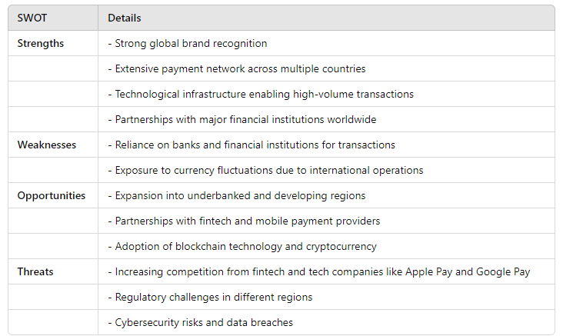

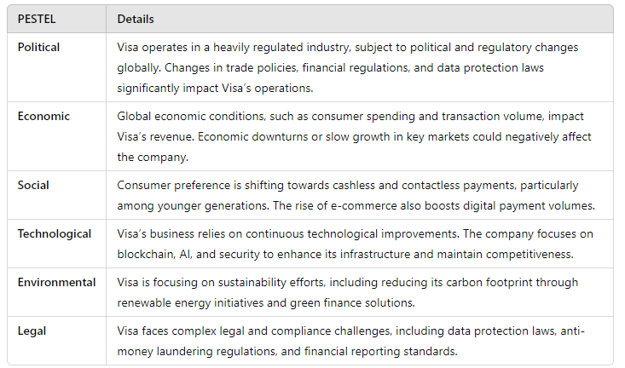7. **PESTEL Analysis Grid**

**8. Competitive Environment**

Visa operates in an intensely competitive environment. While Mastercard remains its closest rival in the traditional card payments market, the rise of fintech companies like Square and Stripe is reshaping the landscape. These fintech disruptors offer faster, more flexible, and cost-effective digital payment solutions, appealing to small businesses and tech-savvy consumers.

To maintain its competitive edge, Visa continues to invest heavily in technology, security infrastructure, and strategic partnerships. Mastercard has adopted a similar approach, increasingly focusing on fintech acquisitions and collaborations with governments to expand its reach in underbanked regions. Fintech companies, in contrast, are leveraging their agility to disrupt traditional payment systems with more efficient services, pushing Visa to innovate and diversify its offerings.

**Conclusion**

Visa Inc. stands at a pivotal moment within the rapidly evolving financial services landscape, primarily driven by the shift toward cashless transactions and technological advancements. The company's robust global payments network positions it well to capture significant market share, particularly in emerging regions where mobile payments are gaining traction. However, Visa faces fierce competition from both established players like Mastercard and innovative fintech disruptors such as PayPal, Square, and Stripe.

Additionally, the rise of cryptocurrencies and decentralized finance presents long-term challenges that could disrupt traditional payment models. To sustain its competitive advantage, Visa must continue investing in technological advancements, cybersecurity, and strategic partnerships while adapting to changing consumer preferences and emerging market trends.

Overall, while the challenges are significant, Visa's proactive approach to innovation and market expansion suggests a strong potential for growth in the evolving digital payments landscape.