**Peer Identification**

1. Overview

A peer group can be defined as a group of comparable companies which compete in the same industry and almost the same size. For identification purposes I will be guided by the following variables

* Business activities
* Demand factors
* Cost structures
* Access to capital

Five companies will be covered in this report which are Marriot, Tesla, Netflix, Nnividia and Pfizer. The following ratios will be used to determine efficiency, liquidity and profitability relative to its peers

* Liquidity - Quick ratio
* Asset utilisation - total asset turnover
* Profitability - EBIT margin

For profitability we are going to use EBIT margin/operating profit margin because it is the best measure of how a company is managing its costs. For liquidity we selected the quick ratio because this ratio can present better insight into the short-term liquidity of the firm because of the exclusion of inventory. Finally total asset turnover will be used to measure how well organisations utilised their assets to generate revenue.

1. Marriot Inc

This company is in the hospitality industry with a global presence in 139 countries, 40 brands and 1.5 million rooms

| Peer | Justification |
| --- | --- |
| 1. Hilton Worldwide | * Both in hospitality industry * Present in 122 countries, 22 brands and over a million rooms |
| 1. Accor | * Both in hospitality industry * Same size as Accor has more than 800000 rooms and 40 brands * Same market with a global presence in 110 nations |
| 1. IHG hotels & Resorts | * Both in the hospitality industry * All big in terms of size with more than 920000 rooms and 19 brands * All multinationals with a presence in more than 100 countries |

2.1. Quick ratio

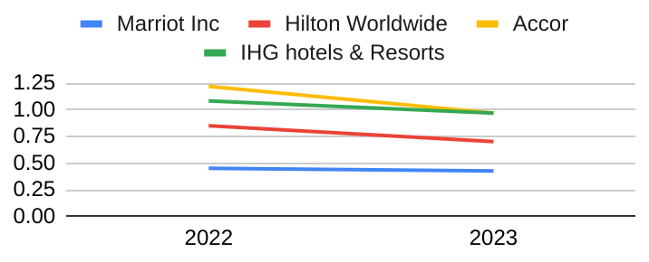

2.2. EBIT margin

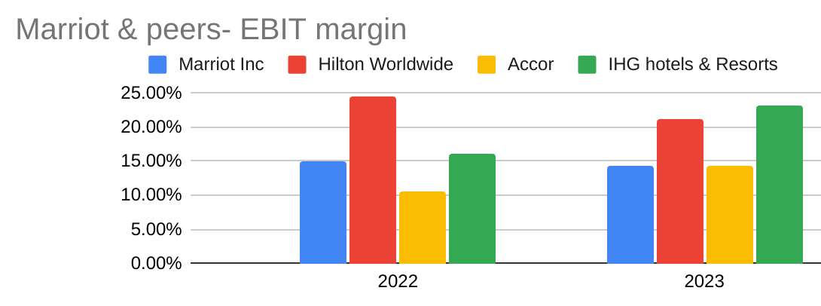

**2.3. Total asset Turnover**

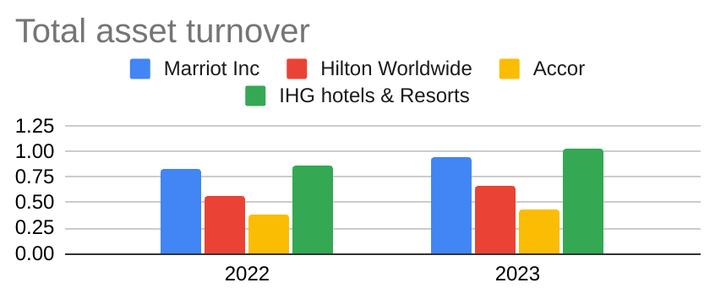

**2.4. Ratio analysis**

Liquidity of Marriot Inc is below the generally accepted levels and even below its peers. Profit margin is lower relative to the peer averages as well while asset efficiency is averagely higher. It is a sign that although the company is doing well in generating sales, its failing to manage current assets and keeping low costs.

**3. Tesla Inc**

Tesla is a leading brand with a global market in the auto-motive industry and specifically EV(electric vehicle) sector. The peer group established here is based on companies in EV production.

| Peer | Justification |
| --- | --- |
| 1. BYD company limited | 1. Same type of business 2. Competing in the same global market 3. In the top 2(with tesla) list of EV producers |
| 2. VW group | 1. All in EV manufacturing 2. A global giant 3. In the top 3 according to: *impact report 2023* |
| 3. General motors | 1. All US based companies 2. Produce EV automotives 3. In the top 6 worldwide in EV production 4. A big competitor on the global market as well |

**3.1. Quick ratio**

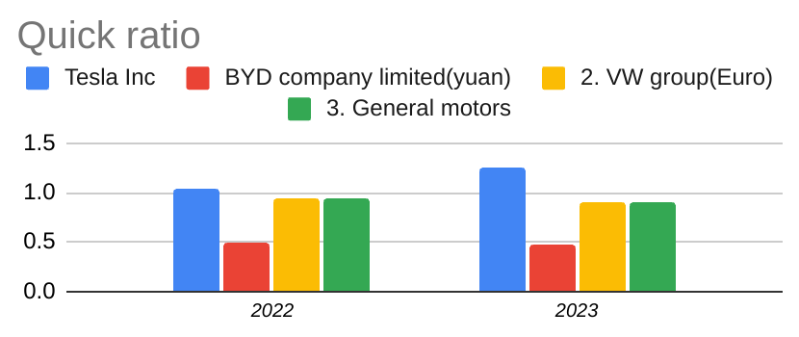

**3.2. EBIT margin**

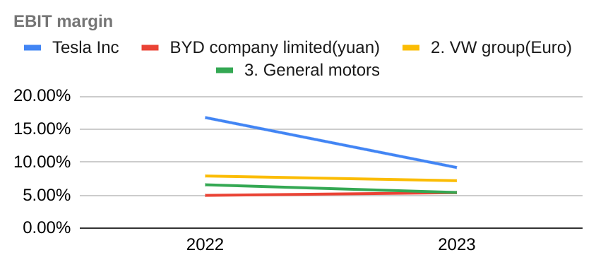

**3.2. Total asset turnover**

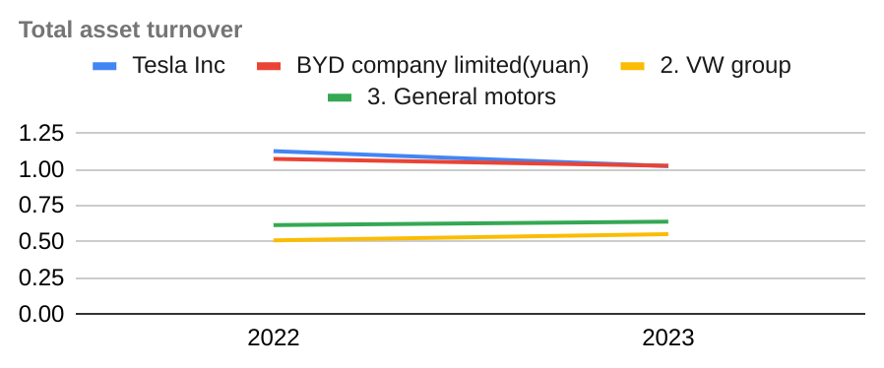

**3.4. Ratio analysis**

**Tesla** has a good quick ratio of above 100%, better EBIT margin than all 3 peers and finally the best in terms of asset efficiency. The company is taking advantage of its efficient assets to minimise costs and mobilise optimal current assets to meets daily operational needs.

**4. Netflix**

Netflix is a big player in the video streaming business with a market share of 21% in the US while its market extends beyond US borders. Its main peers are shown in the table below

| Peer | Justification |
| --- | --- |
| 1. Amazon Prime | * Both invest in original content * Both compete to expand their libraries * Both offer inherent user interfaces, high quality streaming and personalised recommendations * Both available on the global platform * Both entertainment media companies |
| 1. Disney + | * Both entertainment media companies * Both offer original content * All available on the global platform * Both invest in extensive library |
| 1. Paramount + | * Both compete heavily in the US market * All provide subscription & video streaming services * Are in the same entertainment & technology industry |

**4.1. Quick ratio**

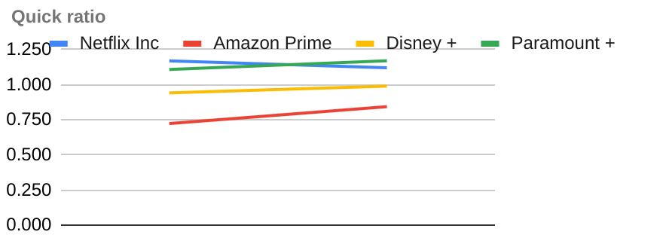

**4.2. EBIT margin**

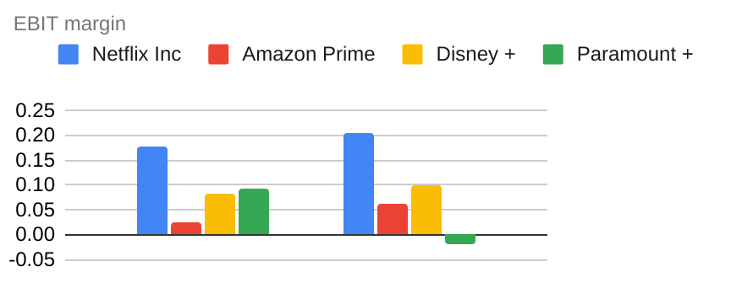

**4.3. Total asset turnover**

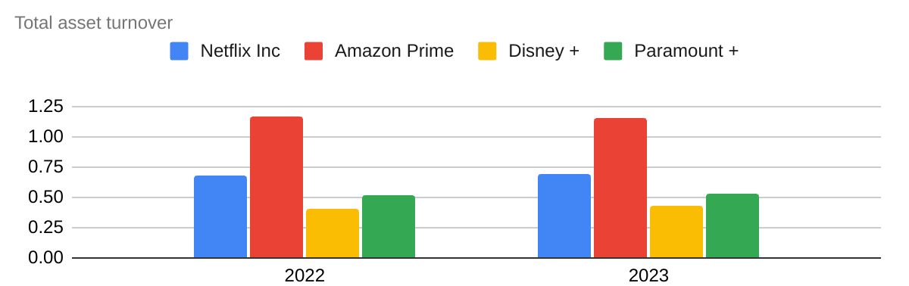

**4.4. Ratio analysis**

**Net**flix has a favourable quick ratio, best EBIT margin among its peers and relatively average asset turnover ratio. So when compared with its industry peers, the company is doing in generating sales, keeping costs under control and therefore liquid enough to meet immediate financial obligations.

**5. Nvidia Inc**

Nvidia is an American based multinational corporation and technology company. Below is tabular list of its main peers

| Peer | Justification |
| --- | --- |
| 1. Cisco | * Both technology companies * Compete and operate in the same US market * All public companies |
| 1. Hewlett Packard Enterprise | * Both technology companies * All based in US * All public companies * All in artificial intelligent & cloud computing business |
| 1. Broadcom | * All technology companies * All in semiconductors & software business * All based in US * All public companies |

**5.1. Quick ratio**

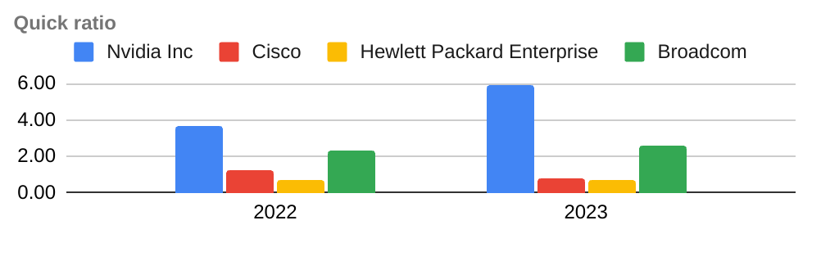

**5.2. EBIT margin**

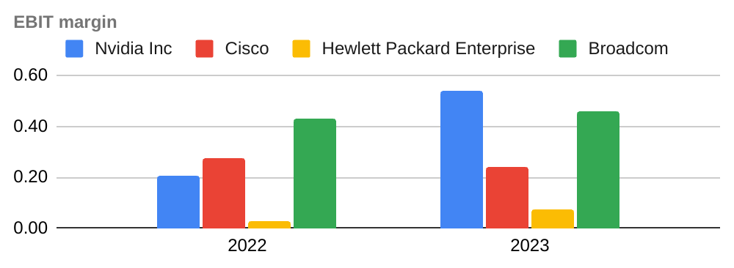

**5.3. Asset turnover**

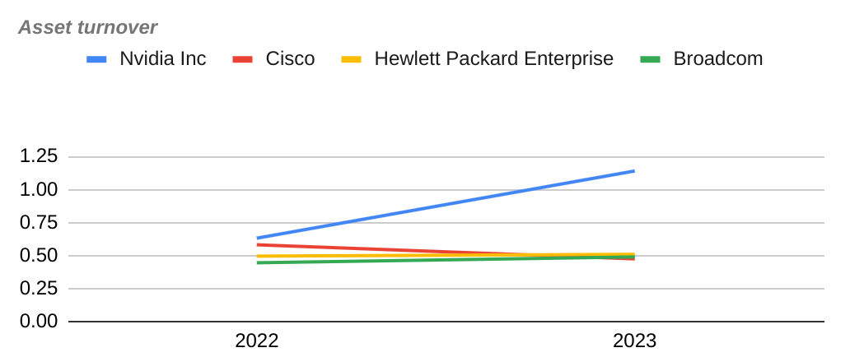

**5.4. Ratio analysis**

With a very good liquidity position amongst its peers, viable EBIT margin and best asset turnover, Nvidia is doing well in business. Again its ability to generate sales is placing the company in a better position to meet daily business needs and build more profits.

**6. Pfizer Inc**

Pfizer is an American biotechnological and pharmaceutical corporation with a market capitalization of $160.59 billion as on 4 October 2024. Had a total revenue of $58.5 billion in 2023 with more than 50% of its revenue generated from overseas markets. Some of its key peers in business are listed on the table below

| Peer | Justification |
| --- | --- |
| 1. Johnson & Johnson | * Both in pharmaceutical & biotechnology business * A big player as well with revenue of $85.2 billion in 2023 * All public companies * All US based companies * A big competitor in terms of size with market cap of $395.2 billion |
| 1. Roche Holding AG | * All pharmaceutical companies. * Big competitor on the global market * Almost same size with a revenue of $69.1 billion in 2023 and market cap of $256.6 billion |
| 1. Merck & Co Inc | * With a market cap of $297 billion and 2023 revenue of $60.1 billion, they are in the same size category. * All US based public companies * All in pharmaceutical and biotechnological companies |

6.1. Quick ratio

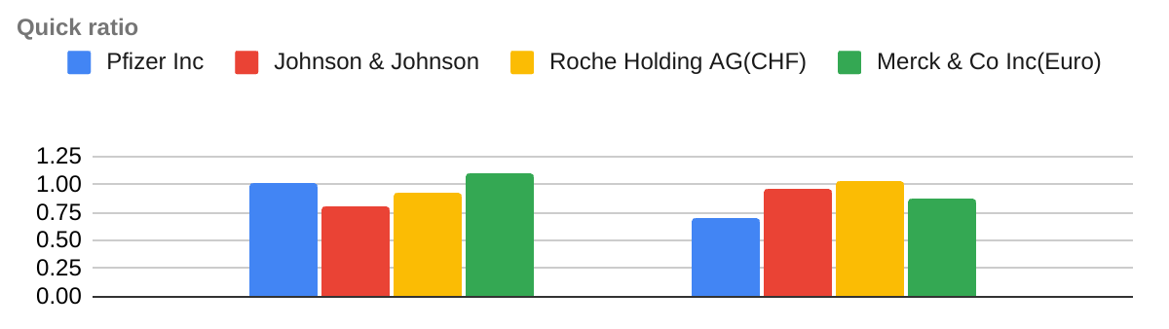

6.2. EBIT Margin

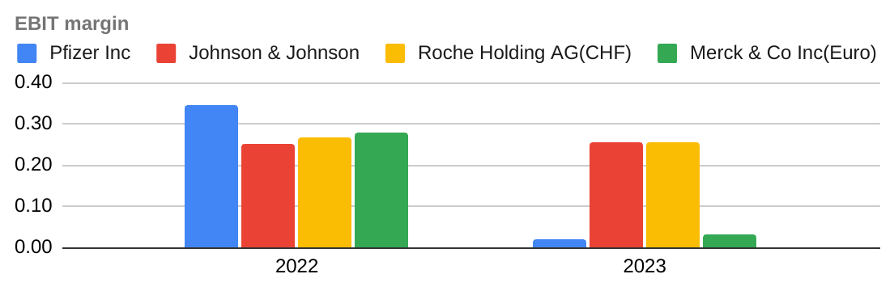

6.3. Total asset turnover

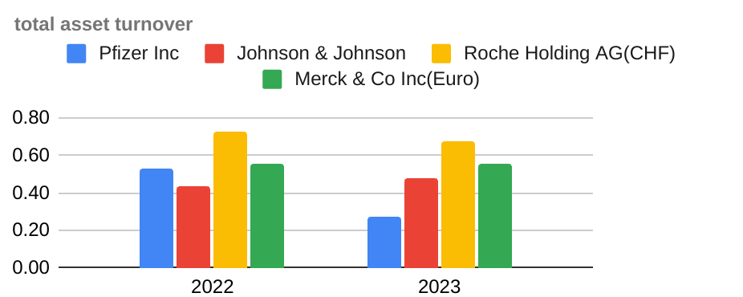

**6.4. Ratio analysis**.

The 3 computed ratio shows that the company is not in a healthy liquidity position, an unstable profit margin and probably below average asset turnover. Though in nominal terms it has a higher revenue figure and is bigger in size, its efficiency in utilising assets is comparatively below par.

**References**

1. <https://hotelresortdesign-south.com/>
2. investopedia.com
3. <https://www.globaldata.com>
4. <https://www.nasdaq.com/market-activity/stocks>
5. https://finance.yahoo.com/quote