**Revenue & cost drivers**

**Case of Marriot Inc & Johnson & Johnson**

1. **Overview**

Revenue drivers are those factors that directly influence or activities that generate company revenue. Similarly, cost drivers determine the level of various costs in an organisation. We are going to analyse revenue and cost drivers for Marriot Inc and Johnson & johnson focusing mainly on the 3 year period from 2021 to 2023.

1. **Revenue drivers**

2.1. Marriot Inc

Revenue is made up of the following major components

* Base Management and Incentive Management Fees: For managed properties and licences to intellectual property. This is based on a percentage of revenue or profit as defined in each contract.
* Franchise Fee and Royalty Fee Revenue: on

franchisees and operators licence to intellectual property for use of brand names.

* Owned and Leased Hotel Revenue: At owned and leased hotels which provides accommodations and other ancillary services to hotel guests.
* Cost Reimbursements: reimbursed for certain

costs we incurred on behalf of the managed, franchised, and licensed properties.

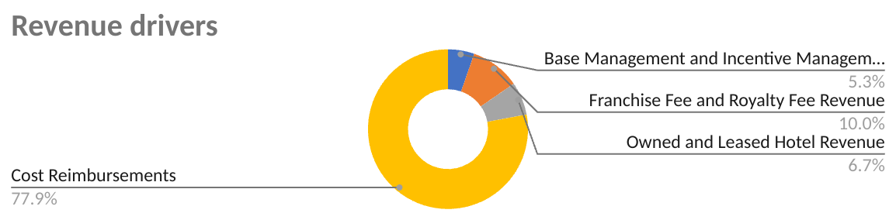

The above 4 revenue components are directly influenced by the following drivers.

* Number of available rooms
* Quality of hotel management services
* Charging a competitive price since accommodation services are price elastic
* Marketing strategies for customer retention and new customers
* Number of franchises

***Price volume analysis(PVA)*** - Data available over the 3 year period from 2021 to 2023 shows that much of the change in revenue could be attributed to the number of rooms available and clientele base. The table below shows a positive relationship between changes in those variables.

|  | 2023 | 2022 | **% change** |
| --- | --- | --- | --- |
| Revenue | 25069 | 22355 | **0.1214046075** |
| Number of rooms | 1,597,380 | 1,525,407 | **0.04718281744** |

An increase in revenue due to increase in rooms available will be dependent on other related variables like good marketing strategies, product mix and price as well. Due to stiff competition on the market an increase in price will reduce demand and revenue while a drop in prices might increase sales volume but costs increase as well. So prices must be maintained above the break even point but not too high to chase away customers.

2.2. Johnson & Johnson

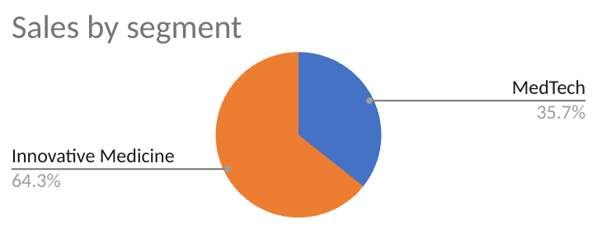

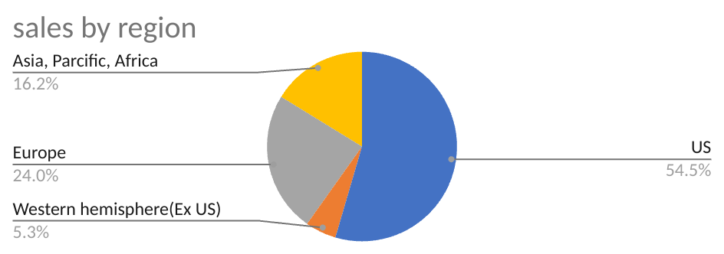

Revenue sources can be categorised as segments or regions and the following table explains drivers responsible for sales movements

| Driver | Explanation |
| --- | --- |
| 1. Enterprise | * Being a leader through transformational science & technology * It ensures that products will meet customer needs and expectations |
| 1. MedTech | * Delivering growth through geographical expansion * Growth through differentiated products |
| 1. Innovative medicine | * Innovations that will lead to breakthrough treatments * Delivering a wider product expansion |
| 1. Strong financial foundation | * Continued funding on research & development and asset acquisitions |

***Sales Volume analysis***

| Sales increase/(decrease) due variable changes | 2023 | 2022 |
| --- | --- | --- |
| Volume | 6.80% | 8.30% |
| Price | 0.60% | -1.80% |
| Currency | -0.90% | -4.90% |
|  |  |  |
| Total | 6.50% | 1.60% |

Sales volume increased but not proportional to sales value as what would have been expected. Thus revenue changes were influenced by a mix of volume, price and currency. In 2022 There was 1.6% change in revenue as a result of 1.8% drop in prices on products, 4.9 % negative change in exchange rates and 8.3% increase in sales volume. Again in 2023 it can be seen that currency changes had a negative effect on revenue while price change and sales volume had a positive effect.

**3. Cost drivers**

Cost drivers are those factors which affect the level of business costs. They need to be well understood so as to be managed and improve profitability. They can be directly related to revenue, overhead or activity based.

3.1. Marriot Inc

The table below identify main cost drivers for Marriot Inc and how they are related to business operational functions

| **Cost item** | **Relationship with revenue** | **driver** |
| --- | --- | --- |
| 1. Owned & leased property expenses | Directly related to property revenue | Volume of properties owned or leased |
| 2. Reimbursement expenses | Directly related to reimbursement cost revenue | Volume of franchises and licences |
| 3. Merger related expenses | No strong relationship | Mergers and acquisition of other companies |
| 4. Depreciation & amortisation | Overhead expenses and not directly related to revenue | Value of properties and assets held by the company |
| 5. Administrative expenses | Not directly related to revenue | This is driven by the amount of activity happening in the organisation. |

**3.2.** Johnson & Johnson.

| **Cost item** | **Relationship with revenue** | **driver** |
| --- | --- | --- |
| Cost of sales( raw material costs) | * This is directly related to sales | Its a variable cost based on volume of raw material purchased  It also varies according to supplier prices and terms |
| Selling, marketing and administrative expenses | Positively correlated with sales. | It varies according to marketing & promotional activities in the company |
| Research and development expense | Positively correlated with sales. | This is dependent on R & D projects being undertaken. |
| In-process research and development impairments | Negatively related with sales |  |

**4. Company performance**

For a company to achieve its targets, there are costs involved so there is need for cost awareness and sensitivity to make more informed decisions. Costs must be kept at optimal levels that maximise productivity and profits. We are going to analyse the efficiency of each firm's cost management in supporting revenue growth while maximising profits.

4.1. Marriot Inc

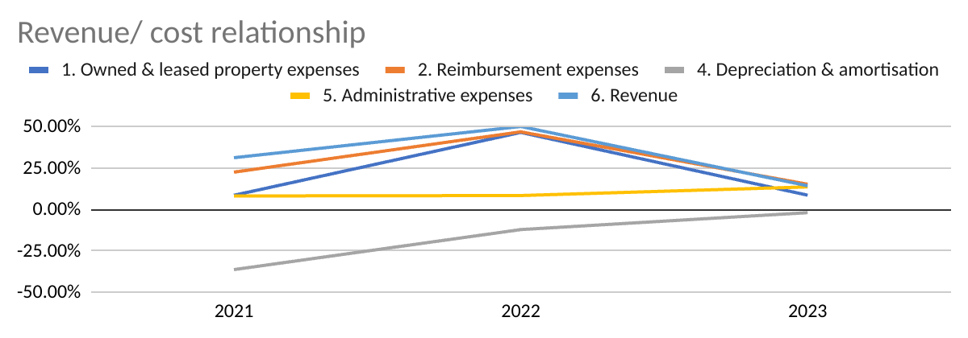

There is a weak correlation between revenue changes, Depreciation and administration expenses. Depreciation is a fixed cost which does not respond to sales trends or day to day activities in an organisation. Furthermore, depreciation is going down implying less investments in acquisition of plant and equipment which might impact negatively on future sales growth. Administration costs as well show little relationship with sales because they are more determined by activity rather than sales directly.

The chart exhibits the effectiveness in managing and keeping costs within optimal range while increasing sales. The percentage change in revenue is always above expenditure changes suggesting that an additional dollar on costs yielded more than a dollar in sales revenue.

4.2. Johnson & Johnson

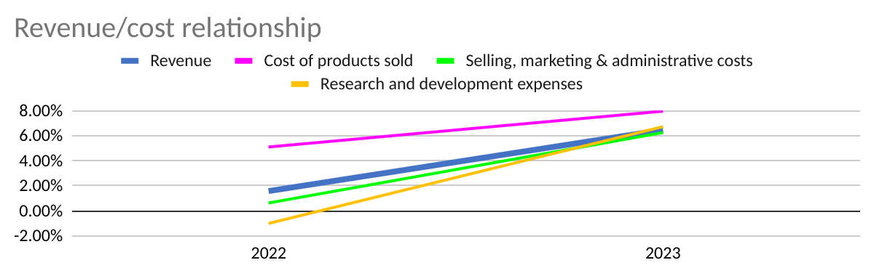

The acceptable scenario is when a change or increase in costs is overwhelmed by a bigger margin increase in revenue and that entails an efficient cost management approach. Nevertheless, the chart above is showing a proportionally bigger growth in cost of sales than revenue. The company needs to pay attention to that and come up with strategies to lower the cost of sales.

1. **Comparison with peers**

5.1. Marriot inc

The sole organisational goal is to increase earnings by boosting sales at the same time maintaining low costs. It is under this premise that we are going to analyses Marriot’s performance by comparison with its industry peers by focusing on operational profit(EBIT) margin. If a company is well managing its revenue and cost drivers, revenue grows while costs are maintained relatively low and evidenced by a favourably higher margin.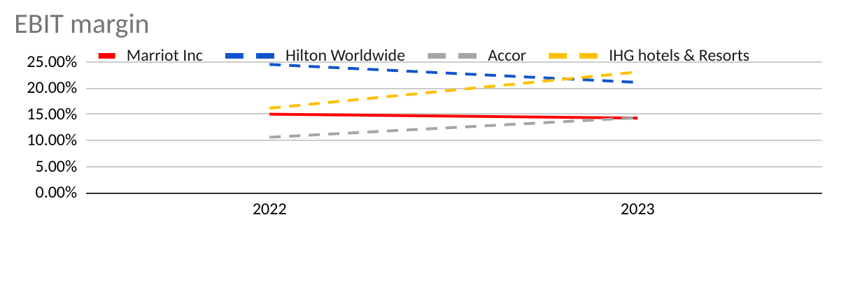

Marriot’s EBIT margin shown by the continuous red line chart is comparatively lower than other peers giving the impression that there is room and need of maintaining lower cost levels.

5.2. Johnson & Johnson

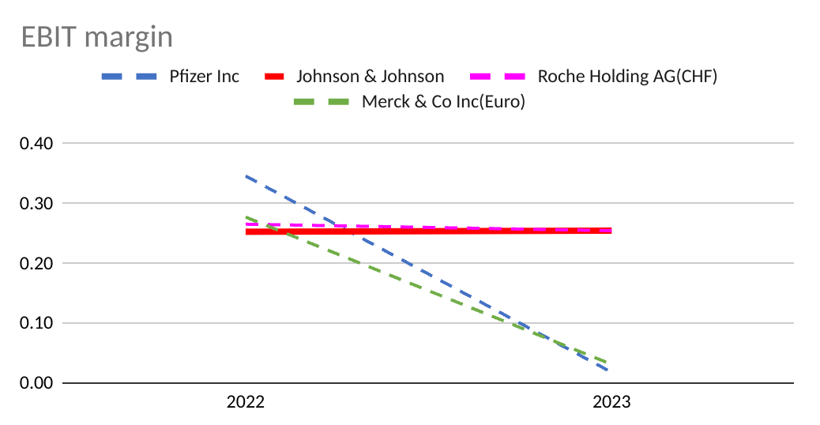

Johnson & Johnson EBIT margin had been consistently about 25% over the two year period. Furthermore, in 2022 its margin was not far from industry peers while in 2023 it was relatively good when compared with other companies from the same industry.

**References**

1. [jnj.com/media-center/press-releases/](http://jnj.com/media-center/press-releases/)
2. <https://fastercapital.com/>
3. https://marriott.gcs-web.com/