**Market research report : Visa Inc**

**1. Overview**

Visa Inc is one of the world’s leaders in digital payments with global presence in more than two hundred countries. The company offers a range of payment solutions including credit, debit, prepaid and cash programs. They also offer transaction processing services such as authorisation, clearing and settlement.

**2. Industry**

**The company** is a global payment technology company that operates in the digital payments industry. It serves individual and commercial clients, financial institutions, government and non governmental organisations.

**3. Peers for Visa Inc**

Two major peers in terms of type of business and market share identified in this report are Mastercard and American express

### 3.1. Mastercard.

### This is a giant in the digital remittances sector which is developing through partnerships and innovations. In recent years it collaborated with EthSwitch of Ethiopia and many other overseas players in the financial remittances sector. These efforts have underscored Mastercard’s position in global remittances making it more accessible and affordable worldwide.

MasterCard is Visa’s main peer due to its closeness in size, type of business, sphere of influence and market share. In the second quarter(Q2) of 2022 Visa’s market capitalisation (cap) was $409.56 billion while MasterCard was $306.85 billion. On market share in 2019 Visa recorded 5 billion transactions compared to 4 billion for MasterCard. Geographically, both cover a wider stretch with Visa payment network covering 200 countries while MasterCard reports a coverage of 210 countries.

**3.2. American Express**

This company is very active in the digital remittances sector through partnerships and innovations. Their recent development is launching its Global Pay Services to send international payments through digital platforms. Furthermore revenue generation has increased to $60 billion in 2023 which is 14% increase from the previous year. Like Visa, American Express is based in the USA but has global coverage.

**4. Substitutes & new markets**

### If one was to find a close substitute for Visa services, MasterCard might be the closest option. This is in terms of the type of services and coverage offered by the two companies. They both do not issue cards directly to customers but do so through partner member financial institutions such as banks and credit unions.

### There are more opportunities for growth in developing countries with an expanding middle class population.

**5. Revenue and cost drivers**

The key revenue drivers are:

* Number of customers who use Visa services globally
* Volume of transactions and amounts involved
* Number of clients who are provided with authorization, clearing, settlement; value added services related to issuing, acceptance, and risk and identity solutions; network access; and other maintenance and support services that facilitate transaction and information processing among the Company’s clients globally.
* International transaction for cross-border transaction processing and currency conversion activities.

On the other hand key cost drivers are

* Number of staff and organisational structure
* Marketing activities
* Network & processing activities

6. **Cost/revenue drivers in relation to industry trends**

**W**e will be comparing cost as a percentage of sales vis a vis figures for one major local and industry peer(MasterCard) to the company’s efficiency in managing revenue and cost drivers. The chart shows that Visa is doing relatively good in managing cost drivers and maintaining an optimal level that keeps revenue growing. Over the three years they managed to grow sales volumes while maintaining relatively low costs.

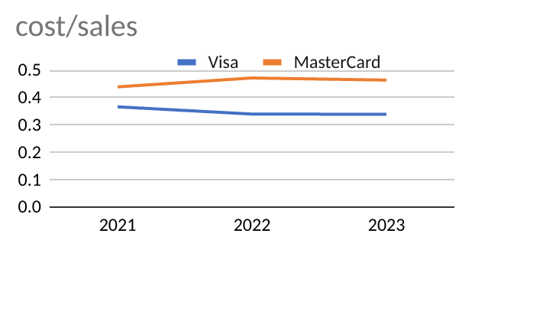

**7. SWOT analysis**

| **Visa Inc SWOT analysis** | | | |
| --- | --- | --- | --- |
| Strengths | **Weakness** | **Opportunities** | **Threats** |
| Largest Market Share Visa has the most significant [market share](https://www.marketing91.com/market-share-definition/) in the United States, reflecting its strong position in the worldwide payments business. Its dominance extends to digital transactions, demonstrating a solid position as the segment leader. It is viewed as a strong bank card company commanding a 50% USA market in card payments.  * Global Presence- It operates over two hundred countries giving it a significant geographical advantage for future growth. * Strong financial performance- Revenue growths has been recorded over the years * **Brand Reputation-** A globally known and established brand * Innovative products, advanced technology infrastructure, strong relationship with financial institutions etc | Risks & Hazards: There have been cases where transactions were compromised through fraudulent activities and bogus payments. Such incidents will basically lead to customers shunning Visa in preference to competitors productsDisagreements in Product Range. Limited customer choices because their products lack sense of diversity  * **Probe and Expansion;** There is need to catch up with innovation o defend their market share as other competitors in the financial sector are doing * **High Dependency Rate on Large Contracts-** Loss of these big contracts will greatly affect financially * Increasing competition, inability to expand in other regions, high operation costs, over dependence on banks etc | Increasing Use of Electronic Payments- Due to increase in technology, electronic payments are increasingly fast and convenient as customers quit cash.  * Expanding into emerging markets * Partnership with financial technology companies * Investing in cybersecurity and technological innovations * A developing cashless society and mobile payment apps and platforms | Global Transactions- Activities cover many nations thereby increasing exposure to currency fluctuations which has effect company revenuesCompeting Environment- Presence of big players like American Express, Mastercard and others increases the competitive environment.  * **Regulatory changes-** This imposes restrictions such as data protection, anti money laundering, interchange fees etc * **Cybersecurity Threats- Data** breaches and hacking imparts negatively by degrading consumer trust * Political instability |

**8. PESTEL grid**

| **Visa Inc PESTEL analysis** | | | | | |
| --- | --- | --- | --- | --- | --- |
| **Political** | **Economic** | **Social** | **Technological** | **Environmental** | **Legal** |
| **-** political uncertainties, international hostilities, armed conflicts, wars will affects money transactions within or between affected countries | -Adverse macroeconomic conditions within the U.S. or internationally which includes but not limited to recessions, inflation, rising interest rates, high unemployment, currency fluctuations, impacts directly revenue and expenditure steams | -Residual effects of COVID-19 negatively affected and may constitute to affect business, customer behaviour, cash flows and finances in general | -Developing substitute payment methods and technologies like block chain and cryptocurrencies can change the balance on the existing payment methods thus reducing Visa’s relevance to customers. | -Climatic change effects and recurrence of extreme weather conditions, effects on the power grid and other natural hazards will have a negative impact on financial transactions. | The company is obliged to meet legal, compliance and regulatory frameworks in the countries of operation. Failure will result in lawsuits, fines and finally financial losses. |

**9. Market competition**

**The** chart shows the competitive environment relative to its peers. Though the payment values for all players on the chart have increased, market share for Visa dropped from 43% in 2019 to 38% in 2023. These figures further explain competitiveness in the market such that more acquisitions, innovations and technological improvements are necessary. The company is trying to maintain its competitive advantage by coming up with growth strategies which increase purchases via its digital platforms. An example is its partnership with Starbucks.

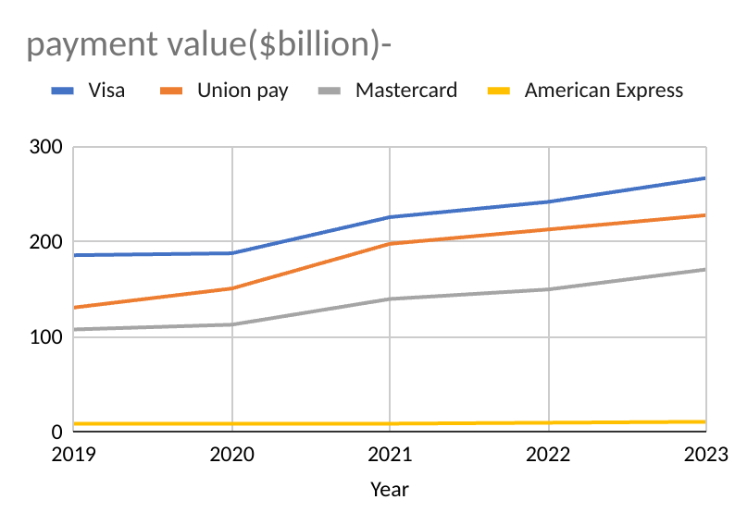

**References**

1. [https://annualreport.visa.com › home](https://annualreport.visa.com/home/default.aspx)
2. <https://www.marketing91.com>
3. <https://scoop.market.us>
4. <https://www.visualcapitalist.com/visa-mastercard-unionpay-transaction-volumes/>
5. <https://investor.mastercard.com/>
6. https://www.forbes.com/

