Instructions:
- After deriving the intrinsic share price based on our model, the next step is to focus on putting together a report with an investment recommendation.
- You are required to fill in the report template below using the sample report attached and your readings on the company’s guidance in terms of key segments and products.
  - Identify two to three key products that are vital for the company’s growth and you can discuss about the trends and expectations. But remember to keep them all short cause and effect sentences.
- You can take up to two days for this task and feel free to reach out to me if you have any questions.
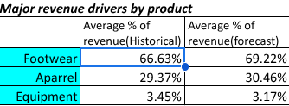
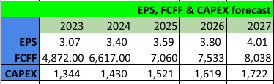
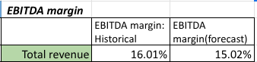
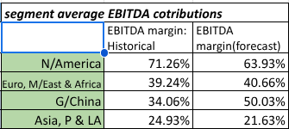
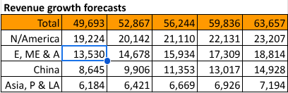
Company Name: NIKE, INC
Ticker NKE
Current Share Price : 116.15
Upside/Downside to current share price: 0.8450 [(214.30-116.15)/116.15]

Keep this blank for tables

Investment thesis:
Nike stock price is expected to grow from $116.15 in 2022 to $214.3 in 2027. This growth will be attributed mainly from the companies global market footprint, established brand and increased demand of its products

We expect EBITDA margins to be maintained above 15% of revenue in the next 5 years. North America will have a bigger share in earnings contribution averaging 63% followed by Greater China(50%), Europe/Middle east/Africa at 40% and Asia/Pacific/Latin America finally contributing 21.63% of group EBITDA
EPS, FCFF and Capex
To achieve revenue forecasted figures, the company will invest more in research and development, Capex and marketing related costs. Resultantly EPS and FCFF therefore increases. Market expansion, customer retention and product development will be a key pipeline for sales growth.
Revenue growth: Revenue is expected to grow from $46710(m) in 2022 to $63067(million) in 2027 with North America contributing much. Footwear will continue to be the largest proportion of sales revenue averaging 70% of total revenue

