**Instructions:**

1. After deriving the intrinsic share price based on our model, the next step is to focus on putting together a report with an investment recommendation.
2. You are required to fill in the report template below using the sample report attached and your readings on the company’s guidance in terms of key segments and products.
   1. Identify two to three key products that are vital for the company’s growth and you can discuss the trends and expectations. But remember to keep them all short cause-and-effect sentences.
3. You can take up to two days for this task and feel free to reach out to me if you have any questions.

**EPS, FCFF, and Capex Forecasts:** Nike's EPS is projected to grow from $3.88 in 2023 to $5.94 in 2027, this analysis shows that the company is improving its profitability and managing capital efficiently. The growth in revenue, margin expansion, and share repurchases support this. The FFCF trends upward growing from $5.70 billion in 2023 to $9.29 billion in 2027. This increase is due to rising operating cash flow, digital transformation, and strategic investment in regions with high growth rates. The rise in Capex is due to the expansion of store networks in markets with high potential growth rates and the enhancement of digital infrastructure, including supply chain automation and e-commerce platforms. The ongoing focus of Nike is on sustainable innovation like using recycled materials, reducing its carbon footprint, and launching more eco-friendly footwear and apparel lines. Lastly, Nike is required to strengthen its direct-to-consumer (DTC) strategy further and continue to pay attention to premium footwear lines, like Nike Air Max, Jordan, and Converse.

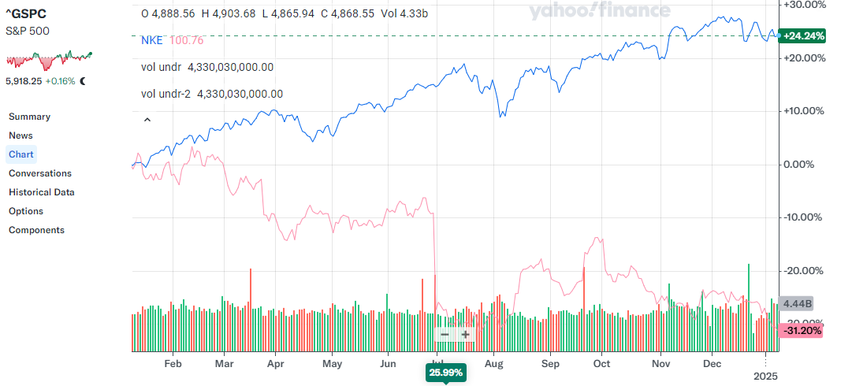







**EBITDA and Margin**: Forecasted Nike’s EBITDA grow steadily from $13.01 billion in 2023 to $19.70 billion in 2027. Also, the EBITDA margin is expected to be between 26% and 29%, this shows there is operational efficiency which is propelled by cost control and pricing strategies together with revenue growth, especially in the aspect of product innovation in premium products like footwear and apparel. Footwear has the highest contribution to revenue, with strong demand across all regions followed by apparel. North America is the largest revenue contributor while EMEA is the fastest-growing revenue segment. Over the years Nike has significantly invested in R&D to improve customer satisfaction and enhance product differentiation. They also invest in data analytics and digital platforms to foster and improve customer engagement and inventory management.

**Revenue growth expectation, and key segment performance:** Nike group revenue is expected to grow constantly from $49.68 billion in 2023 to $68.31 billion in 2027, a CAGR of exactly 8.2%. The steady growth shows that Nike has a strong brand presence and the capacity to leverage innovation and market expansion. North America is the largest revenue-contributing segment. This segment remains the main growth driver that significantly contributes to total revenue. Nevertheless, the EMEA segment demonstrates the highest growth potential, growing from $13.96 billion in 2023 to $22.11 billion in 2027. This makes this segment the fastest-growing segment that is driven by the increasing expansion of e-commerce channels, adoption of athleisure and greater market penetration especially in European countries.

**Investment thesis:** Based on my model, Nike’s stock is expected to experience consistent growth for the next decade. The projected share price steadily increases from $148.82 in 2022 to $288.29 by 2032, this suggests an upward trajectory driven by market confidence and robust business fundamentals.

Company Name: Nike Inc.

Ticker: NKE

Current Share Price: 148.82

Upside/Downside to current share price: ((Forecasted Price – Current Price)/Current Price): 0.09 or 9%

**Net debt, ROE, P/E, and EV/EBITDA:**

There is a slight decline in the net debt of Nike from -$790 million in 2022 to a net debt of $825 million in 2025. This implies that the firm is utilizing its cash reserves efficiently for investment activities like expanding its stores, investing in Capex and digital transformation. The company has a high value of ROE which is around 37%. This value suggests that the firm can consistently give its shareholders high returns, meaning Nike is generating enough funds as it efficiently uses its capital. The Price-to-Earnings Ratio decreased from 20.8% in 2022 to 16.9% in 2025 which shows that the stock of the firm is now more attractive and implies a potential upside for investors. Similarly, the EV/EBITDA decreases from 16.9% in 2022 to 13.7% in 2025. This multiple decrease in EV/EBITDA reveals the earnings potential of the firm.

**Sales growth, EBIT growth and margin, Net profit growth, net margin, and EPS growth:**

There is a gradual increase in the sales of Nike as it grows from 4.9% in 2022 to 8.0% in 2025. This reveals that the firm steadily captures market opportunities and can expand its global presence using several strategies like digital sales channels. Nike’s EBIT grows from a decrease of -1.0% in 2022 to a positive percent of 6.4 in 2023, 7.0% in 2024 and 8.0% in 2025. This progressive growth implies improvement in the company’s operational activities and cost control. EBIT margin is constant a 14.7% from 2022 to 2025. This is also evidence of improved operations that is the firm is able to manage its operating expenses while at the same time driving revenue growth. The decline in net profit growth from -0.6% in 2022 to -8.0% in 2025 is an indication of several challenges like rising costs (for example rise in inflationary rate, rise in supply chain expenses and so on), and increase in investment in R&D etc. it is observed that the top-line growth is strong and the bottom line is weak due to some of this challenges. Also, a decline from 12.9% to 12.2% is recorded for the net margin from 2022 to 2025. This little deviation shows the problems of converting operational income into net profit as a result of increasing financial costs, taxes and the like. However, the EPS values of the firm remain positive and grow from 5.2% in 2022 to 10.9% in 2025. This constant increase indicates a share buyback program of the company and strong earnings generation even during net profit challenges.





