Revenue and Cost Drivers: Marriott Inc. and Johnson & Johnson

Revenue Drivers

Marriott Inc.

- Marriott's revenue primarily comes from hotel room bookings, food and beverages, and other hospitality services.
- Key drivers include:
- Price: Room rates, services (e.g., premium services), and brand premium.
- Volume: Occupancy rates, number of rooms available, and geographical expansion.
- Revenue growth is affected by economic conditions, tourism trends, and Marriott Inc.'s ability to innovate in services.

Revenue breakdown

- Price component:
  - Average Daily Rate – This is the average price charged for hotel rooms. Increasing rates directly boosts the revenue. The Average Daily Rate is influenced by market demand, competition, and location.
  - Premium services – Marriott Inc. offers premium services, such as upgraded room options, food and beverage packages, and event hosting, which increases the average customer spending.
- Volume component
  - Occupancy rates – The percentage of available rooms sold over a period. Higher occupancy rates drive revenue growth when coupled with a strong Average Daily Rate.
  - Number of properties and rooms – Expanding Marriott Inc.’s portfolio through property development or acquisition increases available room nights, which contributes to volume growth.
  - Geographical expansion – Entry into new markets increases the volume of customers, especially in high-demand regions like tourist hotspots or emerging markets.

When the Average Daily Rate increases without a drop in occupancy, Marriott Inc. can experience significant revenue growth. On the other hand, price sensitivity may lead to reduced occupancy if rates are too high. Higher occupancy rates drive revenue growth by increasing room sales, especially during peak season. Expansion in high-demand regions supports sustained revenue growth.

Johnson & Johnson

- Johnson & Johnson generates revenue through three main segments: Pharmaceuticals, Medical Devices, and Consumer Health products.
- Key drivers include:
- Price: Prescription drug pricing, pricing of medical devices, and consumer products.
- Volume: Prescription volumes, product launches, and market penetration.
- Revenue is sensitive to regulatory changes, patent expiration, and competition in pharmaceuticals.

Revenue breakdown

- Price component
  - Pharmaceutical pricing – Prescription drug prices are a significant revenue driver. These are influenced by patent protection, regulatory frameworks, and competition. Price increases, within regulatory limits, leads to revenue growth.
  - Consumer goods and medical devices – The pricing of products like Band-Aid, Neutrogena, and medical devices affects sales volumes. Price adjustments can shift consumer demand, especially in competitive markets.
- Volume component
  - Prescription volume – Increasing the number of prescriptions for Johnson & Johnson’s pharmaceutical products directly boosts revenue. This is driven by new product launches, geographic expansion, and disease prevalence.
  - Product sales – The volume of consumer health products and medical devices sold impacts revenue. High demand for healthcare products or new launces increases volume.
  - Geographical market expansion – Expanding into new markets increases sales volume, especially in fast-growing economies.

Price increases in pharmaceuticals, especially for patented products, have a strong effect on revenue growth. However, after the patent expires, prices often drop significantly due to competition from generics.

Volume growth in Johnson & Johnson’s diverse portfolio ensures sustained revenue, particularly when new product launches or geographical expansion tap into unmet needs.

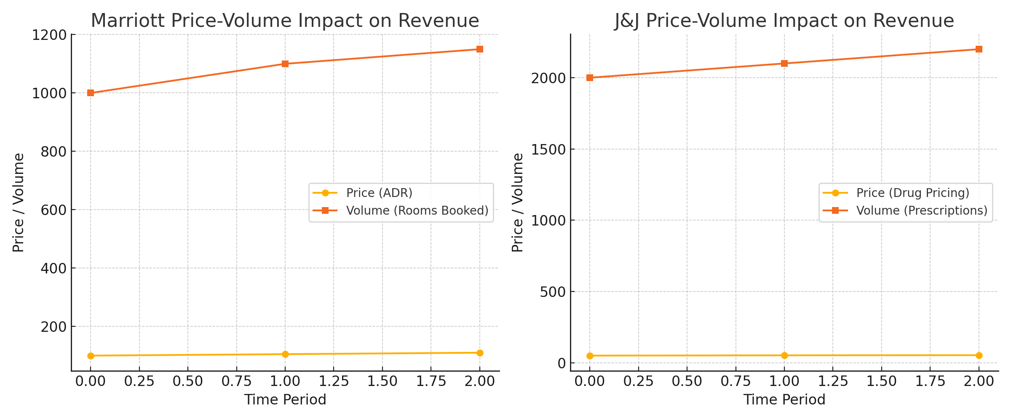

Cost Drivers

Marriott Inc.

- Fixed Costs: Infrastructure (hotels), brand development, franchise fees, and administrative costs.
- Variable Costs: Housekeeping, food and beverages, labour costs (which vary based on occupancy rates), and energy.
- The proportion of fixed and variable costs means that Marriott Inc.'s margins are highly dependent on occupancy rates.

Fixed costs remain constant and do not adjust based on revenue. Variable costs, especially housekeeping and food and beverage services, fluctuate with room occupancy and guest volumes. As Marriott Inc. increases its room sales, its variable costs grow proportionally.

Johnson & Johnson

- Fixed Costs: Research and development (R&D), manufacturing facilities, administrative costs.
- Variable Costs: Manufacturing costs, labour, raw materials (particularly for consumer and medical products), and marketing expenses.
- Variable costs are influenced by production volumes and raw material prices.

Fixed costs such as research and development and manufacturing remain stable regardless of short-term revenue shifts. Variable costs, including raw materials and distribution, rise with production volumes and product sales. As Johnson & Johnson expands its sales volumes in pharmaceuticals, medical devices, and consumer goods, these variable costs adjust accordingly.

Company Performance

Marriott Inc.

- Marriott's performance is highly influenced by the global tourism industry and economic cycles.
- Cost control and high occupancy rates help boost profit margins, while lower demand (e.g., during economic downturns or crises) leads to a disproportionate impact on margins due to high fixed costs.

Johnson & Johnson

- Johnson & Johnson's diversified portfolio helps smooth revenue volatility, with pharmaceuticals being a key growth driver.
- Strong R&D investments ensure a pipeline of innovative products, although regulatory pressures and patent cliffs may impact long-term revenue growth.

Peer Comparison

Marriott Inc.

- Hilton Worldwide Holdings
- Hyatt Hotels Corporation.

Marriott Inc. has shown steady revenue growth driven by its extensive global presence, including franchise models and expansions into luxury and boutique segments.

Hilton Worldwide Holdings also reported strong revenue growth, driven by its asset-light business model and higher occupancy rates, though its revenue is slightly less diversified compared to Marriott Inc.’s extensive global reach.

Hyatt Hotels Corporation focuses more on high-end and luxury segments, and although it has a smaller footprint than Marriott Inc., it has seen growth in high-value properties and emerging markets.

Johnson & Johnson

- Pfizer
- Merck & Co.

Johnson & Johnson’s diversified portfolio across pharmaceuticals, consumer health, and medical devices has enabled consistent revenue growth, particularly with strong performance in the pharmaceuticals segment.

Pfizer has experienced robust growth, particularly from its COVID-19 vaccine and antiviral products, though it is more reliant on the pharmaceutical sector and is subject to larger revenue swings from the expiration of patents and regulatory changes.

Merck & Co Inc. has focussed on high growth areas such as oncology and vaccines, leading to strong growth in specific therapeutic areas. However, it lacks the diversification that Johnson & Johnson’s broader portfolio offers.

Both Marriott and Johnson & Johnson show strong market positions, but their growth drivers and cost structures differ significantly. However, Marriott Inc. leads its peers in global footprint and brand diversification compared to its peers, while Johnson & Johnson stands out among its peers for its diversified portfolio.

