**Instructions:**

1. After deriving the intrinsic share price based on our model, the next step is to focus on putting together a report with an investment recommendation.
2. You are required to fill in the report template below using the sample report attached and your readings on the company’s guidance in terms of key segments and products.
   1. Identify two to three key products that are vital for the company’s growth and you can discuss about the trends and expectations. But remember to keep them all short cause and effect sentences.
3. You can take up to two days for this task and feel free to reach out to me if you have any questions.

Nike's revenue is expected to grow steadily at about 4.9% annually through 2027. This growth reflects strong demand in key markets and the company’s ability to recover from pandemic-related challenges. Footwear remains Nike’s largest and most important segment, driving a significant portion of the company’s revenue. Within this, iconic products like the Air Max line, the Nike Flyknit line, and the Jordan brand play a big role. Air Max drives sales due to constant innovation and strong consumer loyalty, keeping it a top seller. Nike Flyknit appeals to eco-conscious buyers, boosting growth with its sustainable, lightweight design. The Jordan Brand maintains high demand through its iconic reputation and popular collaborations, fueling continued growth.

Nike's EBITDA margin has improved to 14.7%, driven by operational efficiency and high-margin products. The Footwear segment, led by Air Max and Jordan, is the largest contributor, followed by Apparel at a lower margin. Nike expects stable margin growth of 4.9% annually, supported by premium pricing and innovation. R&D costs are rising due to investment in sustainable products, while supply chain and marketing expenses are increasing as Nike expands globally.

Nike’s EPS is forecasted to remain steady at around $3.76 per share, supported by strong earnings and share repurchases. FCFF is projected at $7.7 billion in 2024, driven by robust cash flow. Capex is expected to be $972 million as Nike invests in innovation, digital transformation, and manufacturing. Nike's future developments focus on expanding its digital presence, with investments in e-commerce and direct-to-consumer sales. The company is also prioritising sustainability through eco-friendly product lines and renewable materials. Nike doesn't have a drug pipeline like a pharmaceutical company but its emphasis on innovation, sustainability, and digital transformation is key to its growth strategy moving forward.

**Investment thesis:**

Nike is expected to exhibit steady revenue growth at a compound annual growth rate of ~4.9% through to 2027, driven by strong operational performance and a return to stable EBIT margins of ~14.7%. This suggests moderate but consistent stock performance.

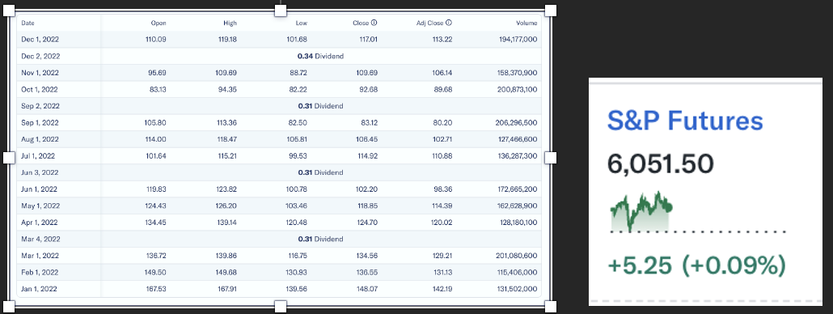

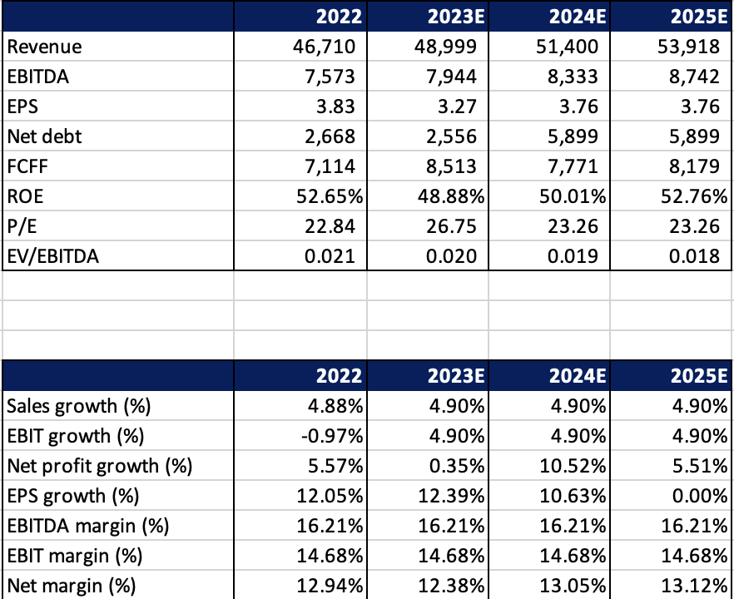

Company Name: **Nike**

Ticker: **NKE**

Current Share Price: **$78.86 as at 3rd December 2024**

Upside/Downside to current share price: ((Forecasted Price – Current Price)/Current Price): **(86.70 – 78.86)/78.86 = 9.94% (upside)**