**Ratio Analysis:**

1. **Liquidity ratios**

Over the years the liquidity position is getting worse but the condition is not that serious given the size of operations and cash available with the firm the firm can manage at current levels, but if it falls below 0.5(Current ratio), then if might create some concerns and we need to evaluate accordingly. By looking at the trend and the current position, there is no major risk of liquidity related issues.

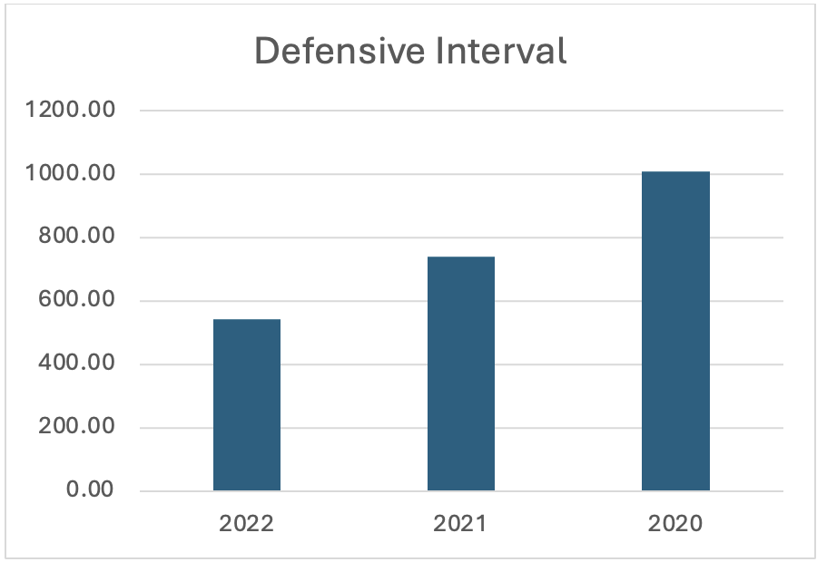

The company has significant amount of liquid current assets, and it can service the operational expenses for a long period of time, though it has reduced in the last few years but that is mainly due to the increasing operational expenses. Still, it is around 500 days which is a pretty strong number and hence no issues.

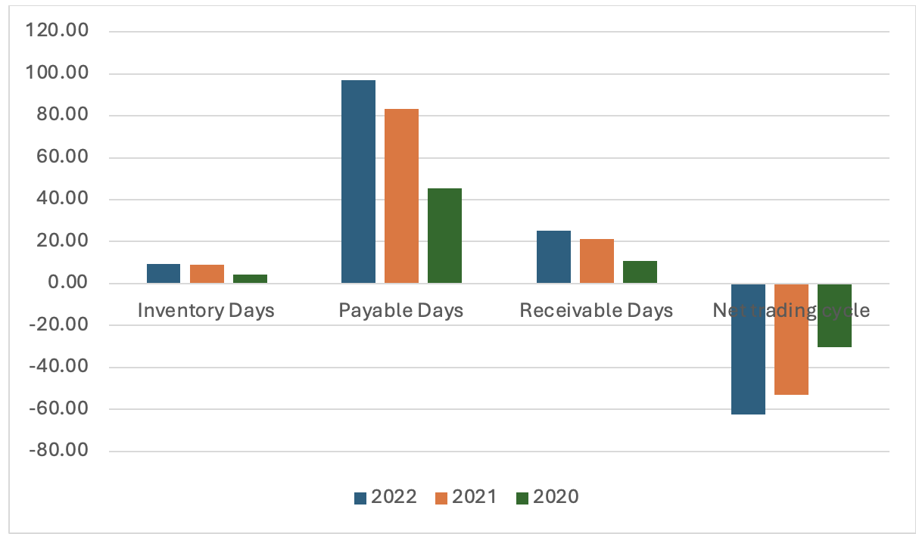

Payable days have increased by a significant amount and that shows an increase in the bargaining power of the company. There has been an increase in the receivables and inventory days as well but the impact of increasing payable days is higher. That has led to a negative working capital in 2022. This shows the working capital is improving for the company and the overall impact has been positive. The net trading cycle also shows similar trend. It is a positive sign and continuation of this trend will show strength in the operations of the business.

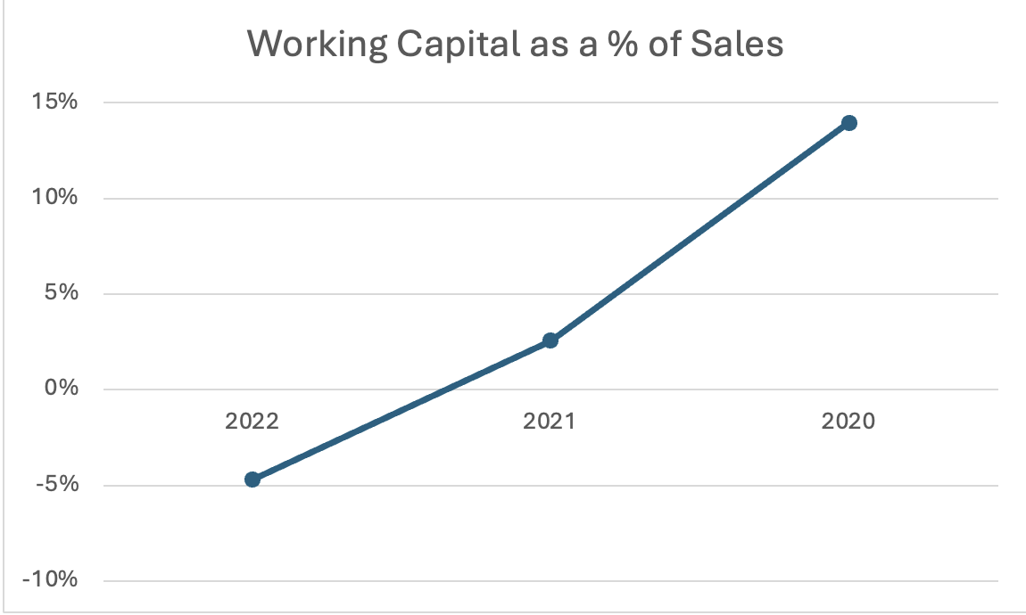

This is a positive sign as the WC as % of sales is consistently going down. In 2022, it is in the negative range that shows strengthening terms for the company. It would be great if the company follows the trend and maintain the negative WC cycle.

1. **Profitability**

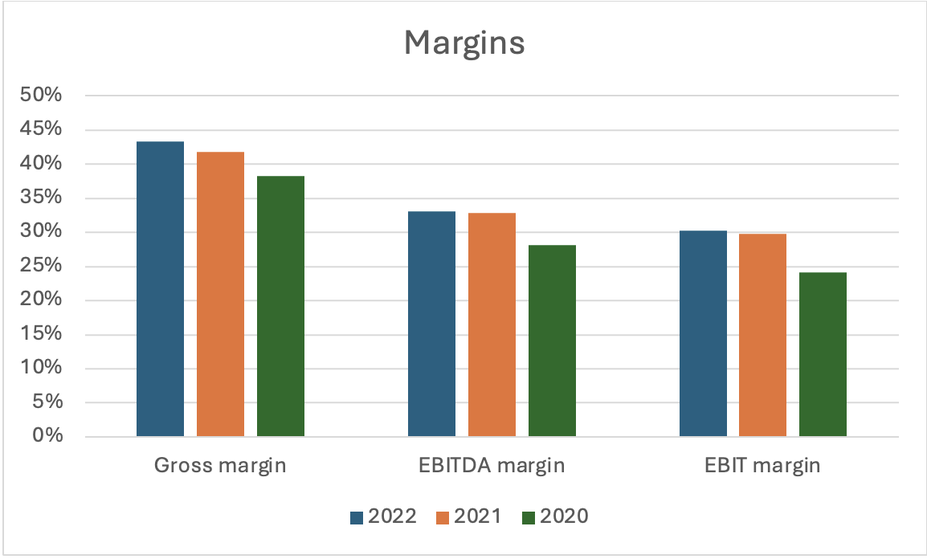

All the important margins are going up, that is a positive sign. Between 2021 and 2022 there has not been a major jump in the margins, they are almost flattish. But the overall trend is positive. We saw a decent growth in margins from 2020 to 2021.

1. **Solvency/Debt management**

We can see that the debt to total assets has remain almost flattish in the given years but there has been a significant change in the D/E ratio. The company is increasing the debt over the years and the ratio crossed 2 in 2022, that is an important observation, and we should keep a track of that. A consistent increase in the D/E ratio can lead to balance sheet strength issues in the future and hence an important parameter to track. The other ratios do not show any major concern. As of now, there are no solvency issues visible and the debt management is also decent, but we should track these ratios consistently over the years to get a better picture.

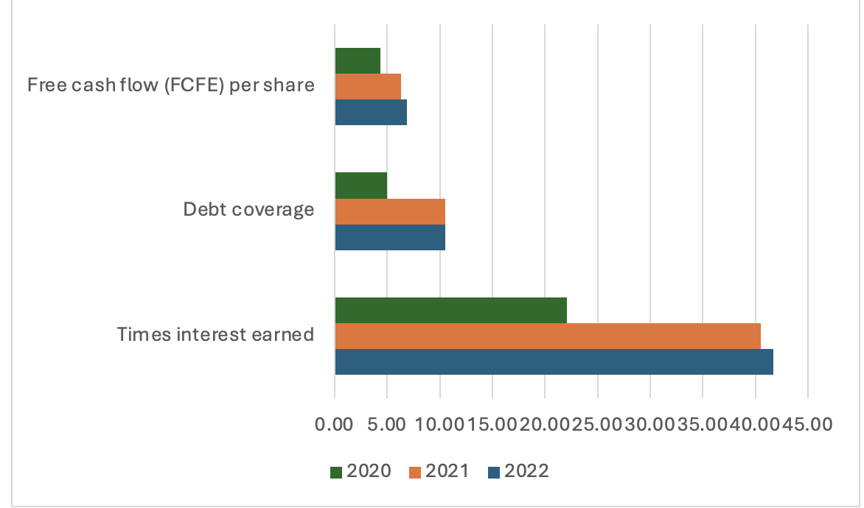

FCFE/share is getting better over the years and the ability to pay the interest is also going up. Due to the increase in the profit from operations we can see the debt coverage ratios are getting better. The trend is positive and will lead to much better financial stability if is supported by positive and strengthening profits.

1. **Asset Utilization**

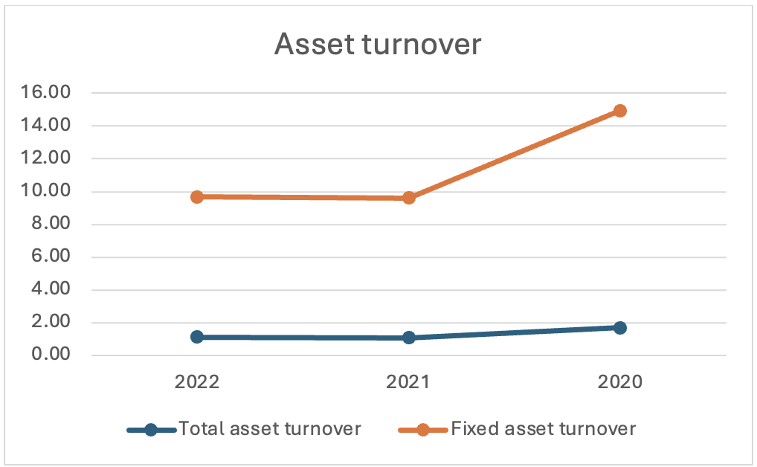

Fixed asset turnover went down from 2020 levels, but it is still at decent levels so the assets are being utilized properly and in an efficient manner. Total asset turnover is also at similar levels. As the business is not that asset heavy, this ratio might not make a lot sense in terms of analysis but at the same time due to the size of the operations and different segments we need to keep a check on the number as well. The ratios are fine and not major red flag is there.

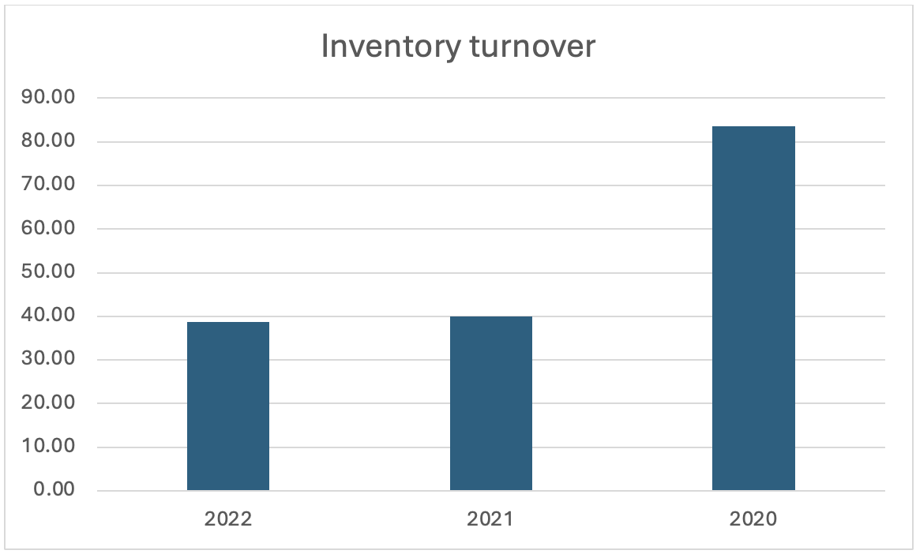

Inventory turnover is getting worse when we compare to 2020 levels and that has also led to increase in inventory days. There is a scope of improvement in the inventory turnover levels and that will improve the WC cycle even more. We can monitor this for the coming years and if it reaches the 2020 levels, that will be a positive sign for companies operations.

1. **Investor/Market ratios**

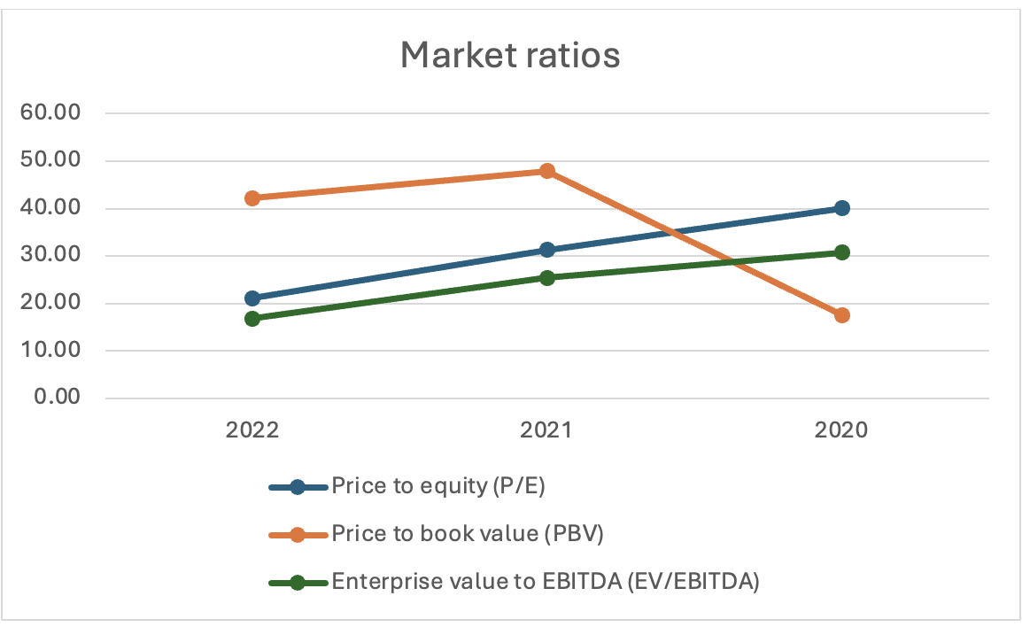

P/E and EV/EBITDA ratios have been falling in the past 2 years. The P/E ratio is supported by a positive earnings trend that is a positive sign as earning growth is also there. Also, EBITDA growth is decent. This shows that maybe the price is not getting revised in tandem with the earnings growth, that shows falling P/E ratios. But at the same time, it is not a bad sign as support from earnings growth is still there. If the earnings growth is strong consistently in future also, a falling P/E can create good opportunity to accumulate the stock as the multiple re-rating will certainly follow a strong earnings growth and future expectation.

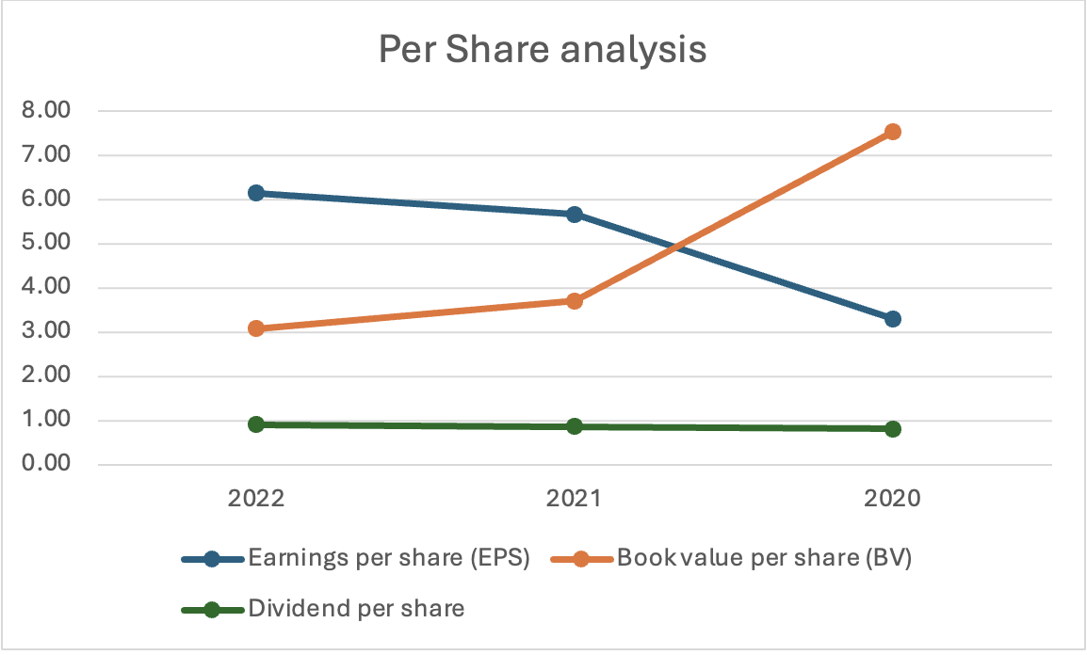

Earnings growth is good and the dividend per share has been in the similar range for the last 3 years. Different opportunities available to invest and grow the business can lead to a lower growth in dividends and that is acceptable if the capital is used wisely and leading to better growth in profits, which is the case with Apple.

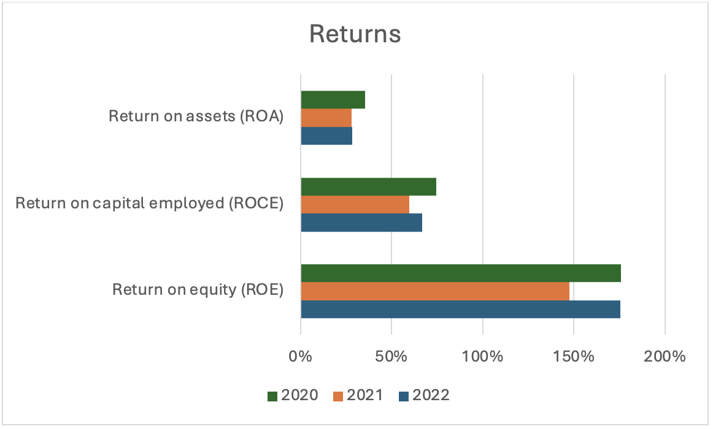

The company has very strong return ratios. The company maintains very high ROE, there was a temporary drop in the ROE in 2021 but it was again up to similar levels as 2020.

The company also has high ROCE, that shows they are good capital allocators and the high ROCE over the years confirms this observation.

To maintain such high ROE and ROCE numbers is commendable and shows that the business has a sustainable competitive advantage and has the ability to maintain that.