**Financial Analysis of Amazon.com, Inc. for Fiscal Years 2021 and 2022**

**Introduction**

This report analyzes the financial performance of Amazon.com, Inc. for the years ending December 31, 2021, and December 31, 2022. We examine key financial metrics, including liquidity, profitability, solvency, asset utilization, and investor ratios, to understand the company's financial health and operational efficiency during this period.

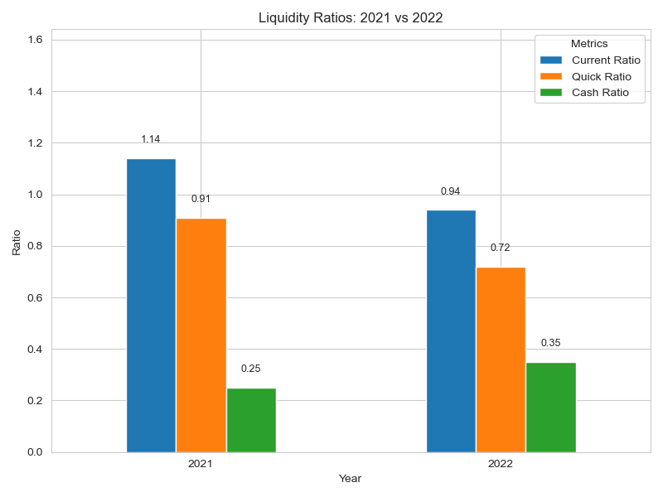**Liquidity Analysis**

Liquidity ratios indicate a company's ability to meet its short-term obligations. Important liquidity ratios for Amazon are:

* Current Ratio: Decreased from 1.14 in 2021 to 0.94 in 2022.
* Quick Ratio: Dropped from 0.91 to 0.72.
* Cash Ratio: Increased from 0.25 to 0.35.

In 2022, both the current ratio and quick ratio fell below 1, suggesting that current assets are less than current liabilities. This may raise concerns about Amazon's ability to cover short-term debts without additional financing. However, the increase in the cash ratio indicates that the company has more cash available relative to immediate liabilities.

The defensive interval declined from 143.02 days to 124.20 days, meaning Amazon has fewer days of operational expenses covered by liquid assets. Inventory days slightly decreased from 29.53 to 28.13 days, showing improved inventory turnover. The net trading cycle improved from -16.08 days to -6.88 days, remaining negative, which is favorable as it indicates that Amazon collects cash from customers before paying suppliers.

The working capital turned negative in 2022, shifting from $19,314 million to -$8,602 million. As a percentage of sales, it moved from 4.11% to -1.67%. Negative working capital can be efficient in some industries but may also pose liquidity risks if not managed properly.

**Profitability Analysis**

Profitability ratios assess a company's ability to generate earnings relative to sales and assets.

* 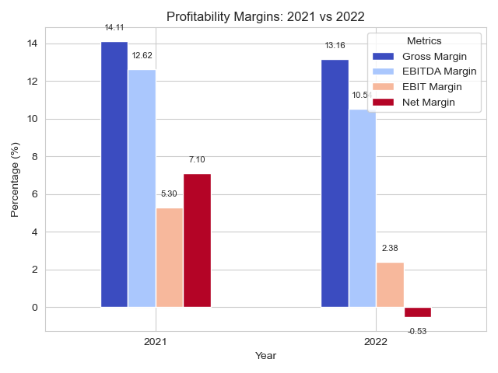Gross Margin: Slightly decreased from 14.11% in 2021 to 13.16% in 2022.
* EBITDA Margin: Reduced from 12.62% to 10.54%.
* EBIT Margin: Declined from 5.30% to 2.38%.
* Net Margin: Dropped from 7.10% to -0.53%.

The decrease in margins suggests that Amazon faced increased costs or reduced pricing power in 2022. The negative net margin indicates a net loss for the year, possibly due to higher operating expenses or strategic investments that have not yet produced returns.

EBITDA decreased from $59,312 million to $54,169 million, and EBIT declined from $24,879 million to $12,248 million, reflecting lower operating profitability.

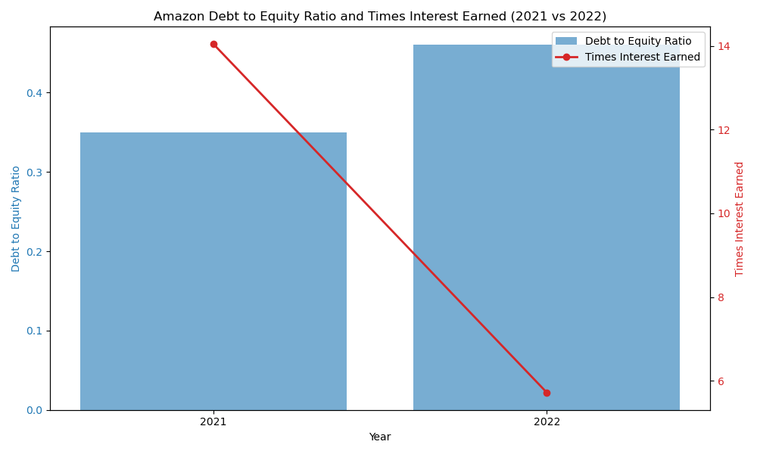**Solvency and Debt Management**

Solvency ratios measure a company's ability to meet long-term obligations.

* Debt to Equity Ratio: Increased from 0.35 to 0.46.
* Debt to Total Assets: Rose from 0.12 to 0.15.
* Long-term Debt to Capital: Went up from 0.26 to 0.31.

These increases indicate that Amazon has taken on more debt relative to equity and assets, which may increase financial risk. The times interest earned ratio decreased from 14.04 to 5.72, suggesting a reduced ability to cover interest expenses from operating income.

The debt coverage ratio declined from 5.34 to 1.32, indicating less cash flow available to cover debt obligations. Despite these challenges, the free cash flow to equity (FCFE) was $20,873 million in 2022, with an FCFE per share of $2.05, showing that Amazon continues to generate positive cash flow for shareholders.

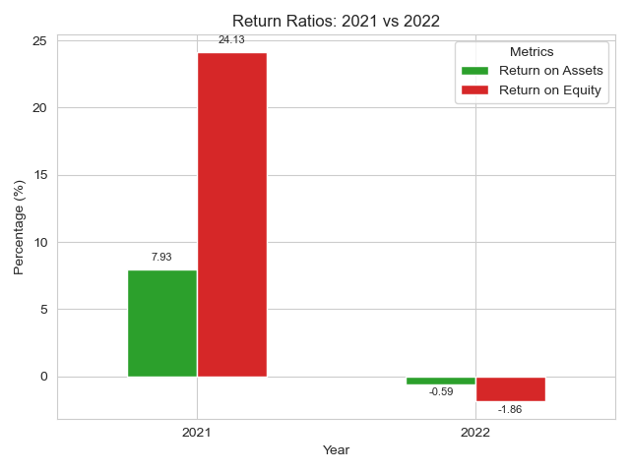**Asset Utilization**

Asset utilization ratios evaluate how efficiently a company uses its assets to generate revenue.

* Total Asset Turnover: Slightly decreased from 1.12 to 1.11.
* Fixed Asset Turnover: Declined from 2.93 to 2.75.
* Inventory Turnover: Improved from 12.36 to 12.97.

The minor decrease in total asset turnover suggests stable efficiency in using assets to generate sales. The reduction in fixed asset turnover may indicate that recent investments have not yet translated into increased sales. The improved inventory turnover reflects better management of inventory levels.

Return on Assets (ROA) fell from 7.93% to -0.59%, indicating that assets are generating less income, and the company experienced a loss relative to its assets in 2022.

**Investor and Market Ratios**

These ratios provide insights into the company's valuation and returns from an investor's perspective.

* Price to Earnings (P/E) Ratio: Changed from 51.45 to -314.43 due to negative earnings.
* Earnings per Share (EPS): Decreased from $3.24 to -$0.27.
* Price to Book Value (P/BV): Improved from 12.42 to 5.86.
* Book Value per Share (BVPS): Increased from $13.43 to $14.33.

The negative EPS and P/E ratio reflect the net loss in 2022. The lower P/BV ratio may make the stock more attractive to value investors. Return on Equity (ROE) dropped significantly from 24.13% to -1.86%, indicating a loss to shareholders. Return on Capital Employed (ROCE) also decreased from 8.94% to 3.99%, showing reduced efficiency in generating profits from capital employed.

The Enterprise Value to EBITDA (EV/EBITDA) ratio improved from 29.15 to 16.05, suggesting that the company's valuation relative to EBITDA has become more favorable.

**Growth Rates**

* Product Sales Growth: Minimal increase of 0.46%.
* Services Sales Growth: Strong growth of 18.88%.
* Total Net Sales Growth: Increased by 9.40%.
* Gross Profit Growth: Modest increase of 2.00%.
* Fulfillment Costs: Grew by 12.23%.
* Technology and Content Costs: Increased by 30.62%.
* SG&A Expenses: Rose by 30.83%.

The significant growth in services sales indicates a successful expansion in areas like cloud computing (AWS), subscriptions, and advertising services. However, operating expenses, particularly in technology, content, and SG&A, grew faster than revenues, which negatively affected profitability.

**Margins as a Percentage of Net Sales**

* Cost of Goods Sold (COGS) Margin: Increased from 85.89% to 86.84%.
* Technology and Content Margin: Rose from 11.93% to 14.24%.
* SG&A Margin: Increased from 8.81% to 10.53%.
* Operating Income Margin: Decreased from 5.30% to 2.38%.
* Net Profit Margin: Fell from 7.10% to -0.53%.

The higher COGS margin suggests increased cost pressures. Rising technology, content, and SG&A margins indicate higher operating expenses relative to sales, contributing to the decline in operating and net profit margins.

**Additional Items**

* Income Tax Rate: Changed from -12.56% to -54.19%, indicating tax benefits, possibly due to net losses.
* Capital Expenditures (CapEx) as a Percentage of Sales: 13.30%.
* CapEx as a Percentage of Fixed Assets: 36.61%.

The significant CapEx reflects ongoing investments in infrastructure and technology to support future growth.

**Conclusion**

The financial analysis of Amazon for 2021 and 2022 shows:

* Liquidity: Decreased ratios suggest potential short-term financial constraints, though the higher cash ratio provides some reassurance.
* Profitability: Declining margins and a net loss highlight challenges in cost management and profitability, despite revenue growth.
* Solvency: Increased debt levels and reduced interest coverage ratios point to higher financial risk.
* Asset Utilization: Efficiency remains relatively stable, with improved inventory turnover but decreased returns on assets.
* Investor Perspective: Negative earnings have impacted investor ratios, but lower valuations may present opportunities for investors.

Overall, Amazon faced profitability challenges in 2022, possibly due to increased costs, market conditions, or significant investments. While revenue growth, especially in services, remains strong, the company may need to focus on controlling expenses and improving operational efficiency to enhance profitability and shareholder value in the future.