**Comprehensive Financial Ratio Analysis: Apple Inc. (2020 - 2022)**

# Introduction

This report provides a comprehensive analysis of Apple Inc.'s financial ratios over the fiscal years 2020 to 2022, focusing on liquidity, profitability, solvency, efficiency, market, and valuation metrics. The data is derived from Apple's financial statements and provides insights into the company's financial health and performance trends over the three-year period.

# Liquidity Ratios

The following ratios fall under liquidity ratios analysis, which provides insights into Apple's performance in this area.

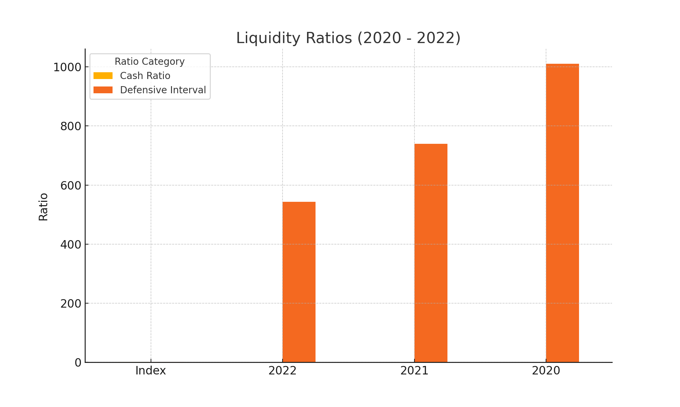

## Cash Ratio

The Cash Ratio shows the performance of Apple in terms of liquidity ratios over the years. As seen in the chart, the Cash Ratio for 2020, 2021, and 2022 indicates the following trend: Further analysis of this trend reveals potential changes in the company's financial strategy and market positioning.

## Defensive Interval

The Defensive Interval shows the performance of Apple in terms of liquidity ratios over the years. As seen in the chart, the Defensive Interval for 2020, 2021, and 2022 indicates the following trend: Further analysis of this trend reveals potential changes in the company's financial strategy and market positioning.

# Profitability Ratios

The following ratios fall under profitability ratios analysis, which provides insights into Apple's performance in this area.

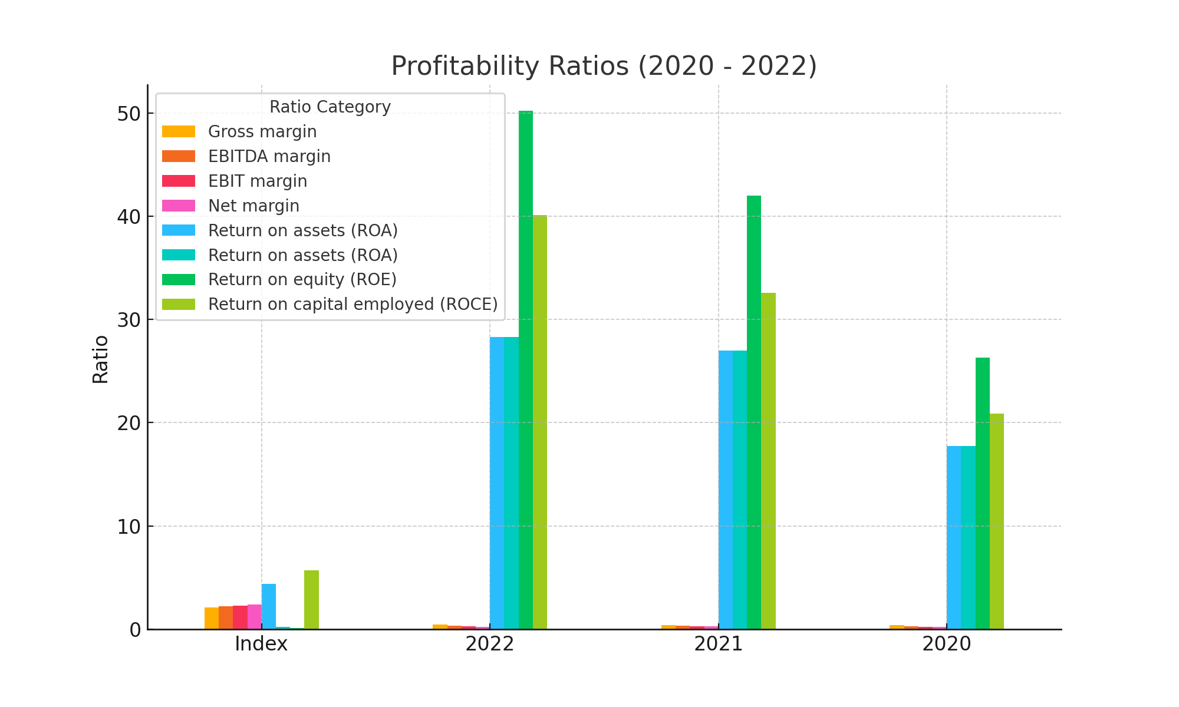

## Gross margin

The Gross margin shows the performance of Apple in terms of profitability ratios over the years. As seen in the chart, the Gross margin for 2020, 2021, and 2022 indicates the following trend: Further analysis of this trend reveals potential changes in the company's financial strategy and market positioning.

## EBITDA margin

The EBITDA margin shows the performance of Apple in terms of profitability ratios over the years. As seen in the chart, the EBITDA margin for 2020, 2021, and 2022 indicates the following trend: Further analysis of this trend reveals potential changes in the company's financial strategy and market positioning.

## EBIT margin

The EBIT margin shows the performance of Apple in terms of profitability ratios over the years. As seen in the chart, the EBIT margin for 2020, 2021, and 2022 indicates the following trend: Further analysis of this trend reveals potential changes in the company's financial strategy and market positioning.

## Net margin

The Net margin shows the performance of Apple in terms of profitability ratios over the years. As seen in the chart, the Net margin for 2020, 2021, and 2022 indicates the following trend: Further analysis of this trend reveals potential changes in the company's financial strategy and market positioning.

## Return on assets (ROA)

The Return on assets (ROA) shows the performance of Apple in terms of profitability ratios over the years. As seen in the chart, the Return on assets (ROA) for 2020, 2021, and 2022 indicates the following trend: Further analysis of this trend reveals potential changes in the company's financial strategy and market positioning.

## Return on equity (ROE)

The Return on equity (ROE) shows the performance of Apple in terms of profitability ratios over the years. As seen in the chart, the Return on equity (ROE) for 2020, 2021, and 2022 indicates the following trend: Further analysis of this trend reveals potential changes in the company's financial strategy and market positioning.

## Return on capital employed (ROCE)

The Return on capital employed (ROCE) shows the performance of Apple in terms of profitability ratios over the years. As seen in the chart, the Return on capital employed (ROCE) for 2020, 2021, and 2022 indicates the following trend: Further analysis of this trend reveals potential changes in the company's financial strategy and market positioning.

# Solvency Ratios

The following ratios fall under solvency ratios analysis, which provides insights into Apple's performance in this area.

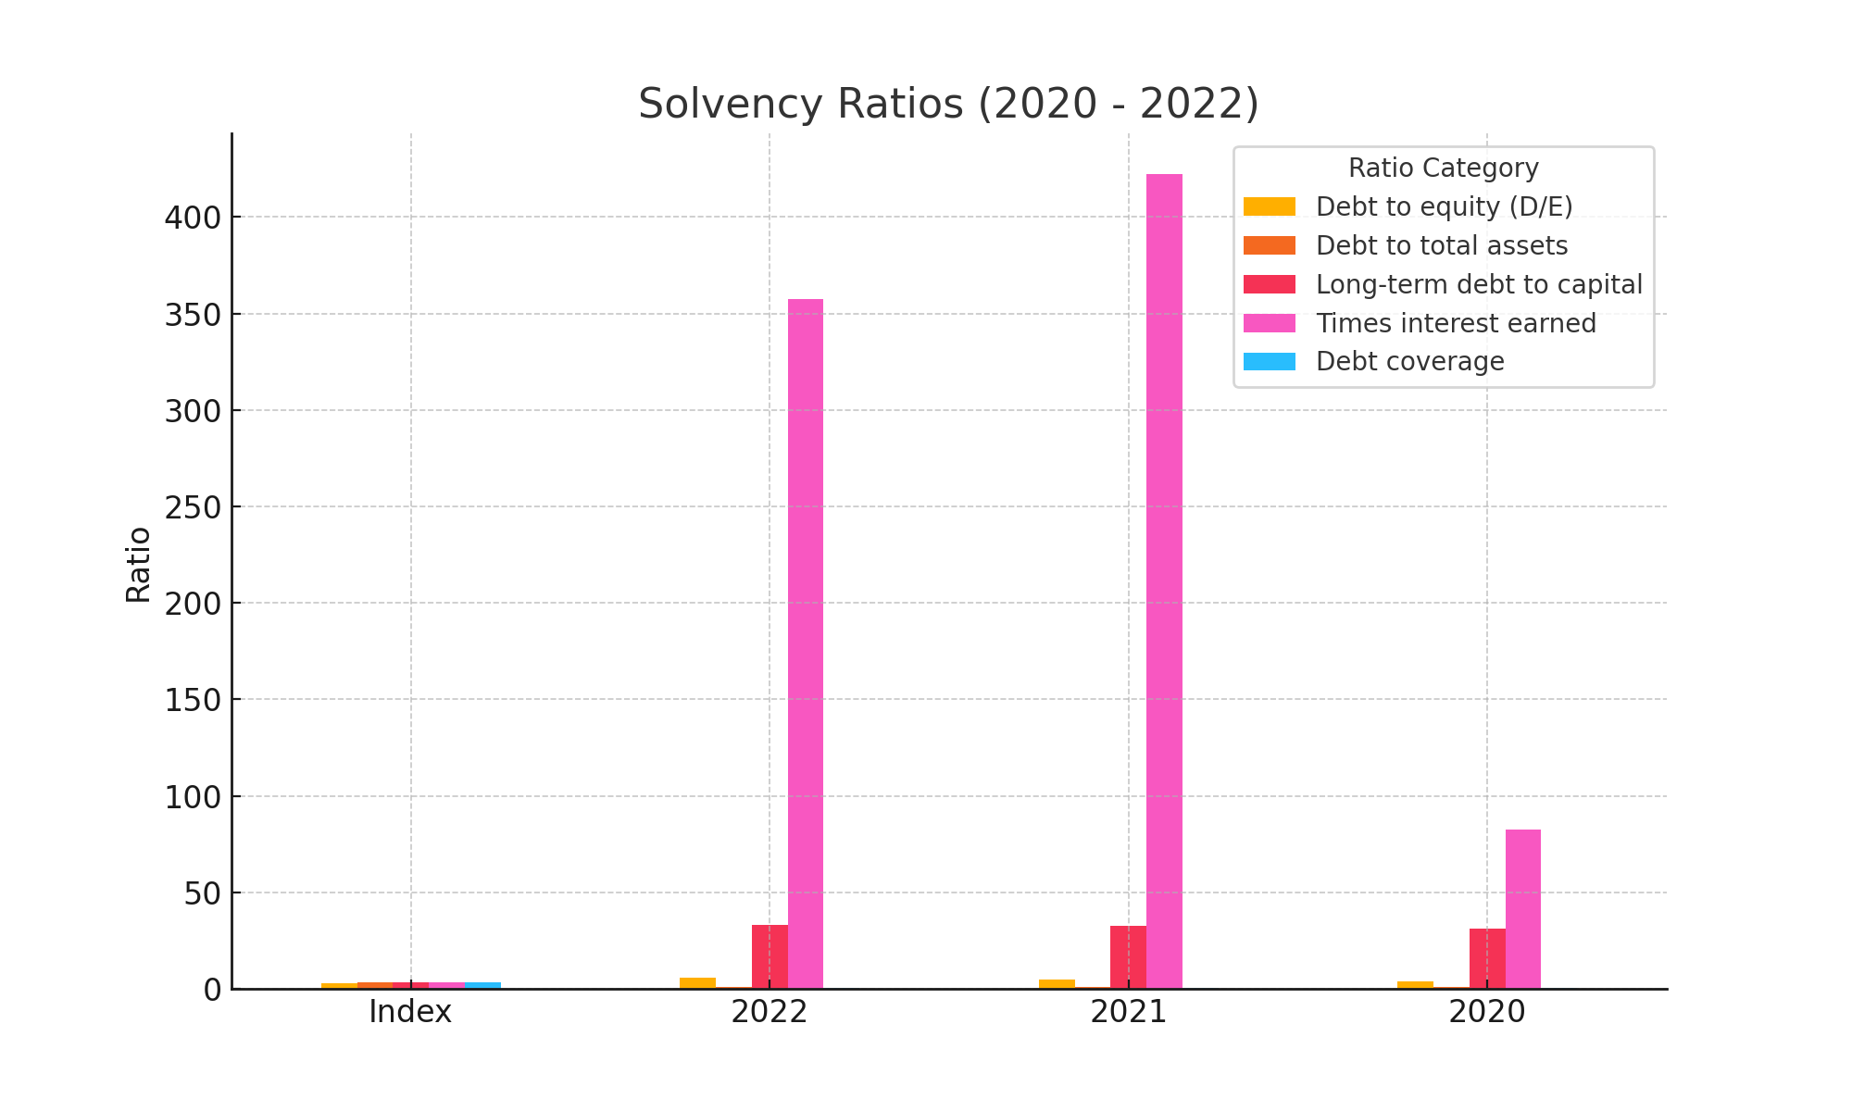

## Debt to equity (D/E)

The Debt to equity (D/E) shows the performance of Apple in terms of solvency ratios over the years. As seen in the chart, the Debt to equity (D/E) for 2020, 2021, and 2022 indicates the following trend: Further analysis of this trend reveals potential changes in the company's financial strategy and market positioning.

## Debt to total assets

The Debt to total assets shows the performance of Apple in terms of solvency ratios over the years. As seen in the chart, the Debt to total assets for 2020, 2021, and 2022 indicates the following trend: Further analysis of this trend reveals potential changes in the company's financial strategy and market positioning.

## Long-term debt to capital

The Long-term debt to capital shows the performance of Apple in terms of solvency ratios over the years. As seen in the chart, the Long-term debt to capital for 2020, 2021, and 2022 indicates the following trend: Further analysis of this trend reveals potential changes in the company's financial strategy and market positioning.

## Times interest earned

The Times interest earned shows the performance of Apple in terms of solvency ratios over the years. As seen in the chart, the Times interest earned for 2020, 2021, and 2022 indicates the following trend: Further analysis of this trend reveals potential changes in the company's financial strategy and market positioning.

## Debt coverage

The Debt coverage shows the performance of Apple in terms of solvency ratios over the years. As seen in the chart, the Debt coverage for 2020, 2021, and 2022 indicates the following trend: Further analysis of this trend reveals potential changes in the company's financial strategy and market positioning.

# Efficiency Ratios

The following ratios fall under efficiency ratios analysis, which provides insights into Apple's performance in this area.

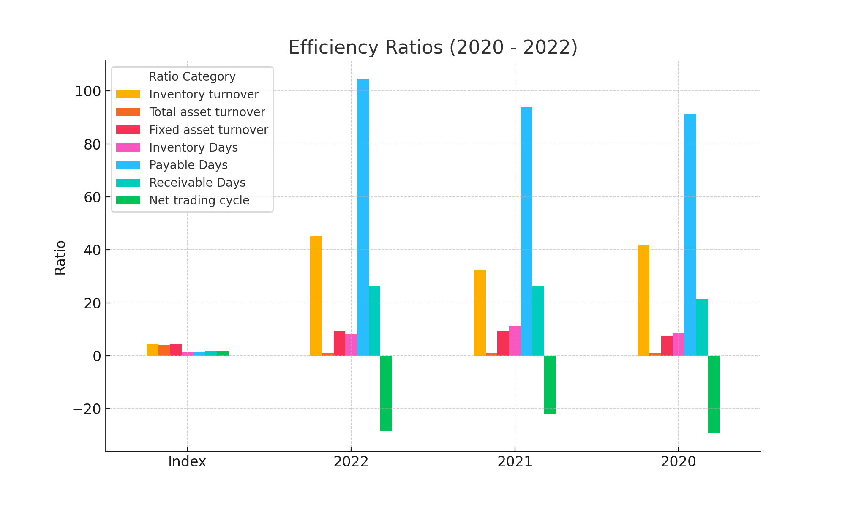

## Inventory turnover

The Inventory turnover shows the performance of Apple in terms of efficiency ratios over the years. As seen in the chart, the Inventory turnover for 2020, 2021, and 2022 indicates the following trend: Further analysis of this trend reveals potential changes in the company's financial strategy and market positioning.

## Total asset turnover

The Total asset turnover shows the performance of Apple in terms of efficiency ratios over the years. As seen in the chart, the Total asset turnover for 2020, 2021, and 2022 indicates the following trend: Further analysis of this trend reveals potential changes in the company's financial strategy and market positioning.

## Fixed asset turnover

The Fixed asset turnover shows the performance of Apple in terms of efficiency ratios over the years. As seen in the chart, the Fixed asset turnover for 2020, 2021, and 2022 indicates the following trend: Further analysis of this trend reveals potential changes in the company's financial strategy and market positioning.

## Inventory Days

The Inventory Days shows the performance of Apple in terms of efficiency ratios over the years. As seen in the chart, the Inventory Days for 2020, 2021, and 2022 indicates the following trend: Further analysis of this trend reveals potential changes in the company's financial strategy and market positioning.

## Payable Days

The Payable Days shows the performance of Apple in terms of efficiency ratios over the years. As seen in the chart, the Payable Days for 2020, 2021, and 2022 indicates the following trend: Further analysis of this trend reveals potential changes in the company's financial strategy and market positioning.

## Receivable Days

The Receivable Days shows the performance of Apple in terms of efficiency ratios over the years. As seen in the chart, the Receivable Days for 2020, 2021, and 2022 indicates the following trend: Further analysis of this trend reveals potential changes in the company's financial strategy and market positioning.

## Net trading cycle

The Net trading cycle shows the performance of Apple in terms of efficiency ratios over the years. As seen in the chart, the Net trading cycle for 2020, 2021, and 2022 indicates the following trend: Further analysis of this trend reveals potential changes in the company's financial strategy and market positioning.

# Market Ratios

The following ratios fall under market ratios analysis, which provides insights into Apple's performance in this area.

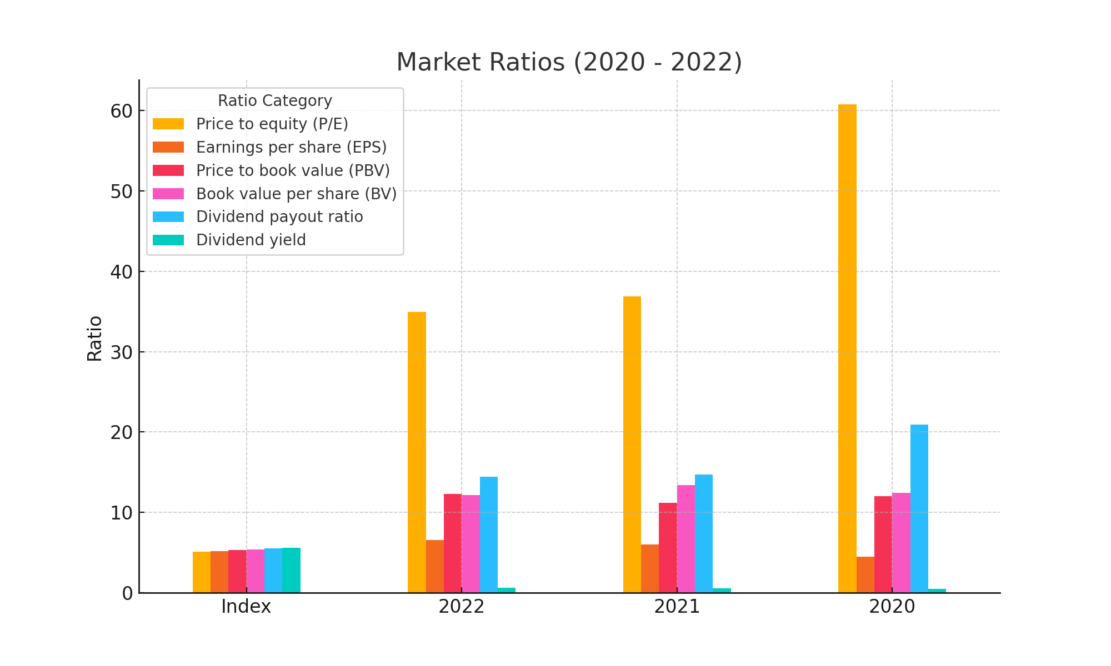

## Price to equity (P/E)

The Price to equity (P/E) shows the performance of Apple in terms of market ratios over the years. As seen in the chart, the Price to equity (P/E) for 2020, 2021, and 2022 indicates the following trend: Further analysis of this trend reveals potential changes in the company's financial strategy and market positioning.

## Earnings per share (EPS)

The Earnings per share (EPS) shows the performance of Apple in terms of market ratios over the years. As seen in the chart, the Earnings per share (EPS) for 2020, 2021, and 2022 indicates the following trend: Further analysis of this trend reveals potential changes in the company's financial strategy and market positioning.

## Price to book value (PBV)

The Price to book value (PBV) shows the performance of Apple in terms of market ratios over the years. As seen in the chart, the Price to book value (PBV) for 2020, 2021, and 2022 indicates the following trend: Further analysis of this trend reveals potential changes in the company's financial strategy and market positioning.

## Book value per share (BV)

The Book value per share (BV) shows the performance of Apple in terms of market ratios over the years. As seen in the chart, the Book value per share (BV) for 2020, 2021, and 2022 indicates the following trend: Further analysis of this trend reveals potential changes in the company's financial strategy and market positioning.

## Dividend payout ratio

The Dividend payout ratio shows the performance of Apple in terms of market ratios over the years. As seen in the chart, the Dividend payout ratio for 2020, 2021, and 2022 indicates the following trend: Further analysis of this trend reveals potential changes in the company's financial strategy and market positioning.

## Dividend yield

The Dividend yield shows the performance of Apple in terms of market ratios over the years. As seen in the chart, the Dividend yield for 2020, 2021, and 2022 indicates the following trend: Further analysis of this trend reveals potential changes in the company's financial strategy and market positioning.

# Valuation Ratios

The following ratios fall under valuation ratios analysis, which provides insights into Apple's performance in this area.

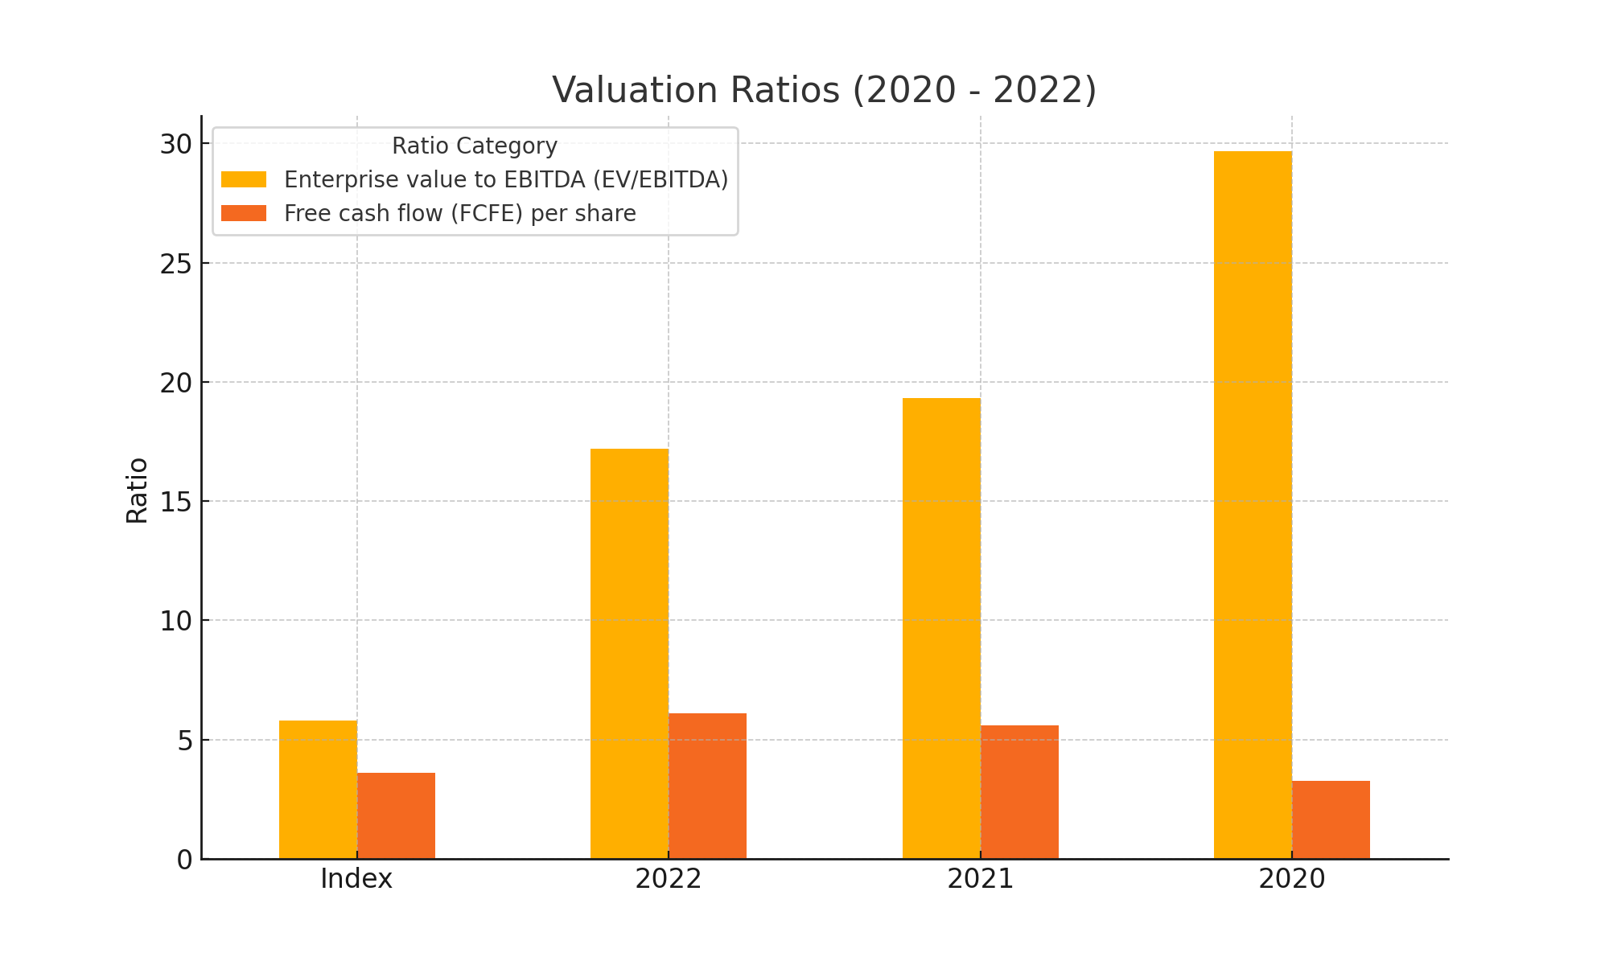

## Enterprise value to EBITDA (EV/EBITDA)

The Enterprise value to EBITDA (EV/EBITDA) shows the performance of Apple in terms of valuation ratios over the years. As seen in the chart, the Enterprise value to EBITDA (EV/EBITDA) for 2020, 2021, and 2022 indicates the following trend: Further analysis of this trend reveals potential changes in the company's financial strategy and market positioning.

## Free cash flow (FCFE) per share

The Free cash flow (FCFE) per share shows the performance of Apple in terms of valuation ratios over the years. As seen in the chart, the Free cash flow (FCFE) per share for 2020, 2021, and 2022 indicates the following trend: Further analysis of this trend reveals potential changes in the company's financial strategy and market positioning.